Advanced Programming

Lab 13: Alarm Clock Application

Ubaid ur Rehman

Reg. Number: 123495

Class: BSCS-5B

NUST – SEECS

Thursday, December 28, 2017

2017

**Quizzer (Rendered Click through models)**

Table of Contents

Application details 2

Working details: 2

Software used: 2

Screens: 2

Features: 2

Flow diagrams 2

Screen Views (Interfaces): 3

Select Hour: 3

Select Minute: 4

# Application details

## Working details:

Create a GUI based digital clock using Android SDK, which shows the current time for any timezone in the world. The timezone will be selected by the user.

The user can also create any number of alarms in future, which will be monitored in separate threads. Once, the alarm goes off, it will allow the user to either dismiss it, finishing the thread or snoozing for another 5 mins, in which case the same alarm will ring again after this duration.

Create unit tests for checking correct time, after selection of a timezone and the result of 3 alarms going off near to each other which will be snoozed for random number of times.

You can make any other assumption, without invalidating the original problem.

Each student must, individually build the complete application on their own. Students must upload their solutions on LMS to qualify for evaluation.

## Software used:

* Android Studio Version 3.0.1

# Screens:

1. Main Screen

# Features:

1. Set alarm through GUI
2. See current time

# Flow diagrams

Views of these screens are provided in next section.

# Screen Views (Interfaces):

## Select Hour:

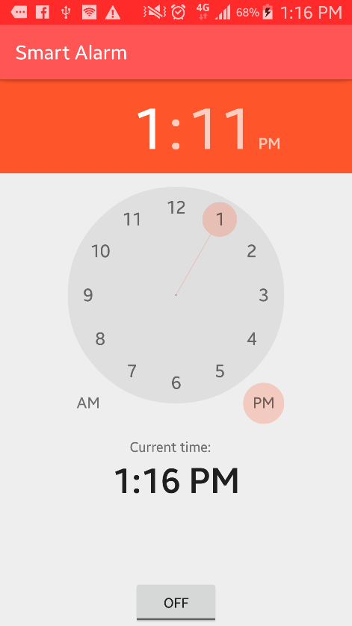

## Select Minute:

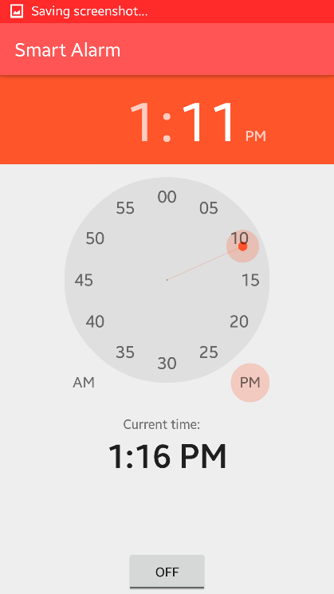

## Github Link:

https://github.com/uurehman/SmartAlarm