Software Requirements Specification
For
Autismo
Version 1.0 approved
Prepared by Ubaid Ur Rehman, Iqra Rafiq and Khursand Shakeel
SEECS - NUST
January 4, 2018
Table of Contents
1. Introduction 1
1.1 Purpose 1
1.2 Intended Audience and Reading Suggestions 1
1.3 Product Scope 1
1.4 References 1
2. Overall Description 2
2.1 Product Perspective 2
2.2 Product Functions 2
2.3 User Classes and Characteristics 2
2.4 Operating Environment 2
2.5 Design and Implementation Constraints 2
2.6 User Documentation 3
2.7 Assumptions and Dependencies 3
3. External Interface Requirements 3
3.1 User Interfaces 3
3.1.1 Interface views are shown as follows: 3
3.1.2 Hardware Interfaces 4
3.2 Software Interfaces 5
3.3 Communications Interfaces 5
4. System Features 5
4.1 Separate sections for parent and child 5
4.2 Teaching the Autistic Children 5
5. Other Nonfunctional Requirements 6
5.1 Performance Requirements 6
5.2 Safety Requirements 6
5.3 Security Requirements 6
5.4 Software Quality Attributes 6
6. Other Requirements 6
6.1 Native Language 6
6.2 Autistic Learning Aspects 6
6.2.1 Being a Good Friend 6
6.2.2 Schedule 7
6.2.3 Emotions 7
6.2.4 Vocabulary 7

Revision History
Name | Date | Reason For Changes | Version
Ubaid ur Rehman | January 4, 2018 | Initial Draft | 1.0
Iqra Rafiq | January 6, 2018 | Improvements | 1.0
Ubaid ur Rehman | January 7, 2018 | Review | 1.0

Introduction

Purpose
This software requirement specification SRS document is for an application AUTISMO, designed for autistic children’s learning. Autismo provides guidelines to assist to the parents and the teachers, who are educating autistic children aging 3 – 21 with identified Autism Spectrum Disorders in educational settings. The document is to describe all the aspects and features of the application.

Intended Audience and Reading Suggestions
This document is for the developers, customers, and Faculty advisor. The developers should read every section to ensure that there is an understanding for the project. The main sections for the customers and faculty advisor to review are section 1.4 Project Scope, 2.7 Assumptions, and section 3. Features.

Product Scope
The purpose of this application can be broken down into three major goals.
- The first is to allow experimental data to be collected from the user of this application. This data is valuable in the research of Autism Spectrum conditions.
- The second goal is basic learning that actually helps people with Autism Spectrum conditions to recognize daily life routine tasks. This goal is important because many people with Autism spectrum conditions have difficulty in performing their daily life tasks based on living necessaries.
- The third goal is to Identifying appropriate interventions for students with ASD requires an understanding of how a child learns and their communication skills.

References
<List any other documents or Web addresses to which this SRS refers. These may include user interface style guides, contracts, standards, system requirements specifications, use case documents, or a vision and scope document. Provide enough information so that the reader could access a copy of each reference, including title, author, version number, date, and source or location.>

Overall Description

Product Perspective
The Autismo Application will be a new addition in the major learning characteristics of autism spectrum disorders as:
- Language delays and/or deficits
- Abnormal ways of relating to people, objects, or events
- Uneven developmental abilities, scattered strengths and weaknesses.

Product Functions
- Application should be informative.
- Each activity and section should belong to Autistic children
- Focus of all features should be the learning of special children.
- Application UI should be self-explanatory and focus on targeted audience.
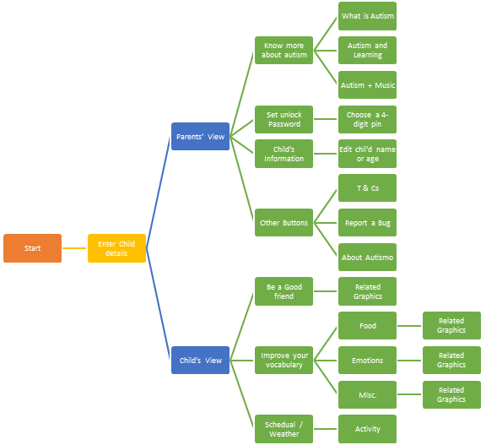

User Classes and Characteristics
The set of users who will most frequently use this software who will have an Autism spectrum condition or the parents of the children who have autism spectrum disorder. These conditions may vary greatly, but the main user audience will consist of high-functioning Autistic users. The target demographic will be children, young adults and parents, but the experimental data collected would be valuable from any age group.

Operating Environment
The Autismo application will require the android platform in order to run on a client’s machine. This software can only be run in android phones.

Design and Implementation Constraints
The main design constraint is that the application must be usable by people with Autism spectrum conditions, therefore the proper considerations must be made for the users. Another major constraint is that application must be in native language so that it will be easy to understand for local users. There are certain safety requirements that we must follow. See section 5.2.
The Autismo application will be developed in java using the android SDK on android studio. Therefore, Autismo application will comply with the programming practices of JAVA.
The delivered software will be open-source and publically available for developers to further work on it. Software will be published on Google Play Store.

User Documentation
There will be a basic README.md document along with app to aid developers with installing and running up with the code.

Assumptions and Dependencies
- Assuming the user (Parent / Child) has basic knowledge of English / Urdu reading.
- User has knowledge about the basic feature of android device.
- The Autismo application will be fully functional and available at play store.
- Backend code remains stable and compatible with most of flavors of android.
- The Autismo application will complete all necessary functional requirements.

External Interface Requirements

User Interfaces
The look and feel must match the current Autismo application mockup plan look and feel and must capture part of the space theme prevalent throughout the program. Other than these specific constraints the UI we have free reign as long as we also are cautious of using autistic friendly UI designs. Any instruction will have to be visual and be concise complicated procedures will prove difficult for Autistic users.

Interface views are shown as follows:
Get-Started View: User (Parent/Teacher) is shown some information about the application and is asked to enter the details of child, who is going to use the application.  It is one time information, that user has to provide | 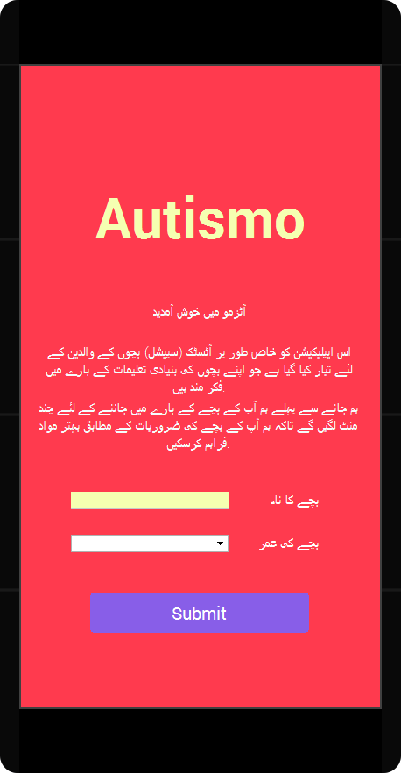
Home Screen: The home screen view is simple. And easy to use. Once user open the application, he will be shown this interface. Which is self-explanatory. | 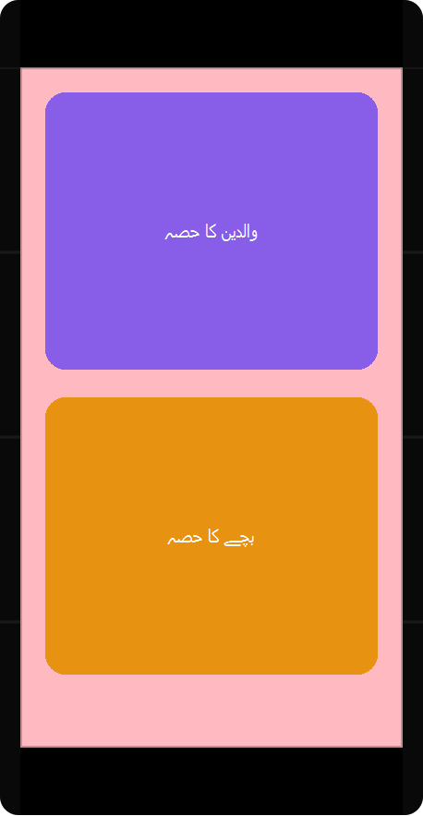
Parents’ View: This view is for parents where they can setup the application and some features that should be shown only to parents. View is self-explanatory. | 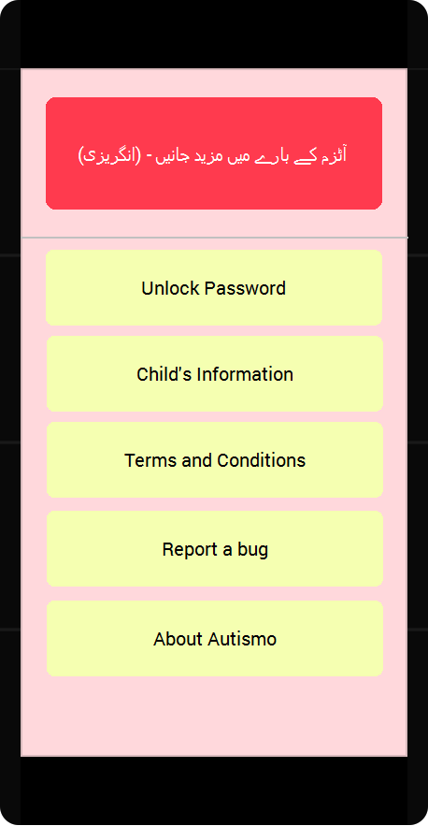
Child’s view: The main view that child is provided with is also self-explanatory. Upper-right corner has a logout button which requires a 4-digit pin to get back to the main screen. So that child can only play with what is made for him/her. | 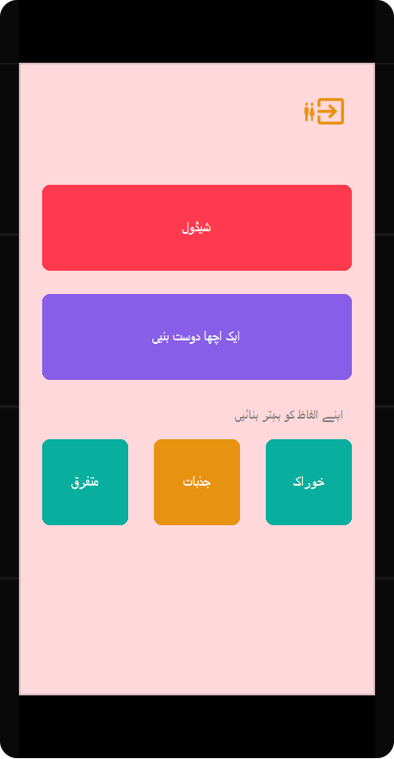

Hardware Interfaces
Autismo is a mobile application so there are touch interface and keyboard for us to interact with application. These requirements are handled by all android platform and will mostly be simple for us to interact with.

Software Interfaces
The application currently only supports the android platform like android phones.

Communications Interfaces
There aren’t any communication interfaces as currently the application is for personal use of user and does not send out the data it collects unless run in the lab.

System Features
Main purpose of Autismo application is to teach autistic children some basic humanitarian norms.

Separate sections for parent and child
4.1.1 Description and Priority
Parent and child’s separate sections are important. In which parent may have the access of child’s section but reverse should not be possible. Benefit of this application would be, that child would not leave the application or change the settings without parent’s consideration.
4.1.2 Stimulus/Response Sequences
User would be provided with separate list of actions they can perform corresponding to their section.
4.1.3 Functional Requirements
REQ-1: All user related features would be in the section corresponding.
REQ-2: Child’s section should be locked child should face difficulty to leave his section.
REQ-3: An unlocking mechanism should exist through which only parent can leave the child’s section.

Teaching the Autistic Children
Description and Priority
The main purpose of Autismo is to teach autistic children some basic skills. Details about this section have been discussed in section 6.2 Autistic Learning Aspects.

4.1.2 Stimulus/Response Sequences
In a light and soft environment, child should be able to see some organized list of actions.

Other Nonfunctional Requirements

Performance Requirements
Application would be working in offline mode, structure of application should be simple enough to be efficiently supported the devices with low hardware specifications.

Safety Requirements
The main safety concern that we will be dealing with is the possibility of inducing seizure in the user. Some autistic children are very susceptible to flashing lights and this can be problematic. To safeguard against this we will try to keep flashing lights and rapid screen movements down to a minimum. We will not flash the screen or change colors rapidly when it is unnecessary to do so.

Security Requirements
Security will not be a concern for this project since there is no sensitive data being stored.

Software Quality Attributes
The two main quality attributes that the Autismo application will be focusing on is correctness and usability. The system needs to be able to track time correctly. Usability is also a priority because this is for learning purpose. If the user were to be confused or annoyed by the user interface, then the application would be less enjoyable and will have zero impact on user. There are also special considerations for autistic children to include when developing the UI.

Other Requirements

Native Language
Application should be in native language so that local users can benefit from it. In our case, Urdu would be preferred language.

Autistic Learning Aspects

Being a Good Friend
Child should be taught how to be social with and help others in some situations when needed.

Schedule
Autistic children get it very challenging to schedule a task and manage time. This section should be some activity that can help them with scheduling things.

Emotions
Child should be able to know about different emotions of humans, their names and some graphical view related to those emotions.

Vocabulary
Child should be able to know about some words of basic vocabulary that would be presented to him with graphical view. We will be including these three sub-domains in this part:
- Food
- Emotions
- Others / Miscellaneous

Appendix A: Glossary
Words | Meanings | Words | Meanings
Autism | a developmental disorder | ASD | Autism Spectrum Disorder
Autismo | Name of Application | Autistic | The person diagnosed with autism

