1. Open The Code and then open the step.rb

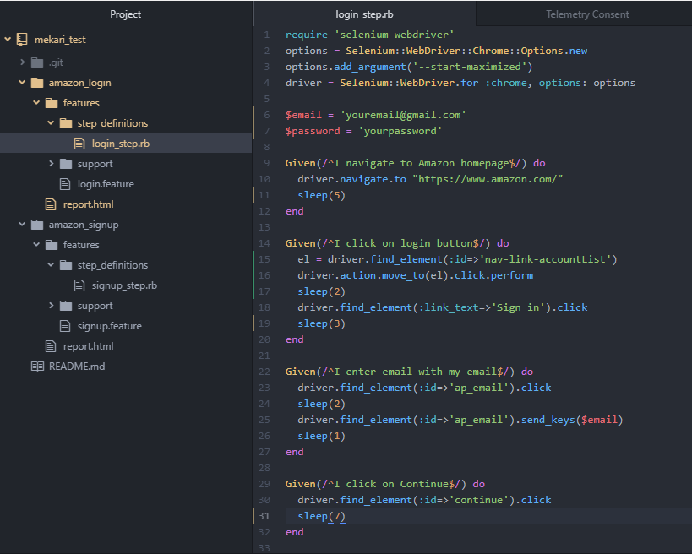

1. You can enter email and password with your data test

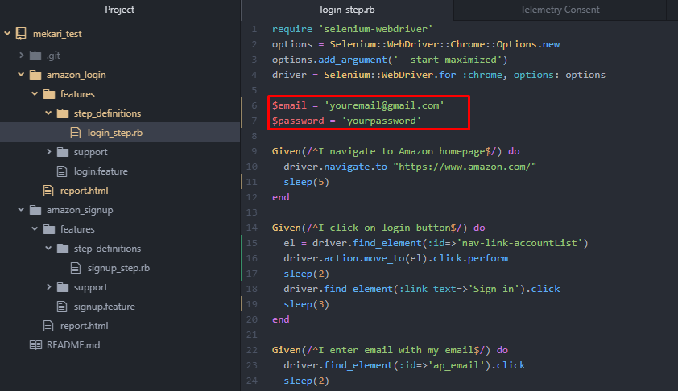

1. Open cmder to run the code

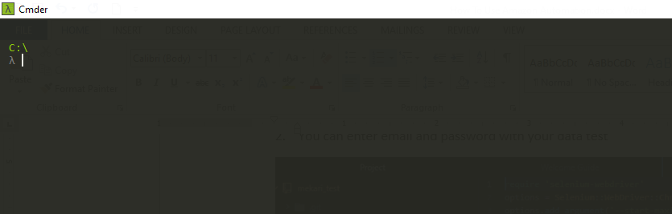

1. Go to your code location

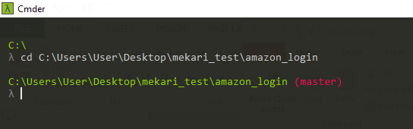

1. Then type cucumber to run the code

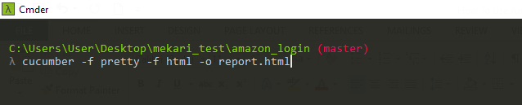

1. Then the code should be run and doing test automation

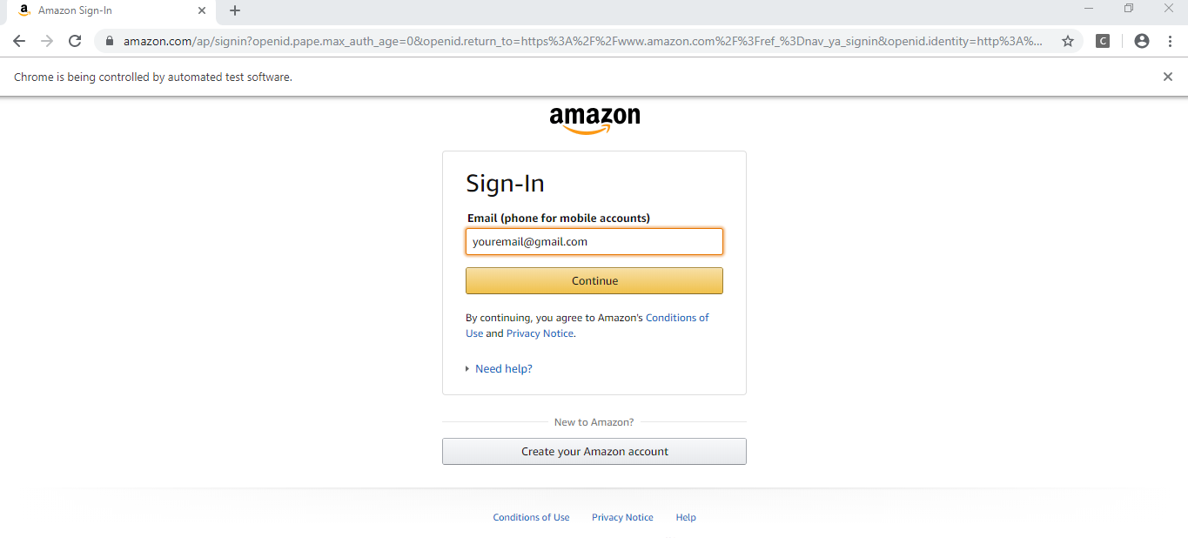

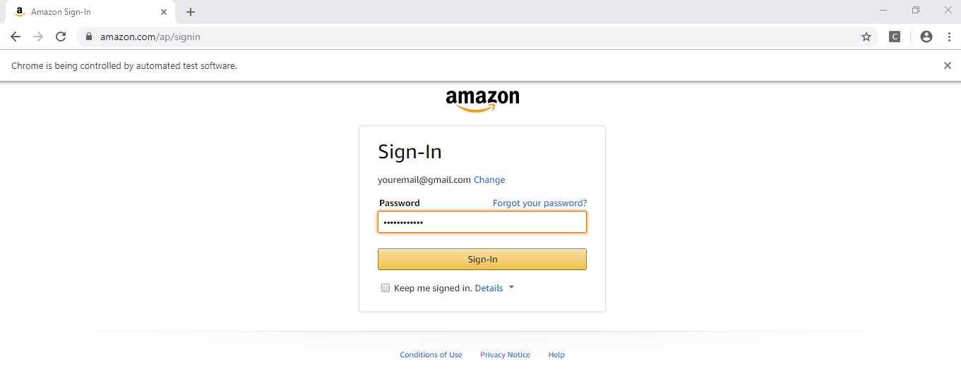

1. Result of test case

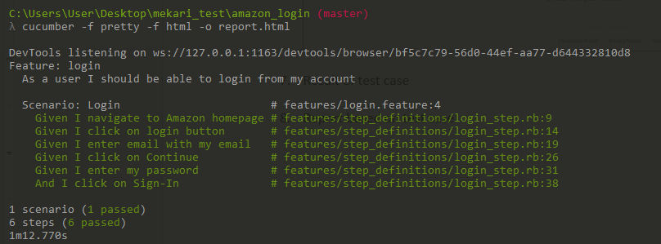

1. Report based on test case

