Data
The raw fluorescence measurements of the endocervix have the form of:
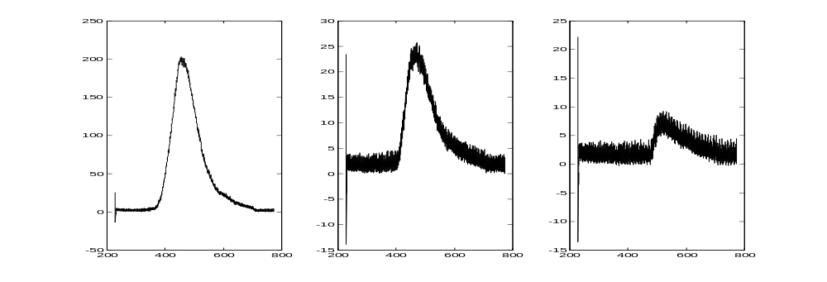
These data is re organized for all measurements r as :
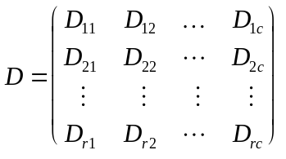

a
b
c

where c represents the emission wavelengths and r the measurements. In general and D has the size of 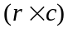.
The data is adjusted to the system resolution and the wavelength dependent system correction factors are applied.
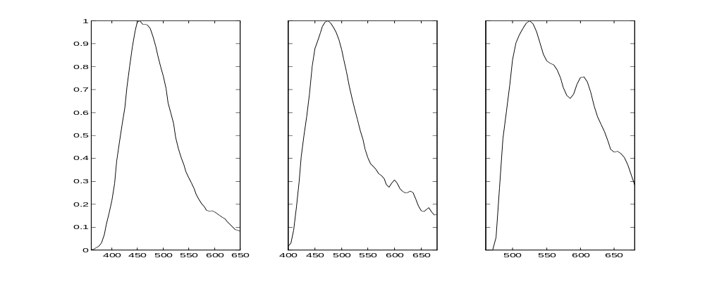

There are 4 different data preprocessing algorithms available:

- Covariance about origin (1)
- Covariance about mean (statistical covariance) (2) (current algorithm)
- Correlation about origin (unit length) (3)
- Correlation about mean (unit variance) (4)

These processes can be done either in Q (column) or R (row) mode.

In general this data preprocessing has the form of:
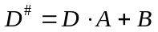
which is a scaling and a offset subtraction.

We produce a square matrix Z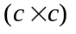 with the data matrix:
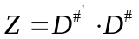

In the covariance about the origin (1)
A takes the form of 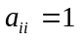, 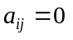 , 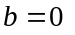 which means the data is not processed at all. Each data point is weighted by its absolute value and large data points are given more statistical importance.
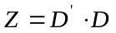

The covariance about the mean (2)
has the form , , 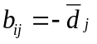 which subtracts a mean spectrum from all spectra.
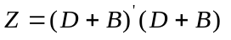
This is equivalent with the statistical covariance. Mean subtraction is equivalent with DC-offset removal.

The correlation about the origin (3)
is calculated like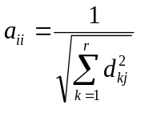, ,
This results in an equal weighting of all the columns (emission wavelengths).
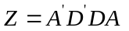
because A is a diagonal matrix:
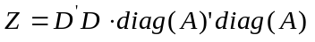
A division of every data column by its summed square is equivalent to a normalization of the energy of the signal.

The correlation about the mean (4)
is performed as following 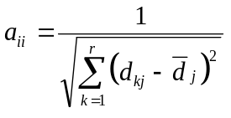, , 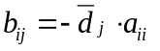
which results with 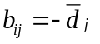 in
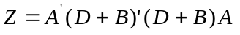
and because A is a diagonal matrix:

This proprocessing normalizes the data to unit standard deviation. Signalvariation over the column vector will be removed.

Only the method covariance about the origin (1) will preserve all the attributes of the data.

Application with Matlab:

Method (2): The covariance matrix in Matlab is calculated like:
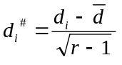 , 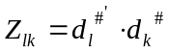
which results in a preprocessed matrix
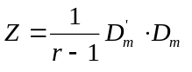
built with the mean sided data matrix.

Method (4): The standard deviation function in Matlab can be used as following
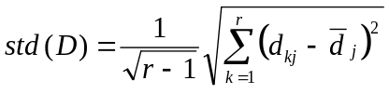

Eigen analysis
Z is decomposed into its normalized Eigenvalues 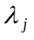and Eigenvectors 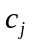 with:
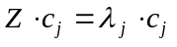
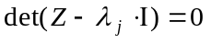
The principal components are mutually orthogonal. So are the Eigenvectors. As a result the inverse of the C is it's transpose:
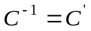
For the Eigen value problem:
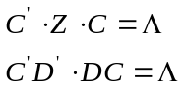

The principal component score is calculated with:
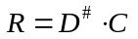
which results in:
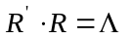
And the data can be reconstructed with:
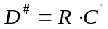
With the preprocess data this results in:

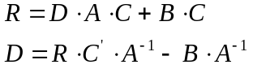

Since

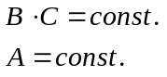

The scaling and offset value for the principal components R only affects the reconstruction. The separation of the distribution of the PC is still the same.

Covariance around mean (2) produces with our fluorescence spectra 20 significant Eigenvectors. Covariance around origin (1) produces only 3 significant Eigenvectors. Two of this 3 are equivalent to the most important ones from method 2.

Datareduction
The variance 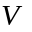accounted by the first n Eigenvalues is calculated with:
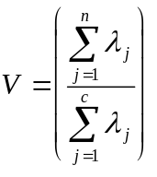
The reduced Eigen vector matrix 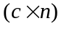 that incorporates % of the variance is:
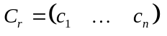
It includes the Eigenvectors with the largest Eigenvalues. The next figure shows a set of these Eigen vectors. The Eigen vector 1 represents normally up to 50% of the data variance. And the first three Eigen vectors may include 75%.

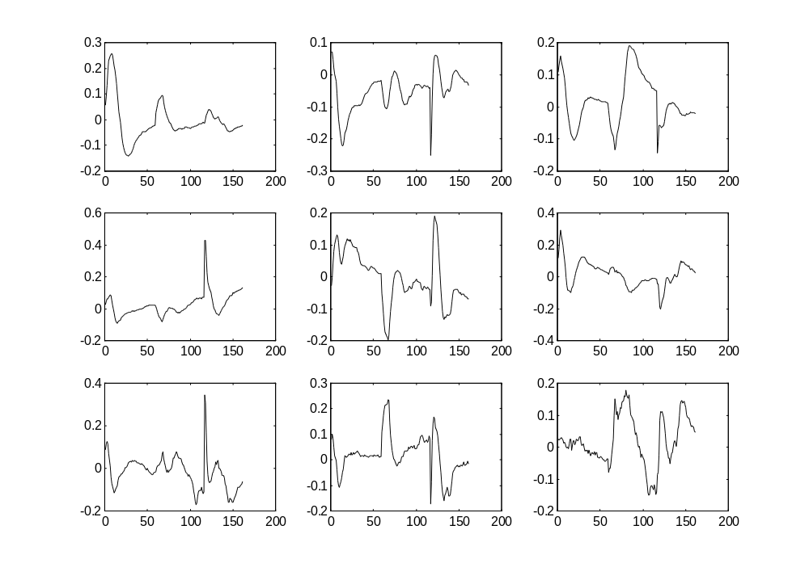
Finally the principal components score matrix has the form of 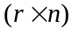which represents a principal component for every Eigen vector and measurement.

We can reconstruct our data set with:
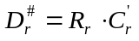
Because 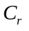is representing the variance of our data, redundant data components will not show in this simple reconstruction. If we account for the preprocessing with the original data is:
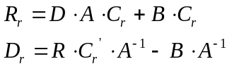
The next figure shows a reconstruction with 99% and 90% of the data variance.
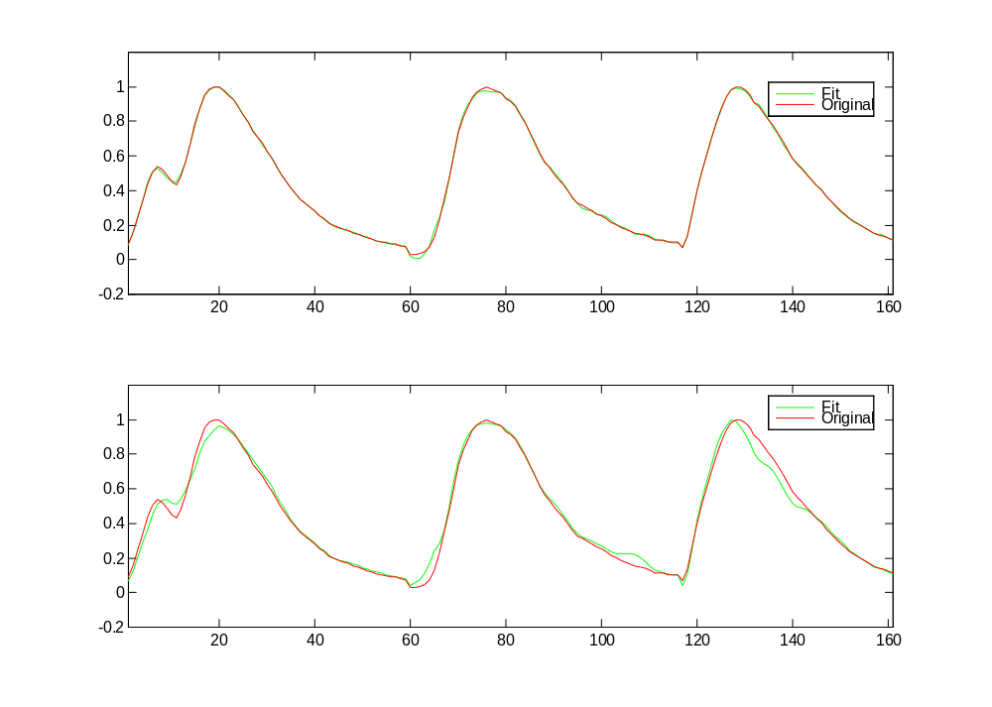
An example of a data reconstruction with measurements originating from a false or disturbed data set is shown in the next figure:
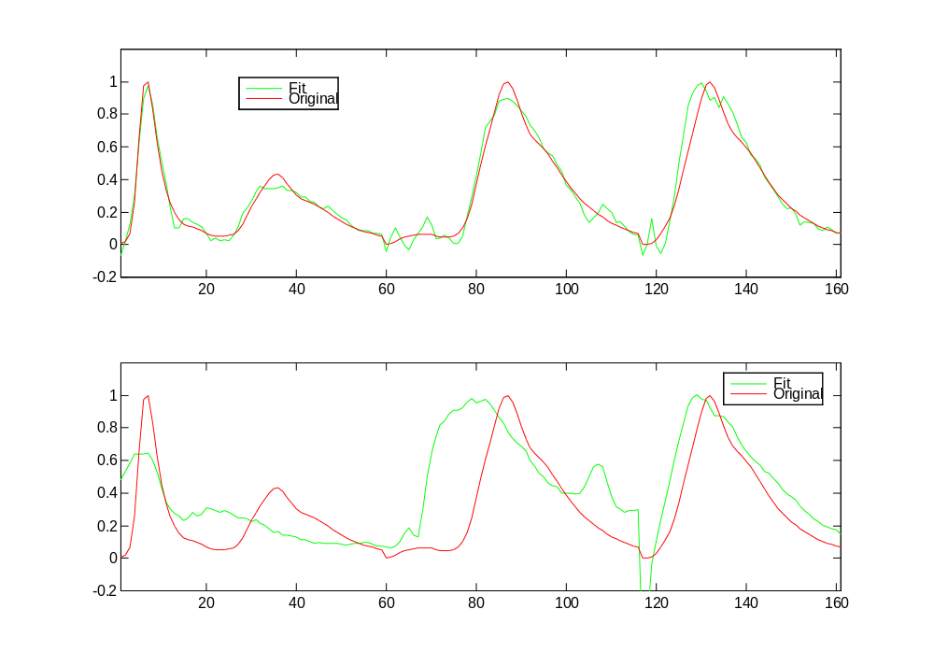It shows that the data reconstruction tries to interpolate the shape of known spectra in the new one.

The next figure compares two data sets (endo/ecto cervical data) which shows the mean difference between the reconstructed data. The reconstruction for both data sets is based on the Eigen vectors form the training group of one data set.

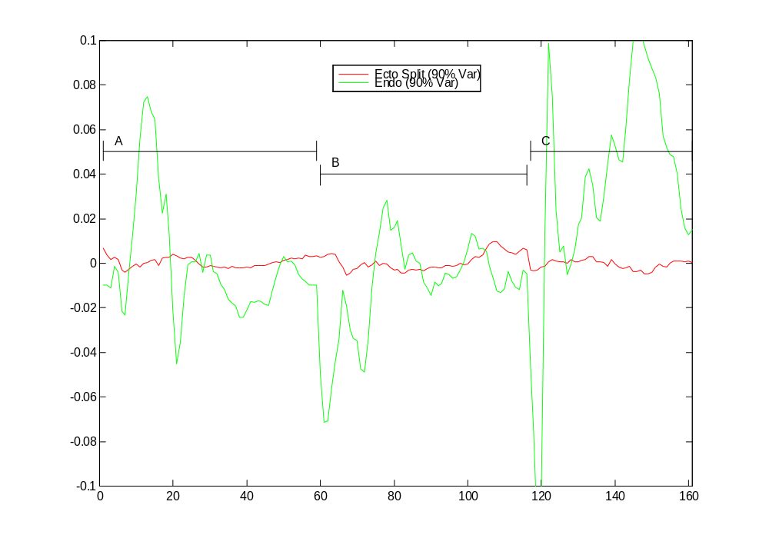

Component Loading

The component loading is calculated with:
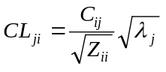

where 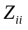is the variance of the i'th variable. CL represents the correlation between the i'th variable and the j'th principal component.

Statistical Analysis
As shown in the data reconstruction 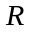represents the decomposition of a measurement into its principal components. Our experience with cervical tissue measurements shows that fluorescence measurements can be successfully represented with 5-10 PC’s or eigenvectors.

represents the diagnostic vector that corresponds to the Data matrix. It has the form of 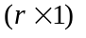.
The diagnostic vector is split by a random process into a training and validation set. Measurements belonging to the same specimen should be part of one or the other group.
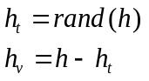

The diagnostic vectors can be further split into different categories (1-l) according the diagnostic values: 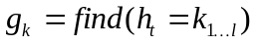

The frequency distribution of the principal components can be fitted with either a Gaussian or Gamma distribution. As a result the probability of the principal component score belonging to group 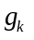 can be expressed as:
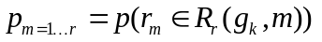

.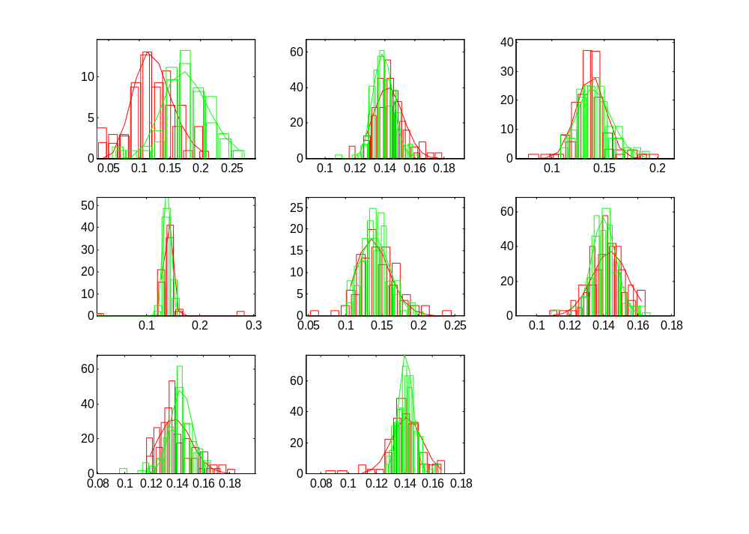
Since every measurement is represented with r reduced principal components we can calculate r probabilities.

We can calculate the combined probability of measurement x being a member of group from a set of probabilities with:
If we additionally know the prior probability of a measurement 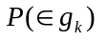being a member of group and if we introduce a cost function 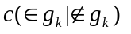of miss-classifying a measurement into group the Bayes classification can be applied:
INVIVO5X Data structure

A at 337 nm excitation
B at 380 nm excitation
C at 460 nm excitation

The suffix "v" corresponds to the calibration set used to develop and optimize algorithm.
The suffix "t" corresponds to the prediction set used to test the algorithm in an unbiased manner.

In each data file,
1) the first column corresponds to the patient file name
2) the second column corresponds to the legend:

(1) normal squamous
(2) normal columnar
(3) metaplasia
(4) inflammation
(5) low grade SIL
(6) high grade SIL

Our objective is to differentiate between (1), (2), (3), (4) / (5), (6) and between (5) / (6)

The remainder of the columns of each data file correspond to intensities as a function of emission wavelength:

Emission wavelength range @ 337 nm excitation: 360 nm - 650 nm
Emission wavelength range @ 380 nm excitation: 400 nm - 680 nm
Emission wavelength range @ 460 nm excitation: 460 nm - 680 nm

Directory structure:

The original raw data:
T:\Nimmi_data\CLINICAL\INVIVO5\RAW\ASCII\
directories: PT116...PT211\
files: xxA/B/C.ASP RFA/B/C.ASP where xx is the location 01-12

The correction factors and lamp spectra:
T:\Nimmi_data\CLINICAL\INVIVO5\RAW\ASCII\CAL CORR-337/380/460.TXT

Processed spectra normalized to peak fluorescence intensity of the rhodamine calibration standard and correction factors applied:
T:\Nimmi_data\CLINICAL\INVIVO5\PROCESS\PAIRED\PTX###.OUT X allwavelengths A,B,C
T:\Nimmi_data\CLINICAL\INVIVO5\PROCESS\UNPAIRED\PT###/###/A,B,C.out

Histology:
T:\Nimmi_data\CLINICAL\INVIVO5\PROFILE pt histology

The preprocessed spectra (normalized, meanscaled-normalized) all in Excel format;

T:\NIMMI\NIMMI\FLRSCNCE\PCA\INVIVO5X\SN-SIL,LG-HG,CN-SIL\ALL_EEM\INVIVOX/T/V.out
T:\NIMMI\NIMMI\FLRSCNCE\PCA\INVIVO5X\SN-SIL,LG-HG,CN-SIL\RED_EEM not all emission wavelengths

