
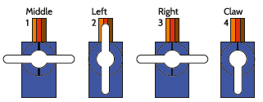

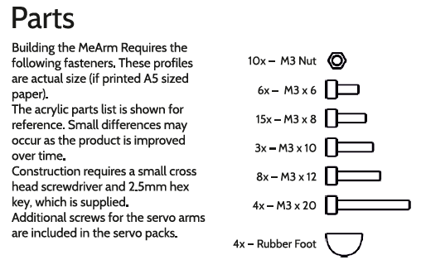
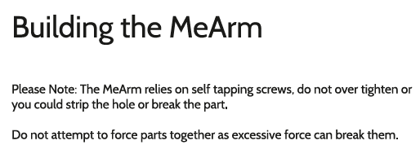
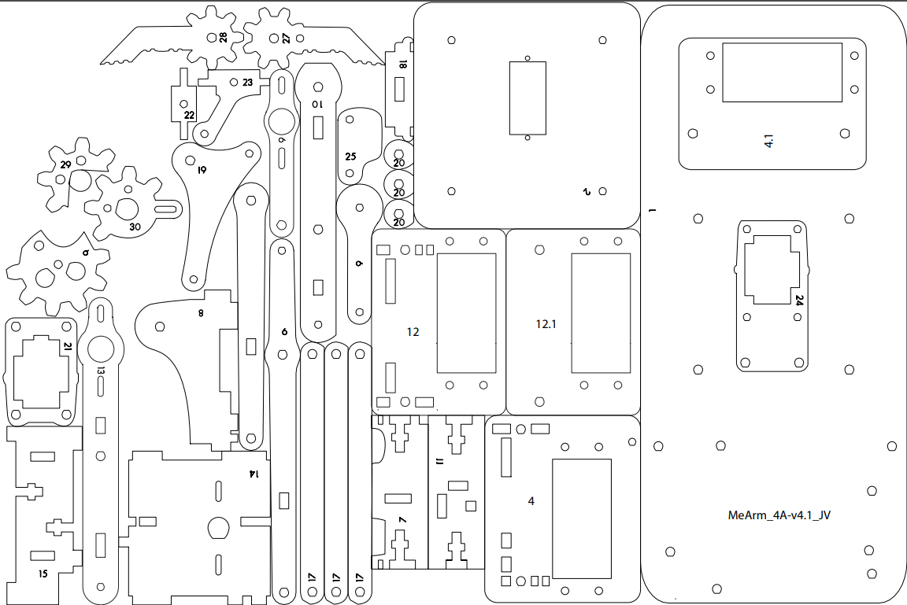
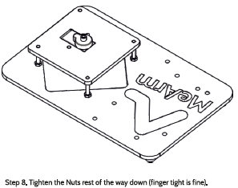
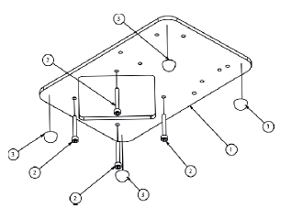
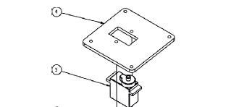
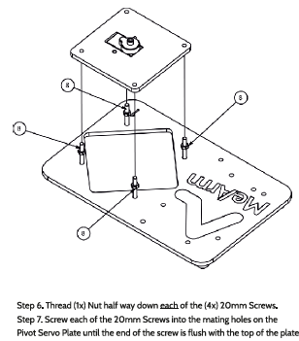
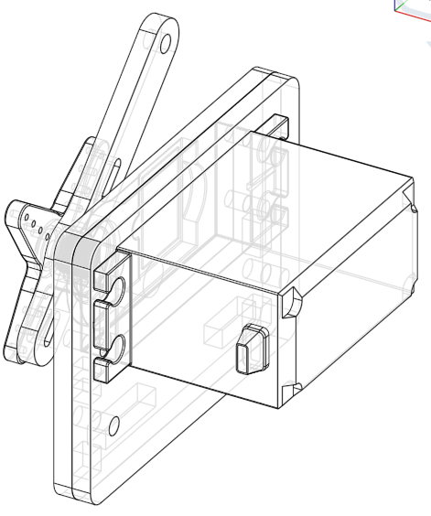
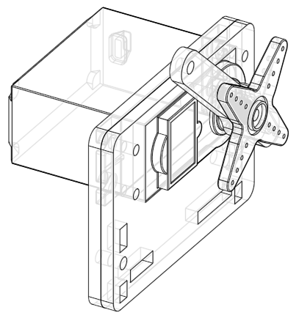
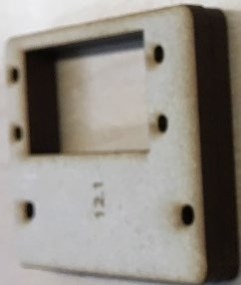
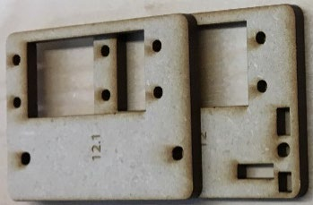

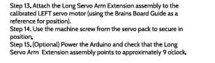
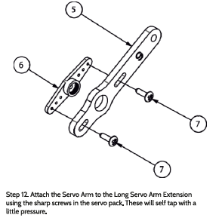
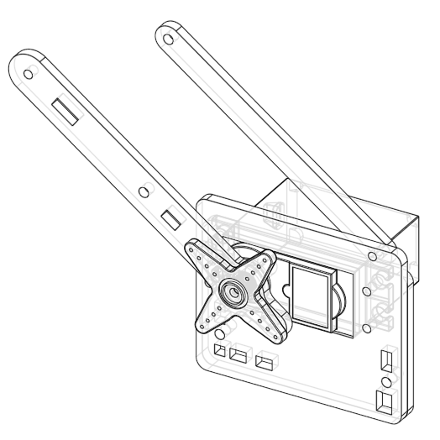
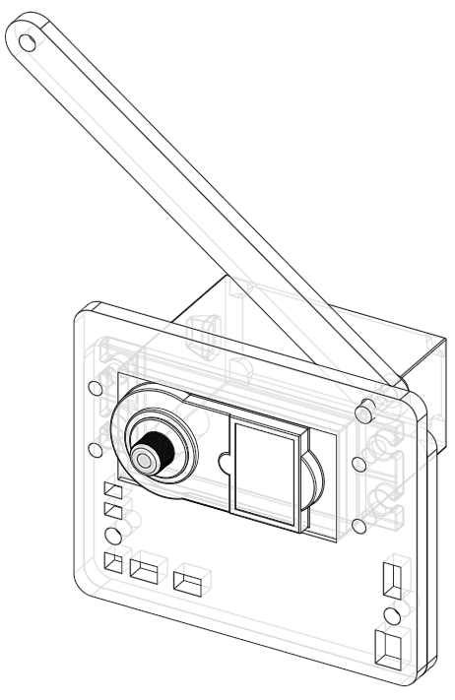
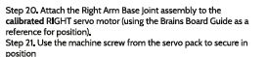
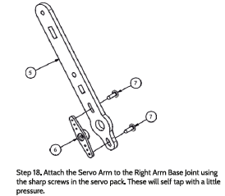
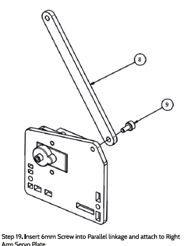
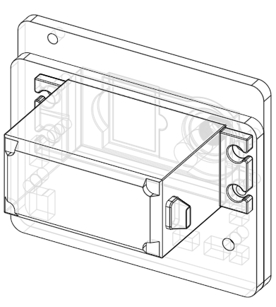
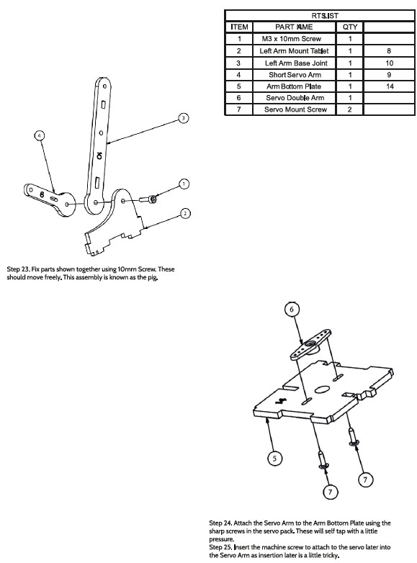

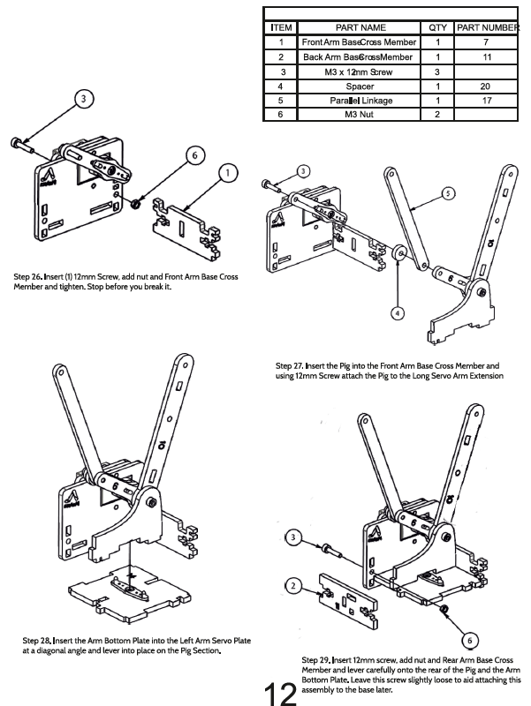
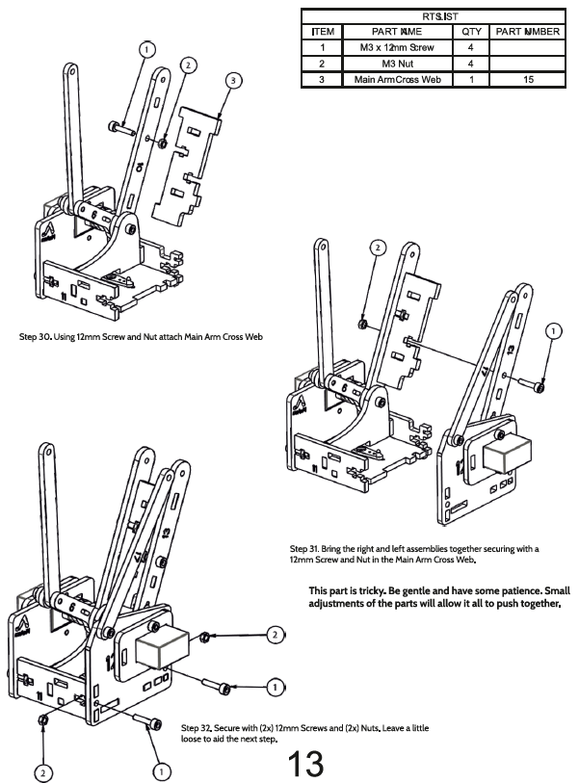
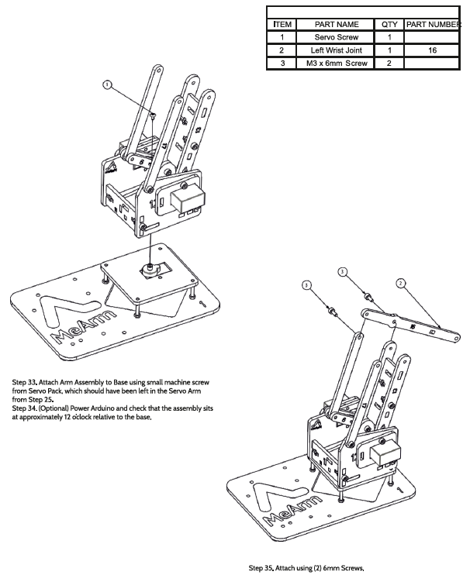
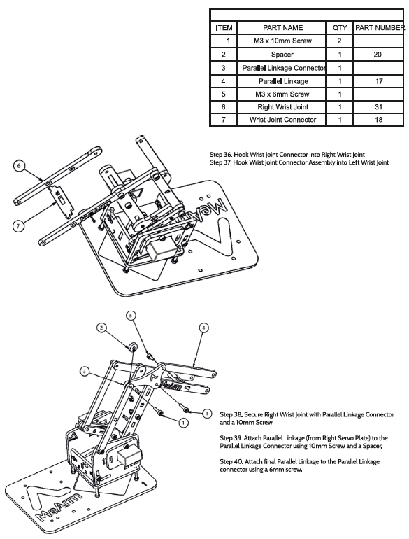
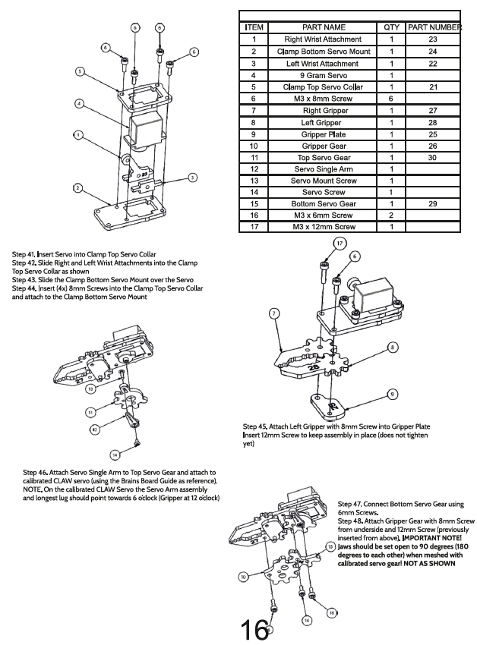
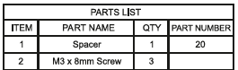
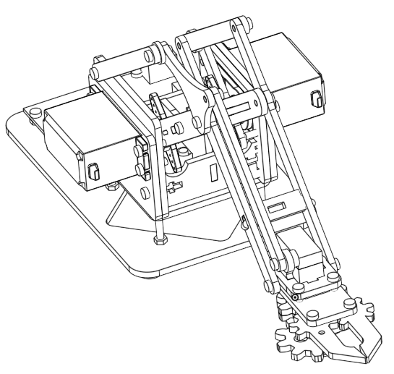
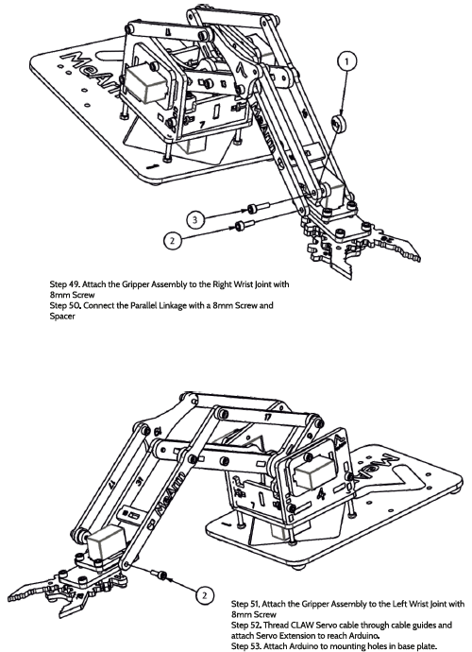
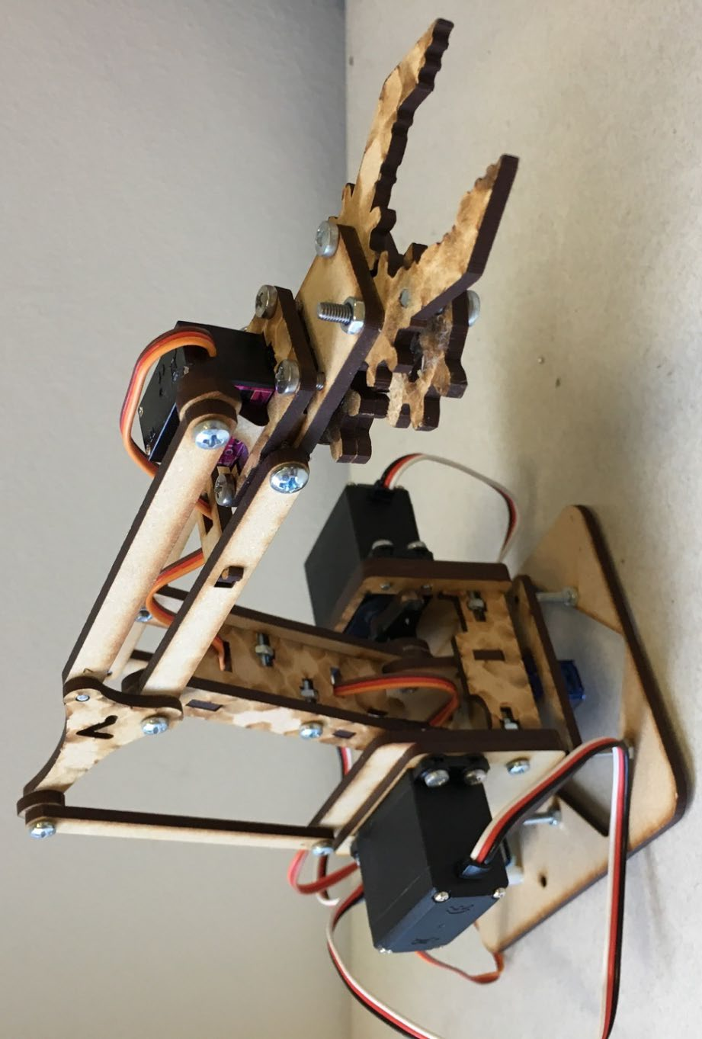
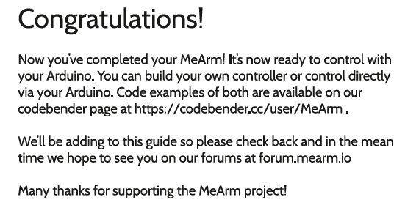
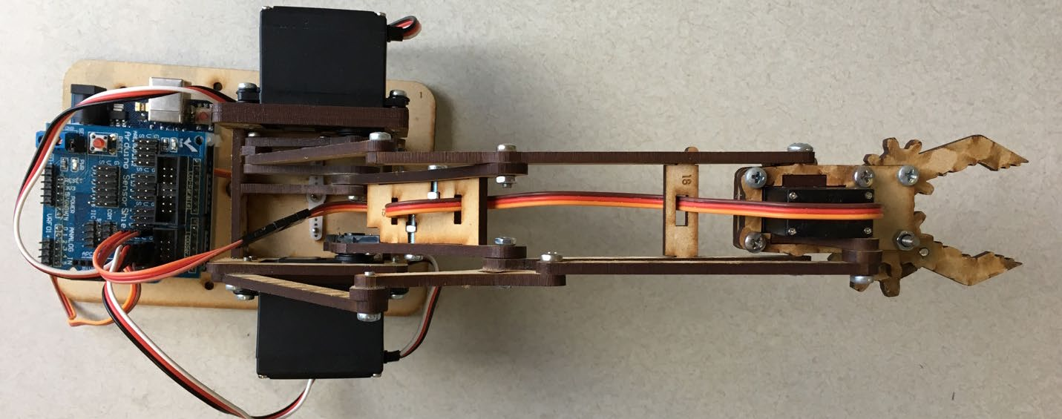
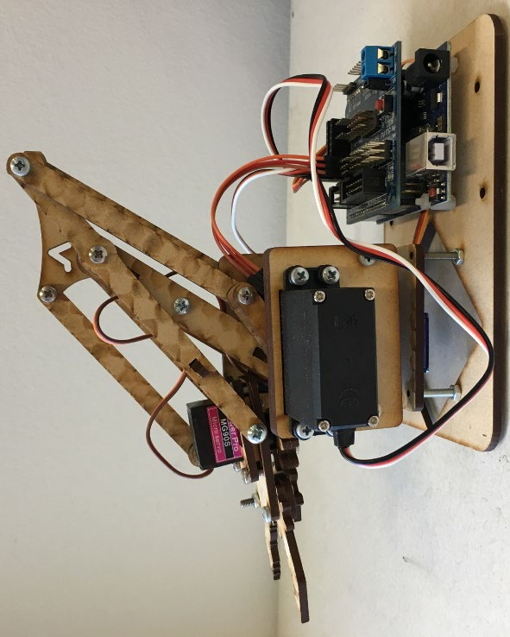
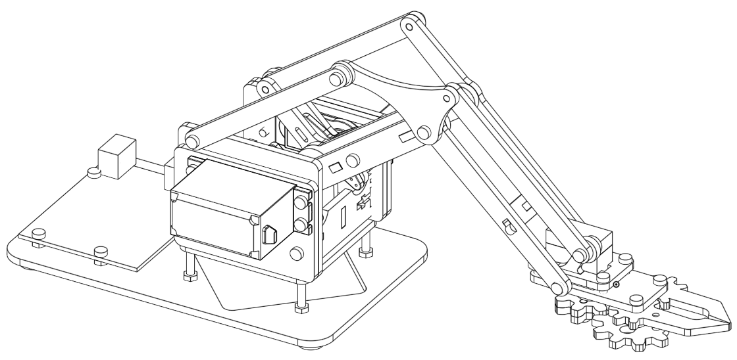

This assembly manual is based on a work by Scott Pierce
Manual Revision 4.1 by Joshua Vanderwall March 2019
Arduino & RasPi Edition
MeArm.io
Assembly Manual for v4.1

0

References……………………………………………………………………………………………………………………………….24
Building the MeArm…………………………………………………………………………………………………………………11
Calibrating the Servo Motors……………………………………………………………………………………………………10
Setting up the Servos with Raspberry Pi…………………………………………………………………………………….8
Setting up the Raspberry Pi………………………………………………………………………………………………………..5
Setting up the Arduino……………………………………………………………………………………………………………….3
Introduction……………………………………………………………………………………………………………………………….2

CONTENTS

1

Composition and Edits: Peter Jansen, Urs Utzinger, David Lesser, Joshua Vanderwall
Content: Carl Monk, Scott Pierce
All the best!
Thank you for joining us on the MeArm Project.
connect everything together.
also need a power supply capable of delivering 5-6V at 2A, a breadboard and a few wires to
This version is for use with an Arduino or Raspberry Pi board to control your MeArm. You will
mastering coding, electronics, robotics or whatever your plans for world domination require.
no prior knowledge and will finish as a robot builder -- ready to take the first steps towards
document you can build the MeArm with nothing but a screwdriver and enthusiasm. You need
This manual is for the assembly of the MeArm Version 4.1. It is my intention that with this
INTRODUCTION

2

3

4

and the Pi isn’t set up for that. Better safe than have to buy a new Pi!
advised to draw the power for the servos through the GPIO, they can draw up to an amp each
connect the 6V power to the GPIO (other than connecting the ground wire). Also it’s not
PWM lines (the servo control wires that come from the GPIO) directly into the servos. Don’t
all the grounds and all the power lines and wire them directly to the power, then bring the
The breadboard used in the image is just to make things look tidy. In reality you can just attach

5

7 on P1-22 GPIO-25
6 on P1-18 GPIO-24
5 on P1-16 GPIO-23
4 on P1-15 GPIO-22
3 on P1-13 GPIO-27
2 on P1-12 GPIO-18
1 on P1-11 GPIO-17
0 on P1-7 GPIO-4
Servo mapping:
Using P5 pins:
Using P1 pins: 7,11,12,13,15,16,18,22
Output levels: Normal
Maximum width value: 250 (2500us)
Minimum width value: 50 (500us)
Pulse increment step size: 10us
Servo cycle time: 20000us
Number of servos: 8
Idle timeout: 2000
Using DMA channel: 14
Using hardware: PWM
Board revision: 2
timeout=2000
pi@raspberry ~/PiBits/ServoBlaster/user $ sudo ./servod –idle-
gcc -Wall -g -O2 -o servod servod.c -lm
pi@raspberry ~/PiBits/ServoBlaster/user $ make servod
pi@raspberry ~ $ cd PiBits/ServoBlaster/user
Checking connectivity… done.
Resolving deltas: 100% (154/154), done.
done.
Receiving objects: 100% (359/359), 362.62 KiB | 311.00 KiB/s,
remote: Total 359 (delta 0), reused 0 (delta 0)
remote: Reusing existing pack: 359, done.
Cloning into ‘PiBits’…
git://github.com/richardghirst/PiBits.git
pi@raspberry ~ $ git clone

used a fresh install of Raspian.
STEP 1: Get to the command line on your Pi. Either boot to it or use a terminal in your GUI. We
Setting up the Raspberry Pi

6

root = Tk()
import os
from Tkinter import * #allows us to make a GUI with TKinter
| #!/usr/bin/env python
save.
popular, stronger and better looking). I called it MeArm.py. Add the following code to it and
Create a new file using your favorite file editor (it should be GVIM - it will make you more
STEP 3: Use Python and something called TKinter (which should be installed on your Pi already).
1=20% > /dev/servoblaster will send servo 1 to 20% of its 0 –>180 degree range.
NOTE: This will send servo 0 (the one attached to GPIO 4) to 50% of its range. Changing to echo
/dev/servoblaster
pi@raspberry ~/PiBits/ServoBlaster/user $ echo 0=50% >
STEP 2: If everything is working ok, you’ll be able to send the command
Setting up the Raspberry Pi

7
micro = (1000 + (ACurs[Servo] * 8.3333))
# micro = (1000 + (ACurs[Servo] * 5.555))
ACurs[Servo] = ACurs[Servo]+Step
if ACurs[Servo] < AMaxs[Servo]:
def AAdd(Servo):
frame.focus_set()
def callback(event):
ASub(3)
if repr(event.char) == “‘k’”:
AAdd(3)
if repr(event.char) == “‘i’”:
ASub(2)
if repr(event.char) == “‘l’”:
AAdd(2)
if repr(event.char) == “‘j’”:
ASub(1)
if repr(event.char) == “‘s’”:
AAdd(1)
if repr(event.char) == “‘w’”:
ASub(0)
if repr(event.char) == “‘d’”:
AAdd(0)
if repr(event.char) == “‘a’”:
print “pressed”, repr(event.char)
def inc(event):
from the current servo angle.
statements below it either calls a process to add or subtract
#inc listens for all key presses. On certain presses in the if
servo controller
timeout=2000’) #This line is sent to command line to start the
os.system(‘sudo /home/pi/PiBits/ServoBlaster/user/servod –idle-
print(SNums[i],AInis[i],AMins[i],AMaxs[i],ACurs[i])
for i in range(4):
Step = 5
ACurs = AInis #Current angles being set as the initial angles
AMaxs = [180,165,180,180] #Maximum angles for Servos 0-3
AMins = [0,60,40,60] #Minimum angles for Servos 0-3
AInis = [90,152,90,60] #Initial angle for Servos 0-3
SName = [“Waist”,”Left”,”Right”,”Claw”] #Names of Servos
ServoBlaster
SNums = [0,1,2,3] #Numbers of the Servos we’ll be using in
STEP 1: Use the following code to setup the servos using lists
Raspberry Pi

8

control your MeArm!
STEP 3: All being well you should now have a pop-up box that tells you to click inside it to
pi@raspberry ~ $ python MeArm.py
STEP 2: Using a terminal or the command line type the following
root.mainloop()
frame.pack()
frame.bind(“<Button-1>”, callback)
frame.bind(“<Key>“,inc)
boxtext.pack()
of the MeArm. Use the a d s w j l i and k keys for control.”)
boxtext = Label(root, text=”Click this box for keyboard command
frame = Frame(root, width=500, height=300)
print “Min Angle Reached”,SName[Servo],”Servo”
else:
(SNums[Servo],micro))
os.system(“echo %d=%dus > /dev/servoblaster” %
print(ACurs[Servo],micro)
micro = (1000 + (ACurs[Servo] * 8.3333))
# micro = (1000 + (ACurs[Servo] * 5.555))
ACurs[Servo] = ACurs[Servo]-Step
if ACurs[Servo] > AMins[Servo]:
def ASub(Servo):
print “Max Angle Reached”,SName[Servo],”Servo”
else:
(SNums[Servo],micro))
os.system(“echo %d=%dus > /dev/servoblaster” %
print(ACurs[Servo],micro)

9

STEP 4: Move onto Building the MeArm

NOTE: These images are not to scale. You will have two large servos and two small servos.
Be careful not to move the position of the spindle now that they are calibrated.
fixings packs. Leave these attached until you are required to use them in building the MeArm.
STEP 3: Attach the Servo Arms as shown below using a small machine screw from the servo

STEP 2: Using a marker, make a line across the Servo Motor Body and spindle (as shown)
STEP 1: Follow the Setup steps for either Arduino or Raspberry Pi
Calibrating the Servo Motors

10

11

12

4
M3 Nut
6

2
M3 x 8mm Screw
5

1
Servo Motor
4
2
1
Pivot Servo Plate
3

4
M3 x 20mm Screw
2
1
1
Base Plate
1
NUMBER
PART
QTY
PART NAME
ITEM
PARTS LIST

Servo Base)
Pivot Servo Plate or even slightly lower (to catching on the
NOTE: Be sure the screw ends sit flush with the top of the

PART NUMBER
NOTE: This Base Plate has been reconfigured under the same

Step 2 – 4: Insert 2 x Servo Mount Screws shown as item 7
Plate
Servo
Step 1: Insert MIDDLE Servo Motor from the top side of Pivot

13

1
Servo Screw
7

2
Screw
Servo Mount
6

1
Servo Double Arm
5
6
1
Large Servo Arm
4

1
Large S3003 Servo
3

2
M3 x 8mm Screw
2
12 and 12.1
2
Plate
Left Arm Servo
1
PART NUMBER
QTY
PART NAME
ITEM
PARTS LIST

together using PART 12 and PART 12.1.
Note: The image above is made up of two brackets stacked

M3 x 12mm with 2x M3 nuts.
The two screws mounting the plate to the structure are
10mm.
the Servo to the rectangular hole. To do this, use 4x M3 x
Step 9 – 11: Use Left Arm Servo plates 12 and 12.1 and mount
Note: The above figure is comprised of Parts 12 and 12.1.

14

1
Servo Screw
10

1
M3 x 6mm Screw
8

1
Parallel Linkage
7

2
Servo Mount Screw
6

1
Servo Double Arm
5
13
1
Right Arm Base Joint
4

1
Large S3003 Servo
3

2
M3 x 8mm Screw
2
4 and 4.1
2
Right Arm Servo Plate
1
PART NUMBER
QTY
PART NAME
ITEM
PARTS LIST

Note: The image above comprised of PART 4 and PART 4.1.

M3 x 12mm with 2x M3 nuts.
The two screws mounting the plate to the structure are
the Servo to the rectangular hole. To do this, use 4x M3 x 10mm.
Step 16 – 17: Use Right Arm Servo plates 4 and 4.1 and mount
Note: The above figure shows Parts 4 and 4.1 combined

15

16

17

18

19

20

21

22

23

[4] https://www.instructables.com/id/MeArm-Robot-Arm-Your-Robot-V10/
arduino/MeArm_v1.0_Manual_for_Arduino_v1.0.pdf
[3] https://learn.mime.co.uk/assets/docs/control-your-mearm-from-
[2] https://learn.mime.co.uk/docs/control-your-mearm-from-raspberry-pi/
[1] https://mime.co.uk/blog/2016/01/26/mearm-on-the-raspberry-pi/
Reference Material

24

25

