Software Requirements Specification

for

MyAnyList

Prepared by Jonathan Souter

15/12/2019

Table of Contents

Table of Contents ii

Revision History iii

1. Introduction 1

1.1 Purpose 1

1.2 Document Conventions 1

1.3 Intended Audience and Reading Suggestions 1

1.4 Project Scope 2

1.5 References 2

1.6 Product Perspective 2

1.7 Product Features 2

1.8 User Classes and Characteristics 2

1.9 Operating Environment 3

1.10 Design and Implementation Constraints 3

1.11 User Documentation 3

1.12 Assumptions and Dependencies 3

2. Specific System Requirements 4

2.1 General User 4

2.2 Carpool Seeker 5

2.3 Carpool Provider 6

2.4 System administrator 7

3. External Interface Requirements 8

3.1 User Interfaces 8

3.2 Hardware Interfaces 8

3.3 Software Interfaces 8

3.4 Communications Interfaces 9

4. Other Nonfunctional Requirements 10

4.1 Performance Requirements 10

4.2 Safety Requirements 10

4.3 Security Requirements 10

4.4 Software Quality Attributes 11

5. Other Requirements 12

5.1 Security and Safety 12

5.2 Website Quality 12

6. Reflection 12

7. Appendices 14

Appendix A: Glossary 14

Appendix B: Analysis Models 15

Appendix C: Issues List 19

Appendix D: Elicitation Report 19

Appendix E: Team Meeting Minutes 21

Meeting Minutes 1 21

Meeting Minutes 2 22

Meeting Minutes 3 23

Meeting Minutes 4 25

Meeting Minutes 5 26

Meeting Minutes 6 27

Revision History

|  |  |  |  |
| --- | --- | --- | --- |
| **Name** | **Date** | **Reason for Changes** | **Version** |
| Jonathan Souter | 21.09.19 | Initial Version | 01.00.00 |
|  |  |  |  |

# Introduction

## Purpose

This document describes the design requirements that act as aims during the construction of the MyAnyList media tracking app for Android. This is the first revision of this software requirements specification. This document aims to act as a record of all functional and non-functional requirements of the system as it pertains to all users and elements of the software.

## Intended Audience and Reading Suggestions

This document is primarily intended to be used as a guideline during development for the developer, but it should also have value for users and other interested parties viewing the app.

~~The document is separated into seven sections. Section 1 is the introduction and is a valuable section for navigating the other sections of the specification. Section 2 describes the system as a whole, including the plan and intent of the system, the intended users and the constraints put on the project by operating environment and other sources. Section 3 is a full record of use cases for the system, section 4 is the external interface constraints and section 5 contains the remaining nonfunctional use cases. Section 6 contains any remaining requirements that do not fit under the prior descriptions. Section 7 contains a reflection by the project management team after completing this document.~~

~~General readers will get the most value out of sections 2 and 3. These give a succinct summary of how the system works and what its goals are. Section 6 also describes requirements that are less focused on the software elements of the system and may be useful or interesting to a general reader.~~

~~Technical readers will get the most value out of section 3, 4 and 5, assuming they already understand the goals of the system. These three sections describe the functions the system is designed to fulfill and the other restrictions and requirements that the system fall under in terms of software and hardware.~~

~~Testers and quality assurance should focus on section 5.4 for the software quality attributes that form a basis for how the system is expected to behave. They should also spend some time reading section 2 through 5 to understand the functions and goals of the software and whether or not the current system is working in line with these requirements.~~

## Project Scope

The aim of this project is to create an inclusive media tracking app for android, allowing users to keep tabs on titles they have completed, are currently completing, plan to complete and have dropped from media such as books, films and video games. The design is modular, allowing users to create their own media types, title states and data types for specific titles.

## Product Perspective

The MyAnyList app aims to bring multiple media tracking services into one place for user convenience. It also allows the user to take their collection offline, giving them full control of the system and separating the experience from reliance on servers being maintained and functional by a third party.

## Product Features

The key features of this system are:

1. Media Tracking
2. Modification of app-side media parameters
3. Data autofill from other services

## User Classes and Characteristics

From a functionality standpoint the app does not connect to the internet and does not require maintenance, and as such there is only one user class

1. End user

End users are looking to track and plan their media consumption. There may be multiple end users using the one instance of the app.

## Operating Environment

The system will be designed for compatibility with Android API 21, meaning it will function on Android devices running Android 5.0 Lollipop or newer.

## Design and Implementation Constraints

The memory and processor load will be benchmarked so that any device capable of running Android Lollipop should be capable of running MyAnyList.

## User Documentation

~~When using the system for the first time, a user will be presented with a getting started guide, comprising of a set of images and very short descriptions to familiarize them with the most basic functions of the software. This should be designed to get the functions across to a user as quickly and simply as possible.~~

~~The mobile and web apps will have a help section that runs through the full capability of the system in detail. This help system should be logically separated via function and should avoid overwhelming a user with information unless it’s clear that they are looking for very in-depth information.~~

~~The backend system should ship with a digital manual of how to maintain the service and how to modify elements of it as necessary. This manual expects a much higher level of software literacy compared to the end user documentation.~~

## Assumptions and Dependencies

~~The following elements of the design are assumed and must be considered during the design process. If these assumptions are incorrect, they will likely have an effect on the final result of the system.~~

* + - 1. ~~Central server architecture~~

~~At this point it is assumed that the most efficient system will involve communication between end user devices and a central server. Depending on the intelligence of the system and the allowable resources it may be more realistic to run the system as a peer-to-peer system directly between clients. This will do away with the need for a central server and system administrators to maintain them.~~

# Specific System Requirements

~~The use requirements of the system can be grouped into four user classes. Note that these user classes are not necessarily static, and a user can move between different classes depending on their current situation. The General User class covers simple tasks that can be completed by both carpool seekers and providers~~

## ~~General User~~

~~1.1.1 Register Account~~**~~Actors:~~** ~~Carpool Seeker (Primary, Initiator), Carpool Provider (Primary, Initiator)~~**~~Type:~~** ~~Primary, Essential~~**~~Description:~~** ~~This use case begins when a user first installs the app or loads the website. The user is initially directed to an okta portal to log into their flinders account. Once they have successfully logged in with their Flinders account the okta system sends a unique token to the app service to link to the air carpooler system. The user is prompted to supply a user photo, phone number and other information if necessary, before being directed to register as a carpool seeker, carpool provider, or both.~~

# External Interface Requirements

## User Interfaces

~~This section describes the requirements of the user interface of the system. These requirements are subject to heavy change depending on the results of user testing.~~

1. ~~The app will have a consistent interface between its web and app versions.~~
2. ~~The app will open on a log in screen which redirects to the okta login portal.~~
3. ~~Once the user is logged in, the app will give a binary choice between using the app as a carpool provider or a seeker.~~
4. ~~The app will have either a hamburger menu on mobile or a menu bar at the top on desktop which that is always shown to give users access to the key menu items.~~
5. ~~New users will be given large options to fill in their information for a new carpool offer or search.~~
6. ~~A live map will show distribution of drivers and passengers in common areas with the option to tap on the map for more information.~~

## Hardware Interfaces

~~This section describes the requirements of the hardware interfaces on the system.~~

1. ~~The system should be accessible through mobile and desktop devices, with as high compatibility as possible.~~
2. ~~The central server should be stored in a secure location on Flinders University property.~~
3. ~~The system supporting the website front end and app services should be separated from the database.~~
4. ~~The website / app and database servers should be connected with a hardware link.~~
5. ~~The website / app server should communicate with the database server whenever it receives a request to supply or modify information.~~
6. ~~Users will be able to access the web app and system server through a valid internet connection.~~

## Software Interfaces

~~This section describes the requirements of the software interfaces on the system.~~

1. ~~The webapp will be accessed using a modern web browser~~
2. ~~The webapp will be optimised for the firefox, google chrome and safari and the browsers that share the same browser engine.~~
3. ~~Both the app and website should function on devices at least 5 years old.~~
4. ~~The website / app server should store a minimal amount of data locally and should divert as much storage to the database server as possible.~~
5. ~~Server administrators will be able to interact with the database both through the website / app and directly through the database server itself.~~

## Communications Interfaces

~~This section describes the requirements of the communications interfaces on the system.~~

1. ~~User interfaces shall communicate with the website / app server directly using https.~~
2. ~~User login details and personal information should be encrypted by the server whenever they are being stored or transmitted publicly.~~

# Other Nonfunctional Requirements

## Performance Requirements

~~This section describes the requirements of the performance of the system. This includes system loading times and ease of rollback in the case of a catastrophic failure.~~

1. ~~Loading the list of eligible carpool providers should take under 15 seconds to complete on the server side.~~
2. ~~The Android and iOS apps should take no longer than 5 seconds on current generation mobile devices.~~
3. ~~In the event of a catastrophic system failure, restoring a system backup should take less than 30 minutes to complete.~~

## Safety Requirements

~~This section describes the requirements of the safety of the system. This includes reducing risk of further harm being done if data is leaked, as well as responses to inappropriate or dangerous behaviour through the app.~~

1. ~~All user information should be encrypted to reduce the risk of misuse if it is taken.~~
2. ~~A reporting system will be implemented to report inappropriate or dangerous behaviour by other users of the service. All reports should be taken seriously and forwarded to Flinders University and the police if necessary.~~

## Security Requirements

~~This section describes the requirements of the system regarding information/ reputation integrity, protecting user privacy, secure payment and website security.~~

1. ~~Secure verification during registration/ login as flinders student/ staff via okta service integrated with the university.~~
2. ~~SMS two factor authentication should be required to prevent malicious access of user data.~~
3. ~~A feedback option will be provided to users to review the service provided to them. However, users will only be given this option after a successful carpool transaction to protect the integrity of the feedback system.~~
4. ~~User payment will be finalized and completed prior to the commencement of carpooling, to prevent confusion and to ensure carpool providers are paid before providing their service.~~
5. ~~Location arrangements will be finalized after discussion but before payment to prevent negotiation after payment, to reduce confusion about the transaction and to prevent users from trying undercut / overcharge other users.~~
6. ~~Traffic should be encrypted utilizing https as well as the service maintaining an active SSL certificate to prevent malicious users from accessing data provided to the service.~~
7. ~~Sensitive information provided to the website, e.g. user payment information, pickup and drop off location and contact details should be stored in hashed form inside the database.~~
8. ~~Users will only have access to the site via the internet, users will not have the option to download any content to their device.~~
9. ~~User information will not be provided prior to acceptance of a communication request from the sending user.~~
10. ~~Users have the authority to decide what is hidden or provided on their profile, e.g. if a user doesn’t want to provide a phone number or wants to initially provide a suburb instead of a specific pickup/ drop-off location they should have the choice.~~
11. ~~Users will be required to log back into the service after a specified time period, to prevent unauthorized access to user data.~~

## Software Quality Attributes

1. ~~Website should be of equally high visual quality whether viewed in a desktop or mobile environment.~~
2. ~~Website should be of high visual quality using standard resolutions, with emphasis on resolutions of 1366x768, 1920x1080, 1280x800, 1440x900 and 1600x900.~~
3. ~~A new, untrained user should be able to reach any section of the site within 45 seconds.~~
4. ~~Website should be optimized for viewing on most browsers, emphasizing Chrome, Safari, Firefox, Edge, Samsung Internet and Opera.~~
5. ~~Website should run on older versions (up to 3 years old) of the websites emphasized in 4.4.5.~~
6. ~~Website should have an average uptime greater than 99.5% and unscheduled downtime should not exceed 30 minutes.~~
7. ~~Users should be notified of downtime due to maintenance and this should be announced at least 1 week in advance.~~
8. ~~When accessing and navigating the website, average page load times should not exceed 4 seconds.~~

# Other Requirements

## Security and Safety

1. ~~Due to the potential risk of sexual or physical assault, extra research should be done by people outside of the development team to find the most effective strategies to keep passengers and carpool providers safe during the use of the service.~~
2. ~~The okta system should provide a safe middleman service to store user data, but the system will be audited regularly to ensure that user data is kept safe.~~

## Website Quality

1. ~~The website design will follow w3c international standards for web development.~~
2. ~~The website will be reactive and will support landscape and portrait orientations of the most common resolutions and aspect ratios.~~
3. ~~The website will support both touch screen and mouse and keyboard input.~~
4. ~~The website will be take steps to be as accessible to differently abled users as possible.~~

# Reflection

~~Due to problematic circumstances during development of this document, the contents are not as in-depth as the time would have liked. However, it does form a good overview of how the system is expected to work, with use cases for the three types of users (as well as shared use cases organised separately). The document also covers the other requirements of the system, supplying guidelines for how the system should perform and on what platforms, as well as answering key questions about the safety and security of the system as a whole.~~

~~The system follows a logical structure and aims to be as reader-friendly as possible. While certain readers may only need to read certain sections to complete their tasks, the document is written succinctly and using plain English where possible to allow for all users and developers to get a good understanding of how the system works. The glossary in appendix A describes and acronyms and technical terms that may not be immediately clear to a casual reader.~~

~~The use cases have been separated into the three types of users, with system administrators use cases left open ended, as they way that they interact with the system is prone to change and may require changes on the system unforeseen by the development team. As carpool providers and carpool seekers share a lot of common use cases (logging in, modifying user information, using the app’s chat service), some of these use cases have been grouped accordingly to avoid redundant information. The document has been structured to make the importance of the General User “user class” as clear as possible. Besides these shared use cases, specific use cases have been grouped depending on the action a user wants to currently take (either provide or seek a carpool ride) to make the srs as efficient to read as possible.~~

~~We believe that this Software Requirement Specification can be used to effectively guide the development team to create the system as efficiently as possible.~~

# Appendices

## Appendix A: Glossary

~~The glossary aims to explain the terms and acronyms used in throughout the document that are not in common parlance.~~

**~~Actor~~** ~~– A human or external system that interacts with the system, with its actions defined by a use case.~~

**~~Browser~~** ~~– A piece of software that allows an actor to interact with a website on the World Wide Web.~~

**~~Browser engine~~** ~~– A subsystem of a browser that translates web code into a visual web page.~~

**~~Database~~** ~~– An organized collection of data.~~

**~~External entity~~** ~~– A system or user that acts on the system from the outside.~~

**~~Forum~~** ~~– An online system designed to facilitate conversation between users using organised topics and posts which can then be replied to by other users.~~

**~~http~~** ~~– Hypertext Transfer Protocol; the application protocol that forms the basis for the world wide web.~~

**~~Operating system~~** ~~– System software that manages hardware and software resources and acts a link between computer hardware and computer programs.~~

**~~Password~~** ~~– A string of characters or a phrase used to prove ownership of a user account.~~

**~~SRS~~** ~~– Software Requirements Specification; A detailed description of a software package to be developed, describing what functionality is required for the system to be deemed complete.~~

**~~Use case~~** ~~– A list of events that a user and system are required to undertake to complete an action.~~

**~~Username~~** ~~– A name, either artificial or real, used to identify a user account.~~

## Appendix B: Analysis Models

~~This appendix includes all of the pertinent visual media and charts that can help to visualise the functions of the system. These include use case diagrams and data flow diagrams.~~

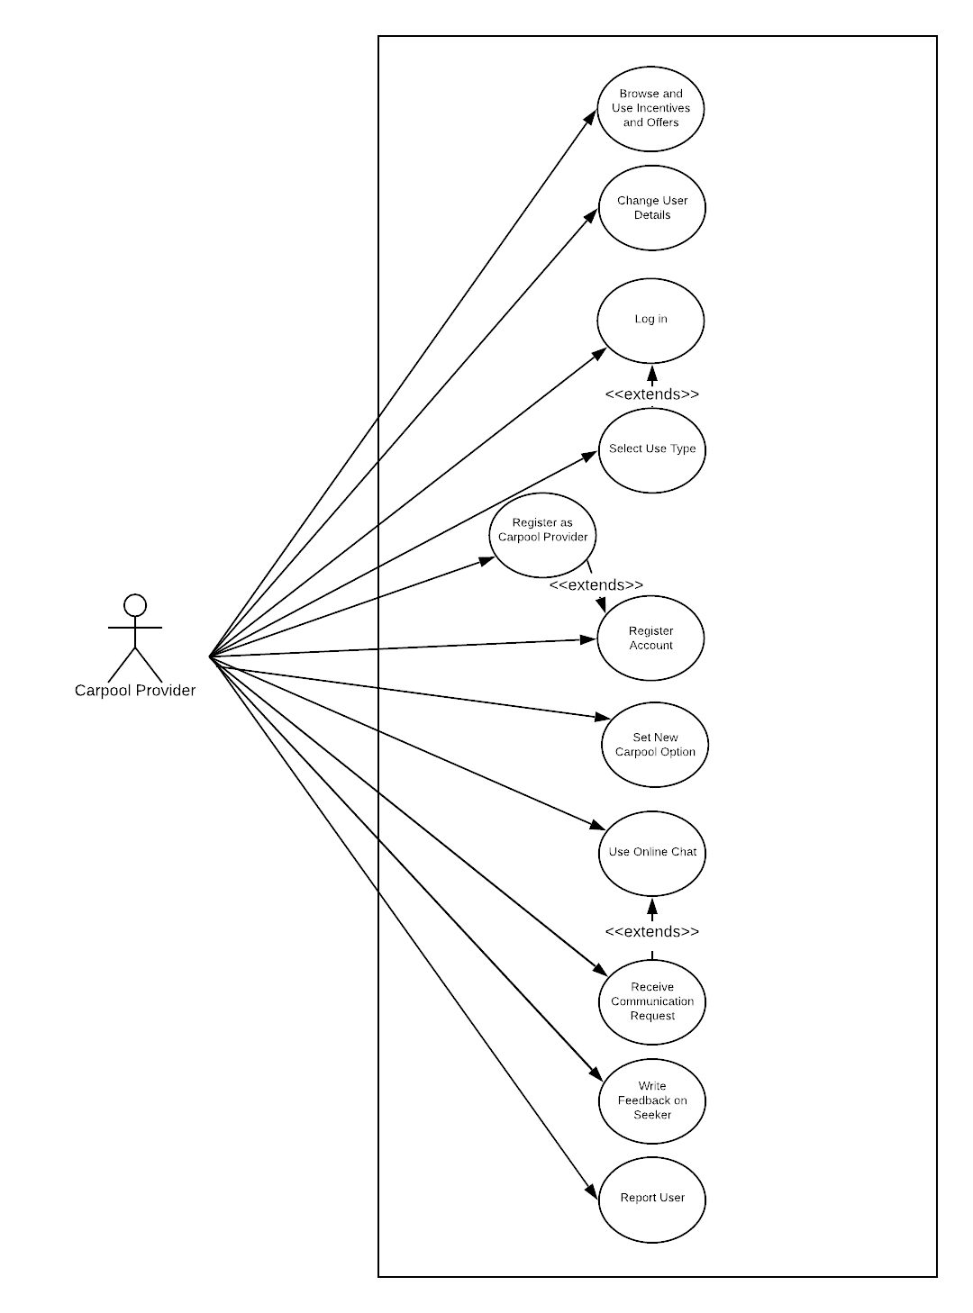

Figure 1 Carpool Provider Use Case Diagram

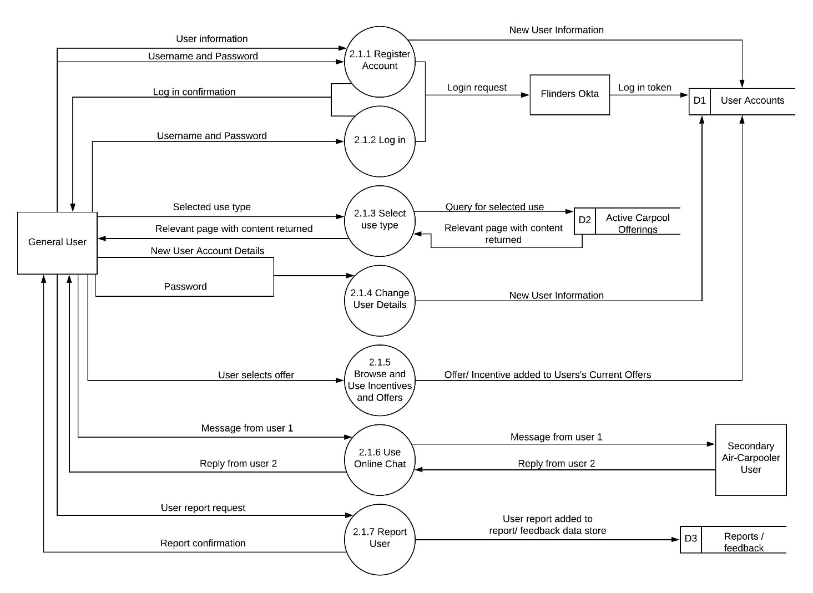

Figure 4. General User Data Flow Diagram

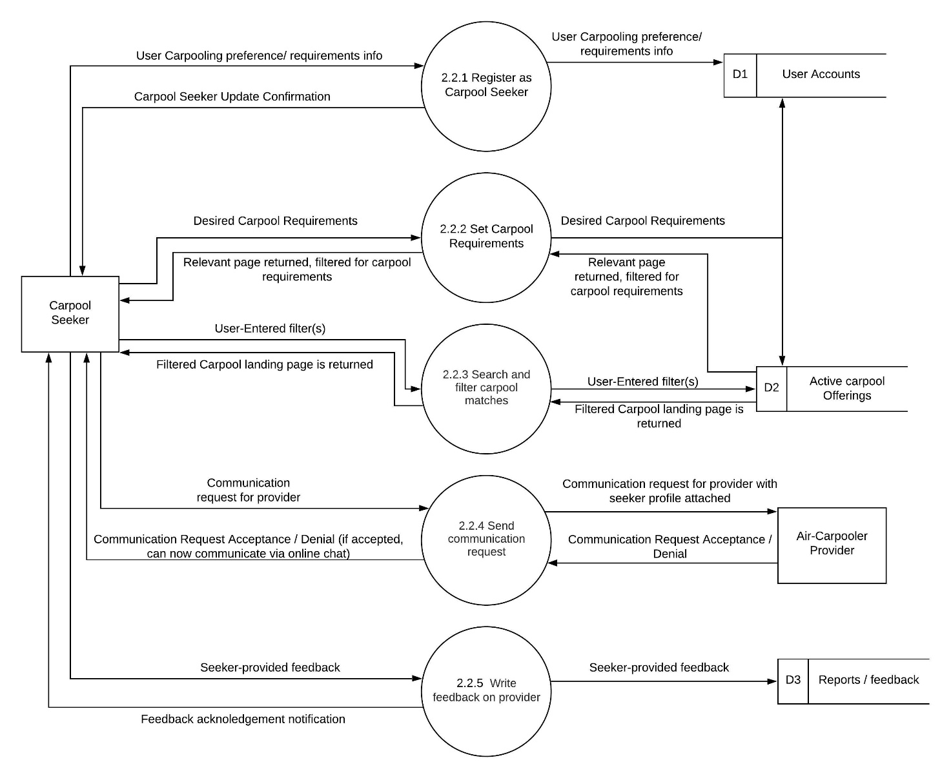

## Appendix C: Issues List

~~The following list summarises the hurdles that still need to be overcome before completion of the project. Some of these issues will need to be resolved before the project is commenced, some will require further research, and some will potentially be able to be dismissed once further information is gathered through the development process.~~

* ~~The size and scale of the beginning userbase will need to be determined to create more precise development requirements in terms of networking at server tasks.~~
* ~~The potential allocated budget for the project should be determined in order to shape the direction of the rest of the project.~~
* ~~In general, the project will require more user research in terms of personal habits, the effectiveness of the user interface, etcetera.~~
* ~~The user surveys should take extra care to determine the types of user-centred design that can be used for users that may be differently abled.~~
* ~~The development team should know whether the project will begin as a trial or as a fully-fledged product, and if it is the latter, how long the expected lifespan of the product will be~~