1

Name change

To recent achievements

Change

Group of Energy Storage Devices (GESD)

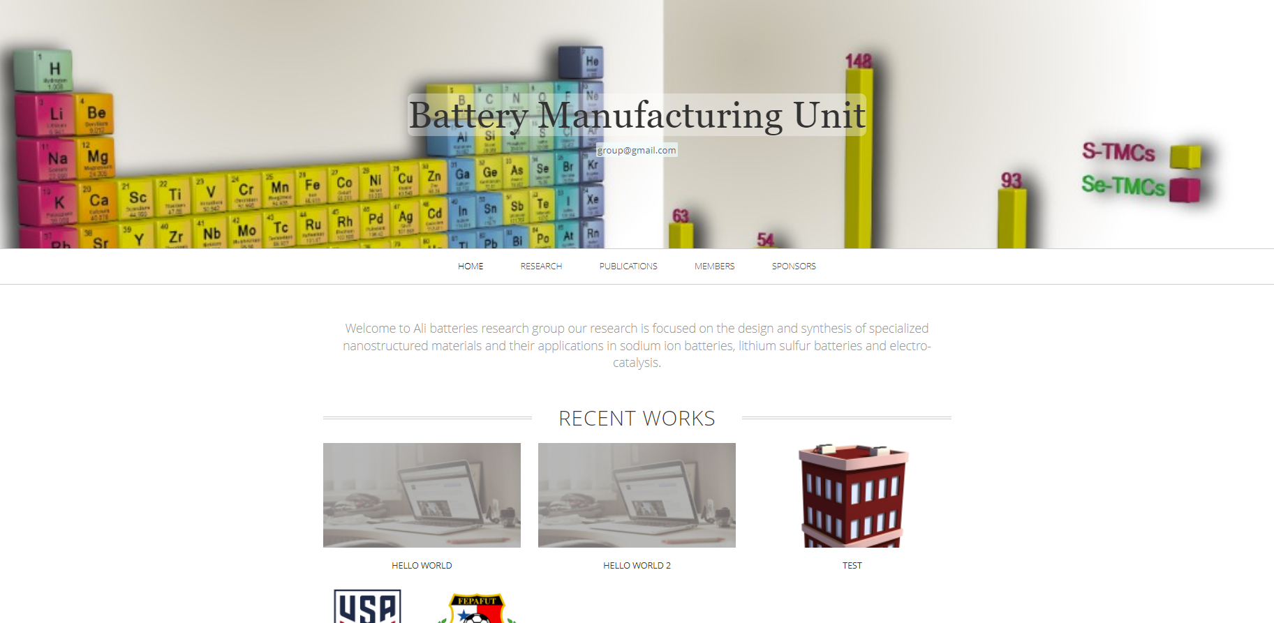

Remove email

2

Name change

Group Leader

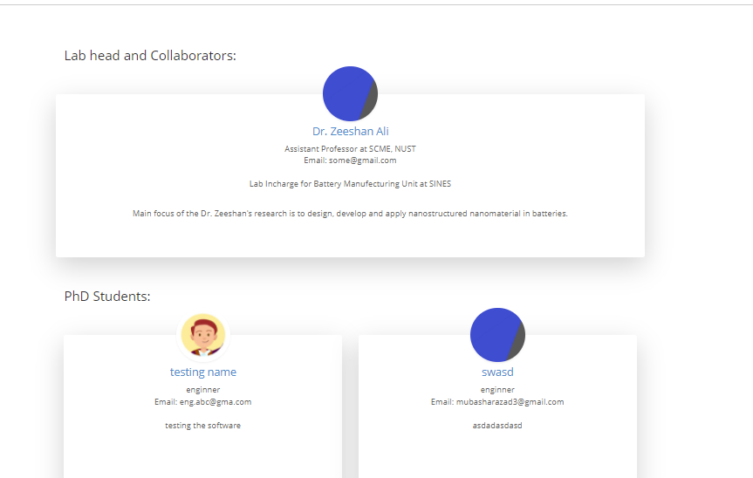

3

change sponsors to collaborators and make the page like members

4

At home page create funding agencies and image can be added only