Analysis on the Winning Rate of the First player On the condition of Monte Carlo Simulation

1.Welcome Interface

battle choice is for human-computer interaction

challenge choice is for Monte Carlo Simulation

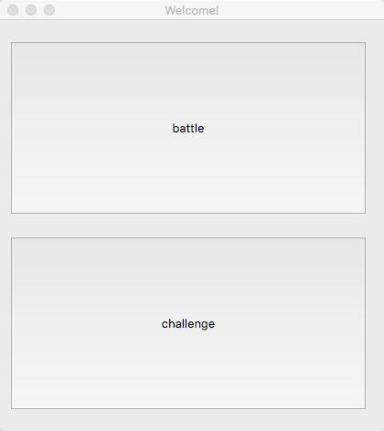

2.1.choose battle.

There are three modes which coordinates with three AIs.

Easy Mode: An absolutely random choosing policy AI

Med Mode: An almost-random choosing policy AI except when there is a chance to win, it will choose that position.

Hard Mode: An intelligent AI who will use the scores to make choice

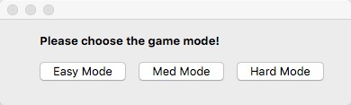

2.1.1.choose Easy Mode.

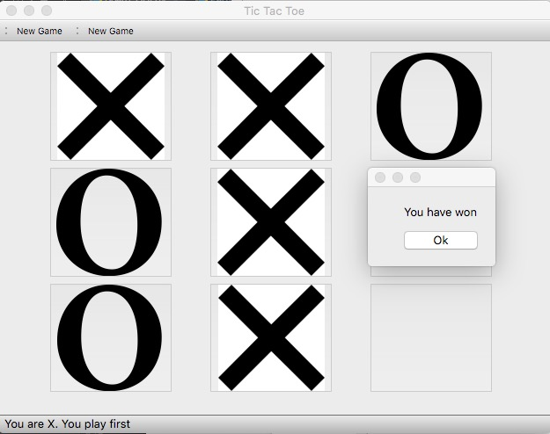

2.1.2 choose the Medium Mode.

The human player will also find it easy to win.

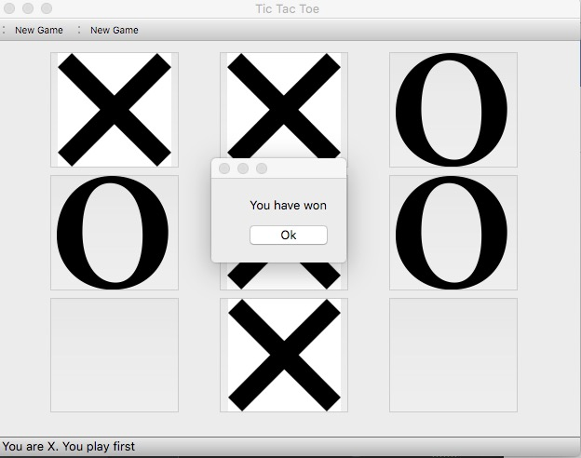

2.1.3. hard mode

normally , we will get the draw situation

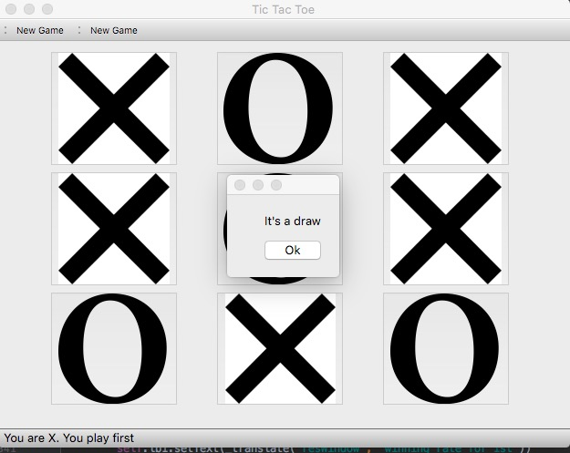

2.2.

choose challenge.

Using Monte Carlo Simulation to simulate nine situation battles: Easy to Easy; Easy to Med; Easy to Hard; Med to Easy; Med to Med; Med to Hard; Hard to Easy; Hard to Med; Hard to Hard

2.2.1.

mode: Easy to Easy;

number of MCS: 1000;

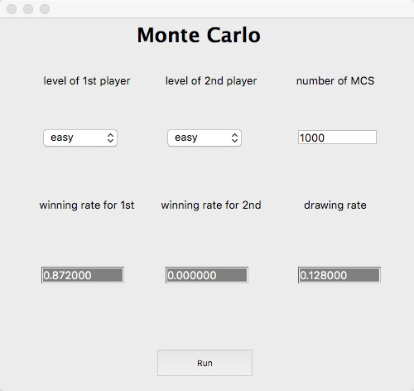

2.2.2

mode: Easy to Medium

number of MCS: 1000

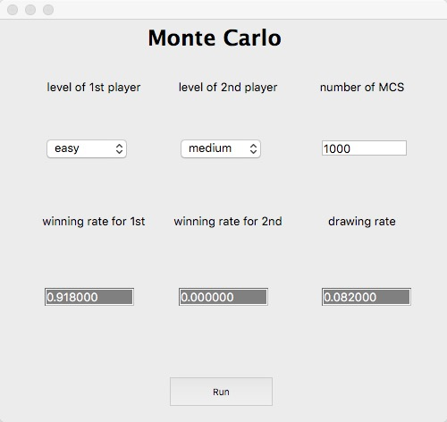

2.2.3

mode: Easy to Hard

number of MCS: 1000

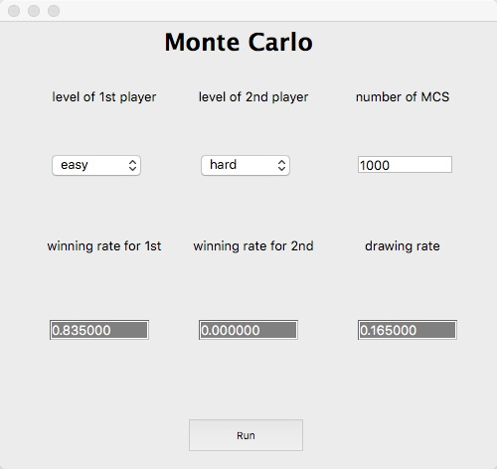

2.2.4

mode: Med to Easy

number of MCS: 1000

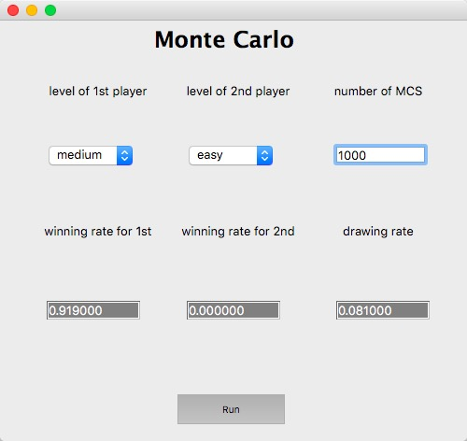

2.2.5

mode:Med to Med

number of MCS: 1000

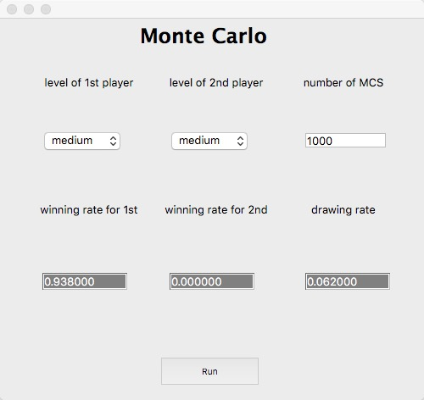

2.2.6

mode: Med to Hard

number of MCS: 1000

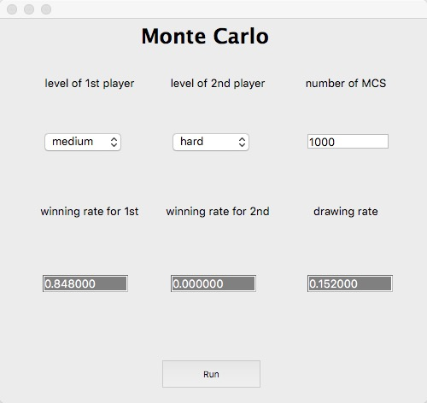

2.2.7

Hard to Easy

Number of MCS:1000

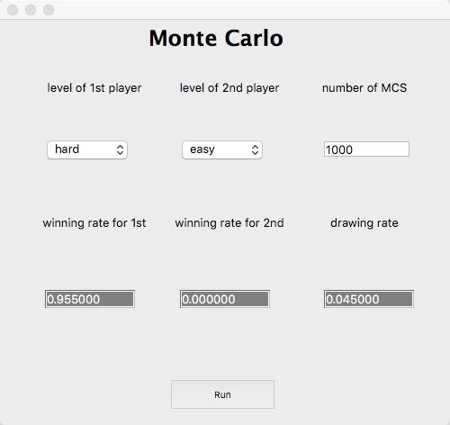

2.2.8

Hard to Medium

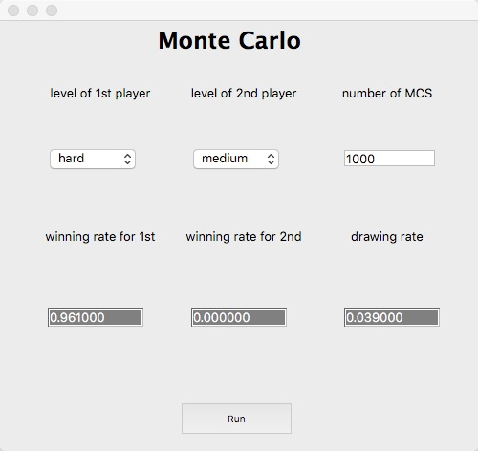

2.2.9

Hard to Hard

