Smart & Connected Communities Outline

### Goal

A significant amount of data relevant to evidence-based policymaking is collected at the local community level (e.g. education, housing, zoning, traffic, emergency services, social services). Existing local level data are a rich source of information that can be repurposed to support community-level decision-making. However, many communities lack the resources and technical expertise (i.e. the ability to clean, re-purpose, store and analyze data) to take advantage of decision-making enhancements to be found in their own local administrative data.

Therefore, as part of the outreach mission of U.S. Land Grant Universities, we will work with local governments to enhance their capability for data-driven decision making by providing a virtual analytic venue where government analysts and academic researchers can work cooperatively on community-relevant issues using all available locality-relevant datasets, including locally-derived data sources (e.g administrative data, sensor data), sources derived by neighboring communities, state and federal data sources, and data provided by non-governmental entities (e.g. community-oriented non-profit organizations).

### Objectives

To support this goal: * Provide and support a comprehensive, end-to-end set of data science processes, including processes of data ingestion and management, data analytics, and analysis presentation.

* Support the set of data science processes with a set of actively managed technology platforms providing the latest in open-source database, GIS, data analytic, and data presentaion technologies
* Establish a community-engagement model that keep barriers to participation as low as possible. For example, there will be no expectation of any significant modification to existing local government data systems, such as data standards, as a prerequisite of particiption. Instead, the system host (VT/ISU) takes on the responsibility for:
  + maintaining a comprehesive database of metadata of all data sources being provided by participating localities, including mappings between data sets using different data standards
  + providing to the locality, with support, the requisite technologies needed to securly connect their existing data resources to the venue.

### Plan

1. Deploy initial set of data platforms (see figure 1)
   * Data Management Platform
   * Data Analytics Platform
   * Data Lexicon
   * Data Presentation Platform
2. Begin by working with local government with whom we have existing working relationships
3. Commence a Community Engagement Process including:
   * Issue Identification & Preliminary Hypothesis Generation: develop, via situational analysis, an understanding of critical community issues as well as a set of variables suspected to be causitively related to each issue
   * Initiation of three distict discovery processes:
     + Data Management System Status Discovery
     + Data Analytics Capabilities Assessment
     + Data Discovery & Inventory
   * Draft and agree upon necessary data agreements (e.g. MOAs, MOUs)
   * Draft and agree upon a Data Access Plan
4. Deploy necessary data connection technologies as required by the Data Access Plan
5. Profile data and fill the metadata repository (Lexicon)
6. Establish access by local government analysts and academic researchers to platforms
   * Prove training and support
7. Conduct cooperative analysis
8. Generate reports, dashboards, etc for presentation to local government decision-makers
9. Cooperatively assess the utility of the provided analyses for decision-making purposes (focus groups?)

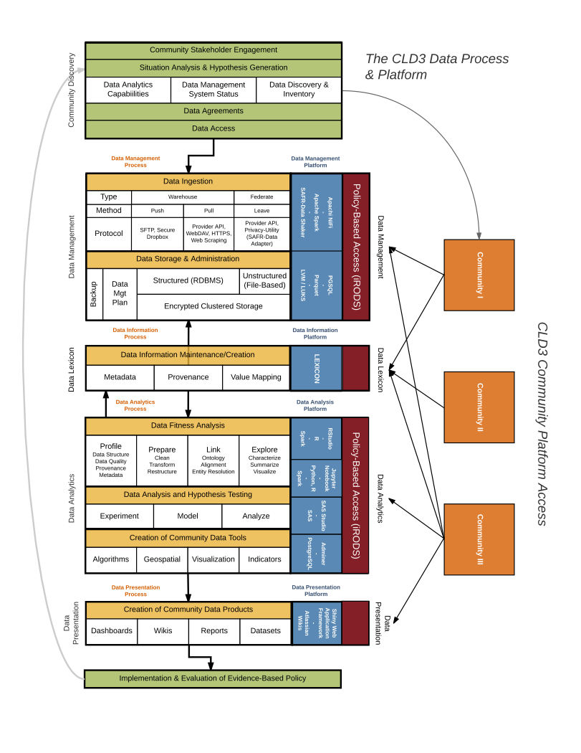

Figure 1: CLD3 Processes and Platforms Framework