Smart & Connected Communities Outline

### Goal

Existing data flows at the local level, public and administrative records, geospatial data, social media, surveys, as well as other federal, state, and local databases, are ubiquitous in our everyday life. Local government decision-making based on these data and the associated research are instrumental to improving performance, cost, and function. Despite the enormous potential of these data to advance the pubic good, communities lack the awareness, analytical expertise, or knowledge to apply these data in ways that improve conditions for our rural communities, inner cities, youth, elderly, disadvantaged, and ordinary citizenry.

As a natural part of the outreach mission of our institutions, we will work with local governments to enhance their capability for data-driven decision making by providing a virtual analytic venue where government analysts and academic researchers can work cooperatively on community-relevant issues using all available locality-relevant datasets, including locally-derived data sources (e.g administrative data, sensor data), sources derived by neighboring communities, state and federal data sources, and data provided by non-governmental entities (e.g. community-oriented non-profit organizations).

### Objectives

To support this goal:

* Develop, provide, and implement a sustainable comprehensive, loosely federated, end-to-end set of data science processes, including processes of data ingestion and management, data analytics, and analysis presentation that will support local government evidence-based decision making and researchers engaged in community based research. These Data Processes and Platforms will be developed in a manner to make them easily replicated and curated beyond their development stage to create a statewide and ultimately national ecosystem.
* Develop and implement the set of data science processes with a set of actively managed technology platforms providing the latest in open-source database, GIS, data analytic, and data presentaion technologies
* Establish a community-engagement model that keep barriers to participation as low as possible. For example, there will be no expectation of any significant modification to existing local government data systems, such as data standards, as a prerequisite of particiption. Instead, the system host (VT/ISU) takes on the responsibility for:
  + maintaining a comprehesive database of metadata of all data sources being provided by participating localities, including mappings between data sets using different data standards
  + providing to the locality, with support, the requisite technologies needed to securly connect their existing data resources to the venue.
* Create and implement a sustianibilty plan for these Data Processes and Platroms.

### Plan

1. Deploy initial set of data platforms (see figure 1)
   * Data Management Platform
   * Data Analytics Platform
   * Data Lexicon
   * Data Presentation Platform
2. Begin by working with local government with whom we have existing working relationships
3. Commence a Community Engagement Process including:
   * Issue Identification & Preliminary Hypothesis Generation: develop, via situational analysis, an understanding of critical community issues as well as a set of variables suspected to be causitively related to each issue
   * Initiation of three distict discovery processes:
     + Data Management System Status Discovery
     + Data Analytics Capabilities Assessment
     + Data Discovery & Inventory
   * Draft and agree upon necessary data agreements (e.g. MOAs, MOUs)
   * Draft and agree upon a Data Access Plan
4. Deploy necessary data connection technologies as required by the Data Access Plan
5. Profile data and fill the metadata repository (Lexicon)
6. Establish access by local government analysts and academic researchers to platforms
   * Prove training and support
7. Conduct cooperative analysis
8. Generate reports, dashboards, etc for presentation to local government decision-makers
9. Cooperatively assess the utility of the provided analyses for decision-making purposes (focus groups?)

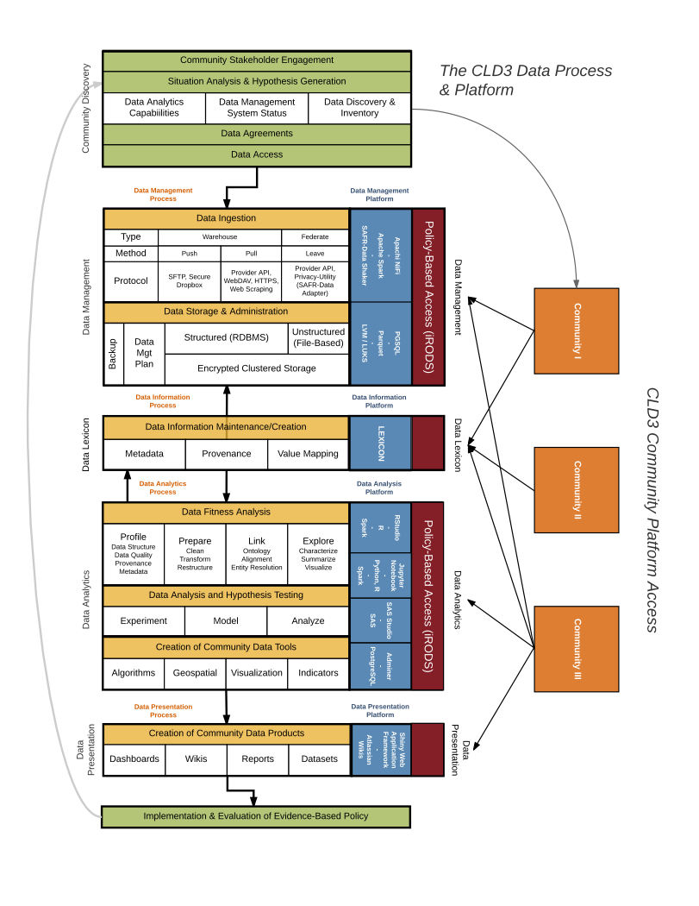

Figure 1: CLD3 Processes and Platforms Framework