#### S&CC-IRG Preliminary Proposal Track 2: Building Local Government Capacity for Data-Driven Governance and Regional Analysis

#### Aaron Schroeder (PI), Virginia Tech and Alan Dotts (co-PI), Iowa State University

#### Summary

#### Data flows relevant to local government decision-making, such as local administrative records, surveys, geospatial data, and sensor data, as well as federal, state, and social media data sources, are ubiquitous. Local government decision-making based on these data are instrumental to increasing efficiency and improving outcomes. Despite the enormous potential, many local governments lack the general knowledge or technical and analytical expertise to utilize these data sources to inform their decision-making process. While many issues that are the perview of local government (e.g. educational attainment, opioid addiction, disconnected youth, poverty, homelessness), many policy decisions end up being informed by anecdotes rather than data-derived evidence.

To enhance their capacity, we are working directly with local governments to provide experience in using local, state, federal, and other data sources, and in working collaboratively with issue-area researchers, to support a data-driven model of governance. This capacity building effort is presently being achieved through the development and deployment, and collaborative use with the community of, a set of **data science processes** and **supporting technological platforms**. Capacity is being gained by participating communites as they work collaboratively with issue-area researchers through the processes necessary to prepare these data for use in the decision-making process.

The development of a more formalized, scalable, portable, and inter-jurisdictionally secure version of these processes and platforms and piloting it across Virginia and Iowa is the focus of this proposal. This new **comprehensive framework of** **secure** **data science processes and platforms** will mediate access to data and data tools, adhere to necessary data privacy and security constraints, and, as it is deployed and used to build capacity in multiple communities, allow for the creation of a **loosely federated data infrastructure** across an entire state.

Our Land Grant Universities will serve as the stewards of this architecture, ensuring accessibility by local communities, researchers, and state agencies.

**Intellectual Merit**

New institutional priorities across the country are focusing on the need for an increase in the amount and quality of community-based research. New partnership models are viewed as a method to achieve this and to increase the dissemination of such research in peer-reviewed journals. This project will help extend the type and reach of scholars who become involved in community-based research, as well as increasing the capacity for evidence-based decision making at the local level.

**Broader Impacts**

This research will have significant benefit to society through creating a replicable architecture capable of rapid translation of research to practice that will enable data-driven governance across rural and urban communities. This will include a **comprehensive framework of** **secure** **data science processes and platforms** that can be adopted or adapted by other states. Land Grant Universities will become the stewards of this infrastructure ensuring it is accessible by local communities, researchers, and state agencies.

## Project Description (4-page limit)

### Vision & Goals

###### Describe the vision and goals of the proposed research. Briefly describe how the project will contribute to our understanding of S&CC research, to research capacity-building, and to the engaged community.

In this project we are pursuing a vision of local governments acquiring the capacity for data-driven, inter-jurisdictional, evidence-based decision-making in their governance processes.

There is tremendous potential for enhancing the effectiveness of local government decision-making by bringing to bear analyses of all locality-relevant data sources, regardless their location. Local government decision-making based on these data and the associated research are instrumental to improving performance, cost, and function. Local governments themselves often have significant stores of historic and current electronic data at their disposal. However, the insights and patterns that analysis of that data might reveal are often obscured from use by siloed information technology systems that have been developed solely for the purpose of processing isolated transactions (Goldsmith, 2016).

Unfortunately, many localities lack both the analytic and technological capacity to carry out just the first steps of re-purposing their administrative datasets (i.e. profiling, cleaning, transforming) to make them ready for analysis in combination with other datasets (e.g. State, Federal, other). In turn, this inability to provide datasets suitable for analysis can make it exceedingly difficult to work cooperatively with policy-area researchers who can bring invaluable insights to the decision-making process.

As a natural part of the outreach mission of our institutions, we will work with local governments to enhance their capability for data-driven decision making by providing a virtual analytic environment where government analysts and academic researchers can work cooperatively on community-relevant issues using all available locality-relevant datasets, including locally-derived data sources (e.g. administrative data, sensor data), sources derived by neighboring communities, state and federal data sources, and data provided by non-governmental entities (e.g. community-oriented non-profit organizations). This virtual analytic environment is based on Virginia Tech’s current work with Virginia localities using a set of data science processes and supporting technological platforms designed to support cooperative community research.

To support this vision, we will achieve the following goals:

* Develop, provide, and pilot the implementation in four communities a sustainable **comprehensive framework of** **secure** **data science processes and platforms**, including:
  + processes of data ingestion and management, data analytics, and analysis presentation that will support local government evidence-based decision making and researchers engaged in community based research,
  + a set of actively managed technology platforms providing the latest in open-source database, GIS, data analytic, and data presentation technologies, as well as enabling secure and policy-based sharing of data across jurisdictions
* These Data Processes and Platforms will be developed in a manner to make them easily replicated and curated beyond their development stage to create a statewide and ultimately national ecosystem.
* Establish a community-engagement model that keep barriers to participation as low as possible. For example, there will be no expectation of any significant modification to existing local government data systems, such as data standards, as a prerequisite of participation. Instead, the system host (VT/ISU) takes on the responsibility for:
  + maintaining a comprehensive database of metadata of all data sources being provided by participating localities, including mappings between data sets using different data standards
  + providing to the locality, with support, the requisite technologies needed to securely connect their existing data resources to the venue.
* Create and implement a sustainability plan for maintain the Architecture of Data Processes and Platforms.

### Integrative Research Approach

###### Describe clearly the proposed research including its plan for integrative research and community engagement. Define the community, associated stakeholders, and how the community will engage in meaningful ways with the proposed research. Briefly describe the evaluation approach including initial metrics.

Deploy Virtual Analytic Environment: To enable community engagement and our integrative research process, we will begin by deploying a supporting set of scalable, transferable, and cost-effective data management, data analytics, and data presentation technology platforms (see figure 1)

* Built using the latest open-source data technologies, individual technology platforms can be hosted locally or in the cloud. A set of Virtual Private Servers (VPSs) is dedicated to each participating community.
* As the data management and analysis expertise of a community grows, it may become desirable for that community to have a more direct controlling role over the technology platforms. In fact, such developments are a sure sign of success in capacity-building efforts. The technology platforms are purposely designed and constructed for ease of transferability for just such a circumstance.
* The computer code that underlies the technology platforms is open-source and will be made available to any community under GNU Public License along with documentation.

Starting with community-chosen issue areas, VT issue-area researchers will work cooperatively with our partner communities (Arlington, Alexandria, Des Moines, Perry). We will begin building community capacity for managing the data science process by working collaboratively through the processes of community engagement and discovery, data ingestion and management, data fitness analysis, data analysis and hypothesis testing, and data & analysis results presentation.

1. During the Community Engagement & Discovery Process, we will work with the community to:
   1. conduct a **preliminary hypothesis generation process** where we start with critical community-defined issues and work with community leaders to elicit an initial set of variables suspected to be causatively related to each issue;
   2. conduct a **data management system status discovery process** to ascertain the methods and technologies currently employed for data management, as well as their capacity to handle the data storage and management requirements of the entire process;
   3. conduct a **data analytics capabilities assessment** to ascertain the community’s current level of data analysis expertise; and,
   4. conduct a **data discovery and inventory process** where first, potential data sources that could be related to the specific issue areas are identified and screened to determine their potential usefulness in supporting the research questions, and second, additional details are inventoried for those that are deemed worthwhile and in need of additional data profiling.
   5. deploy necessary data connection technologies as required by an already established **data access plan** to enable the data transfer and management
2. During the **data ingestion & management process**, the community will gain the capacity to execute the processes necessary to configure their datasets for secure transfer and/or secure remote dynamic-access. This process entails:
   1. establishing the **type and method of data transfer**: is the data being pushed to or pulled into the cooperative platform, or is the data staying where it is and being dynamically queried in a federated manner as needed?
   2. establishing the **best protocol(s)** to use given the types and method of transfer (e.g. SFTP, secure dropbox, secured REST API, VT SAFR-Data Adapter for secure federated queries)
   3. establishing **data marshalling processes** for: system mediation logic, data pipeline and data transformation, transfer schedule, and data provenance maintenance
   4. establishing **secure data storage procedures** (e.g. each project being stored on a new project-dedicated encrypted partition, original data being stored as non-removable and non-editable)
3. During the **data fitness analysis process**, the community will gain capacity in understanding how to assess their data’s “fitness-for-use” by:
   1. applying a disciplined process for profiling data sources in terms of data quality structure and metadata (Keller et al. 2016);
   2. preparing selected data for analysis via cleaning, transformation and restructuring (Schroeder, others);
   3. creating linked datasets securely and at the highest possible level of accuracy (Schroeder, others);
   4. testing the prepared dataset(s) as adequate for use in proposed analyses/modelling approaches (Keller census report);
4. During the **data analysis and hypothesis testing process**, the community will gain to capacity to:
   1. transform preliminary hypotheses collected during the community engagement process into more formal research hypotheses
   2. create analytic experiements to test their hypotheses
   3. understand or even begin to create statistical models
   4. understand or even begin to perform statistical analyses to test their hypotheses

??Creation of Community Data Products, such as problem-specific algorithms, geographic visualizations, and new community indicators.

Mediating the architecture’s ability to support the linkage and use of dataets from different sources is the Lexicon. At its base, the Lexicon serves the function of a metadata repository—a database created to store metadata from various systems. Metadata is information about the structures that contain the actual data. Metadata is often said to be "data about data", but the Lexicon goes far beyond this definition, proving a centralized node of data source information that can be used for provenance tracking and data linkage within a heterogeneous network of data sources (A. D. Schroeder 2013b). Specifically, the Lexicon is an inventory of and history of changes to:

* every available data field in every available data source
* the structure of their storage
* possible values and meanings of the information stored
* possible transformations of each set of field values from one data source to another set of field values from another data source
* methods of data source access
* matching algorithms and how they are to be used in conjunction with possible field value transformations

The Lexicon provides fundamental functions for the operation of the framework. It is a requirement that all data partners in the network provide the data information necessary for its operation. The Lexicon is maintained in an RDBMS by CLD3 staff, thus removing the complexity required for high quality data linkage from all data partners (i.e., a standardization scheme enforced among data partners).

### Research Capacity-Building

###### Describe activities towards building, developing, and engaging research talent to focus on S&CC integrative research challenges.

### Integration and Multi-Disciplinary Context

###### Characterize the multidisciplinary, holistic nature of the approach by identifying the disciplines involved in the research, and how the proposed research elements are integrated.

Definition of Transdisciplinary

Public Administration & Policy

Statistics

Economics

Computer Science

Psychology

### Management

###### Describe the participating institution(s) and key personnel briefly (see Project Personnel and Partner Institutions section). Address the roles and responsibilities of the project’s management, and how it will support integration of tasks at a high level and engagement with the community throughout the course of the planned research activities. Describe the approach to collaboration among project members.

### Budget and Subawardees

###### Provide an estimated aggregate budget request with number of years of support requested. Provide a list of subawardee institutions.

## Project Personnel and Partner Institutions (1-page limit)

###### Provide current, accurate information for all personnel and institutions involved in the project. Follow the same format as described for Project Personnel and Partner Institutions in the Full Proposal Preparation Instructions below. Submit as a supplementary document.

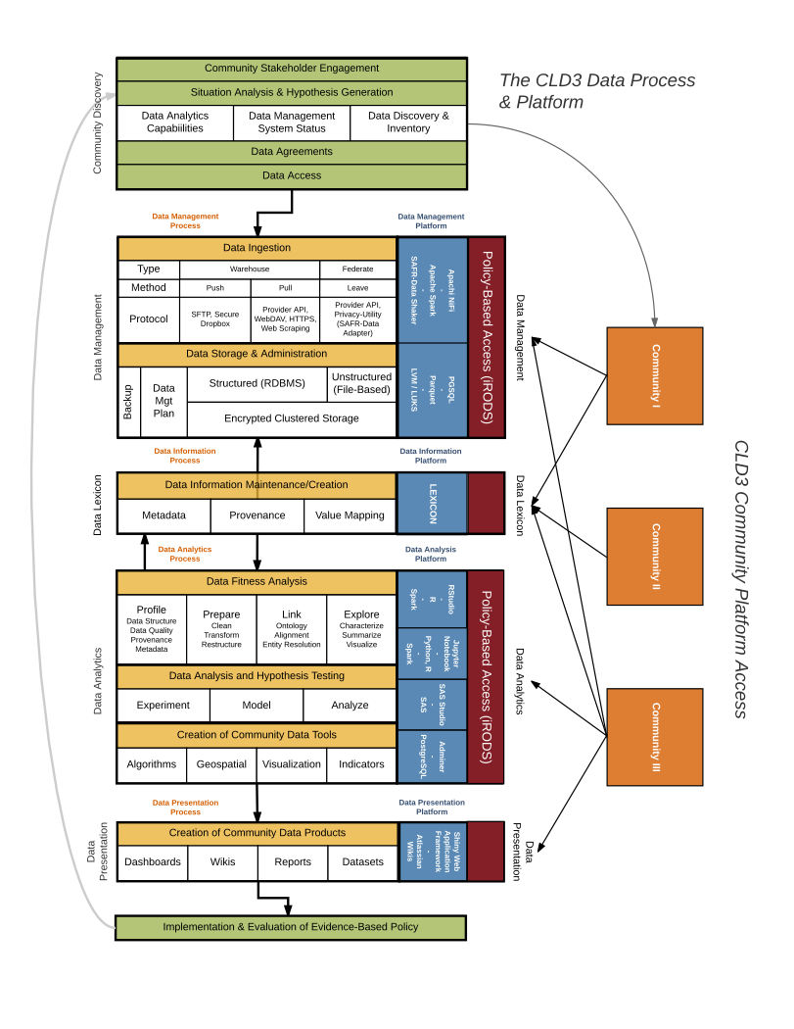

Figure 1: CLD3 Processes and Platforms Framework

References

Goldsmith, S., Crawford, S., & Weinryb Grohsgal, B. (2016). Innovations in Public Service Delivery: Issue No. 4: Predictive Analytics: Driving Improvements Using Data. Inter-American Development Bank.