**PAUSELAB – BECVILLE:** USER MANUAL

The PauseLab BeCville web application facilitates community betterment through placemaking and civic engagement. The application will follow the timeline of a community project from the collection of ideas to the finalization of the physical projects.

This user manual will outline the utilization of the PauseLab BeCville website with respect to the various types of users that will be present.

COMMON FUNCTIONALITIES

**Account Creation**

Site users, unless assigned by an admin, must create an account for access to features specific to certain roles. However, an account is not needed by the members of the community to submit ideas, view and vote on proposals or follow the blog.

To create an account, users must first click on the “login” button, upon which they will be redirected to the login page.

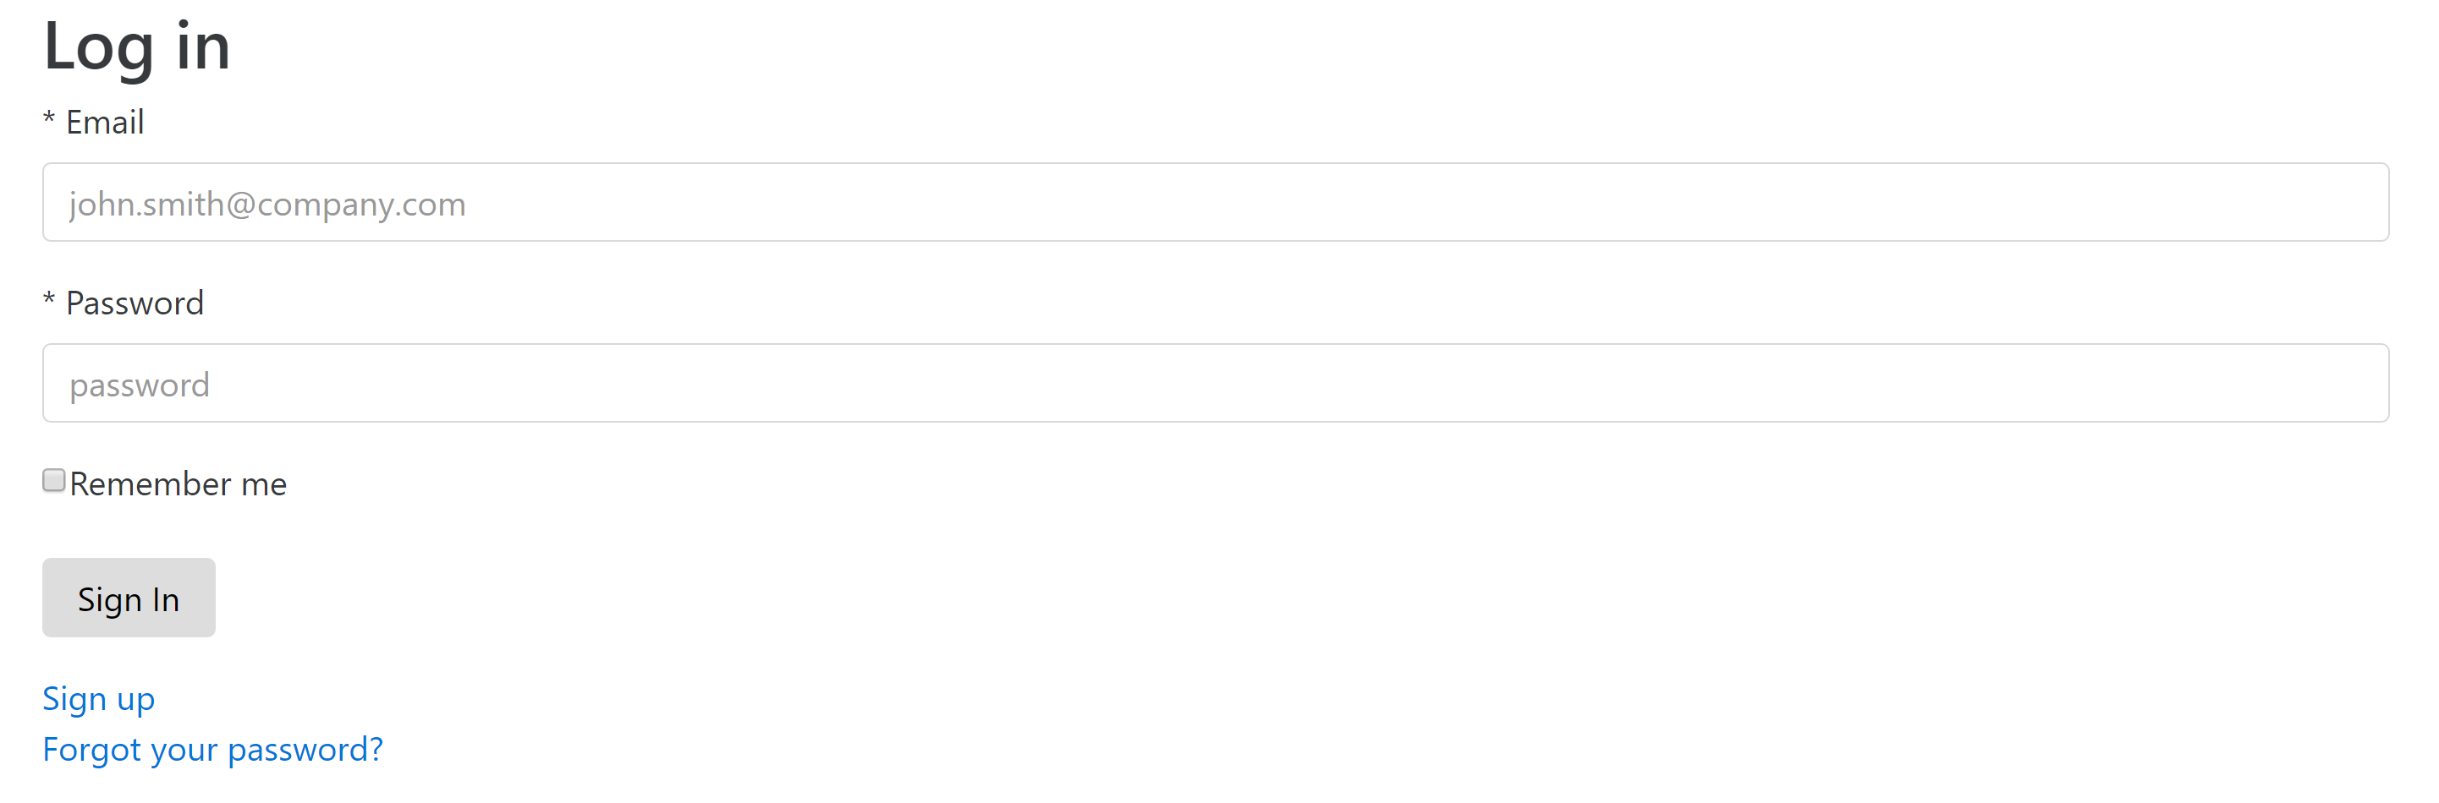

If the user has an account already, they may simply login using their email and password. New users, however, will click “Sign up”. To create an account, the users must fill out the new account form.

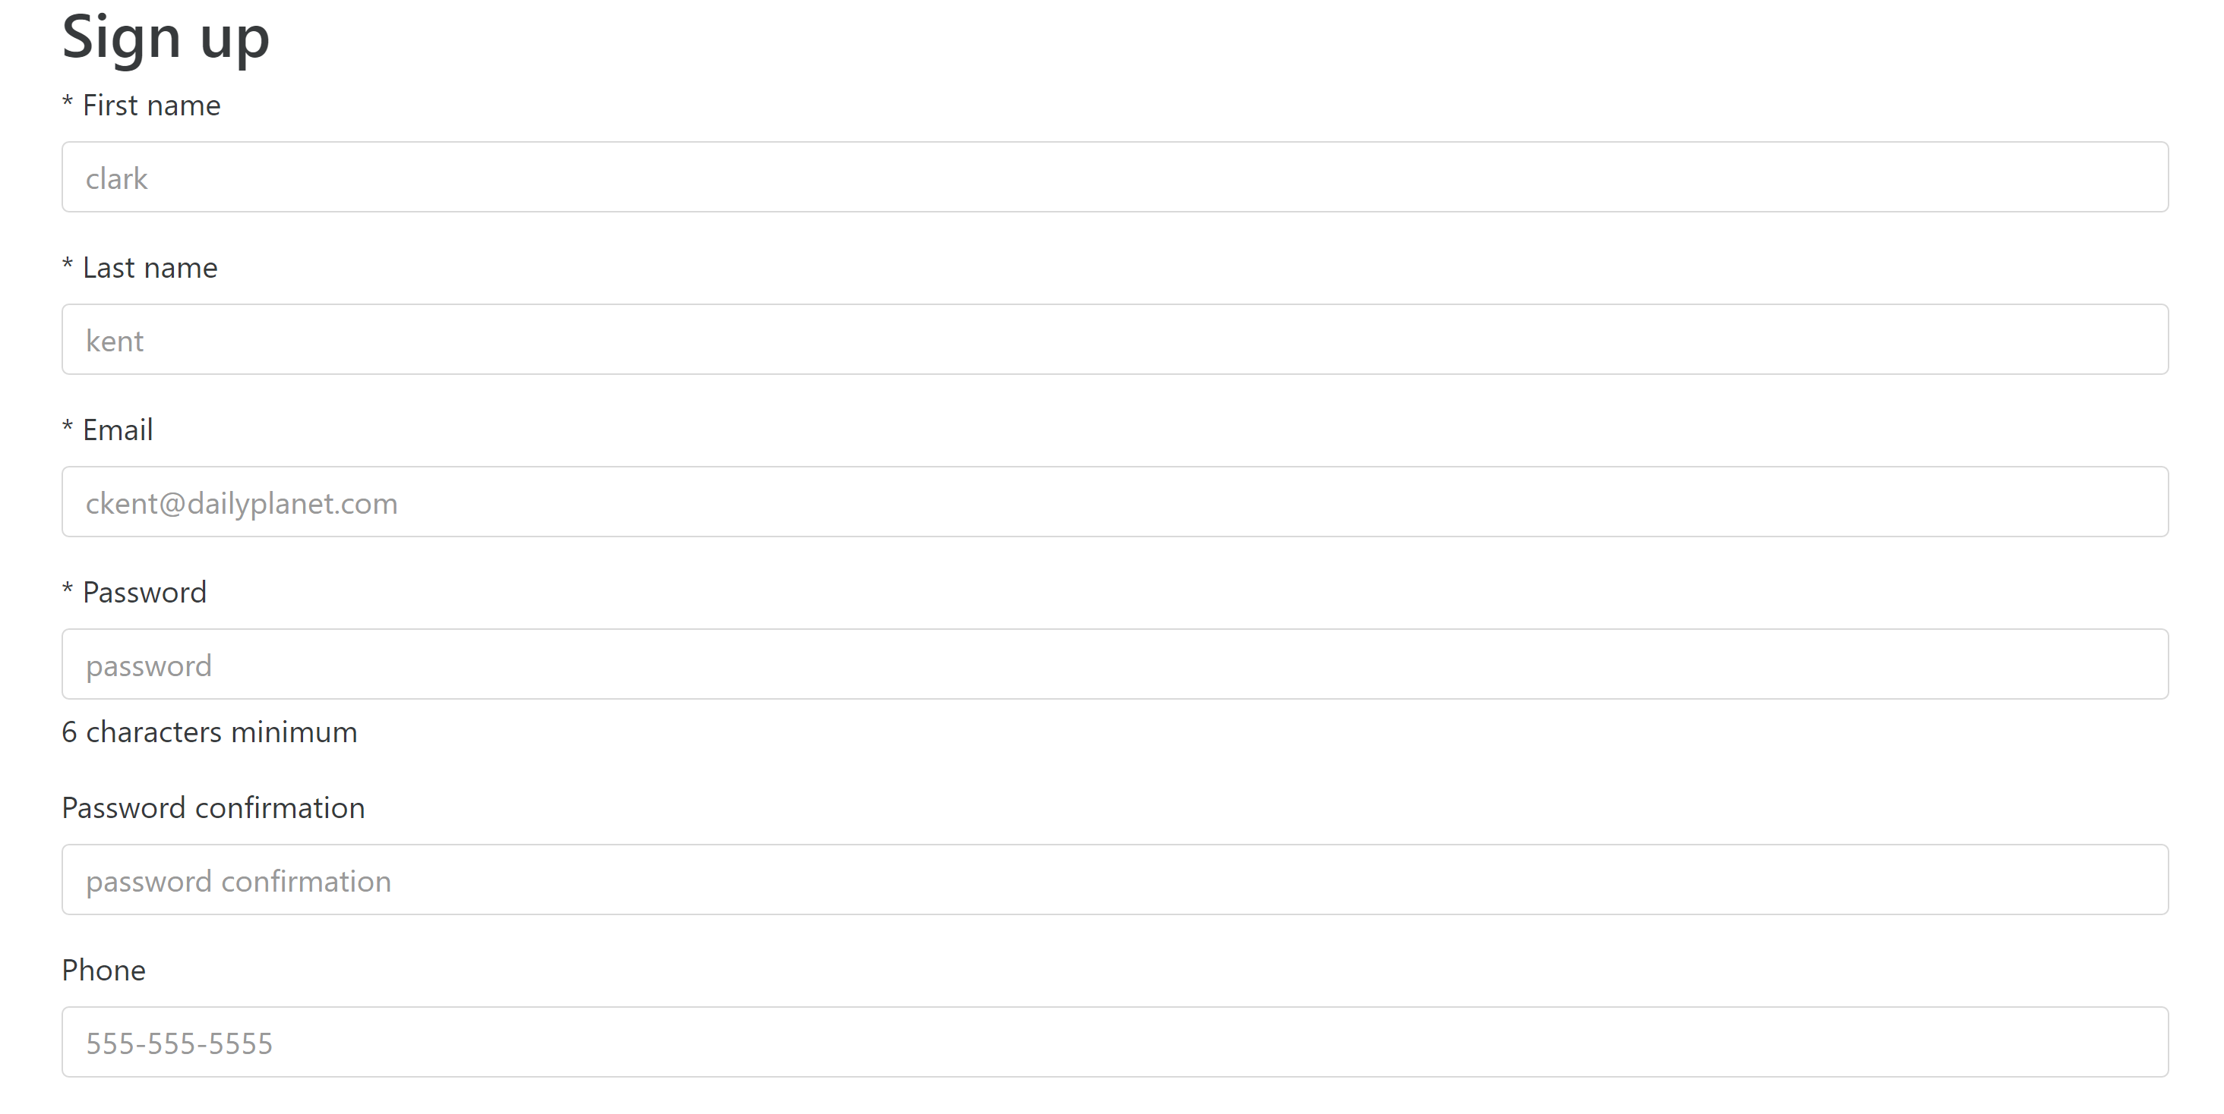

After the form is completed, the users will have an account with the role of Artist. They may sign out of the website at any time by pressing the “logout” button on the top left corner of the website.

**Idea Submission**

The idea submission feature is open to the general public with no PauseLab account needed. This idea submission feature, however, will only be available during the Idea Collection Phase of the project lifecycle.

There are two ways that users may submit ideas. The first is by clicking “submit an idea” on the homepage of the website.

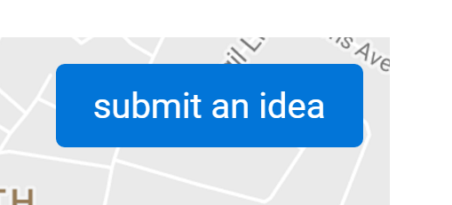 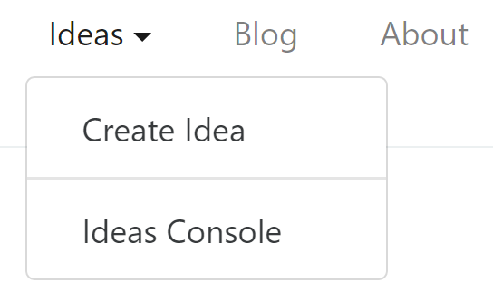

Another way is to click on the “Ideas” drop down menu on the navigation bar at the top of the page and then selecting “Create Idea”. These methods will not be available after the Idea Collection phase.

Once on the Idea Submission page, users will be asked to fill out a form with basic information about their idea and to select a location to which the idea corresponds to. Additionally, the users must specify a pre0defined category for the idea. They may then submit the idea for approval.

