10/17/16

**PCCS Initial Wireframes**

**Contest Page**

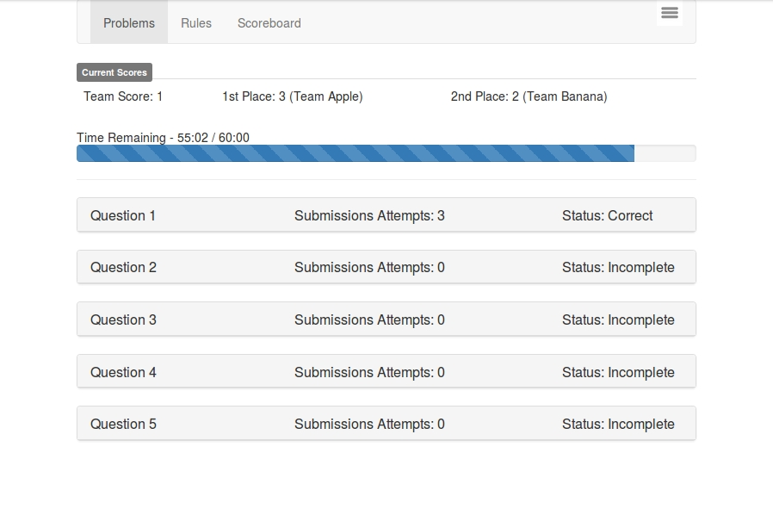

**Contest Page with Question Selected**

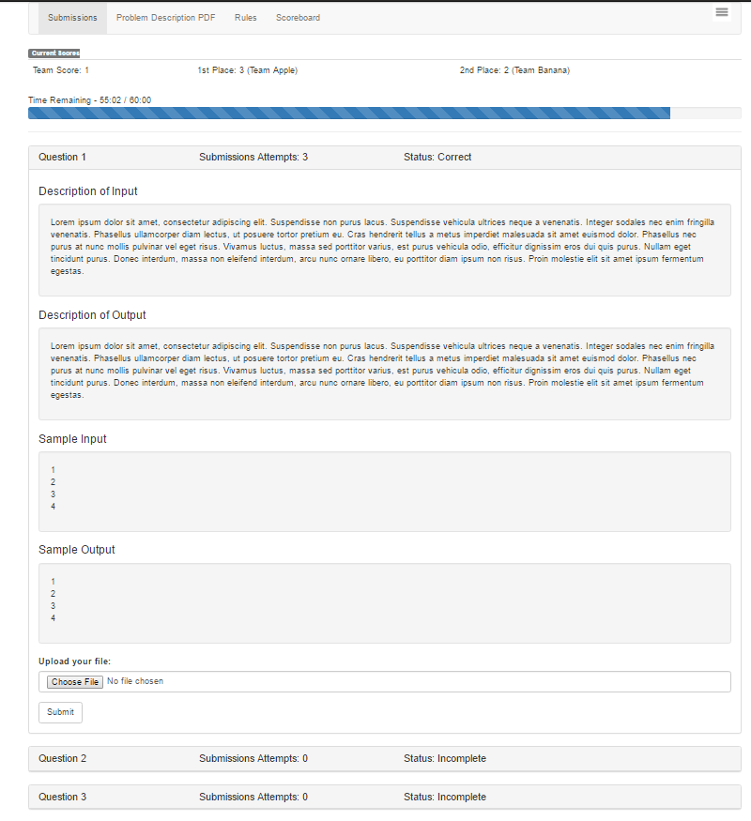

**Contest Scoreboard**

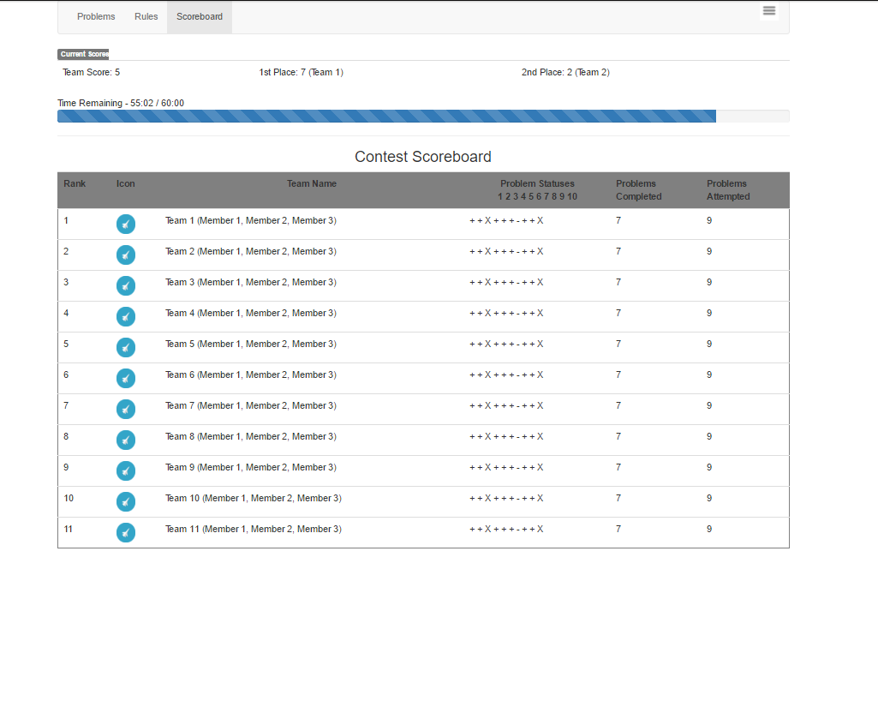

**Contest Creation Page**

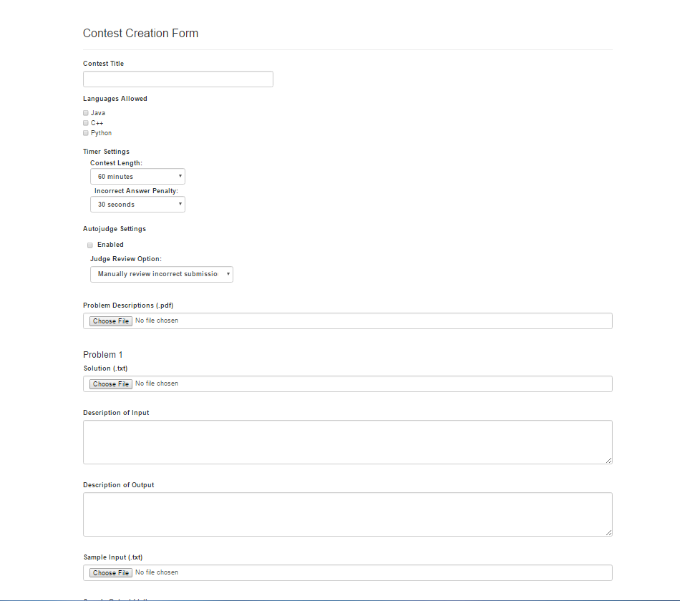

**User Landing Page**

