Circuit Simulation README.

Leakage Modeling Procedures

1. Determine parameters of the single transistor model.

Our leakage model of a single transistor is given by the following equation:

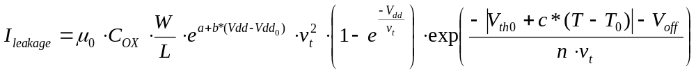(1)
The subthreshold leakage and the leakage caused by DIBL effect are taken into account in this equation. u₀ is the zero bias mobility, C_{ox} =ε₀/t_{ox} is gate oxide capacitance per unit area, W/L is the aspect ratio of the transistor, eª is the adjust parameter to fit the simulation result, e^{b*(Vdd-Vdd0)} is the DIBL factor, V_{dd0} is the default supply voltage for each technology, v_{t}=kT/q is the thermal voltage, V_{th0} is zero bias threshold voltage in the room temperature T₀=300K, c is the temperature factor of threshold voltage, n is the sub threshold swing coefficient, V_{off} is an empirically parameter.

Given a specific technology, there are several parameters (a, b, c, V_{off}, n) should be determined by the curve-fitting methods, while u₀, t_{ox}, Vdd0 and Vth0 and W/L is given by the user. Transistor level simulation is needed for both NMOS and PMOS in order to determine curve-fitting parameters. It can be done by Spice or Spectre simulator. Following figure shows the schematic of NMOS and PMOS.

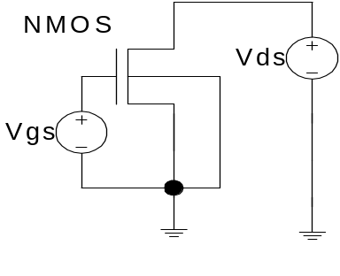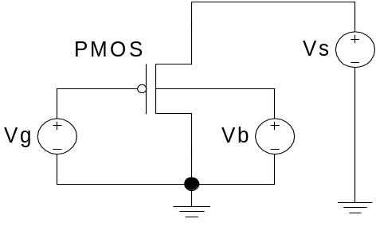

Figure.1 Schematic of NMOS and PMOS single transistor simulation.
We are interesting in the current I(DS) which flow through the transistor when the transistor is off. For NMOS, we measure the current of Vds when Vgs=0 and Vds=Vdd. For PMOS, we measure the current of Vs when Vg=Vs=Vb=Vdd.
For both NMOS and PMOS, we vary aspect ratio (W/L), temperature (T), threshold voltage (Vth0) and supply voltage (Vdd) respectively thus four curves are obtained. By using the curve fitting method, we are able to determine parameters (a, b, c,V_{off}, n). To make the curve-fitting method more effective, we should take advantage of the physical meanings of these parameters. Here it is the steps:
1) Based on the experiments, we know the approximate range of these parameters. Initially, we set the parameters at reasonable values to make the curve-fitting method more effective (a: 1~10, b: 1~5, c:0.1e-3 ~0.5e-3, Voff: -0.01~-0.1, n: 1.5~2).
2) We first generate I(DS)~W/L curve by calculating leakage based on the equation (1). Compared with curve we got from simulation, we are able to get parameter a which determine the slope of the I(DS) ~W/L curve.
3) Generate I(DS)~T curve by calculating leakage based on the equation (1). Compared with curve we got from simulation, we are able to get the parameter c.
4) Generate I(DS)~Vdd curve by calculating leakage based on the equation (1). Compared with curve we got from simulation, we are able to get the parameter b.
5) Generate I(DS)~Vth0 curve by calculating leakage based on the equation (1). Compared with curve we got from simulation, we are able to get the parameter n and Voff.

In every step, we only vary one parameter and make other parameters fixed. It is based on the assumption that these parameters are independent. The assumption simplifies the curve-fitting method but also makes the results inaccurate. We need go through several iterations to make sure that each curve is fitting well.

2. Determine k_{design} (kn and kp) for a specific cell
For a specific cell, the leakage current is given by the following equation:

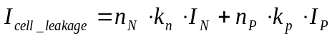 (2)
kn and kp are the design factors of NMOS transistor and PMOS transistor and they can be derived by similar method of the single k_{design} model. I_{N} and I_{P} is the unit leakage current calculated based on equation (1) when W/L is equal to 1.n_{N} and n_{P} is the number of NMOS and PMOS transistors respectively.

To determine the kdesign factor, transistor level simulation is required for the specific cell. For a given cell, we divide all possible inputs into two groups: one group inputs will turn off the pull-down network which composed by NMOS transistor; another group will turn off the pull-up network which is composed by PMOS transistor. Correspondingly, the leakage currents measured from simulation are also divided into two groups (I_{1n}, I_{2n} … I_{kn}...) and (I_{1p},I_{2p}...I_{kp}…). I_{kn} is leakage current when pull-down network is turned off while I_{kp} is the leakage current when pull-up network is turned off. Kn and kp are given by the following equation:
(3)
N is the number of all possible combinations input. For an example, figure 2 is the diagram of two input NAND gate.
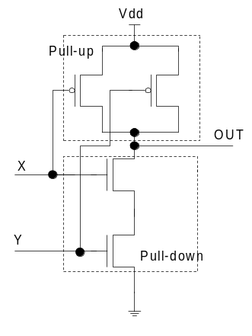
Figure 2. Diagram of 2 input NAND gate.

There two inputs X and Y which make four combinations. Three combinations: {X=0,Y=0}, {X=0,Y=1} and {X=1,Y=0} will turn off the pull-down network. I_{1n},I_{2n} and I_{3n} are the leakage current corresponding to these three inputs. Only {X=1 Y=1} will turn off the pull-up network and I_{1p} is the corresponding leakage current. Kn and kp are given by following equation:
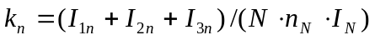
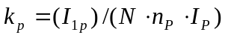 (4)
Here N is equal to 4 and n_{N} and n_{P} both are equal to 2.

Unfortunately, k_{design} factors are not a constant when T, Vth and Vdd vary. Based on our experiments, k_{design} factors are almost constant when threshold voltage varies, while k_{design} factors are linear functions of temperature and supply voltage. Curve-fitting method are applied here to get an accurate equation of k_{design} factors.
(5)
Here k_{design0} is the design factors at room temperature T₀=300K and default supply voltage Vdd0. Parameter g and h are derived from curve-fitting method.

The following circuit parameters map to the corresponding variables in leakinit.c

Parameters Mapping:
M0n, M0p: zero bias mobility for NMOS and PMOS (u₀).
Tox: gate oxide thickness (t_{ox}).
Cox: gate oxide capacitance per unit area (C_{ox}).
Vnoff0, Vpoff0: empirically determined model parameter for NMOS and PMOS (V_{off}).
N_{a}, P_{a}: V_{dd} curve fitting parameters for NMOS and PMOS (a).
N_{b}, P_{b}: V_{dd} curve fitting parameters for NMOS and PMOS (b).
Vnthx, Vpthx: Temperature curve fitting parameters for NMOS and PMOS (c).
NEta, PEta: subthreshold swing coefficients for NMOS and PMOS (n).
Kndesign, Kpdesign: design factors for NMOS and PMOS (k_{n}, k_{p}).
t_slope: curve fitting parameter for kdesign (g).
h_slope: curve fitting parameter for kdesign (h).

SRAM CELL MODELED:

The SRAM cell modeled has the same threshold voltages for all the N-type and P-type irrespective whether it’s an access transistor or not. The default threshold voltages are specified according to different technologies. (These are taken from the SIA Roadmap). These are specified as parameters so the user can change these. (For e.g., if one needs to make the access transistors high Vt or low Vt.)

