**RESOLUTIONS ADOPTED BY THE BOARD OF VISITORS**

**APRIL 13, 2012**

**PAGE**

**Resolution to Approve Additional Action Items 8685**

**Approval of Proposed Increase in Faculty and Staff Housing 8686**

**Rates for 2012-2013**

**Approval of Student Housing Rates for 2012-2013 8689**

**Approval of Proposed Contract Rates for Dining Services for 8691**

**2012-2013 for the Academic Division and The University of**

**Virginia’s College at Wise**

**Approval of Tuition, Required Fees, and Other Charges for the 8696**

**Academic Division for Fiscal Year 2012-2013**

**Approval of Allocation of Required Fee for 2012-13 Regular 8698**

**Session of the Academic Division**

**Approval of Allocation of Required Fee for the 2012-2013 8698**

**Special Sessions of the Academic Division**

**Approval of Allocation of Required Fee for the 2013 January 8699**

**Term of the Academic Division**

**Approval of Required Off-Grounds Fee for the 2012-2013 Academic 8699**

**Division**

**Approval of Tuition, Required Fees and Other Charges for The 8699**

**University of Virginia’s College at Wise for Fiscal Year**

**2012-2013**

**Approval of Tuition, Fees and Other Charges for the Academic 8700**

**Division and The College at Wise for Fiscal Year 2012-2013**

**SUBJECT TO THE**

**APPROVAL OF THE**

**BOARD OF VISITORS**

**April 13, 2012**

**The Board of Visitors of the University of Virginia met, in Open Session, at 3:30 p.m., Friday, April 13, 2012, in the Board Room of the Rotunda; Helen E. Dragas, Rector, presided.**

**Present were Ms. Allison Cryor DiNardo, W. Heywood Fralin, Robert D. Hardie, Ms. Glynn D. Key, Mark J. Kington, Stephen P. Long, M.D., Vincent J. Mastracco Jr., John L. Nau III, Timothy B. Robertson, and Jonathan B. Overdevest.**

**A. Macdonald Caputo, The Honorable Alan A. Diamonstein, Randal J. Kirk, and Edward D. Miller, M.D., participated by telephone.**

**Present as well were Ms. Teresa A. Sullivan, Michael Strine, John D. Simon, Ms. Susan G. Harris, Paul J. Forch, Steven T. DeKosky, M.D., Ms. Yoke San L. Reynolds, Ms. Colette Sheehy, Ms. Carol S. Wood, Ms. Nancy A. Rivers, Richard A. Kovatch, and Ms. Debra D. Rinker. Mr. Simeon E. Ewing participated by telephone.**

**Hillary A. Hurd, the student member-elect of the Board of Visitors, was present as well.**

**The Rector called the meeting to order and requested the approval of the resolution to consider addenda to the published agenda. On motion, the following resolution was approved.**

**RESOLUTION TO APPROVE ADDITIONAL ACTION ITEMS**

**RESOLVED, the Board of Visitors approves the consideration of addenda to the published Agenda.**

**- - - - - - - - -**

**The Rector said the purpose of the meeting is to determine the housing and dining rates and tuition and fees for the 2012-2013 fiscal year, in order to provide timely information on education costs to students. Because the General Assembly at this time has not passed a budget, she said the Board would vote on these items with the proviso that the tuition and fee decisions are subject to the actions of the General Assembly and the Governor on the state budget. A resolution authorizing the Executive Committee to act following the adoption of a budget would be considered later in the meeting.**

**The Rector introduced Mr. Michael Strine, Executive Vice President and Chief Operating Officer. Mr. Strine introduced Mr. Richard A. Kovatch, Associate Vice President for Business Operations, to report on faculty and staff housing rates, student housing rates, and dining rates for 2012-2013.**

**Mr. Kovatch said that a state directive requires market rates for the 90 faculty and staff housing units at the University. Rates are proposed to increase by an average of .88%, effective July 1, 2012.**

**The University proposes a $223 increase, 4.5%, in the average housing double room rate to $5,169 per nine-month academic year for 2012-2013. The rate increase last year was also 4.5%. The University of Virginia’s College at Wise proposes a $369 increase, 7%, to an average housing rate of $5,642. The proposed resolution also addresses summer session housing rates at the University, the College at Wise, and Mountain Lake Biological Station.**

**Mr. Kovatch described dining services available to students, ranging from unlimited dining to a $200 dining spending account. Revenues must cover all operating costs, including food, labor, capital and indirect costs. Proposed University meal plan rate increases for 2012-2013 range from zero to 4.5%, with an average increase of 3.7%. Personnel services and food costs are expected to increase 3%. This school year, approximately 8,600 University students purchased contract meal plans. The College at Wise meal plan rate increases range from 4.8% to 5.1%. The College serves approximately 810 students on contract meal plans.**

**Mr. Kovatch compared 2011-2012 rates for student housing, dining contract rates, and combined room and board rates to other Virginia public institutions and also peer institutions.**

**On motion, the following resolutions were approved by the Board of Visitors.**

|  |  |  |  |  |  |  |  |  |  |  |  |  |  |  |  |  |  |  |  |
| --- | --- | --- | --- | --- | --- | --- | --- | --- | --- | --- | --- | --- | --- | --- | --- | --- | --- | --- | --- |
| **APPROVAL OF PROPOSED INCREASE IN FACULTY AND STAFF HOUSING RATES**  **FOR 2012-2013** | | | | | | | | | | | | | | | | | | | |
|  | | |  | | |  | | |  | | |  | | |  | | |  | |
| **RESOLVED, the faculty and staff housing rates are approved as indicated, effective July 1, 2012. The Executive Vice President and Chief Operating Officer, or his designee, is authorized to increase the rates to market level when a property is vacated during the year.**  **RESOLVED FURTHER, the President proposes the rate for the property occupied by the Executive Vice President and Chief Operating Officer.** | | | | | | | | | | | | | | | | | | | |
|  | | | | | | | | | | | | | | | | | | | |
| **ACADEMIC DIVISION** |  | |  | | |  | | |  | | |  | | |  | | |
| **Properties** | **Utilities**  **Furnished** | | **Rents**  **2011-2012**  **Per Month** | | | **Amount**  **of Increase** | | | **Percent**  **of Increase** | | | **Prop. Rents**  **2012-2013 Per Month** | | | **Utilities Paid By Occupant** | | |
|  |  | |  | | |  | | |  | | |  | | |  | | |
| **Piedmont Estates** |  | |  | | |  | | |  | | |  | | |  | | |
| 1 Bedroom Apt. (7)(F) | WS,E,G,C,T,AC | | $705 | | | $0 | | | 0.00% | | | $705 | | |  | | |
| 2 Bedroom Apt. (16)(UF) | WS,E,G,C,T,AC | | $825 | | | $0 | | | 0.00% | | | $825 | | |  | | |
| Houses (3BR) (16)(UF) | WS,C,T,HVAC | | $1,200 | | | $0 | | | 0.00% | | | $1,200 | | | E,G | | |
| Townhouses (3BR)(5)(UF) | WS,C,T,HVAC | | $1,100 | | | $0 | | | 0.00% | | | $1,100 | | | E,G | | |
| Farmhouse Apts-1&3 (1BR)(F) | WS,E,G,C,T,AC,D | | $734 | | | $0 | | | 0.00% | | | $734 | | |  | | |
| Farmhouse Apt. 2 (3BR)(F) | | WS,E,G,C,T,AC,D | | | $1,050 | | | $0 | | | 0.00% | | | $1,050 | | |  | | |
| Farmhouse Apt. 4 (2BR)(F) | | WS,E,G,C,T,AC,D | | | $880 | | | $0 | | | 0.00% | | | $880 | | |  | | |
|  | |  | | |  | | |  | | |  | | |  | | |  | | |
| **Sundry** | |  | | |  | | |  | | |  | | |  | | |  | | |
| Vyssotsky Cottage (3BR)(UF) | | WS,T,AC | | | $1,120 | | | $30 | | | 2.68% | | | $1,150 | | | E,G | | |
| McGuffey Cottage (Eff)(F) | | WS,E,V,T,AC,D,C | | | $565 | | | $35 | | | 6.19% | | | $600 | | |  | | |
| Upper Mews (1BR)(F) | | WS,E,HP,C,T,AC,D | | | $800 | | | $0 | | | 0.00% | | | $800 | | |  | | |
| Lower Mews (1BR)(F) | | WS,E,HP,C,T,AC,D | | | $775 | | | $0 | | | 0.00% | | | $775 | | |  | | |
| Monroe Hill Range (1BR)(UF) | | WS,E,HVAC,T,V,D,C | | | $1,050 | | | $0 | | | 0.00% | | | $1,050 | | |  | | |
| Brown College Apts. (2) (2BR)(UF) | | WS,E,HVAC,T,V,D,C | | | $806 | | | $0 | | | 0.00% | | | $806 | | |  | | |
| Hereford Coll. Apts. (2) (2BR)(UF) | | WS,E,HVAC,T,V,D,C | | | $930 | | | $0 | | | 0.00% | | | $930 | | |  | | |
| Hereford Coll. Princ. Res. (3BR)(UF) | | WS,E,HVAC,T,V,D,C | | | $1,395 | | | $50 | | | 3.58% | | | $1,445 | | |  | | |
| 102 Cresap Fac. Apt. (1BR)(F) | | WS,E,G,T,HVAC,V, D,C | | | $850 | | | $0 | | | 0.00% | | | $850 | | |  | | |
| Hedge House (2BR)(UF) | | WS,C,T,AC | | | $900 | | | $0 | | | 0.00% | | | $900 | | | E,G | | |
| Orchard House (5RMS)(F) | | WS,E,G,C,T,AC,D | | | $475 | | | $0 | | | 0.00% | | | $475 | | |  | | |
| 118 Oakhurst, Upper (2BR)(UF) | | WS,G,C,AC | | | $900 | | | $0 | | | 0.00% | | | $900 | | | E,T | | |
| 118 Oakhurst, Lower (2BR)(UF) | | WS,G,C,AC | | | $1,020 | | | $0 | | | 0.00% | | | $1,020 | | | E,T | | |
| 424 Shea House,(1BR)(UF) | | WS,E,G,C,HVAC,V,D | | | $852 | | | $0 | | | 0.00% | | | $852 | | |  | | |
| 423 Shea House,(2BR)(UF) | | WS,E,G,C,HVAC,V,D | | | $983 | | | $0 | | | 0.00% | | | $983 | | |  | | |
| 004 Lewis, (1BR)(UF) | | WS,E,G,C,HVAC,V,D | | | $852 | | | $0 | | | 0.00% | | | $852 | | |  | | |
| **Birdwood Properties** | |  | | |  | | |  | | |  | | |  | | |  | | |
| Cottage (1BR)(UF) | | WS,C,T,AC | | | $680 | | | $0 | | | 0.00% | | | $680 | | | E | | |
| Garage Apt. (2BR)(UF) | | WS,C,T,AC,P | | | $950 | | | $0 | | | 0.00% | | | $950 | | | E | | |
| Cash House (3BR)(UF) | | WS,C,T,AC,P | | | $1,150 | | | $0 | | | 0.00% | | | $1,150 | | | E | | |
| Middleton House (4BR)(UF) | | WS,C,T,AC,P | | | $2,000 | | | $0 | | | 0.00% | | | $2,000 | | | E | | |
| **Properties** | | **Utilities**  **Furnished** | | | **Rents**  **2011-2012**  **Per Month** | | | **Amount**  **of Increase** | | | **Percent**  **of Increase** | | | **Prop. Rents**  **2012-2013 Per Month** | | | **Utilities Paid By Occupant** | | |
| **E & G Properties (UF)** | |  | | |  | | |  | | |  | | |  | | |  | | |
| Montebello (3BR) | | WS,E,G,AC | | | $1,265 | | | $35 | | | 2.77% | | | $1,300 | | | C,T | | |
| Big Morea (4BR) | | WS,E,G,AC,T | | | $1,215 | | | $45 | | | 3.70% | | | $1,260 | | | C | | |
| Little Morea (2BR) | | WS,E,G,AC,T | | | $950 | | | $50 | | | 5.26% | | | $1,000 | | | C | | |
| Sunnyside (3BR) | | WS,E,O,AC,T | | | $1,875 | | | $0 | | | 0.00% | | | $1,875 | | | C | | |
| Monroe Hill House (3BR) | | WS,E,HVAC,T,V,D | | | $1,300 | | | $75 | | | 5.77% | | | $1,375 | | | C | | |
| Weedon House (6BR) | | WS,E,HVAC,T,V,D | | | $3,000 | | | $0 | | | 0.00% | | | $3,000 | | | C | | |
| Pavilion I (3BR) | | WS,E,HVAC,T,V,D | | | $1,550 | | | $75 | | | 4.84% | | | $1,625 | | | C | | |
| Pavilion II (3BR) | | WS,E,HVAC,T,V,D | | | $1,350 | | | $75 | | | 5.56% | | | $1,425 | | | C | | |
| Pavilion III (3BR) | | WS,E,HVAC,T,V,D | | | $1,300 | | | $25 | | | 1.92% | | | $1,325 | | | C | | |
| Pavilion IV (3BR) | | WS,E,HP,T,V,AC,D | | | $1,000 | | | $50 | | | 5.00% | | | $1,050 | | | C | | |
| Pavilion V (5BR) | | WS,E,HVAC,T,V,D | | | $1,800 | | | $0 | | | 0.00% | | | $1,800 | | | C | | |
| Pavilion VI (4BR) | | WS,E,HVAC,T,V,D | | | $1,300 | | | $75 | | | 5.77% | | | $1,375 | | | C | | |
| Pavilion VIII Upper (3BR) | | WS,E,HVAC,T,V,D | | | $850 | | | $50 | | | 5.88% | | | $900 | | | C | | |
| Pavilion VIII Lower (1BR) | | WS,E,HVAC,T,V,D | | | $600 | | | $50 | | | 8.33% | | | $650 | | | C | | |
| Pavilion IX (3BR) | | WS,E,HVAC,T,V,D | | | $1,250 | | | $75 | | | 6.00% | | | $1,325 | | | C | | |
| Pavilion X (4BR) | | WS,E,HP,T,V,AC,D | | | $1,110 | | | TBD | | | TBD | | | TBD* | | | C | | |
| **Blandy Farm** | |  | | |  | | |  | | |  | | |  | | |  | | |
| Curator's House | | WS | | | $0 | | | $0 | | | 0.00% | | | $0 | | | E,O | | |
| Green Farm House | | WS | | | $65 | | | $185 | | | 284.62% | | | $250 | | | E,O | | |
|  | |  | | |  | | |  | | |  | | |  | | |  | | |
| **Notes:** | |  | | |  | | |  | | |  | | |  | | |  | | |
| * Under renovation. New rate to be determined after post-renovation market appraisal.   * A total of 89 properties will be within the market range for the 2012-2013 fiscal year. * The (F) designates properties that are furnished. The (UF) designates properties that are unfurnished. * Utility abbreviations are as follows: WS (water, sewer), E (electric), G (gas), O (oil), HP (heating plant), HVAC (heating, ventilating and air conditioning), AC (window air conditioning), C (cable TV), V (voice), T (trash), D (data) and P (propane). | | | | | | | | | | | | | | | | | | | |

|  |  |  |  |  |  |  |
| --- | --- | --- | --- | --- | --- | --- |
| **APPROVAL OF STUDENT HOUSING RATES FOR 2012-2013** | | | | | | |
| **RESOLVED, rental increases for student housing facilities are**  **approved as shown below, effective beginning with the 2012-2013 session:** | | | | | | |
|  | |  |  |  |  |  |
|  | |  | **Actual** |  |  | **Proposed** |
|  | |  | **2011-2012** | **Amount** |  | **2012-2013** |
|  | |  | **Per Student** | **of** | **Percent** | **Per Student** |
| **First-Year Housing** | |  | **Per Session** | **Increase** | **Increase** | **Per Session** |
|  | |  |  |  |  |  |
| ***First-year facilities have one rate – Alderman, McCormick and Gooch-Dillard, all rooms; Hereford, Brown College and the International Residential College, first-year rooms only.*** | | | | | | |
|  |  | |  |  |  |  |
| **Alderman Road Houses** |  | |  |  |  |  |
| **Double Room** |  | | **$4,870** | **$220** | **4.52%** | **$5,090** |
| **McCormick Road Houses** |  | |  |  |  |  |
| **Double Room** |  | | **$4,870** | **$220** | **4.52%** | **$5,090** |
| **Small Double Room** |  | | **$4,870** | **$220** | **4.52%** | **$5,090** |
| **Single Room** |  | | **$4,870** | **$220** | **4.52%** | **$5,090** |
| **Gooch-Dillard** |  | |  |  |  |  |
| **Double Room** |  | | **$4,870** | **$220** | **4.52%** | **$5,090** |
| **Single Room** |  | | **$4,870** | **$220** | **4.52%** | **$5,090** |
| **Hereford College** |  | |  |  |  |  |
| **Double Room** |  | | **$4,870** | **$220** | **4.52%** | **$5,090** |
| **Single Room** |  | | **$4,870** | **$220** | **4.52%** | **$5,090** |
| **Brown College** |  | |  |  |  |  |
| **Double Room** |  | | **$4,870** | **$220** | **4.52%** | **$5,090** |
| **IRC – Mary Munford/Roberta Gwathmey** |  | |  |  |  |  |
| **Double Room** |  | | **$4,870** | **$220** | **4.52%** | **$5,090** |

|  |  |  |  |  |  |
| --- | --- | --- | --- | --- | --- |
| **Upperclass Housing** |  |  |  |  |  |
| **Brown College** |  |  |  |  |  |
| **Double Room** |  | **$5,670** | **$260** | **4.59%** | **$5,930** |
| **Lawn** |  |  |  |  |  |
| **Single Room** |  | **$5,480** | **$250** | **4.56%** | **$5,730** |
| **Single Room (no fireplace)** |  | **$5,340** | **$240** | **4.49%** | **$5,580** |
| **Range** |  |  |  |  |  |
| **Single Room** |  | **$5,480** | **$250** | **4.56%** | **$5,730** |
| **Single Room (12-Month Rate)** |  | **$7,640** | **$340** | **4.45%** | **$7,980** |
| **Cracker Box** |  |  |  |  |  |
| **Single Room (12-Month Rate)** |  | **$7,640** | **$340** | **4.45%** | **$7,980** |
| **IRC - Mary Munford/Roberta Gwathmey** |  |  |  |  |  |
| **Double Room** |  | **$4,890** | **$220** | **4.50%** | **$5,110** |
| **Single Room** |  | **$5,480** | **$250** | **4.56%** | **$5,730** |
| **IRC - Lewis/Hoxton** |  |  |  |  |  |
| **Double Room** |  | **$5,300** | **$240** | **4.53%** | **$5,540** |
| **Small Double Room** |  | **$5,050** | **$230** | **4.55%** | **$5,280** |
| **Single Room** |  | **$5,730** | **$260** | **4.54%** | **$5,990** |
| **Single Room (w/bath)** |  | **$5,970** | **$270** | **4.52%** | **$6,240** |
| **Hereford** |  |  |  |  |  |
| **Double Room** |  | **$4,870** | **$220** | **4.52%** | **$5,090** |
| **Single Room** |  | **$4,930** | **$220** | **4.46%** | **$5,150** |

|  |  |  |  |  |  |
| --- | --- | --- | --- | --- | --- |
|  |  | **Actual 2011-2012**  **Per Student**  **Per Session** | **Amount of Increase** | **Percent Increase** | **Proposed 2012-2013 Per Student**  **Per Session** |
|  |  |  |  |  |  |
|  |  |  |  |  |  |
| **French House** |  |  |  |  |  |
| **Large Double Room** |  | **$5,450** | **$250** | **4.59%** | **$5,700** |
| **Double Room** |  | **$5,300** | **$240** | **4.53%** | **$5,540** |
| **Single Room** |  | **$5,840** | **$260** | **4.45%** | **$6,100** |
| **Russia House** |  |  |  |  |  |
| **Double Room** |  | **$5,280** | **$240** | **4.55%** | **$5,520** |
| **Single Room** |  | **$5,750** | **$260** | **4.52%** | **$6,010** |
| **Spanish House** |  |  |  |  |  |
| **Double Room** |  | **$5,300** | **$240** | **4.53%** | **$5,540** |
| **Single Room** |  | **$5,840** | **$260** | **4.45%** | **$6,100** |
| **Shea House** |  |  |  |  |  |
| **Double Room** |  | **$5,300** | **$240** | **4.53%** | **$5,540** |
| **Single Room** |  | **$5,840** | **$260** | **4.45%** | **$6,100** |
|  |  |  |  |  |  |
| **Apartments - Single Student** |  |  |  |  |  |
| **Faulkner (Hench, Mitchell, Younger)** |  |  |  |  |  |
| **Single occupancy** |  | **$5,820** | **$260** | **4.47%** | **$6,080** |
| **Large single occupancy** |  | **$6,770** | **$300** | **4.43%** | **$7,070** |
| **Copeley III & IV, Lambeth Field** |  |  |  |  |  |
| **Two Bedroom (double occ.)** |  | **$5,330** | **$240** | **4.50%** | **$5,570** |
| **Three Bedroom (double occ.)** |  | **$5,200** | **$230** | **4.42%** | **$5,430** |
| **Bice House** |  |  |  |  |  |
| **Two Bedroom (double occ.)** |  | **$5,330** | **$240** | **4.50%** | **$5,570** |
| **Three Bedroom (double occ.)** |  | **$5,200** | **$230** | **4.42%** | **$5,430** |
| **One Bedroom (single occ.)** |  | **$5,820** | **$260** | **4.47%** | **$6,080** |

|  |  |  |  |  |  |
| --- | --- | --- | --- | --- | --- |
|  |  |  |  |  |  |
| **Apartments - Family (per month)** |  |  |  |  |
|  |  |  |  |  |  |
| **Copeley Hill I & II** |  |  |  |  |  |
| **One Bedroom (furnished)** |  | **$705** | **$0** | **0.00%** | **$705** |
| **One Bedroom (unfurnished)** |  | **$675** | **$0** | **0.00%** | **$675** |
| **Two Bedroom (furnished)** |  | **$855** | **$0** | **0.00%** | **$855** |
| **Two Bedroom (unfurnished)** |  | **$825** | **$0** | **0.00%** | **$825** |
| **Three Bedroom (furnished)** |  | **$1,025** | **$0** | **0.00%** | **$1,025** |
| **Three Bedroom (unfurnished)** |  | **$985** | **$0** | **0.00%** | **$985** |
| **University Gardens** |  |  |  |  |  |
| **One Bedroom (furnished)** |  | **$701** | **$4** | **0.57%** | **$705** |
| **One Bedroom (unfurnished)** |  | **$670** | **$5** | **0.75%** | **$675** |
| **Two Bedroom (furnished)** |  | **$870** | **$0** | **0.00%** | **$870** |
| **Two Bedroom (unfurnished)** |  | **$840** | **$0** | **0.00%** | **$840** |
| **College at Wise** |  |  |  |  |  |
| **McCraray** |  | **$4,746** | **$332** | **7.00%** | **$5,078** |
| **Asbury, Thompson, Henson, Randolph, Townhouses, Theme Housing, Culbertson, Commonwealth** |  | **$5,468** | **$382** | **6.99%** | **$5,850** |
|  |  |  |  |  |  |
| **Notes:** |  |  |  |  |  |
| 1. **Family Housing apartments are within the market range. University Gardens one-bedroom properties were increased to be in alignment with the Copeley Hill properties.** 2. **The rate for a double room used as a single is 135% of the double rate.** 3. **The rate for a double room used as a triple is 85% of the double rate.** | | | | | |

|  |  |  |  |  |  |  |  |  |  |  |  |  |  |  |  |  |  |  |
| --- | --- | --- | --- | --- | --- | --- | --- | --- | --- | --- | --- | --- | --- | --- | --- | --- | --- | --- |
| **SUMMER SESSION HOUSING RATES** | | | | | | | | | | | | | | | | |  |  |
|  | | | | | | | | | | | | | | | | |  |  |
| **Summer Session Housing** | | | |  | | | **Actual**  **2012** | | | | **Amount of**  **Increase** | | | | | **Percent**  **Increase** | | **Proposed**  **2013** |
| **Per person, per night, double** | | | |  | | |  | | | |  | | | | |  | |  |
| **(25-night minimum)** | | | |  | | | **$23.00** | | | | **$1.00** | | | | | **4.35%** | | **$24.00** |
|  | | | |  | | |  | | | |  | | | | |  | |  |
|  | | | |  | | |  | | | |  | | | | |  | |  |
| **Summer Session Housing – College at Wise** | | | |  | | | **Actual**  **2011** | | | | **Amount of**  **Increase** | | | | | **Percent**  **Increase** | | **Proposed**  **2012** |
|  | | | |  | | |  | | | |  | | | | |  | |  |
| **Per person, per session, double**  **(34 days)** | | | |  | | | **$837.00** | | | | **$58.00** | | | | | **6.93%** | | **$895.00** |
|  | | | |  | | |  | | | |  | | | | |  | |  |
| **MOUNTAIN LAKE BIOLOGICAL STATION PROPOSED RATES/NEW DAILY RATES** | | | | | | | | | | | | | | | | |  |  |
| **Housing** |  | |  | | |  | | | | |  | | | |  | | | |
| **Actual Daily 2012** | | | | | | **Percent Increase** | | | | **Proposed Daily 2013** | | | | | |
|  |  | |  | |  | | | | |  | | | |  | | | | |
| **Dormitories** | | | **$ 7.25** | | | | | **3.45%** | | | | **$ 7.50** | | | | | | |
| **Cabins/Apartments** | |  | **$10.50** | | | | | **2.38%** | | | | **$10.75** | | | | | | |
|  | |  |  | | | | |  | | | |  | | | | | | |

**- - - - - - - - -**

|  |  |  |  |  |  |
| --- | --- | --- | --- | --- | --- |
| **APPROVAL OF PROPOSED CONTRACT RATES FOR DINING SERVICES FOR 2012-2013 FOR THE ACADEMIC DIVISION AND THE UNIVERSITY OF VIRGINIA’S COLLEGE AT WISE** | | | | | |
|  | | | | | |
| **RESOLVED, the student contract rates for dining services are**  **approved as shown below, effective beginning with the 2012-2013 session:** | | | | | |
|  | | | | | |
| **ACADEMIC DIVISION** | | | | | |
|  | **Actual 2011-12** | **Amount of Increase** | | **Percent Increase** | **Proposed 2012-13** |
| **Regular Meal Plans (1,2)** |  |  | |  |  |
| **Unlimited Entry w/ $150 Plus Dollars** | **$4,090** | **$160** | | **3.91%** | **$4,250** |
| **15 Meals per week w/ $400 Plus Dollars** | **$4,090** | | **$160** | **3.91%** | **$4,250** |
| **13 Meals per week w/ $500 Plus Dollars** | **$4,090** | | **$160** | **3.91%** | **$4,250** |
| **10 Meals per week (first year) w/ $860**  **Plus Dollars** | **$4,090** | | **$160** | **3.91%** | **$4,250** |
| **10 Meals per week (upperclass) w/ $300**  **Plus Dollars** | **$3,530** | | **$140** | **3.97%** | **$3,670** |
| **100 Meals per semester w/ $300 Plus**  **Dollars** | **$2,300** | | **$90** | **3.91%** | **$2,390** |
| **ACADEMIC DIVISION (continued)** | **Actual 2011-12** | | **Amount of Increase** | **Percent Increase** | **Proposed 2012-13** |
| **80 Meals per semester w/ $350 Plus**  **Dollars** | **$2,000** | | **$80** | **4.00%** | **$2,080** |
| **50 Meals per semester w/ $390 Plus**  **Dollars** | **$1,500** | | **$50** | **3.33%** | **$1,550** |
| **50 Meals per semester w/ $100 Plus**  **Dollars (graduate students only)** | **$1,210** | **$0** | | **0.00%** | **$1,210** |
| **Residential College/Language House Meal Plans (1,2,3)** |  |  | |  |  |
| **Unlimited Entry w/ $150 Plus Dollars** | **$4,200** | **$160** | | **3.81%** | **$4,360** |
| **15 Meals per week w/ $400 Plus Dollars** | **$4,200** | **$160** | | **3.81%** | **$4,360** |
| **13 Meals per week w/ $500 Plus Dollars** | **$4,200** | **$160** | | **3.81%** | **$4,360** |
| **10 Meals per week (first year) w/ $860**  **Plus Dollars** | **$4,200** | **$160** | | **3.81%** | **$4,360** |
| **10 Meals per week (upperclass) w/ $300**  **Plus Dollars** | **$3,640** | **$140** | | **3.85%** | **$3,780** |
| **100 Meals per semester w/ $300 Plus**  **Dollars** | **$2,410** | **$90** | | **3.73%** | **$2,500** |
| **80 Meals per semester w/ $0 Plus**  **Dollars (Brown College only)** | **$1,760** | **$80** | | **4.55%** | **$1,840** |
| **80 Meals per semester w/ $350 Plus**  **Dollars** | **$2,110** | **$80** | | **3.79%** | **$2,190** |
| **50 Meals per semester w/ $390 Plus**  **Dollars (Hereford & Brown only)** | **$1,610** | **$50** | | **3.11%** | **$1,660** |
|  |  |  | |  |  |
| **Athletic Meal Plans (1,2)** |  |  | |  |  |
| **Unlimited Entry w/ $150 Plus Dollars** | **$4,200** | **$160** | | **3.81%** | **$4,360** |
| **15 Meals per week w/ $400 Plus Dollars** | **$4,200** | **$160** | | **3.81%** | **$4,360** |
| **13 Meals per week w/ $500 Plus Dollars** | **$4,200** | **$160** | | **3.81%** | **$4,360** |
| **10 Meals per week (first year) w/ $860**  **Plus Dollars** | **$4,200** | **$160** | | **3.81%** | **$4,360** |
| **10 Meals per week (upperclass) w/ $300**  **Plus Dollars** | **$3,640** | **$140** | | **3.85%** | **$3,780** |
| **100 Meals per semester w/ $300 Plus**  **Dollars** | **$2,410** | **$90** | | **3.73%** | **$2,500** |
| **80 Meals per semester w/ $350 Plus**  **Dollars** | **$2,110** | **$80** | | **3.79%** | **$2,190** |
| **Other** |  |  | |  |  |
| **Law School Meal Plan (4)** | **$200** | **$0** | | **0.00%** | **$200** |
|  |  |  | |  |  |

|  |  |  |  |  |  |  |
| --- | --- | --- | --- | --- | --- | --- |
|  | **Actual 2011** | | **Amount of Increase** | | **Percent Increase** | **Proposed 2012** |
| **Summer Session Meal Plan Rates**  **20 Meals w/ $40 Plus Dollars** | **$200** | | **$0** | | **0.00%** | **$200** |
| **40 Meals w/ $80 Plus Dollars** | **$380** | | **$0** | | **0.00%** | **$380** |
| **60 Meals w/ $120 Plus Dollars** | **$560** | | **$0** | | **0.00%** | **$560** |
|  | |  | |  | |  |
| **THE UNIVERSITY OF VIRGINIA'S COLLEGE AT WISE** | |  | |  | |  |
| **19 Meal Plan** | **$3,617** | **$181** | | **5.00%** | | **$3,798** |
| **Freedom 15 Meal Plan (new)** | **n/a** | **n/a** | | **n/a** | | **$4,145** |
| **Freedom 12 Meal Plan** | **$3,252** | **$163** | | **5.00%** | | **$3,415** |
| **80 Block Commuter Plan (per semester)** | **$490** | **$25** | | **5.10%** | | **$515** |
| **50 Block Commuter Plan (per semester)** | **$320** | **$16** | | **5.00%** | | **$336** |
| **25 Block Commuter Plan (per semester)** | **$165** | **$8** | | **4.84%** | | **$173** |
| 1. **Plus Dollars are credited to a student's dining account and may be used in the same manner as cash at any board dining hall and/or retail operation.** | | | | | | |
| 1. **First-year students are required to purchase a 13-, 15- or unlimited-meal plan during their first semester. During their second semester, they may switch to a 10-meal plan with $860 Plus Dollars.** | | | | | | |
| 1. **Some residential colleges and language houses have a dining requirement as part of their program.** | | | | | | |
| 1. **Law School students are allowed to deposit a minimum $200 per academic year into a dining spending account.**   **MOUNTAIN LAKE BIOLOGICAL STATION** | | | | | | |
| |  |  |  |  | | --- | --- | --- | --- | | **Dining** |  | **Proposed Daily 2013** | **Percent Increase** | | **Actual Daily 2012** | | **Adult** | **$27.00** | **$28.00** | **3.70%** | | **Children 13 & older** | **$27.00** | **$28.00** | **3.70%** | | **Children 3 to 12** | **$16.50** | **$17.00** | **3.03%** | | **Children 2 & under** | **$0.00** | **$0.00** | **0.00%** | | | | | | | |

**- - - - - - - - -**

**The Rector turned the meeting back over to Mr. Strine to discuss tuition and fees for the University and The University of Virginia’s College at Wise. Mr. Strine began by focusing on the strategic priorities and principles that the University tries to balance in setting tuition:**

* **Attract, retain and graduate high-quality, diverse student bodies**
* **Ensure sufficient revenues to invest in excellent faculty and programs**
* **Quality, cost (gross/net), access**

**There are four things that primarily drive increases in tuition:**

* **Real decline in state support per student, shifting the cost to individual families**
* **Regulatory requirements and state mandates, including the rising and shifting costs of pension contributions**
* **Competition for top faculty talent**
* **Attracting a talented and diverse student body—the investment in aid to reduce net costs**

**The University has several initiatives to mitigate tuition price increases: limiting salary adjustments, managing the workforce through attrition, improving administrative efficiency, and maximizing other fund sources.**

**Mr. Strine introduced Ms. Colette Sheehy, Vice President for Management and Budget, to provide an in-depth look at proposed tuition and fees.**

**While viewing charts comparing the University’s 2011-12 total price vs. net price for Virginians and Non-Virginians with peer public and private institutions, Ms. Sheehy said the University is more affordable than the public peers. However, private peers with a significantly higher gross price have a lower net price than the University, due to their generous financial aid.**

**The proposal for increases in undergraduate tuition and fees is 3.7%, or $430 for in-state students, to $12,006, and an increase of 4%, or $1,448 for out-of-state students, to $38,018. The administration recommended that the University continue the second of three steps in implementing differential tuition at the McIntire School of Commerce. Third and fourth year students in the McIntire School will pay a $4,000 tuition differential, an increase from $3,000 this year. The application fee will also be increased from $60 to $70, which will put McIntire in line with peers.**

**Ms. Glynn Key asked for information on the percentage of McIntire students with need for financial aid. Mr. Strine said the data would be gathered.**

**Ms. Sheehy said Educational and General fees for in-state students will remain the same. An increase of $10 or 1.5% for out-of-state students was mandated by the General Assembly to cover the required debt service transfer to the Commonwealth.**

**Auxiliary fees, which include Student Health, Intramurals/Recreation facilities, Newcomb Hall, Bus service, student programming, Data Center Microsoft Licensing, Safe Ride, WTJU, and auxiliary reserves is proposed to be increased by 2.6% or $48.**

**Two new fees to cover the increased costs of labs and new technology will be charged: $60 per credit hour in the School of Nursing, and $32 per credit hour in the School of Engineering and Applied Science.**

**Using several slides, Ms. Sheehy demonstrated admission trends, showing the quality of 2012-13 admitted students growing stronger, the number of applicants increasing, the diversity of the entering class, high school rank, and mean SAT scores.**

**The proposed increase in tuition and required fees for in-state graduate non-Engineering students is 3.7% or $564, to $15,662 and 2.3%, or $574 to $25,668 for out-of state. Graduate rates are made up of a blend of class tuition rates and research tuition rates. It is recommended that the increase in engineering school research rates be greater, $150 per credit hour, than for other students ($62 per credit hour) to recognize the resources and faculty effort related to research activity. Therefore, full-time in-state engineering tuition and fees will increase by 7.2%, or $1,092, to $16,190. Full-time out-of-state Engineering tuition will rise by 4.4%, or $1,102, to $26,196.**

**Tuition and required fees for Darden School full-time M.B.A. students are proposed to increase by 4%, or $1,900 for in-state and 3.7%, or $1,900 for non-Virginians. The proposed increase for Law School students is $1,800, or 4% in-state and 3.6% for out-of-state students. This maintains a $5,000 differential between in-state and out-of-state tuition and fees for both the Darden School and the Law School. Both schools compare favorably with peer institutions.**

**The tuition and fees for the School of Medicine are proposed to increase 4.5% for both in-state and out-of-state fourth-year students. First-, second-, and third-year students pay a higher tuition rate, with a 4.6% increase for Virginians and a 4.5% increase for non-Virginians.**

**For The University of Virginia’s College at Wise, tuition and fees are recommended to increase 5% for in-state students, to $8,107, and 5.3% for out-of-state students, to $22,475. Of the $182,000 of increased revenue, $50,000 will be allocated to financial aid. The incremental revenue will be directed to fund two new T&R faculty position and to increase the general faculty reserve.**

**On motion, the following resolutions were approved by the Board of Visitors:**

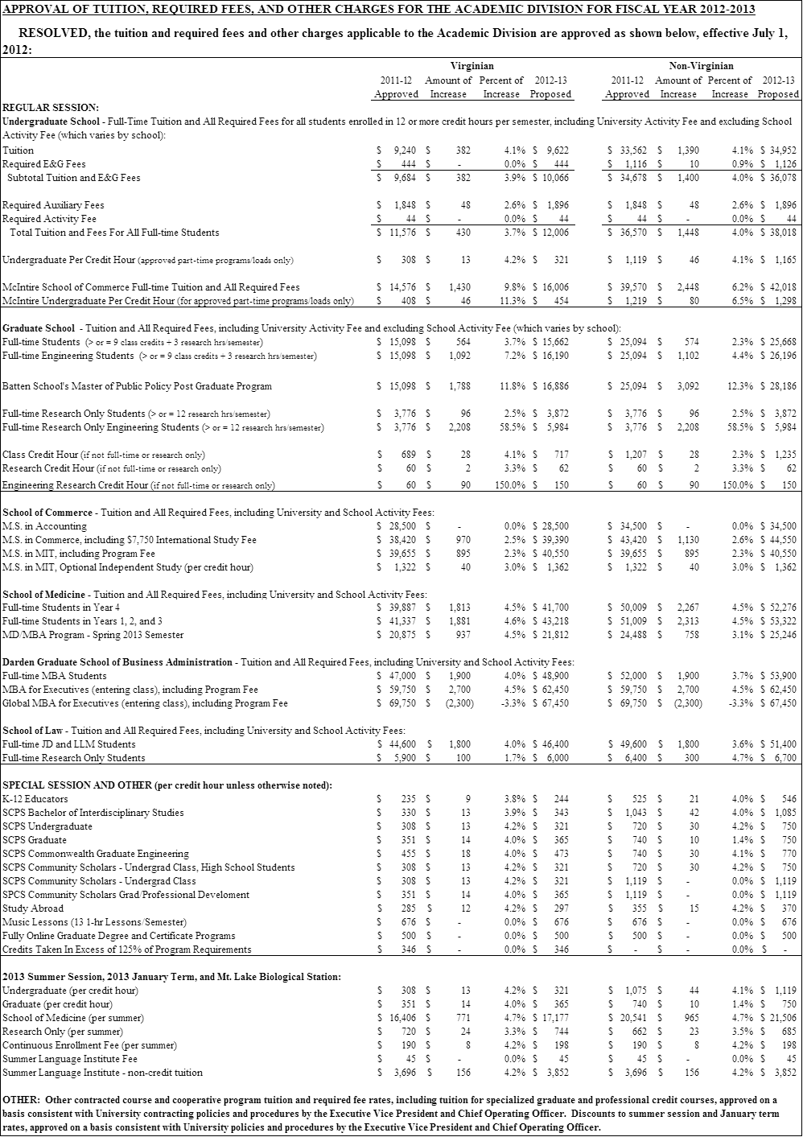

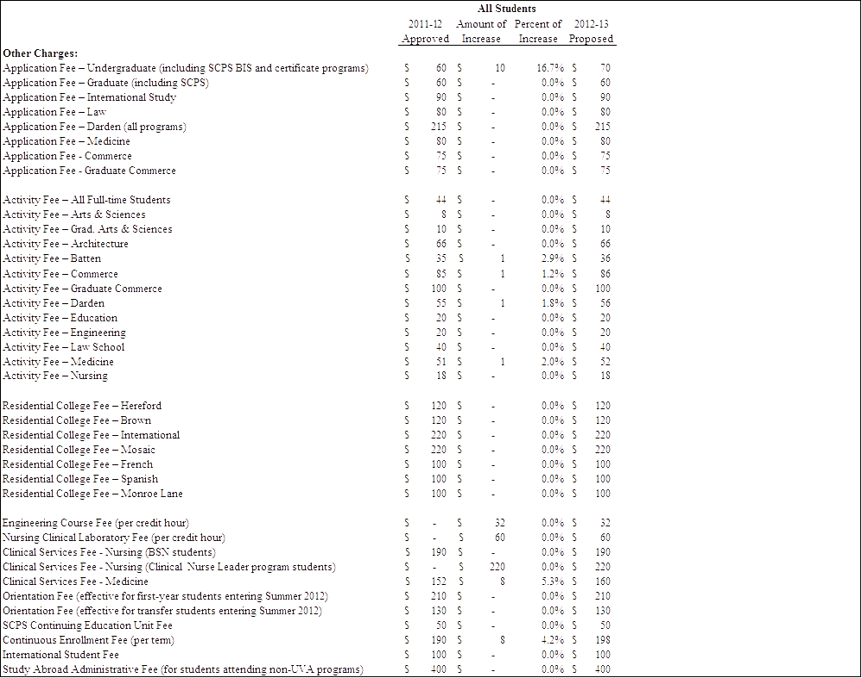





**On motion, the following resolution was approved by the Board of Visitors:**

**APPROVAL OF TUITION, FEES AND OTHER CHARGES FOR THE ACADEMIC DIVISION AND THE COLLEGE AT WISE FOR FISCAL YEAR 2012-2013**

**RESOLVED, the approval of tuition and fees for the academic division and the University of Virginia’s College at Wise for the 2012-2013 academic year and summer session is provisional, subject to final action by the General Assembly on a state budget; and**

**RESOLVED FURTHER, the Executive Committee of the Board is delegated the authority to finalize a tuition and fee structure for the 2012-2013 fiscal year after a state budget is approved by the General Assembly and the Governor should the rates outlined in the resolution dated April 13, 2012 change.**

**- - - - - - - - - -**

**The full Board meeting was adjourned at 4:40 p.m.**

**Respectfully submitted,**



**Susan G. Harris**

**Secretary**

**SGH:lah**

**These minutes have been posted to the University of Virginia’s**

**Board of Visitors website.**

**http://www.virginia.edu/bov/publicminutes.html**