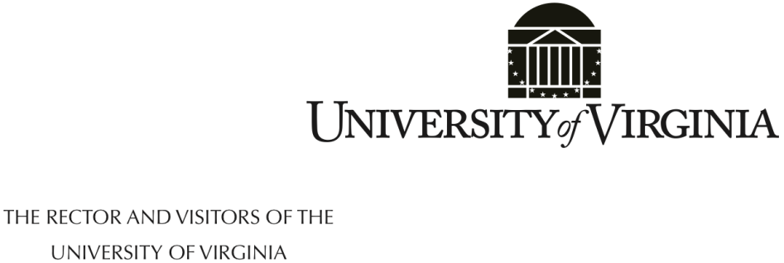

April 20, 2017

The Board of Visitors of the University of Virginia met, in open session, at 3:00 p.m. on Thursday, April 20, 2017, in the Board Room of the Rotunda. William H. Goodwin Jr., Rector, presided.

Present: Frank M. Conner III, Mark T. Bowles, Whittington W. Clement, Elizabeth M. Cranwell, Kevin J. Fay, John G. Macfarlane III, James B. Murray Jr., Nina J. Solenski, M.D., and Phoebe A. Willis

Daniel M. Meyers, Finance Committee Consulting Member, and Ms. Bryanna Miller, student representative to the Board for 2017-2018, were also present.

Participating by telephone: Mr. DePasquale participated from 201 North Union Street, Suite 300, Alexandria VA 22314. Mr. Genovese participated from 4931 Bonita Bay Boulevard, Unit 1003, Bonita Springs FL 34134. Mr. Griffin participated from Blue Ridge Capital, 660 Madison Avenue, 20th Floor, New York NY 10065. Dr. Lateef participated from the Main Lobby of the Kentucky Exposition Park, 937 Phillips Lane, Louisville, Kentucky 40209. Mr. Walker participated from 15 Central Park West, Apt 14D, New York NY 10023. Mr. Clement planned to participate by telephone, but was able to attend in person. Because the meeting notice listed him as participating by telephone, a line was open in his office at Hunton & Williams LLP, Riverfront Plaza, East Tower, 951 East Byrd Street, Richmond VA 23219.

Absent: L.D. Britt, M.D., Barbara J. Fried, Tammy S. Murphy, and James V. Reyes.

Also present were Teresa A. Sullivan, Patrick D. Hogan, Thomas C. Katsouleas, Melody S. Bianchetto, Nicole Ferretti, Susan G. Harris, W. Thomas Leback, Megan K. Lowe, Debra D. Rinker, Nancy A. Rivers, Roscoe C. Roberts, and Colette Sheehy. Donna P. Henry, Simeon E. Ewing, and Huda Aden from the College at Wise participated by telephone.

The Rector opened the meeting and gave the floor to Mr. Murray. Mr. Murray said the University’s proposed 2017-2018 tuition rates for undergraduates represent a 2.2% increase for in-state students and a 3.5% increase for out-of-state. For the University of Virginia’s College at Wise, the increase is 3.0% for in-state and out-of-state undergraduates.

Ms. Sullivan said when setting tuition the University balances the need to meet unavoidable cost increases with keeping education affordable. The proposed increases at the University total $288 a year for first year in-state students and less for returning students. The increase at the College at Wise is $156. There will be budget constraints because state budget cuts will exceed the funding generated by the tuition increases.

Mr. Hogan said the rate increases were determined in consultation with the president, provost, deans, and business unit leaders. He noted the public interest in the cost of higher education, and stated the University is committed to accessibility and affordability. The University understands the challenges facing the legislature and appreciates the support it receives. Several state institutions have set their 20I7-2018 tuition rates. Virginia Tech will increase its rate by 2.9%, William & Mary by 3.5%, and James Madison University by 6%. Christopher Newport University announced a 3.9% increase in its cost of attendance. Across the state, the average tuition increase will be in the 3.0% to 3.5% range. Mr. Hogan said the University is committed to running an efficient operation and is focused on finding permanent funding sources for key operating commitments. He asked Ms. Bianchetto to provide details on the proposed rates.

Ms. Bianchetto said the University’s preliminary and final tuition proposals were vetted with student representatives. The University’s operating challenges include a $7.03 million permanent general fund reduction, the University’s $5.7 million share of state authorized salary increases for faculty and staff, $3.1 million for supplemental faculty increases, $935,000 in unfunded federal compliance, and $7.8 million for IT security enhancements, leases, and periodicals. These would have resulted in a 7.7% increase in undergraduate tuition. To reduce the tuition increase, the University is pursuing efficiency savings including the planned $21.25 million savings from Organizational Excellence, reviewing planned compensation increases for 2017-2018, deferring compliance enhancements, and deferring several budget items to a future year.

Ms. Bianchetto reviewed measures the University adopted to address affordability, the most important concern raised during the student meetings. These include AccessUVA, a guaranteed tuition plan, Cornerstone Grants, and the Bicentennial Scholars Fund. Two-thirds (67%) of University students graduate with no debt. The average debt for the remaining students is $20,500, $5,000 below the national average. Mr. Meyers said the most recent national student debt figures show the average UVA debt at $7,000 below the national average.

Dr. Solenski noted the importance of attracting and retaining top faculty, and expressed concern about the impact of budget constraints on planned faculty salary increases. Mr. Goodwin referenced the Board’s goal of raising the faculty salary average to 20th among American Association of Universities (AAU) institutions. Mr. Hogan said that in the past year the University went from 29th to 28th. When the goal was set, the University was 34th or 35th. Mr. Katsouleas said the 2.2% tuition increase will result in lower salary increases than had been planned when a 3.5% increase was under consideration. Mr. Hogan said the 2.2% tuition increase results in a loss of $1.3 million. Mr. Goodwin suggested that $1.3 million may be found elsewhere given the size of the University’s budget. Ms. Sullivan said there will be raises, but they won’t be as large as originally planned, and suggested the option of a one-time bonus.

Ms. Bianchetto reviewed data for a 25-year period (FY 1991 to FY 2015), a 20-year period (FY 1996 to FY 2015), and a 15- year period (FY 2001 to FY 2015). The 15- and 25- year periods show that the University’s cumulative undergraduate tuition increases on a per-student basis are less than the amount of the decreases in state funding. The 20-year period shows tuition increases slightly higher than state budget cuts. Mr. Goodwin said when inflation is considered, tuition increases have been less than the reductions in state funding. Ms. Bianchetto reviewed a net tuition revenue analysis for FY 2017. It shows that out-of-state students provided 62.5% of the tuition revenue while constituting 31.2% of the undergraduate enrollment. When state funding for in-state students is included, the out-of-state student contribution is 45.5%.

The projected 2017-2018 cost of attendance for in-state students is $31,272, a 2.3% increase over 2016-2017. For out-of-state students the cost is $63,050, a 3.0% increase. For students on aid, the average loan after grants is projected to be $3,142 for in-state students and $6,321 for out-of-state students. A comparison of first year 2016-2017 undergraduate tuition with national public peers shows the University had the second highest in-state and out-of-state tuition. A comparison of the 2016-2017 weighted average undergraduate in-state tuition at Virginia public institutions shows the University had the second highest rate. When non Educational & General (E&G) fees are included, the University has the third highest rate.

Ms. Bianchetto reviewed the tuition-setting context for the College at Wise. It is addressing base budget instability; the quality and stability of its faculty; affordability and student debt burden; and state-authorized salary increases. Continuing investments are being made in Title IX and compliance, regional economic development, and accreditation initiatives to strengthen its market position. The proposed tuition increase is 3.0% or $156 for in-state undergraduates, and 3.0% or $638 for out-of-state undergraduates. Mandatory fees for in-state students increase by 3.0% or $130. The increase for out-of-state students is 3.4% or $168. The total cost of attendance for in-state students is $20,139, a 1.1% increase over 2016-2017. For out-of-state students, the cost is $37,369, a 2.0% increase. When compared to peers in the Council of Public Liberal Arts Colleges, the College’s in-state tuition and fees are in the middle. An analysis of the 2016-2017 weighted average undergraduate in-state tuition and non E&G fees at Virginia public institutions shows the College had the third lowest rate. A declining enrollment is a major challenge. Between fall 2014 and fall 2017, there was a decline of 200 FTE.

Mr. Murray said February data from the Bureau of Labor Statistics shows a 2.7% inflation rate, which is above the University’s proposed increases in tuition and the total cost of attendance for in-state students. He reviewed actions taken by the Board to address affordability, including the Cornerstone Grants program and the Bicentennial Scholars Fund. He also noted the University’s decision to add 100 additional in-state students.

On motion duly made and seconded, the members of the Board who were present and those participating by telephone approved the following resolutions unanimously by a roll call vote. Voting in the affirmative were Mr. Goodwin, Mr. Conner, Mr. Bowles, Mr. Clement, Ms. Cranwell, Mr. DePasquale, Mr. Fay, Mr. Genovese, Mr. Griffin, Dr. Lateef, Mr. Macfarlane, Mr. Murray, and Mr. Walker.





_ _ _ _ _ _ _ _ _ _

The Rector adjourned the meeting at 3:50 p.m.

Respectfully submitted,

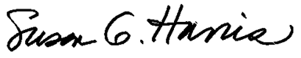

Susan G. Harris

Secretary

SGH:wtl

These minutes have been posted to the University of Virginia’s Board of Visitors website.

<http://www.virginia.edu/bov/publicminutes.html>