Figure 6. Rank of additions among stocks outside the OMXSB index, by year
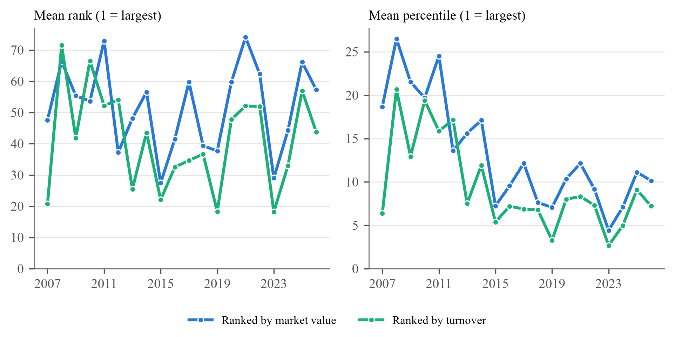
Note. For each addition we rank all stocks on the Nasdaq Stockholm main market that are not OMXSB members on the last trading day of the month before the announcement, by market value (the variable in Greenwood and Sammon, 2025, Figure 8) and by turnover over the previous six months (the variable Nasdaq uses to select OMXSB members). Rank 1 is the largest stock. Left: mean rank by year of the effective date; right: the same rank divided by the number of ranked stocks, in per cent, since the number of listed stocks roughly doubles over the sample (316 to 709 stocks). 284 additions, of which 270 could be ranked. Market value from LSEG for the whole company. Descriptive; no inference.

