Figure 7. Bid-ask spreads, by year
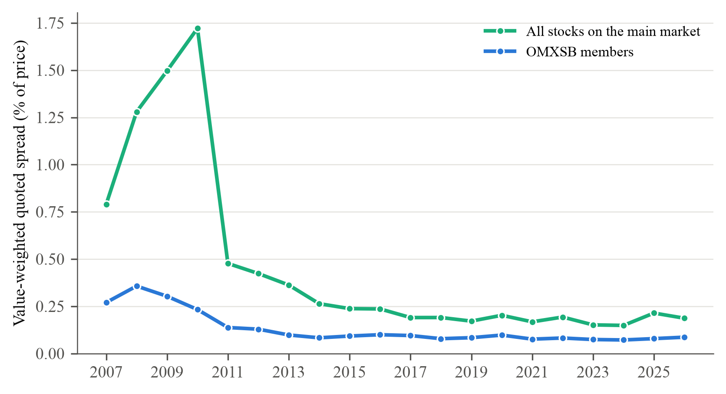
Note. Value-weighted average relative quoted spread, (ask − bid) / midpoint at the close in per cent, by calendar year, for OMXSB members and for all stocks in the price panel of the Nasdaq Stockholm main market (on average 327 to 734 stocks with a quote). Observations above 20 per cent are dropped. Greenwood and Sammon (2025, Figure 9) use the effective spread and the implementation shortfall of index funds; we have only closing quotes. Regressing the total-window CAR of each event on the OMXSB spread in its year gives a slope of 39.64*** [16.35, 79.54] for additions (256 events) and −26.09* [−52.85, 4.75] for deletions (215 events), in percentage points of CAR per percentage point of spread. Inference for the slopes: restricted wild cluster bootstrap by review (Rademacher weights if G ≥ 12, Webb six-point weights otherwise; 9,999 draws), where G is the number of reviews; brackets are 95 per cent confidence intervals obtained by inverting the bootstrap test: they contain every value not rejected at the 5 per cent level; ∞ means that no value within 20 standard errors of the estimate is rejected; stars from the same draws: * p < 0.10, ** p < 0.05, *** p < 0.01.

