Figure 8. Trading volume around the effective date
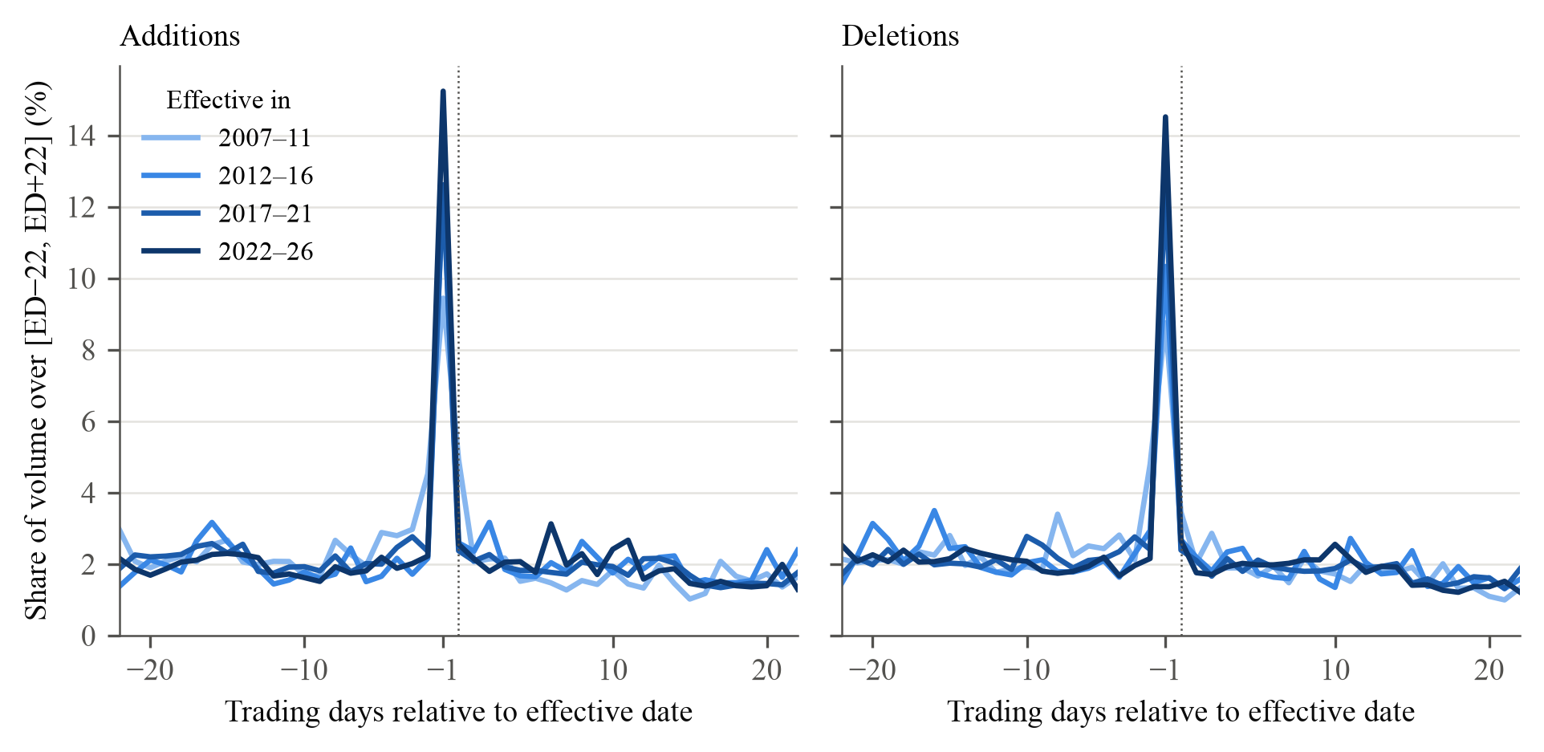
Note. Share of the number of shares traded over the 45 trading days from ED−22 to ED+22 that trades on each day, mean over events by five-year period of the effective date, in per cent. ED is the effective date (dotted line); index funds trade at the close on ED−1, the last day before the change takes effect. Same events as Table 2. As discussed in Greenwood and Sammon (2025, Section II.D). The share traded on ED−1 rises from 9.44 to 15.24 per cent for additions (difference 5.79*** [3.30, 8.84] percentage points) and from 8.75 to 14.52 per cent for deletions (5.76*** [3.26, 8.38]). Inference for the differences: restricted wild cluster bootstrap by review (Rademacher weights if G ≥ 12, Webb six-point weights otherwise; 9,999 draws), where G is the number of reviews; brackets are 95 per cent confidence intervals obtained by inverting the bootstrap test: they contain every value not rejected at the 5 per cent level; ∞ means that no value within 20 standard errors of the estimate is rejected; stars from the same draws: * p < 0.10, ** p < 0.05, *** p < 0.01.

