Figure 3. Net purchases by index trackers and the index effect
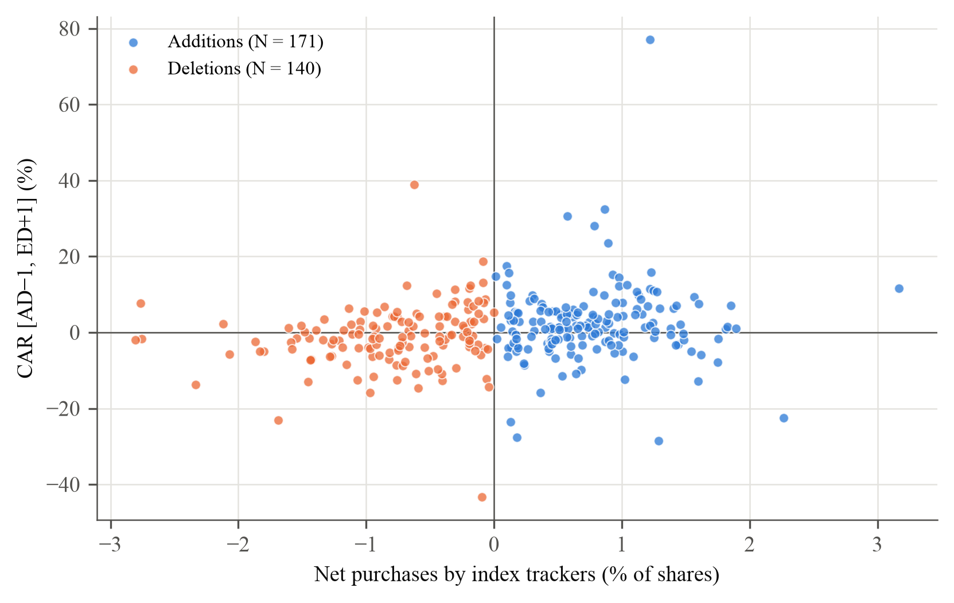
Note. Each point is one addition or deletion with fund holdings data and no share split between the fund reports (311 events, 2009–2026). Horizontal axis: net purchases by OMXSB index trackers including variants, in per cent of shares outstanding (negative for deletions). Vertical axis: cumulative abnormal return from the day before the announcement to the day after the effective date, in per cent. As in Greenwood and Sammon (2025, Figure 3). Descriptive; the multiplier estimates are in Table 5. Deletions caused by a takeover, merger, distressed share issue or a large change in shares outstanding (19 events) are excluded from the fund demand sample.

