Figure 4. Share of the OMXSB index owned by index trackers, by year
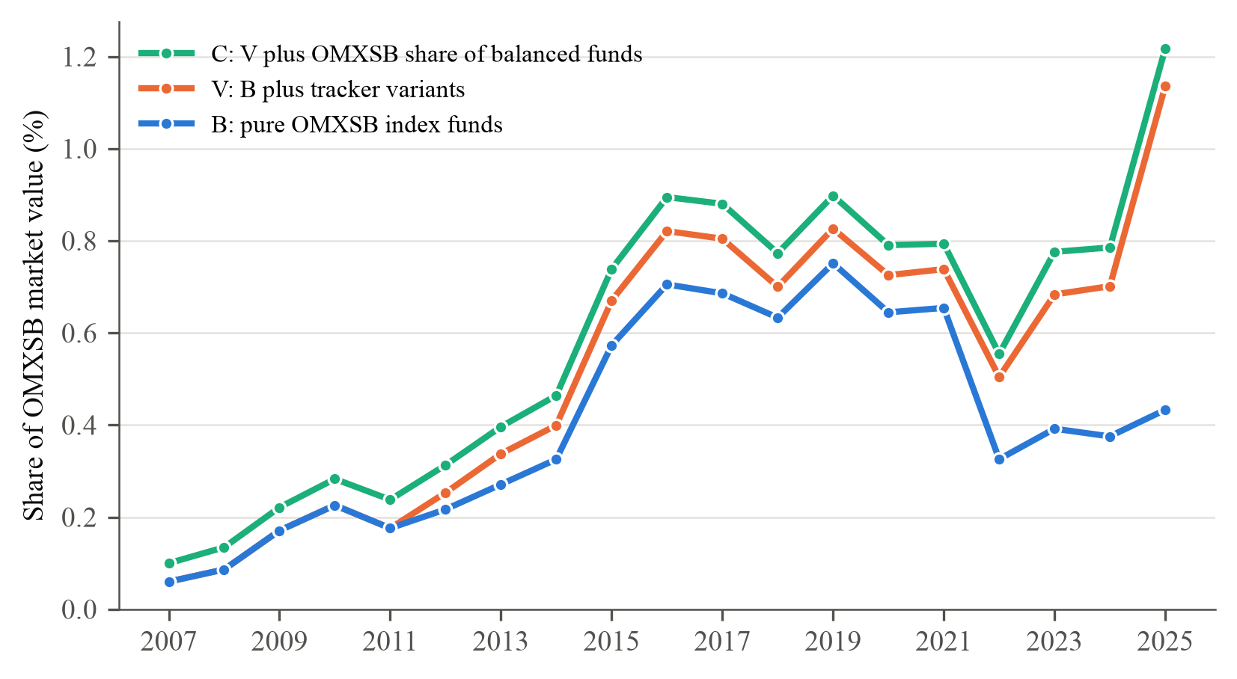
Note. Assets of funds that track the OMXSB index at the end of each year (SHoF fund database), divided by the market value of the OMXSB index. The three lines are cumulative: B counts pure OMXSB index funds, V adds tracker variants, and C adds the OMXSB share of balanced funds, weighted by the OMXSB weight in their benchmark (Finansinspektionen). A fund counts only while its mandate documents show it tracking the index. Comparable to Greenwood and Sammon (2025, Figure 5). 2007–2025. Descriptive; no inference.

