Figure 1. Net buying and selling by OMXSB index trackers, by year
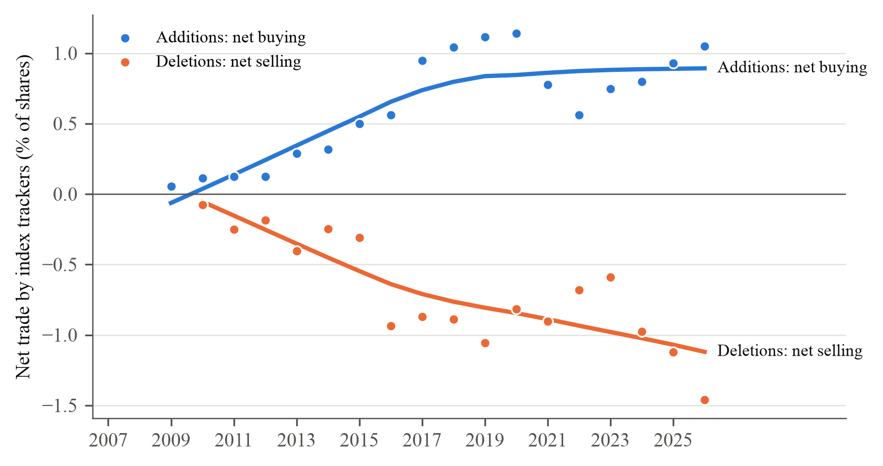
Note. Net buying (additions) and net selling (deletions) by funds that track the OMXSB index, including tracker variants: the change in shares held between the last fund report before the announcement and the first report after the effective date, divided by shares outstanding (multiplied by 100). Fund holdings from LSEG Lipper; events with a share split between the two reports are excluded. Each point is the equal-weighted mean across events by year of the announcement; years without fund data are left out (312 events in total). The line is a LOWESS fit with bandwidth 0.8, as in Greenwood and Sammon (2025, Figure 1). Descriptive; no inference. Deletions caused by a takeover, merger, distressed share issue or a large change in shares outstanding (19 events) are excluded from the fund demand sample.

Table 1. Abnormal returns around OMXSB additions and deletions, by year, 2007–2026
 | Additions |  |  |  | Deletions
Year | N | Ann. | Eff. | Total | N | Ann. | Eff. | Total
2007 | 2 | −0.53 | 5.99 | 7.39 | 6 | 0.28 | −4.87 | −7.22
2008 | 6 | 0.07 | 1.46 | 7.27 | 4 | −0.42 | −2.37 | −15.24
2009 | 9 | 2.41 | 3.57 | 13.87 | 7 | 2.89 | 4.18 | −4.57
2010 | 5 | −0.15 | 3.17 | 13.39 | 6 | −1.95 | −2.93 | −6.62
2011 | 11 | 1.35 | −2.98 | 2.82 | 10 | −3.41 | 2.42 | −2.72
2012 | 12 | 2.23 | −0.84 | −1.70 | 20 | −0.94 | 1.01 | 3.98
2013 | 8 | 5.42 | 1.70 | 8.85 | 6 | −2.93 | −0.69 | −7.78
2014 | 7 | 2.28 | −6.18 | −7.91 | 6 | −3.17 | −8.45 | −14.82
2015 | 11 | 1.92 | 1.48 | 4.19 | 9 | −2.34 | −0.03 | −4.41
2016 | 16 | −0.40 | −0.98 | −1.73 | 5 | −0.43 | −0.85 | −3.59
2017 | 15 | 1.83 | −1.58 | 6.15 | 8 | −0.96 | 2.13 | 0.13
2018 | 15 | 0.69 | 1.22 | 1.16 | 11 | −3.47 | −0.75 | −1.17
2019 | 10 | 0.25 | 1.24 | 4.23 | 14 | −0.07 | 0.92 | 1.56
2020 | 25 | −3.31 | 2.11 | 2.48 | 13 | −2.25 | 2.71 | 1.90
2021 | 17 | 1.67 | −1.69 | 1.16 | 15 | −3.35 | −0.04 | −4.06
2022 | 29 | 1.04 | −0.64 | 0.74 | 21 | −2.98 | −0.76 | −1.37
2023 | 13 | −2.00 | 0.91 | −0.87 | 17 | 1.17 | −0.09 | 0.98
2024 | 17 | 1.74 | −0.65 | 2.34 | 13 | 0.40 | −0.24 | −0.45
2025 | 17 | 1.88 | −1.07 | 1.61 | 12 | −0.30 | −1.71 | −1.54
2026 | 11 | 3.56 | 2.53 | 4.82 | 12 | −1.02 | −4.26 | −6.55
Period means
2007–11 | 33 | 0.96 | 1.16 | 8.52** | 33 | −0.77 | −0.09 | −6.16***
2012–16 | 54 | 1.87** | −0.73 | 0.25 | 46 | −1.71** | −0.85 | −2.47
2017–21 | 82 | −0.16 | 0.38 | 2.85*** | 61 | −2.09** | 0.89 | −0.43
2022–26 | 87 | 1.20 | −0.09 | 1.50* | 75 | −0.71 | −1.23 | −1.53
2007–16 | 87 |  |  | 3.39* | 79 |  |  | −4.01
2017–26 | 169 |  |  | 2.15*** | 136 |  |  | −1.04
Note. Mean cumulative abnormal return in per cent (stock total return minus the OMX Stockholm Benchmark Gross Index, .OMXSBGI) by year of the effective date. Ann.: [AD−1, AD+1]; Eff.: [ED−1, ED+1]; Total: [AD−1, ED+1], where AD is the announcement date and ED the effective date. N counts events with a complete total window. Each year has at most two reviews, so yearly means carry no standard errors. Period rows: the same means pooled over five-year periods and decades, with stars from a restricted wild cluster bootstrap by review (Rademacher weights if G ≥ 12, Webb six-point weights otherwise; 9,999 draws), where G is the number of reviews: * p < 0.10, ** p < 0.05, *** p < 0.01. Confidence intervals in Table 2. 2007 contains only the July and December 2007 reviews, 2026 only the June review.

Table 2. Abnormal returns around OMXSB additions and deletions by period, 2007–2026
 | 2007–11 | 2012–16 | 2017–21 | 2022–26
Panel A. Additions
Announcement [AD−1, AD+1] | 0.96 | 1.87** | −0.16 | 1.20
 | [−0.82, 2.98] | [0.07, 3.93] | [−3.05, 1.88] | [−0.39, 2.68]
Effective [ED−1, ED+1] | 1.16 | −0.73 | 0.38 | −0.09
 | [−1.74, 4.00] | [−2.96, 1.70] | [−1.45, 1.84] | [−1.17, 1.25]
Total [AD−1, ED+1] | 8.52** | 0.25 | 2.85*** | 1.50*
 | [2.46, 14.74] | [−3.73, 5.30] | [1.26, 5.20] | [−0.10, 3.22]
Events | 33 | 54 | 82 | 87
Reviews | 9 | 10 | 10 | 9
Panel B. Deletions
Announcement [AD−1, AD+1] | −0.77 | −1.71** | −2.09** | −0.71
 | [−3.65, 1.84] | [−3.24, −0.86] | [−3.66, −0.58] | [−2.27, 0.94]
Effective [ED−1, ED+1] | −0.09 | −0.85 | 0.89 | −1.23
 | [−4.72, 3.65] | [−6.55, 0.86] | [−0.26, 2.22] | [−2.90, 0.40]
Total [AD−1, ED+1] | −6.16*** | −2.47 | −0.43 | −1.53
 | [−11.41, −2.10] | [−14.42, 3.60] | [−3.43, 3.02] | [−4.24, 0.89]
Events | 33 | 46 | 61 | 75
Reviews | 9 | 10 | 10 | 9
Panel C. Total window [AD−1, ED+1], by decade
 | 2007–16 | 2017–26 | Difference
Additions | 3.39* | 2.15*** | −1.24
 | [−0.25, 7.53] | [1.01, 3.39] | [−5.26, 2.54]
Events | 87 | 169
Deletions | −4.01 | −1.04 | 2.97
 | [−9.48, 1.32] | [−2.88, 0.90] | [−2.94, 8.60]
Events | 79 | 136
Note. Cumulative abnormal return in per cent: the stock's total return minus the return on the OMX Stockholm Benchmark Gross Index (.OMXSBGI), summed over the window. AD is the announcement date and ED the effective date. Each cell gives the mean across events. Inference: restricted wild cluster bootstrap by review (Rademacher weights if G ≥ 12, Webb six-point weights otherwise; 9,999 draws), where G is the number of reviews. Brackets: 95 per cent confidence intervals obtained by inverting the bootstrap test: they contain every value not rejected at the 5 per cent level; ∞ means that no value within 20 standard errors of the estimate is rejected. Stars come from the same bootstrap draws: * p < 0.10, ** p < 0.05, *** p < 0.01. Deletions keep their sign. Events are counted for the total window; the announcement and effective windows include up to three more events per period. Difference in Panel C: 2017–26 minus 2007–16, same inference. Sample: 471 changes in 39 semi-annual reviews with effective dates from 2 July 2007 to 1 June 2026 (Table A1). Ten deletions that follow a takeover offer, a merger or acquisition by the firm, a delisting application or a delisting within 100 trading days are excluded, as in Greenwood and Sammon (2025).

Figure 2. Average index effect by year
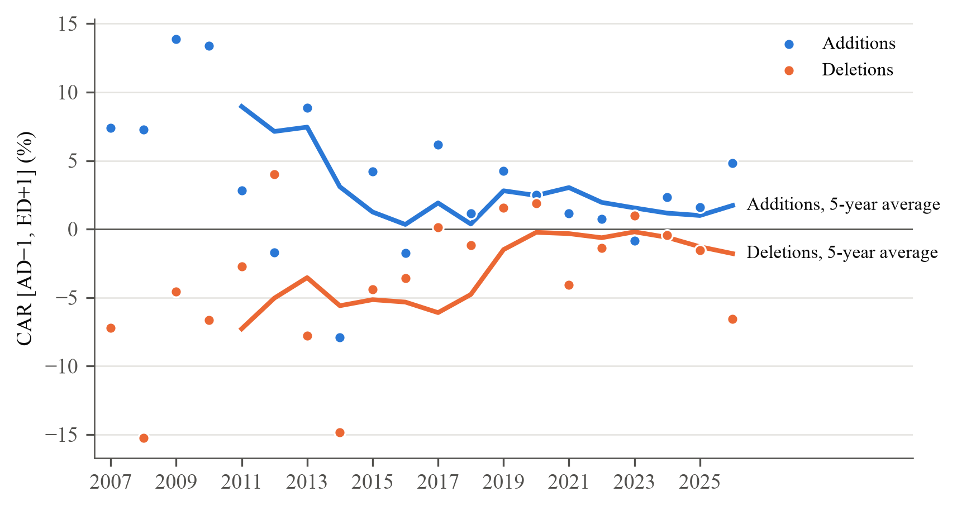
Note. Points: mean cumulative abnormal return from the day before the announcement to the day after the effective date ([AD−1, ED+1], in per cent, stock total return minus .OMXSBGI) by year of the effective date, as in Table 1. Lines: trailing 5-year moving averages of the yearly means (Greenwood and Sammon, 2025, Figure 2, use ten years over a 40-year sample). Descriptive; for inference see Table 2.

Figure 3. Net purchases by index trackers and the index effect
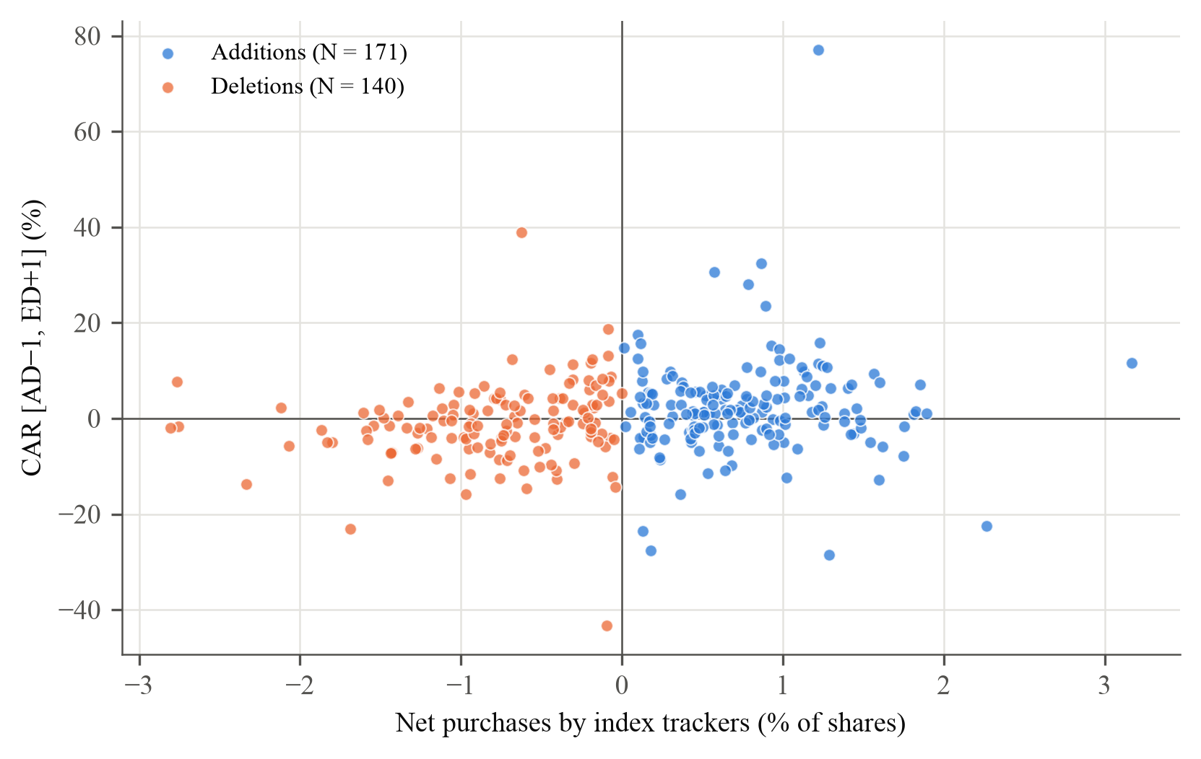
Note. Each point is one addition or deletion with fund holdings data and no share split between the fund reports (311 events, 2009–2026). Horizontal axis: net purchases by OMXSB index trackers including variants, in per cent of shares outstanding (negative for deletions). Vertical axis: cumulative abnormal return from the day before the announcement to the day after the effective date, in per cent. As in Greenwood and Sammon (2025, Figure 3). Descriptive; the multiplier estimates are in Table 5. Deletions caused by a takeover, merger, distressed share issue or a large change in shares outstanding (19 events) are excluded from the fund demand sample.

Table 3. Cumulative abnormal returns, controlling for characteristics
 | CAR additions (%) |  |  | CAR deletions (%)
 | (1) | (2) | (3) | (4) | (5) | (6)
Turnover |  | 6.23 |  |  | −0.68
 |  | [−4.26, 11.25] |  |  | [−2.09, 0.26]
Size |  | 2.34* |  |  | −2.48
 |  | [−0.20, 8.12] |  |  | [−9.15, 4.13]
Arbitrage risk (WZ) |  | −0.09 |  |  | 0.09
 |  | [−0.40, 0.08] |  |  | [−0.19, 0.47]
Analyst coverage |  | −0.23 |  |  | 0.25
 |  | [−0.66, 0.18] |  |  | [−0.06, 0.60]
2007–11 | 8.52** | 10.12** | 8.97** | −6.16** | −6.23** | −5.66**
 | [2.48, 15.02] | [3.29, 16.34] | [1.89, 15.82] | [−13.35, −2.06] | [−13.17, −0.63] | [−14.29, −0.61]
2012–16 | 0.25 | 0.55 | 0.74 | −2.47 | −1.42 | −1.37
 | [−3.74, 5.88] | [−3.45, 5.22] | [−4.07, 6.85] | [−14.33, 3.60] | [−12.64, 3.66] | [−13.45, 3.98]
2017–21 | 2.85*** | 2.33** | 2.64*** | −0.43 | −0.29 | −0.77
 | [1.28, 5.30] | [0.49, 5.12] | [0.85, 5.18] | [−3.48, 3.13] | [−3.26, 3.92] | [−4.02, 3.68]
2022–26 | 1.50* | 1.60*** | 1.59* | −1.53 | −1.95 | −1.83
 | [−0.13, 3.28] | [0.50, 2.62] | [0.03, 3.27] | [−4.29, 0.96] | [−4.41, 0.42] | [−4.18, 0.50]
2007–11 − 2022–26 | 7.03** | 8.52** | 7.37** | −4.62** | −4.28 | −3.83
 | [1.05, 13.26] | [2.12, 14.72] | [1.07, 13.73] | [−9.79, −0.22] | [−10.79, 1.18] | [−10.70, 1.38]
Events | 256 | 237 | 237 | 215 | 185 | 185
Reviews | 38 | 37 | 37 | 38 | 38 | 38
Controls | No | Yes | No | No | Yes | No
Note. Following Greenwood and Sammon (2025, Table II), we regress the cumulative abnormal return over [AD−1, ED+1], in per cent, on dummies for the four five-year periods (by effective date), without and with controls, separately for additions and deletions. Deletions keep their sign. Controls, all measured before the announcement and demeaned: turnover is the stock's mean daily turnover (per cent of market value) over [AD−21, AD−1] minus the same measure for the whole main market; size is the stock's market value in per cent of the total market value of OMXSB members on the day before AD; arbitrage risk is the residual variance from a regression of daily returns on .OMXSBGI over [AD−250, AD−2] (Wurgler and Zhuravskaya, 2002); analyst coverage is the number of earnings forecasts in the consensus the month before AD. Columns (1) and (4) equal Table 2; columns (3) and (6) drop controls but keep only the events with all four controls, so that (2) and (3), and (5) and (6), compare the same events. Row "2007–11 − 2022–26": difference between the first and the last period coefficient. Inference: restricted wild cluster bootstrap by review (Rademacher weights if G ≥ 12, Webb six-point weights otherwise; 9,999 draws), where G is the number of reviews. Brackets: 95 per cent confidence intervals obtained by inverting the bootstrap test: they contain every value not rejected at the 5 per cent level; ∞ means that no value within 20 standard errors of the estimate is rejected. Stars from the same draws: * p < 0.10, ** p < 0.05, *** p < 0.01. Greenwood and Sammon report White standard errors and R²; we report the bootstrap instead.

Figure 4. Share of the OMXSB index owned by index trackers, by year
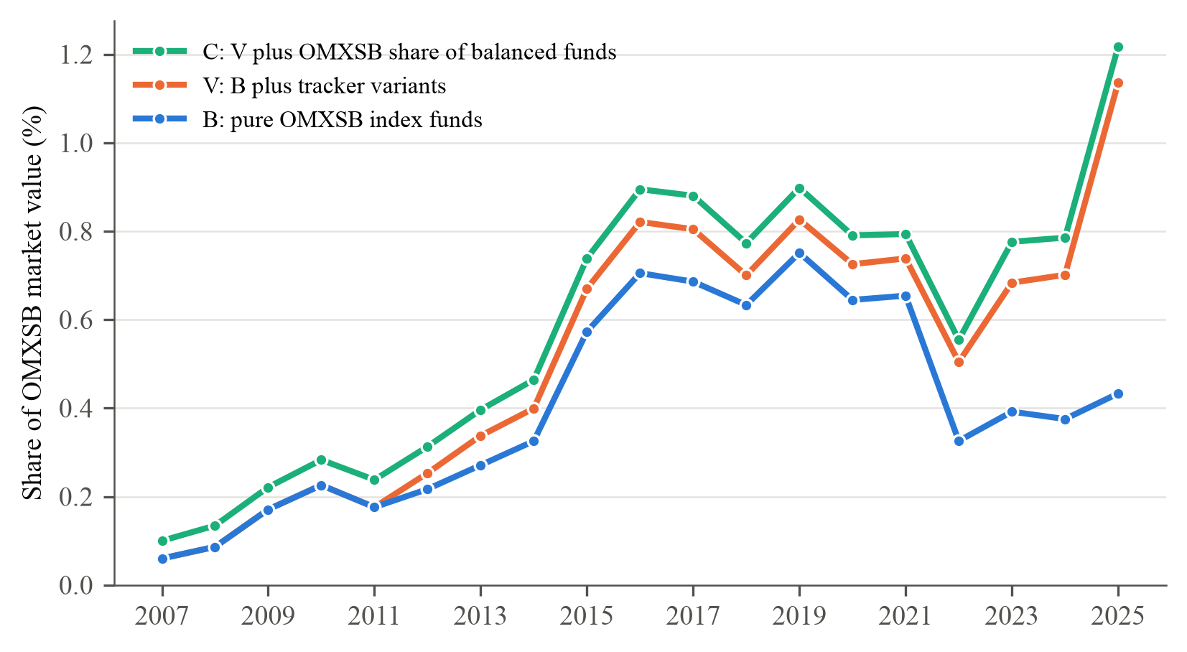
Note. Assets of funds that track the OMXSB index at the end of each year (SHoF fund database), divided by the market value of the OMXSB index. The three lines are cumulative: B counts pure OMXSB index funds, V adds tracker variants, and C adds the OMXSB share of balanced funds, weighted by the OMXSB weight in their benchmark (Finansinspektionen). A fund counts only while its mandate documents show it tracking the index. Comparable to Greenwood and Sammon (2025, Figure 5). 2007–2025. Descriptive; no inference.

Figure 5. Cumulative abnormal returns before and after the announcement
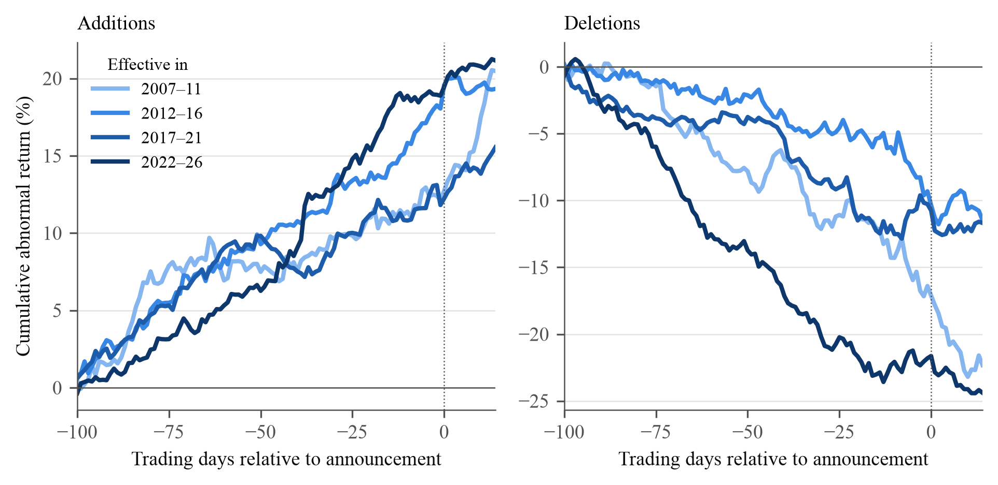
Note. Mean cumulative abnormal return (stock total return minus .OMXSBGI), in per cent, from 100 trading days before the announcement to day k, for k from −100 to +14, by five-year period of the effective date. Day 0 is the announcement date (dotted line). Deletions keep their sign. As in Greenwood and Sammon (2025, Figure 7), which pools by decade. Between 30 and 87 events per line and day. The values at day −1 are the [AD−100, AD−1] row of Table 4. Descriptive; inference in Table 4.

Table 4. Cumulative abnormal returns over pre-announcement windows
 | 2007–11 | 2012–16 | 2017–21 | 2022–26
Panel A. Additions
[AD−100, AD−1] | 12.11** | 18.05*** | 11.82*** | 18.88***
 | [4.56, 20.84] | [8.75, 30.20] | [5.29, 17.81] | [10.06, 29.14]
[AD−50, AD−1] | 3.22 | 7.02 | 1.99* | 12.34***
 | [−3.15, 9.65] | [−3.81, 19.38] | [−0.45, 4.27] | [3.22, 22.49]
[AD−20, AD−1] | 0.32 | 4.11* | 0.60 | 2.94**
 | [−6.41, 7.29] | [−0.73, 9.40] | [−2.19, 4.59] | [0.04, 6.31]
[AD−10, AD−1] | 0.16 | 2.76* | 1.09 | 0.10
 | [−2.81, 2.90] | [−0.52, 5.96] | [−0.52, 3.11] | [−2.56, 3.03]
Events | 36 | 54 | 83 | 84
Reviews | 9 | 10 | 10 | 9
Panel B. Deletions
[AD−100, AD−1] | −16.40** | −9.31** | −10.26* | −21.80***
 | [−30.85, −4.79] | [−38.54, −0.94] | [−19.08, 0.46] | [−30.34, −10.49]
[AD−50, AD−1] | −9.21** | −7.04* | −5.99* | −8.48**
 | [−17.94, −2.34] | [−21.69, 2.18] | [−11.28, 0.33] | [−14.54, −1.80]
[AD−20, AD−1] | −5.56* | −3.70 | 0.54 | −0.48
 | [−12.31, 0.25] | [−9.47, 4.49] | [−4.94, 6.78] | [−4.45, 5.17]
[AD−10, AD−1] | −2.51 | −2.61 | 1.60 | 0.73
 | [−9.70, 1.29] | [−5.83, 6.13] | [−2.90, 5.84] | [−1.51, 2.89]
Events | 33 | 46 | 62 | 74
Reviews | 9 | 10 | 10 | 9
Note. Mean cumulative abnormal return in per cent (stock total return minus .OMXSBGI) from n trading days before the announcement to the day before it, by five-year period of the effective date, as in Greenwood and Sammon (2025, Table IV). Deletions keep their sign. Greenwood and Sammon also report windows ending ten days after the announcement; those overlap the announcement and effective-date windows of Table 2 and are not shown. Events: events with returns over [AD−10, AD−1]; longer windows lose stocks with a short price history (31 to 84 events per cell). The paths behind the table are in Figure 5. Inference: restricted wild cluster bootstrap by review (Rademacher weights if G ≥ 12, Webb six-point weights otherwise; 9,999 draws), where G is the number of reviews. Brackets: 95 per cent confidence intervals obtained by inverting the bootstrap test: they contain every value not rejected at the 5 per cent level; ∞ means that no value within 20 standard errors of the estimate is rejected. Stars from the same draws: * p < 0.10, ** p < 0.05, *** p < 0.01.

Figure 6. Rank of additions among stocks outside the OMXSB index, by year
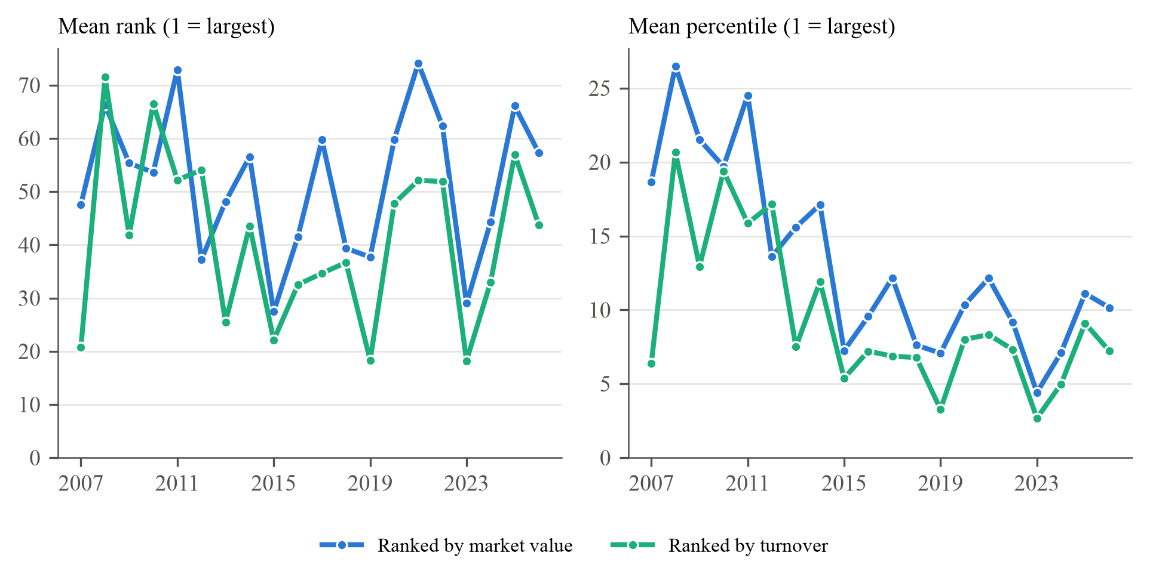
Note. For each addition we rank all stocks on the Nasdaq Stockholm main market that are not OMXSB members on the last trading day of the month before the announcement, by market value (the variable in Greenwood and Sammon, 2025, Figure 8) and by turnover over the previous six months (the variable Nasdaq uses to select OMXSB members). Rank 1 is the largest stock. Left: mean rank by year of the effective date; right: the same rank divided by the number of ranked stocks, in per cent, since the number of listed stocks roughly doubles over the sample (316 to 709 stocks). 284 additions, of which 270 could be ranked. Market value from LSEG for the whole company. Descriptive; no inference.

Table 5. Index effect decomposition: the multiplier M by period
 | Additions |  |  |  | Deletions
Period | N | CAR | D̄ | M | N | CAR | D̄ | M
Baseline window [AD−1, ED+1]
2007–11 | 8 | 8.78 | 0.10 | 84.97 | 7 | 0.19 | −0.20 | −0.93
 |  |  |  | [13.05, 196.38] |  |  |  | [−58.86, 31.41]
2012–16 | 27 | −1.94 | 0.42 | −4.67 | 25 | −2.07 | −0.33 | 6.28
 |  |  |  | [−19.22, 2.20] |  |  |  | [−9.76, 37.14]
2017–21 | 58 | 3.29 | 1.00 | 3.29 | 40 | −0.20 | −0.91 | 0.22
 |  |  |  | [1.00, 6.87] |  |  |  | [−4.52, 3.49]
2022–26 | 78 | 2.28 | 0.78 | 2.94 | 68 | −1.66 | −0.93 | 1.78
 |  |  |  | [0.80, 5.37] |  |  |  | [0.00, 3.18]
2007–16 | 35 | 0.51 | 0.34 | 1.49 | 32 | −1.58 | −0.30 | 5.23
 |  |  |  | [−9.99, 17.50] |  |  |  | [−9.27, 28.01]
2017–26 | 136 | 2.71 | 0.87 | 3.11 | 108 | −1.12 | −0.92 | 1.21
 |  |  |  | [1.44, 5.14] |  |  |  | [−1.00, 2.80]
Extended window [AD−20, ED+1]
2007–11 | 8 | 9.23 | 0.10 | 89.32 | 7 | −3.38 | −0.20 | 16.75
 |  |  |  | [60.57, 157.61] |  |  |  | [−46.06, 100.06]
2012–16 | 27 | −0.94 | 0.42 | −2.26 | 25 | −4.04 | −0.33 | 12.22
 |  |  |  | [−26.51, 14.25] |  |  |  | [−10.35, 55.79]
2017–21 | 58 | 4.69 | 1.00 | 4.69 | 40 | 0.56 | −0.91 | −0.62
 |  |  |  | [1.39, 9.11] |  |  |  | [−6.34, 6.16]
2022–26 | 75 | 6.62 | 0.79 | 8.34 | 67 | −2.91 | −0.94 | 3.09
 |  |  |  | [3.80, 13.27] |  |  |  | [−3.26, 7.30]
2007–16 | 35 | 1.39 | 0.34 | 4.03 | 32 | −3.90 | −0.30 | 12.88
 |  |  |  | [−14.10, 26.28] |  |  |  | [−7.41, 47.67]
2017–26 | 133 | 5.78 | 0.88 | 6.54 | 107 | −1.61 | −0.93 | 1.74
 |  |  |  | [3.51, 10.11] |  |  |  | [−2.96, 5.59]
Note. Following Greenwood and Sammon (2025, Table V), M is the mean cumulative abnormal return divided by the mean net demand of index trackers, CAR = M × D̄, estimated separately for additions and deletions and by period; the implied demand elasticity is ε = −1/M. CAR in per cent. D̄: mean net purchases (negative: net sales) by OMXSB index trackers including variants, in per cent of shares outstanding, between the fund report before the announcement and the report after the effective date. CAR keeps its sign (negative for deletions), so M is positive when prices move with index demand. Events with fund holdings data and no share split between the fund reports. Brackets: pairs cluster bootstrap by review (reviews drawn with replacement; 9,999 draws), percentile 95 per cent confidence intervals. No draw had a mean D of zero or below. Extended window: from 20 trading days before the announcement to the day after the effective date, as in their Table V. Deletions caused by a takeover, merger, distressed share issue or a large change in shares outstanding (19 events) are excluded from the fund demand sample.

Table 6. The multiplier M with and without controls
 | Additions |  | Deletions
 | No controls | Controls | No controls | Controls
M, 2007–11 | 84.97 | 79.68 | −0.93 | 2.17
 | [11.98, 157.95] | [2.94, 156.41] | [−16.84, 14.98] | [−12.48, 16.81]
M, 2012–16 | −4.67 | −1.96 | 6.28 | 4.49
 | [−12.91, 3.57] | [−9.55, 5.63] | [−15.51, 28.07] | [−16.87, 25.84]
M, 2017–21 | 3.29 | 2.88 | 0.22 | −0.02
 | [0.27, 6.31] | [−0.40, 6.16] | [−4.04, 4.47] | [−3.96, 3.92]
M, 2022–26 | 2.94 | 2.57 | 1.78 | 1.93
 | [0.24, 5.65] | [0.92, 4.21] | [−0.46, 4.02] | [−0.47, 4.33]
Differences
2007–11 − 2022–26 | 82.03 | 77.11 | −2.71 | 0.24
 | [−42.16, 140.25] | [−∞, 587.77] | [−∞, ∞] | [−∞, ∞]
2012–16 − 2022–26 | −7.61* | −4.53 | 4.50 | 2.56
 | [−18.81, 1.16] | [−14.24, 4.34] | [−14.44, 53.57] | [−14.14, 48.72]
2017–21 − 2022–26 | 0.35 | 0.31 | −1.57 | −1.95
 | [−4.13, 5.08] | [−3.61, 5.02] | [−7.37, 3.37] | [−7.67, 2.96]
Events | 171 | 163 | 140 | 131
Reviews | 32 | 31 | 29 | 29
Controls | No | Yes | No | Yes
Note. Following Greenwood and Sammon (2025, Table VI), we estimate CAR_i = Σ_k M_k · 1{period k} · D̄_k + b′X_i + e_i separately for additions and deletions, where CAR_i is the cumulative abnormal return over [AD−1, ED+1] in the direction of index trading, D̄_k is the mean net demand of OMXSB index trackers in period k (per cent of shares outstanding), and X_i holds turnover, size, the Wurgler–Zhuravskaya arbitrage-risk measure and analyst coverage, measured before the announcement and centred. Without controls M_k equals the ratio in Table 5. Brackets under M: 95 per cent confidence intervals from standard errors clustered by review and t critical values with G − 1 degrees of freedom (no bootstrap). Differences: restricted wild cluster bootstrap by review (Rademacher weights if G ≥ 12, Webb six-point weights otherwise; 9,999 draws), where G is the number of reviews; brackets are 95 per cent confidence intervals obtained by inverting the bootstrap test: they contain every value not rejected at the 5 per cent level; ∞ means that no value within 20 standard errors of the estimate is rejected; stars from the same draws: * p < 0.10, ** p < 0.05, *** p < 0.01. The 2007–11 period has few events with fund data, so its difference is imprecise. Deletions caused by a takeover, merger, distressed share issue or a large change in shares outstanding (19 events) are excluded from the fund demand sample.

Figure 7. Bid-ask spreads, by year
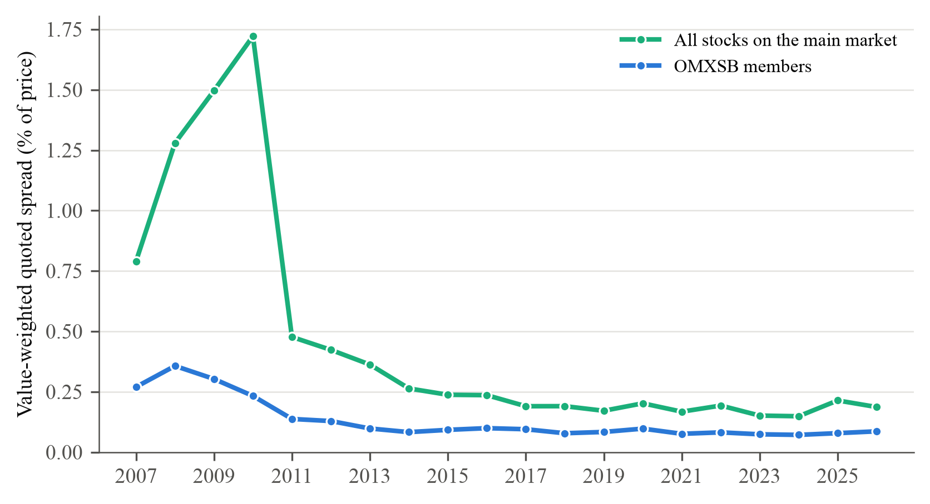
Note. Value-weighted average relative quoted spread, (ask − bid) / midpoint at the close in per cent, by calendar year, for OMXSB members and for all stocks in the price panel of the Nasdaq Stockholm main market (on average 327 to 734 stocks with a quote). Observations above 20 per cent are dropped. Greenwood and Sammon (2025, Figure 9) use the effective spread and the implementation shortfall of index funds; we have only closing quotes. Regressing the total-window CAR of each event on the OMXSB spread in its year gives a slope of 39.64*** [16.35, 79.54] for additions (256 events) and −26.09* [−52.85, 4.75] for deletions (215 events), in percentage points of CAR per percentage point of spread. Inference for the slopes: restricted wild cluster bootstrap by review (Rademacher weights if G ≥ 12, Webb six-point weights otherwise; 9,999 draws), where G is the number of reviews; brackets are 95 per cent confidence intervals obtained by inverting the bootstrap test: they contain every value not rejected at the 5 per cent level; ∞ means that no value within 20 standard errors of the estimate is rejected; stars from the same draws: * p < 0.10, ** p < 0.05, *** p < 0.01.

Figure 8. Trading volume around the effective date
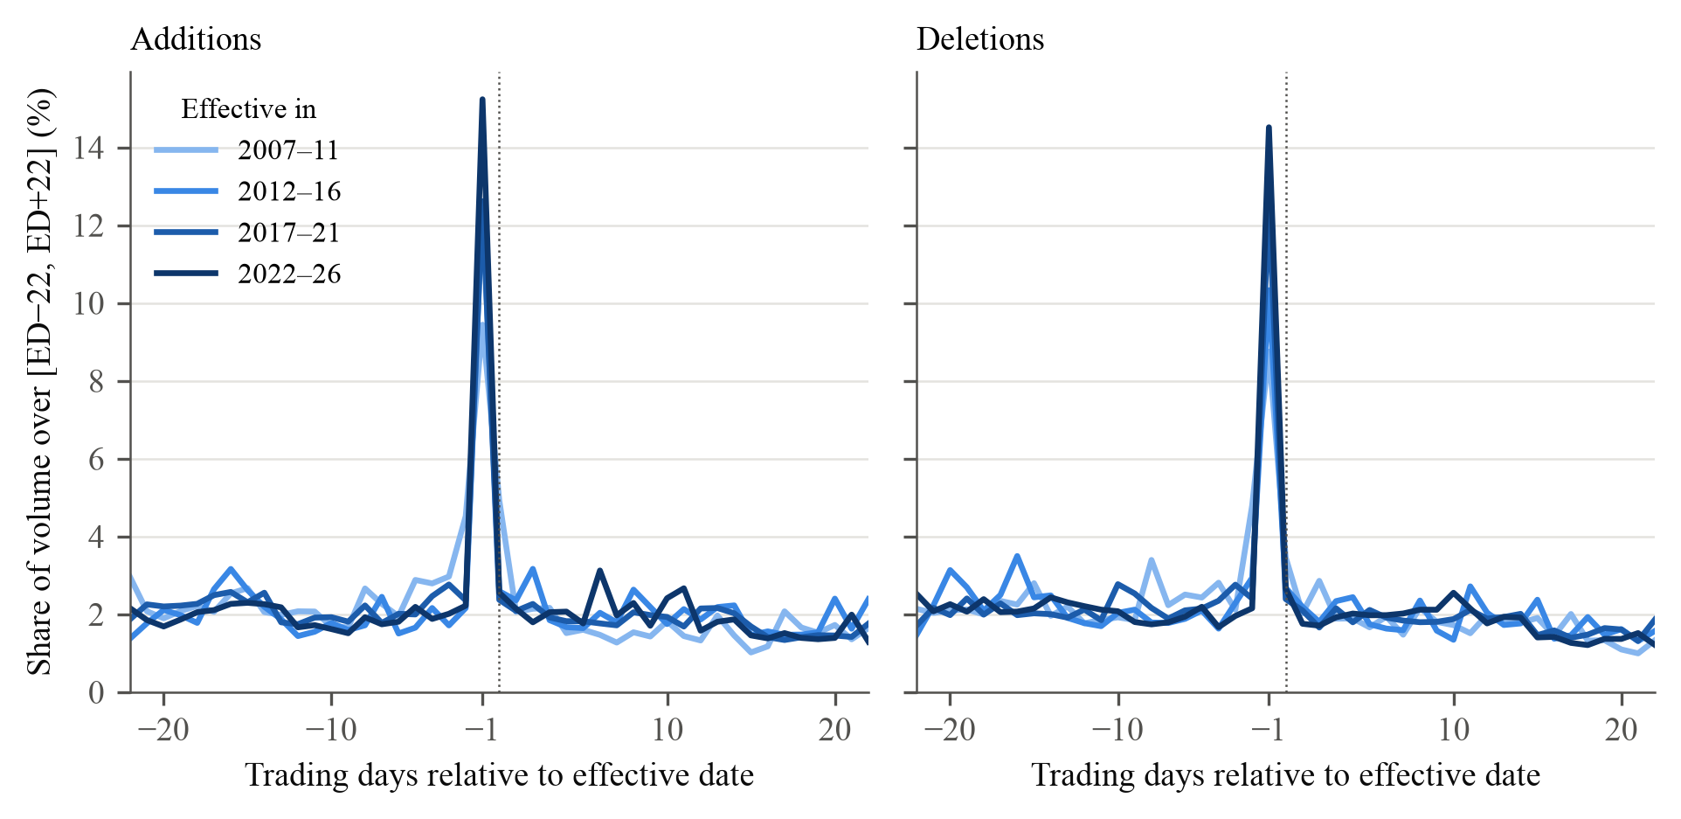
Note. Share of the number of shares traded over the 45 trading days from ED−22 to ED+22 that trades on each day, mean over events by five-year period of the effective date, in per cent. ED is the effective date (dotted line); index funds trade at the close on ED−1, the last day before the change takes effect. Same events as Table 2. As discussed in Greenwood and Sammon (2025, Section II.D). The share traded on ED−1 rises from 9.44 to 15.24 per cent for additions (difference 5.79*** [3.30, 8.84] percentage points) and from 8.75 to 14.52 per cent for deletions (5.76*** [3.26, 8.38]). Inference for the differences: restricted wild cluster bootstrap by review (Rademacher weights if G ≥ 12, Webb six-point weights otherwise; 9,999 draws), where G is the number of reviews; brackets are 95 per cent confidence intervals obtained by inverting the bootstrap test: they contain every value not rejected at the 5 per cent level; ∞ means that no value within 20 standard errors of the estimate is rejected; stars from the same draws: * p < 0.10, ** p < 0.05, *** p < 0.01.

Table 7. Net buying and selling by fund group around OMXSB index changes
 | 2007–11 | 2012–16 | 2017–21 | 2022–26 | 2017–26
Panel A. Additions: net buying
OMXSB index trackers | 0.10 | 0.42 | 1.00 | 0.78 | 0.87
 | [0.06, 0.15] | [0.19, 0.64] | [0.88, 1.12] | [0.52, 1.03] | [0.72, 1.03]
Balanced funds, OMXSB share | 0.00 | 0.03 | 0.09 | 0.07 | 0.08
 | [0.00, 0.00] | [−0.01, 0.06] | [0.07, 0.11] | [0.06, 0.09] | [0.07, 0.09]
Other passive funds | −0.09 | 0.27 | 0.38 | 0.43 | 0.41
 | [−0.57, 0.39] | [0.12, 0.41] | [0.17, 0.58] | [0.18, 0.67] | [0.26, 0.55]
Active funds | 0.92 | −0.03 | −0.42 | 0.03 | −0.16†
 | [−0.78, 2.63] | [−0.92, 0.87] | [−0.86, 0.03] | [−0.39, 0.45] | [−0.47, 0.16]
All funds | 0.94 | 0.68 | 1.04 | 1.30 | 1.19
 | [−1.14, 3.01] | [−0.49, 1.86] | [0.57, 1.52] | [0.54, 2.07] | [0.76, 1.63]
Events | 8 | 27 | 58 | 78 | 136
Reviews | 5 | 8 | 10 | 9 | 19
Panel B. Deletions: net selling
OMXSB index trackers | 0.20 | 0.33 | 0.90 | 0.93 | 0.92
 | [−0.27, 0.68] | [0.06, 0.60] | [0.80, 1.01] | [0.64, 1.23] | [0.75, 1.09]
Balanced funds, OMXSB share | 0.00 | 0.01 | 0.07 | 0.10 | 0.09
 | [−0.01, 0.00] | [−0.02, 0.04] | [0.06, 0.09] | [0.08, 0.13] | [0.07, 0.11]
Other passive funds | 0.17 | 0.08 | −0.16 | −0.11 | −0.13
 | [−0.36, 0.71] | [−0.14, 0.29] | [−0.33, 0.00] | [−0.30, 0.07] | [−0.25, −0.02]
Active funds | −1.76 | 0.69 | 0.08 | 0.60 | 0.40†
 | [−8.88, 5.36] | [−1.19, 2.57] | [−0.99, 1.15] | [0.13, 1.07] | [−0.09, 0.86]
All funds | −1.39 | 1.10 | 0.89 | 1.52 | 1.29
 | [−7.66, 4.89] | [−0.83, 3.03] | [−0.35, 2.13] | [0.96, 2.09] | [0.73, 1.84]
Events | 7 | 25 | 41 | 68 | 109
Reviews | 3 | 7 | 10 | 9 | 19
Note. Mean change in shares held by each fund group between the fund report before the announcement and the report after the effective date, in per cent of shares outstanding, signed in the direction of index trading: positive numbers are purchases at additions and sales at deletions. Fund holdings from LSEG Lipper; events with a share split between the reports are excluded. OMXSB index trackers = pure index funds plus tracker variants. Balanced funds count with the OMXSB weight in their benchmark. Other passive funds are index funds that do not track the OMXSB, Swedish and foreign-domiciled. All funds is the sum of the groups. Brackets: 95 per cent confidence intervals from standard errors clustered by review and t critical values with G − 1 degrees of freedom (no bootstrap), except † where the interval is from a restricted wild cluster bootstrap by review (Rademacher weights if G ≥ 12, Webb six-point weights otherwise; 9,999 draws), where G is the number of reviews (95 per cent confidence intervals obtained by inverting the bootstrap test: they contain every value not rejected at the 5 per cent level; ∞ means that no value within 20 standard errors of the estimate is rejected). Comparable to Greenwood and Sammon (2025, Table VII), who compare index trackers with all 13F institutions. Deletions caused by a takeover, merger, distressed share issue or a large change in shares outstanding (19 events) are excluded from the fund demand sample.

Table 8. Share issuance around OMXSB additions
 | Additions |  |  |  | Near-additions
 | Mean (%) | > 1 % | > 5 % | N | Mean (%) | > 1 % | > 5 % | N
2007–11 | 0.69 | 11.1 | 7.4 | 27 | 1.26 | 8.8 | 5.4 | 354
2012–16 | 2.92 | 14.9 | 10.6 | 47 | 2.14 | 8.5 | 3.9 | 410
2017–21 | 3.29 | 25.6 | 15.4 | 78 | 3.60 | 12.5 | 8.8 | 878
2022–26 | 3.03 | 10.0 | 5.0 | 80 | 1.49 | 8.6 | 4.9 | 712
Additions minus near-additions, 2007–26, review fixed effects
 | Difference (pp) | 95 % interval | p | N | Reviews
Change in shares outstanding | 0.50 | [−1.61, 2.76] | 0.688 | 2586 | 37
Note. Change in the log number of shares outstanding of the company (all listed share classes) from five trading days before the announcement to 60 trading days after the effective date, in per cent, by five-year period of the effective date. Near-additions are stocks that were close to being added in the same review but were not. "> 1 %" and "> 5 %": share of stocks whose number of shares rose by more than 1 or 5 per cent. Greenwood and Sammon (2025, Section II.D) ask whether firms issue shares into the index rebalance. The difference row regresses the change on an addition dummy with review fixed effects. Inference: restricted wild cluster bootstrap by review (Rademacher weights if G ≥ 12, Webb six-point weights otherwise; 9,999 draws), where G is the number of reviews. Brackets: 95 per cent confidence intervals obtained by inverting the bootstrap test: they contain every value not rejected at the 5 per cent level; ∞ means that no value within 20 standard errors of the estimate is rejected. Stars and p from the same draws: * p < 0.10, ** p < 0.05, *** p < 0.01.

Table 9. Index effects for the OMXS30 and the OMXSB
 | OMXS30 |  |  | OMXSB
 | CAR (%) | Events | Clusters | CAR (%) | Events | Reviews
Additions | 0.21 | 19 | 14 | 2.57*** | 256 | 38
 | [−2.65, 3.25] |  |  | [1.20, 4.03]
Deletions | 0.69 | 17 | 12 | 2.13** | 215 | 38
 | [−3.34, 7.16] |  |  | [0.11, 4.11]
All changes | 0.44 | 36 | 15 | 2.37*** | 471 | 39
 | [−2.03, 3.83] |  |  | [1.06, 3.73]
Note. Mean cumulative abnormal return over [AD−1, ED+1] in per cent (stock total return minus .OMXSBGI) for changes in the OMXS30 index (the 30 most traded stocks) and in the OMXSB index, 2007–2026, with the sign reversed for deletions so that a positive number is an index effect in the expected direction. Comparable to Greenwood and Sammon (2025, Table VIII), which compares indices with different tracker ownership. OMXS30 changes that overlap an OMXSB change in the same stock are excluded. OMXSB: the events of Table 2, with returns from the same price panel as the OMXS30 events. Inference: restricted wild cluster bootstrap by review (Rademacher weights if G ≥ 12, Webb six-point weights otherwise; 9,999 draws), where G is the number of reviews; for the OMXS30 the clusters are announcement dates. Brackets: 95 per cent confidence intervals obtained by inverting the bootstrap test: they contain every value not rejected at the 5 per cent level; ∞ means that no value within 20 standard errors of the estimate is rejected. Stars from the same draws: * p < 0.10, ** p < 0.05, *** p < 0.01. We do not test the difference between the two indices: its minimum detectable effect is 3.67 percentage points (507 events), above the limit of 3 percentage points used for this test.

Table 10. The index effect with and without overlapping MSCI Sweden changes
 | All events |  | Excluding overlap |  | Overlap only
Period | CAR | N | CAR | N | CAR | N
Panel A. Additions
2007–11 | 8.52** | 33 | 7.75** | 31 | 20.51 | 2
 | [2.46, 14.71] |  | [2.57, 13.47]
2012–16 | 0.25 | 54 | −0.27 | 50 | 6.79 | 4
 | [−3.71, 5.37] |  | [−3.53, 3.65]
2017–21 | 2.85*** | 82 | 2.26*** | 75 | 9.17 | 7
 | [1.29, 5.19] |  | [1.03, 3.89]
2022–26 | 1.50* | 87 | 0.73 | 82 | 14.16 | 5
 | [−0.14, 3.26] |  | [−0.77, 2.32]
2017–26 | 2.15*** | 169 | 1.46*** | 157 | 11.25 | 12
 | [1.03, 3.39] |  | [0.50, 2.47]
Panel B. Deletions
2007–11 | −6.16*** | 33 | −6.16*** | 33 |  | 0
 | [−12.40, −2.01] |  | [−11.34, −2.09]
2012–16 | −2.47 | 46 | −1.50 | 44 | −23.87 | 2
 | [−14.41, 3.58] |  | [−11.48, 3.64]
2017–21 | −0.43 | 61 | 0.09 | 58 | −10.46 | 3
 | [−3.39, 3.09] |  | [−2.49, 3.22]
2022–26 | −1.53 | 75 | −1.45 | 71 | −2.92 | 4
 | [−4.24, 0.88] |  | [−4.30, 1.23]
2017–26 | −1.04 | 136 | −0.76 | 129 | −6.15 | 7
 | [−2.87, 0.88] |  | [−2.63, 1.12]
Panel C. Multiplier M, baseline window
 | N | CAR (%) | D̄ (%) | M
Additions, 2017–21, all events | 58 | 3.29 | 1.00 | 3.29
 |  |  |  | [0.98, 6.85]
Additions, 2017–21, excluding overlap | 52 | 2.62 | 1.01 | 2.60
 |  |  |  | [0.60, 5.27]
Additions, 2022–26, all events | 78 | 2.28 | 0.78 | 2.94
 |  |  |  | [0.80, 5.31]
Additions, 2022–26, excluding overlap | 73 | 1.47 | 0.74 | 1.98
 |  |  |  | [0.64, 3.98]
Additions, 2017–26, all events | 136 | 2.71 | 0.87 | 3.11
 |  |  |  | [1.48, 5.13]
Additions, 2017–26, excluding overlap | 125 | 1.95 | 0.85 | 2.28
 |  |  |  | [0.98, 3.97]
Deletions, 2017–21, all events | 40 | −0.20 | −0.91 | 0.22
 |  |  |  | [−4.56, 3.53]
Deletions, 2022–26, all events | 68 | −1.66 | −0.93 | 1.78
 |  |  |  | [0.00, 3.19]
Deletions, 2017–26, all events | 108 | −1.12 | −0.92 | 1.21
 |  |  |  | [−1.02, 2.80]
Deletions, 2017–26, excluding overlap | 102 | −0.71 | −0.91 | 0.78
 |  |  |  | [−1.46, 2.40]
Note. An event overlaps when the same company is added to or deleted from the MSCI Sweden index within ten trading days of the OMXSB effective date. Panels A and B: mean cumulative abnormal return over [AD−1, ED+1] in per cent; All events equals Table 2. Inference: restricted wild cluster bootstrap by review (Rademacher weights if G ≥ 12, Webb six-point weights otherwise; 9,999 draws), where G is the number of reviews; brackets are 95 per cent confidence intervals obtained by inverting the bootstrap test: they contain every value not rejected at the 5 per cent level; ∞ means that no value within 20 standard errors of the estimate is rejected; * p < 0.10, ** p < 0.05, *** p < 0.01. Overlap only: descriptive mean, no inference. Panel C: M as in Table 5; brackets from a pairs cluster bootstrap by review (reviews drawn with replacement; 9,999 draws), percentile 95 per cent confidence intervals. Deletions in 2017–21 and 2022–26 are shown only for all events because they have three overlapping events each.

Table A2. Minimum detectable effects
Test | Estimate in | SE | Reviews | MDE
Fall in the addition effect, 2022–26 minus 2017–21 | Table 2 | 1.062 | 38 | 3.06
Fall in the addition effect, 2017–26 minus 2007–16 | Table 2 | 1.819 | 38 | 5.23
Addition effect, 2017–26 | Table 2 |  | 19 | 1.62
Addition effect, 2022–26 | Table 2 |  | 9 | 2.35
Deletion effect, 2017–26 | Table 2 |  | 19 | 2.57
Change in M for additions, 2017–21 minus 2022–26 | Table 6 | 1.988 | 32 | 5.75
Note. Minimum detectable effect for a two-sided 5 per cent test with 80 per cent power: MDE = (t_0.975 + t_0.80) × SE, with G − 1 degrees of freedom, where SE is the standard error clustered by review and G the number of reviews. Analytic, no bootstrap. Units: per cent abnormal return, except the change in M (per cent return per per cent of shares). SE is left blank where the MDE was computed directly from the estimate's file.

Table A3. The multiplier M with net demand from Finansinspektionen fund data, 2019–2026
 |  |  |  | Finansinspektionen |  | LSEG Lipper
Sample | N | Reviews | CAR (%) | D̄ (%) | M | D̄ (%) | M
Additions, excl. split events | 106 | 15 | 2.43 | 1.14 | 2.12 | 0.88 | 2.75
 |  |  |  |  | [0.87, 3.79] |  | [1.10, 5.04]
Additions, incl. split events | 114 | 15 | 2.20 | 1.10 | 2.01
 |  |  |  |  | [0.76, 3.55]
Deletions, excl. split events | 89 | 15 | −1.05 | −1.16 | 0.91 | −0.94 | 1.12
 |  |  |  |  | [−1.21, 2.21] |  | [−1.51, 2.83]
Deletions, incl. split events | 94 | 15 | −1.33 | −1.15 | 1.16
 |  |  |  |  | [−0.69, 2.38]
Note. Not declared in advance; a check on the fund demand measure. Finansinspektionen: net purchases by funds classified as OMXSB index funds from their quarterly holdings in Finansinspektionen's fund data, counted only when classified so in both the quarter before and the quarter after the change, 2019–2026. LSEG Lipper: the measure used in Table 5, on the same events. CAR over [AD−1, ED+1], keeping its sign. M = mean CAR / mean D̄. Brackets: pairs cluster bootstrap by review (reviews drawn with replacement; 4,999 draws), percentile 95 per cent confidence intervals. The LSEG measure is not available for events with a share split between the fund reports.

Table A4. Robustness: events with company news in the window, and the full sample of deletions
 | All events |  | Without company news
 | CAR (%) | N | CAR (%) | N
Panel A. Additions
2007–11 | 8.52** | 33 | 8.52** | 33
 | [2.64, 14.91] |  | [2.52, 14.81]
2017–21 | 2.85*** | 82 | 2.55*** | 79
 | [1.29, 5.22] |  | [1.25, 4.30]
2022–26 | 1.50* | 87 | 1.30** | 84
 | [−0.10, 3.24] |  | [0.12, 2.43]
2017–26 | 2.15*** | 169 | 1.91*** | 163
 | [1.03, 3.38] |  | [1.01, 2.82]
2022–26 − 2007–11 | −7.03** | 256 | −7.22** | 249
 | [−13.13, −1.09] |  | [−13.39, −1.45]
2022–26 − 2017–21 | −1.35 | 256 | −1.25 | 249
 | [−3.81, 0.95] |  | [−3.02, 0.43]
Panel B. Deletions
2007–11 | −6.16*** | 33 | −5.39*** | 32
 | [−11.33, −2.10] |  | [−9.65, −1.88]
2017–21 | −0.43 | 61 | −0.73 | 59
 | [−3.45, 3.11] |  | [−3.55, 2.43]
2022–26 | −1.53 | 75 | −1.53 | 75
 | [−4.31, 0.87] |  | [−4.20, 0.85]
2017–26 | −1.04 | 136 | −1.18 | 134
 | [−2.95, 0.91] |  | [−2.97, 0.67]
2022–26 − 2007–11 | 4.62** | 215 | 3.86* | 210
 | [0.25, 9.78] |  | [−0.32, 8.33]
2022–26 − 2017–21 | −1.10 | 215 | −0.81 | 210
 | [−5.14, 2.77] |  | [−4.59, 2.86]
Panel C. Deletions: main sample and all deletions
 | Main sample |  | All deletions
 | CAR (%) | N | CAR (%) | N
2007–11 | −6.16*** | 33 | −6.69*** | 38
 | [−11.41, −2.10] |  | [−11.28, −3.16]
2012–16 | −2.47 | 46 | −2.45 | 47
 | [−14.42, 3.60] |  | [−13.75, 3.50]
2017–21 | −0.43 | 61 | −0.57 | 63
 | [−3.43, 3.02] |  | [−3.58, 2.93]
2022–26 | −1.53 | 75 | −1.52 | 77
 | [−4.24, 0.89] |  | [−4.22, 0.92]
2017–26 | −1.04 | 136 | −1.09 | 140
 | [−2.88, 0.90] |  | [−2.97, 0.83]
2022–26 − 2007–11 | 4.62** | 215 | 5.17** | 225
 | [0.25, 9.81] |  | [1.08, 9.78]
Note. Cumulative abnormal return over [AD−1, ED+1] in per cent (stock total return minus .OMXSBGI); deletions keep their sign. Panels A and B: following a rule written down before the search, we read the company news of the 24 events with an absolute CAR above 20 per cent and drop the 12 with a company announcement dated from AD−1 to ED+1 (interim report, takeover or merger, share issue or other capital action, large contract, regulatory decision or trial result, or a public short report); 1 unclear event is kept. "All events" re-estimates the sample of Table 2 with the same draws as the column next to it, so the brackets can differ slightly from that table. Panel C: the main sample excludes ten deletions that follow a takeover offer, a merger or acquisition by the firm, a delisting application or a delisting within 100 trading days, as in Greenwood and Sammon (2025); "All deletions" keeps them. Main-sample column as in Table 2. Differences: later minus earlier period. Inference: restricted wild cluster bootstrap by review (Rademacher weights if G ≥ 12, Webb six-point weights otherwise; 9,999 draws), where G is the number of reviews. Brackets: 95 per cent confidence intervals obtained by inverting the bootstrap test: they contain every value not rejected at the 5 per cent level; ∞ means that no value within 20 standard errors of the estimate is rejected. Stars from the same draws: * p < 0.10, ** p < 0.05, *** p < 0.01.

