Figure 5. Cumulative abnormal returns before and after the announcement
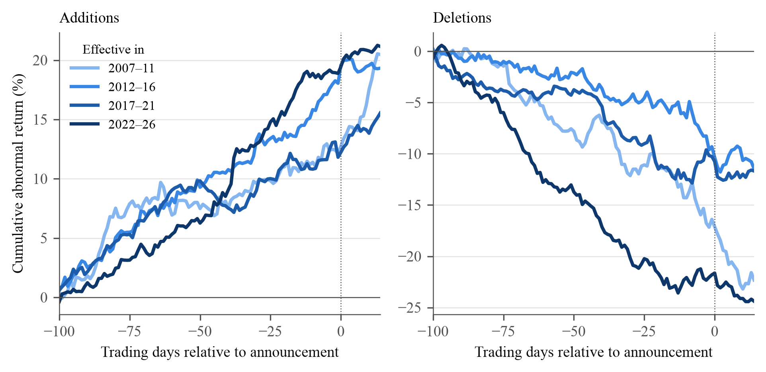
Note. Mean cumulative abnormal return (stock total return minus .OMXSBGI), in per cent, from 100 trading days before the announcement to day k, for k from −100 to +14, by five-year period of the effective date. Day 0 is the announcement date (dotted line). Deletions keep their sign. As in Greenwood and Sammon (2025, Figure 7), which pools by decade. Between 30 and 87 events per line and day. The values at day −1 are the [AD−100, AD−1] row of Table 4. Descriptive; inference in Table 4.

