Figure 3. Net purchases by index trackers and the index effect
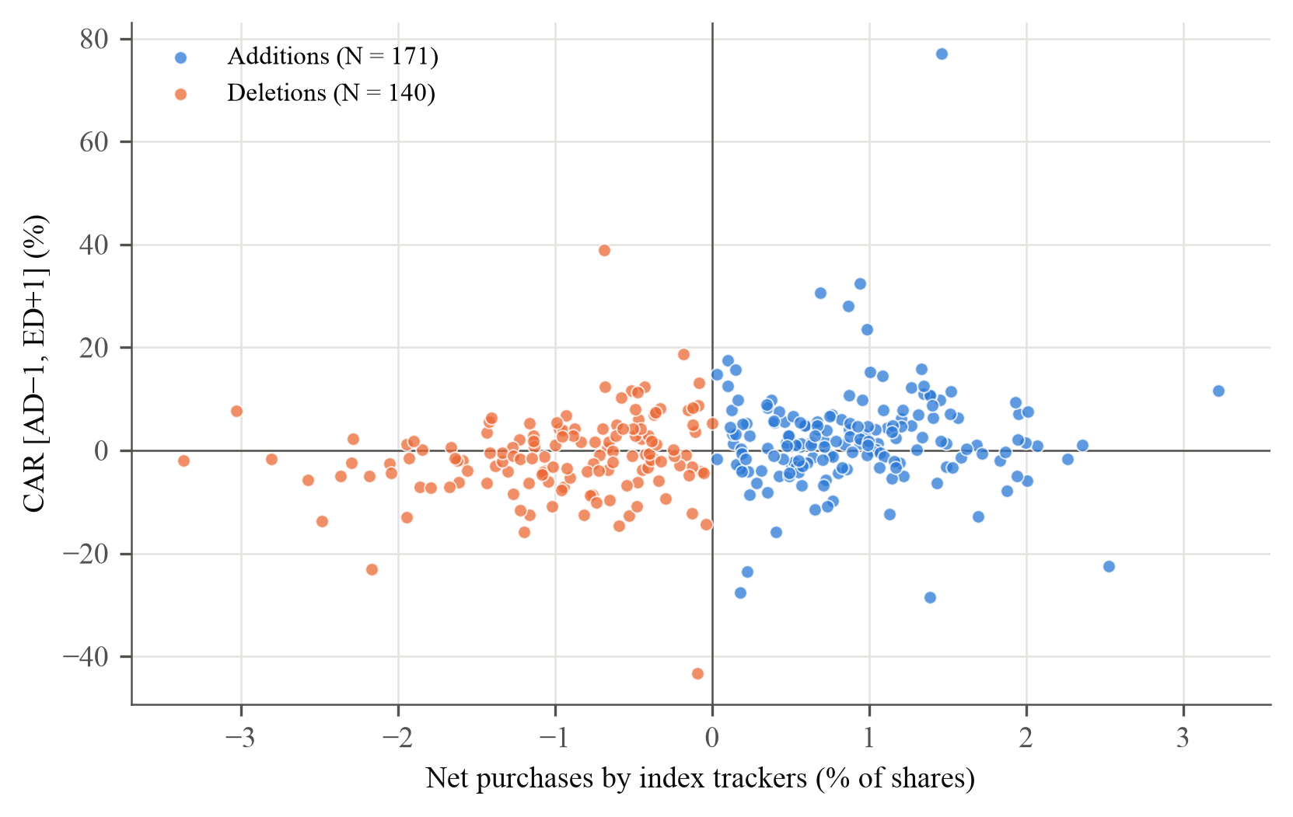
Note. Each point is one addition or deletion with fund holdings data and no share split between the fund reports (311 events, 2009–2026). Horizontal axis: net purchases by OMXSB index trackers (pure index funds, tracker variants and the OMXSB share of balanced funds; a fund counts while its holdings show at least half of the index trades, as in Greenwood and Sammon), in per cent of shares outstanding (negative for deletions). Vertical axis: cumulative abnormal return from the day before the announcement to the day after the effective date, in per cent. As in Greenwood and Sammon (2025, Figure 3). Descriptive; the multiplier estimates are in Table 5. Deletions caused by a takeover, merger, distressed share issue or a large change in shares outstanding (19 events) are excluded from the fund demand sample.

