Figure 1. Net buying and selling by OMXSB index trackers, by year
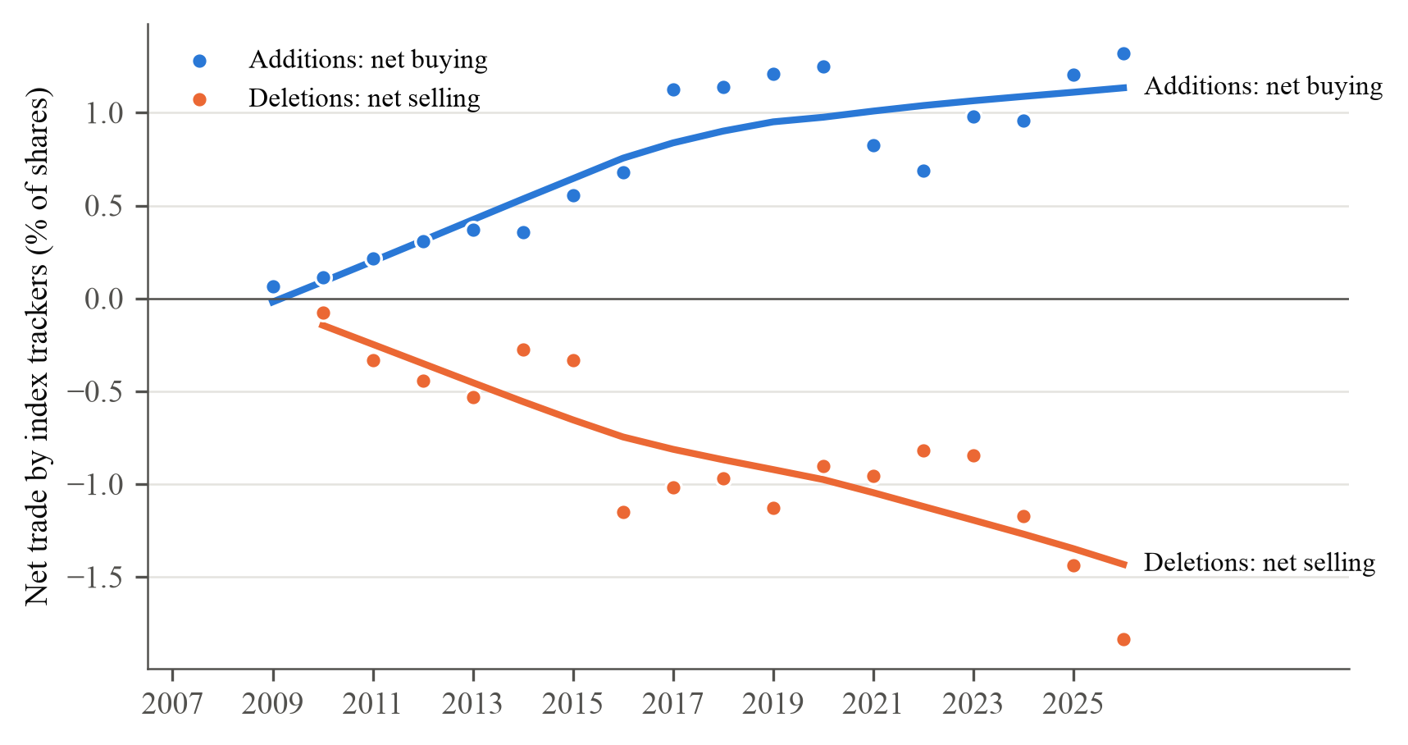
Note. Net buying (additions) and net selling (deletions) by OMXSB index trackers (pure index funds, tracker variants and the OMXSB share of balanced funds; a fund counts while its holdings show at least half of the index trades, as in Greenwood and Sammon): the change in shares held between the last fund report before the announcement and the first report after the effective date, divided by shares outstanding (multiplied by 100). Fund holdings from LSEG Lipper; events with a share split between the two reports are excluded. Each point is the equal-weighted mean across events by year of the announcement; years without fund data are left out (312 events in total). The line is a LOWESS fit with bandwidth 0.8, as in Greenwood and Sammon (2025, Figure 1). Descriptive; no inference. Deletions caused by a takeover, merger, distressed share issue or a large change in shares outstanding (19 events) are excluded from the fund demand sample.

