Figure 2. Average index effect by year
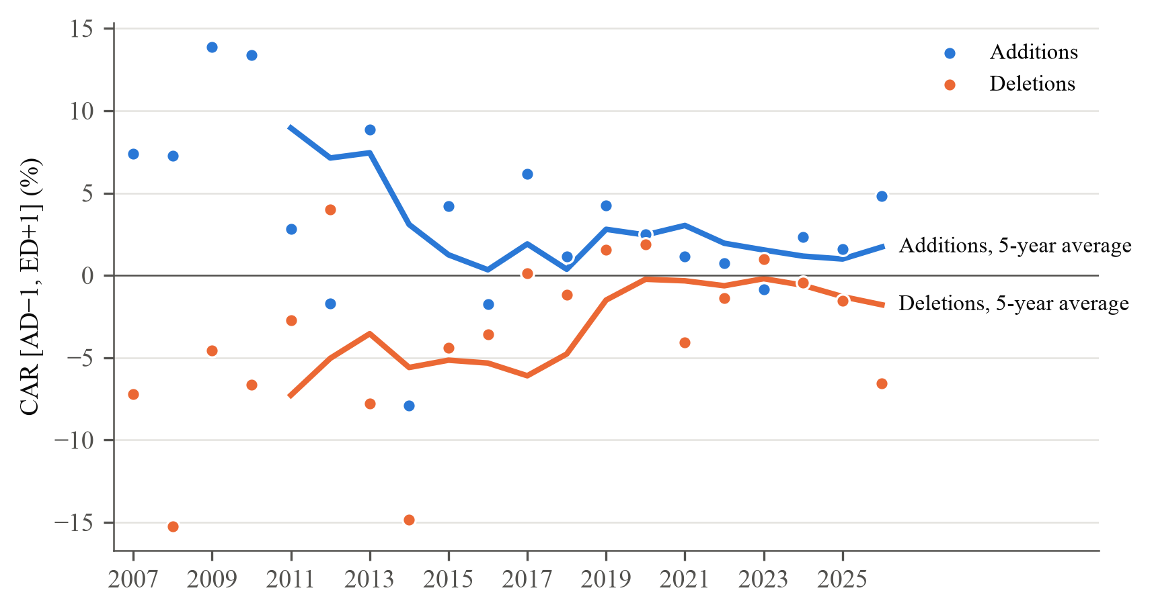
Note. Points: mean cumulative abnormal return from the day before the announcement to the day after the effective date ([AD−1, ED+1], in per cent, stock total return minus .OMXSBGI) by year of the effective date, as in Table 1. Lines: trailing 5-year moving averages of the yearly means (Greenwood and Sammon, 2025, Figure 2, use ten years over a 40-year sample). Descriptive; for inference see Table 2.

