1. For the following application, identify the deployment level and categorize the exact component name for each of the general elements in an IoT framework deployment. Also draw the deployment level diagram specifying the right components. [5 M][CO01][BTL 3]

*XYZ is a company that works on technology-based support for agriculture, offering solutions for****crop monitoring and management****. They have developed wireless sensor networks, based on Libelium technology, in a kiwi plantation with GPRS to****develop accurate irrigation strategies for farmers****. Kiwifruit is one of the****most sensitive fruits in terms of quality****which is given by size, sweetness and dry matter. In order to reach the best quality, it is essential for farmers to develop a good irrigation strategy****to attain marketable products and to reduce product losses****. The Project uses Libelium “Waspmote Plug & Sense! Sensor Platform” for its wide range of sensors and the easy development of software for data acquisition and transmission. For this project, the company has installed****two different wireless sensors to monitor soil water status to plan irrigation****in a kiwi orchard. Two Waspmote Plug & Sense! Smart Agriculture have been deployed with watermark sensors in different depths to control soil moisture with****fruit diameter sensor****to measure the size of the fruit; and****temperature and humidity sensors****to monitor environmental conditions. Both the sensor platforms is connected to a****GPRS shield****. The information collected by the sensors has been sent to XYZ’s cloud platform, esiFARM that includes the GPRS. To manage GPRS stations however a server has to be configured. In this case Meshlium IoT Gateway has been used embedding Meshlium Management System making data handling easier. Farmers can get valuable information to schedule irrigation timing to avoid stress conditions, which is fundamental on kiwi plant.* The same is shown in the picture below:

**Solution:**

1. **Device:** *Two Waspmote Plug & Sense! (with* ***fruit diameter sensor, temperature and humidity sensors****)*
2. **Resource:** functionalities of*“Waspmote Plug & Sense! Sensor Platform”*
3. **Controller Service:** *Meshlium IoT Gateway has been used embedding Meshlium Management System*
4. **Database:** Data storage in*XYZ’s cloud platform, esiFARM*
5. **Web Service:** REST or Websocket service to transfer data through GPRS connection
6. **Analysis Component:** cloud services to analyse fruit size and climatic conditions to irrigation schedule
7. **Application: *crop monitoring and management for*** *irrigation timing*

**Scheme:** Deployment level – 1 marks

Components identification – 2 Marks

Architecture – 2 Marks

1. Identify the most closest requirement among M2M, CPS, WSN, IoT, or WoT to handle the following scenarios and draw its general architecture: [5 M][CO01][BTL 3]
   1. The sensor senses the data and sends it to a base station via a router. There exist routing protocols to identify the most efficient path. These routing protocols also consider the power and resource constraints of the network nodes, time-varying quality of the wireless channel and the possibility of packet loss and delay.

Solution: WSN – as it talks about only sensor node, base station and data transfer to a collection point.

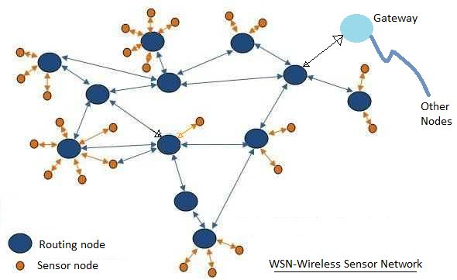

* 1. It is an integration of computation, communication, control, and physical elements to connect physical world with digital world. The physical system is a mechanical part such as actuator or electromechanical system that is used in production line or processing system. Information system is more on network, data storage, and memory management. Meanwhile, heterogenous systems is the interaction controlling between physical and network. External communication network is a common system.

**Solution: CPS – it is an integration of physical system with decision making and actuation with response in both the directions.**

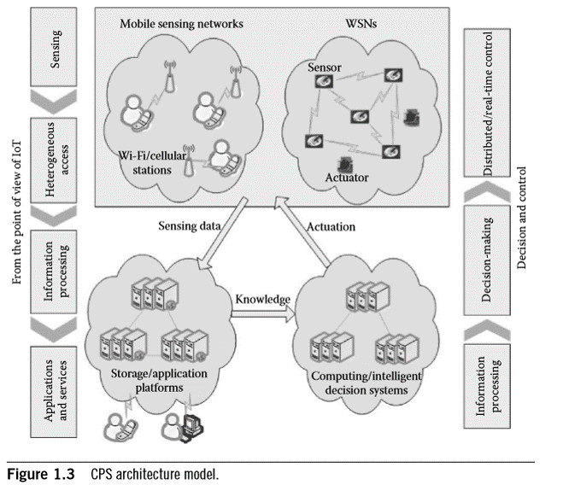

**Scheme : Identification and justification of correct field – 1+1 = 2 Marks**

**Diagram – 2 + 2 = 4 Marks**

1. Answer the following with respect to HTTP vs Websockets [5 M][CO01][BTL 2]
   1. Specify the header field in HTTP used for enabling persistent connection?

**Solution: Keep-alive**

* 1. What is the HTTP 1.1 mechanism used to emulate a server push but not provide exact real-timeness?

**Solution: HTTP long polling**

* 1. What is HTTP 1.1 streaming? How is it different from HTTP 1.1 long polling?

**Solution:** HTTP streaming is a push-style data transfer technique that allows a web server to continuously send data to a client over a single HTTP connection that remains open indefinitely. Essentially, the client makes an HTTP request, and the server pushes out a response of indefinite length.

* 1. How does HTTP 2.0 implement server push?

**Solution:** proactively push assets (stylesheets, scripts, media) to the client cache in advance could be through WebSockets

* 1. Draw the timing diagram to show the process of starting a Web Socket connection through HTTP.

Solution:

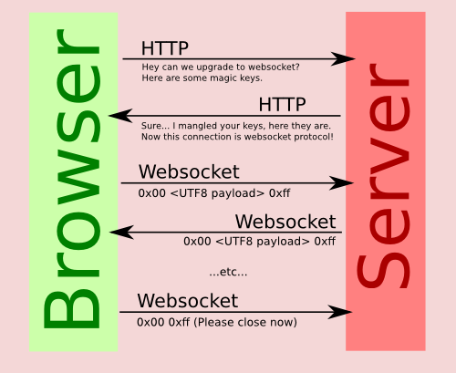

1. Answer the following with respect to Retained Publication in MQTT [5 M][CO01][BTL 4]
   1. What is a retained publication in MQTT?

**Solution:** **A retained message is a normal MQTT message with the retained flag set to true.**

* 1. How many retained publications can a topic have?

Solution: one publication per topic ---- last good value retained need not be the last message.

* 1. What happens if you do a retained publication to a topic with QOS 0?

**Solution**: retained message is still received and the QOS of the published message has no effect.

* 1. What happens if you do a retained publication to a topic with QOS 1?

Solution: retained message is still received and the QOS of the published message has no effect

* 1. What if you publish a non-retained publication toa topic which already has a retained publication present in it?

Solution: continues as normal message and new client sees only the retained message.