Visual Positioning System (VPS) Navigation System for GPS Denied Environments
Project manual and handover guide
2 Core Zone WKSP, E.M.E Corps
Authors
Utkarsh Vats | Aatish Kumar Sahu | Siddharth Kakroo
Thapar Institute of Engineering & Technology, Patiala
2 November 2026
Covers the project from first bring-up (June 2026) to the third flight test day (1 November 2026)
Continuation of this work. Any further work done on this project after this handover will be done by Aatish Kumar Sahu and Siddharth Kakroo.

Contents
1. Summary
2. The problem and the approach
3. The system
4. What is open source and what we developed
5. Version history
6. Methods, alternatives and decisions
7. Flight test results
8. What causes the error
9. Operating limits (where it works)
10. Heading and the compass
11. Connecting the VPS to the flight controller
12. Field procedure
13. Open issues and next steps
14. How this compares with existing systems
15. Where everything is
Appendix A. Glossary
Appendix B. Flight day checklist (short form)
Appendix C. Configuration differences from the stock OpenVINS Orbbec example

1. Summary
The goal. Give a small drone a way to know where it is when GPS is unavailable or jammed, using a downward looking camera instead of satellites. This is called a Visual Positioning System (VPS).
What we built. A working camera based positioning module on a real drone: an Orbbec Gemini 335L stereo infrared camera with a built-in motion sensor (IMU), a Jetson Orin Nano computer running the open-source OpenVINS estimator, and a Cube Orange+ flight controller running ArduPilot. Around it we built the field tools, a measurement method that grades the camera estimate against the flight controller's own log, and a detailed understanding of where the system works and where it fails.
What it achieves today (third flight test day, 1 November 2026, five flights at about 20 m height and up to 10 m/s):
Table 1. Headline results, 1 November 2026.
Measure | Result | What it means
Two-way error (error at landing / round trip) | 0.2 % to 1.7 % on 3 of 4 flights, 4.9 % on one | The drone came back close to where it started
One-way error at the far end, as measured | 5.5 % to 8.5 % | Mostly caused by a 4 degree compass error on the ground
One-way error if a good compass supplies heading | about 1.7 % to 3.8 % (simulated) | What the camera itself contributes
One-way error with a realistic 2.5 degree compass error | about 4.8 % to 6.5 % (simulated, worst case) | The honest planning figure for GPS denied flight
Reliability | OpenVINS ran every flight start to finish | One flight in five had a short tracking failure (about 10 m jump)

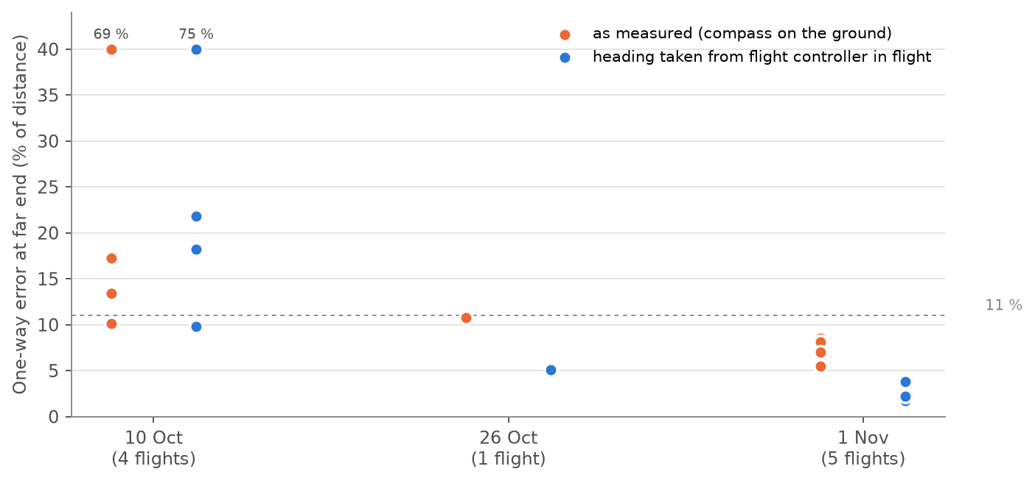
Figure 1. Progress across the three flight test days. Each dot is one flight. Orange: error as measured, using the compass heading taken on the ground. Blue: the same flight with heading supplied by the flight controller in flight, which is what a connected compass is meant to provide. Values above 40 % are drawn at the top with their value written.
Honest position: The estimator itself (OpenVINS) is unmodified open-source software. Our contribution is the integration on real hardware, the fixes that made it work in the field, the evaluation method and the flight results. The system has not yet steered the drone: so far it has only been recorded while the drone flew on GPS.

2. The problem and the approach

2.1 Why GPS denied navigation
A drone normally knows its position from GPS. GPS can be lost under bridges, near tall buildings, indoors, or deliberately jammed or spoofed. Without a position, the flight controller cannot hold position, fly a mission or return home. A VPS replaces GPS with an estimate made from a camera.

2.2 How a camera can estimate position
The camera looks at the ground and picks out small distinctive spots in each image (called corners or features). By following those spots from one frame to the next, and combining that with the IMU (a sensor that measures turning and acceleration), the software works out how far and in which direction the drone has moved. Adding up those small moves gives a position. This is called visual-inertial odometry (VIO).
Because positions are built by adding up small moves, small errors also add up. A camera alone cannot tell where north is or where on Earth it is, so its error grows with distance flown. This is called drift. Good VIO drifts around 0.5 % to 2 % of distance flown in good conditions. Absolute references (compass for heading, rangefinder for height, map matching for position) are what stop that growth.

2.3 Scope of this work
- Integrate a VIO system on the drone and make it reliable in the field.
- Measure honestly how accurate it is in real flights, against the flight controller's GPS.
- Find the conditions under which it works and the causes when it does not.
- Plan and prepare the connection to the flight controller so the drone can fly without GPS.
Final decisions
- Use camera based VIO as the core of the VPS, with compass, barometer or rangefinder, and later map matching, as absolute aids.
- Measure progress with real flights against the flight controller log, not with bench or handheld tests alone.

3. The system
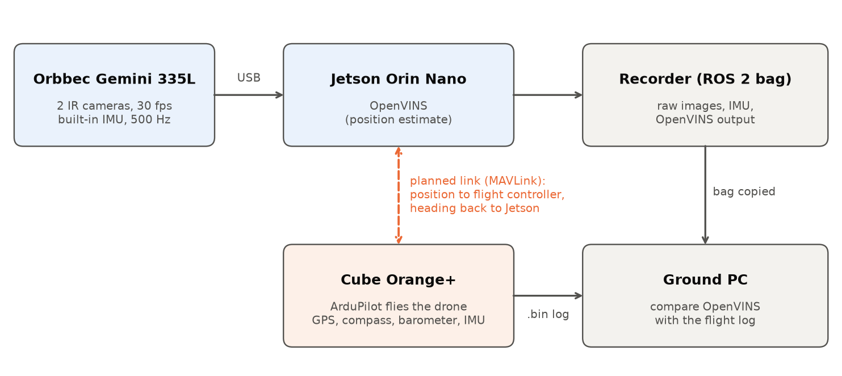
Figure 2. How the parts connect. Solid arrows exist today. The dashed link is planned (Section 11).

3.1 Hardware
Table 2. Hardware.
Part | Model | Role
Camera | Orbbec Gemini 335L | Two infrared (IR) cameras 9.5 cm apart, 848 x 480 pixels at 30 frames per second, global shutter. Built-in IMU at 500 Hz. Mounted facing down, about 5 to 8 degrees off vertical.
Onboard computer | NVIDIA Jetson Orin Nano Super (named vajra) | Runs Ubuntu with ROS 2 Humble, the camera driver, OpenVINS and the recorder. Must run in the MAXN_SUPER power mode.
Flight controller | CubeOrange+ with ArduCopter 4.6.3 | Flies the drone. Has its own IMUs, compass, barometer and a GPS. Its log (.bin) is our reference.
Airframe | Quadcopter, H frame | Flights flown as automatic GPS missions (AUTO mode).

3.2 Software
Table 3. Software stack.
Layer | Software | Notes
Operating system and middleware | Ubuntu (JetPack 6), ROS 2 Humble | ROS 2 moves data between programs as named topics.
Camera driver | Orbbec SDK ROS 2 | Publishes left and right IR images and IMU readings.
Position estimator | OpenVINS (ov_msckf), upstream version 6948812 plus 2 small patches of ours | Produces the position estimate at 15 Hz.
Recorder | ros2 bag | Records raw images, IMU and OpenVINS output for every flight (3.5 to 4 GB per flight).
Flight software | ArduPilot ArduCopter 4.6.3 | Unchanged.
Field tools | flight_start, flight_record, flight_status, flight_stop, flight_logs | One command per step, all processes detached from the network link.
Analysis | Python scripts in scripts/analysis (ours) | Compare OpenVINS with the flight controller log.

3.3 Key settings
Table 4. Settings that matter.
Setting | Value | Why
Jetson power mode | MAXN_SUPER (nvpmodel -m 2) plus jetson_clocks | In the 15 W mode OpenVINS could not keep up and diverged by about 70 m.
Camera IMU rate | 500 Hz | The driver silently falls back to 100 Hz if given an unsupported value such as 400.
Camera time base | global time domain with host time sync | Keeps camera and IMU timestamps consistent.
IR projector (laser dots) | Off | Not needed outdoors; avoids projected dots being tracked as ground features.
Camera to IMU rotation (T_cam_imu) | Near-identity (stock Orbbec values) | The single most important calibration value, see Section 5.2.
OpenVINS track_frequency | 21 (processes about 15 of 30 frames per second) | Unchanged so far; raising it to 31 is a planned test.
OpenVINS feature detector | FAST threshold 20, 200 features | Stock Orbbec example uses threshold 5 and 300 features; planned test.

Final decisions
- Keep the camera's own built-in IMU for OpenVINS (not the flight controller's IMU). It is timed by the same clock as the camera.
- Always run the Jetson in MAXN_SUPER. Never in the 15 W mode.
- Keep the IR projector off outdoors and the IMU at 500 Hz.

4. What is open source and what we developed
The project combines existing open-source software with tools, fixes and methods we developed. The table below makes the split explicit. Licences are given as we understand them; check each licence before redistributing.
Table 5. Third-party components.
Component | Source | Licence (to be confirmed before release)
OpenVINS position estimator | Open source (University of Delaware RPNG lab) | GPL-3.0
ROS 2 Humble | Open source | Apache-2.0
Orbbec camera driver (OrbbecSDK_ROS2) | Open source (Orbbec) | Apache-2.0
ArduPilot flight software | Open source | GPL-3.0
MAVROS (planned link to the flight controller) | Open source | GPL-3.0 / LGPL-3.0 / BSD
Kalibr calibration toolbox | Open source (ETH Zurich) | BSD-3-Clause
OpenCV, NumPy, SciPy, Matplotlib, pymavlink | Open source libraries used by our analysis | Apache-2.0 / BSD / LGPL-3.0
Isaac ROS cuVSLAM (alternative, not flown) | NVIDIA. ROS wrapper is open; the core library is closed source | NVIDIA licence

Table 6. Components developed by us.
Developed by us | What it does | Can be open sourced?
Field routine (scripts/flight: flight_start, flight_record, flight_status, flight_stop, flight_logs, flight_common.sh) | Starts, checks, records and stops everything with one command each, detached from the Wi-Fi link, with per-flight log folders | Yes (already in the public repository)
Jetson system fixes (scripts/jetson_system) | Restores the clock after power-on (no RTC battery), crash dumps, wifi-mode switch | Yes
Two OpenVINS patches (third_party/open_vins/patches) | Clean, immediate exit on stop. Fixes crashes on shutdown | Yes; as changes to GPL software they must stay GPL
Launch files and configuration (launch, config) | Correct camera, IMU and estimator settings for this hardware | Yes
vps_bridge ROS 2 package | Passes the position estimate towards MAVROS with a sanity filter (not flown yet) | Yes
Analysis pipeline (scripts/analysis) | Time sync by gyro correlation, mounting angle fit, anchored error, drift, scale, vibration, image texture and motion | Yes
Replay harness (scripts/replay_diag) | Re-runs recorded flights through OpenVINS with different settings | Yes
Compass offset check and compass simulation (1 Nov analysis) | Measures compass error from the flight log; predicts accuracy with a connected compass | Yes (scripts handed over with the 1 Nov data, not yet in the repository)
Test procedures, checklists, reports, this manual | How to fly, record and judge a test | Yes
Flight data (camera recordings and flight logs) | Raw evidence | No, not publicly. Flight logs contain the site's GPS coordinates

Never publish: flight logs (.bin) or anything else with GPS coordinates of the test site, and any passwords (Jetson login, Wi-Fi). Credentials are handed over separately, in person, not in this document or the repository.

Final decisions
- The estimator stays unmodified upstream OpenVINS plus our two shutdown patches. Improvements so far come from integration, calibration, settings, procedures and flight conditions, not from changes to the algorithm.

5. Version history
The project went through seven versions. Each row is one round of work, what changed, and what it achieved.
Table 7. Version history.
Version | When | What changed | Result
v0 First bring-up | Jun to Jul 2026 | Camera and OpenVINS running on the Jetson. Handheld bench tests. One flight recorded only the OpenVINS output, not the raw data. | Flight: 72 % drift (about 107 m off over 150 m), height swung from +4 m to -76 m. Could not be re-analysed (no raw data). Bench tests reported 1.2 to 1.3 %, later found to have used the wrong IMU.
v1 The wrong fix | Jul to Aug 2026 | A 90 degree camera to IMU rotation was written in as a fix. Repository created (30 Jul). Replay tools, staged test plan, raw data recording. | Every test drifted 20 to 50 %. The replay tools had their own bugs, which hid the cause.
v2 Root cause found | 6 Sep 2026 | Reverted to the stock near-identity rotation. Found the Jetson was in its 15 W mode and switched to MAXN_SUPER. First shutdown patch, first clock fix. | Same recording: 43.7 % to 1.15 %. Public reference dataset (EuRoC): 1.4 %. Estimator settings have not changed since.
v3 First flights | 10 Oct 2026 | Four automatic GPS missions, OpenVINS recorded, run from three SSH terminals. | One-way 10 % to 69 %. OpenVINS stopped mid-flight in 3 of 4 flights. Clock reset to 1970 on every boot.
v4 Field tools and analysis | 10 to 24 Oct 2026 | flight_* scripts (detached from Wi-Fi), clock restore, crash dumps, second OpenVINS patch, analysis pipeline, roadmap. | Reliable start and stop, clock survives reboots, every flight can be graded against the flight log.
v5 Second flight day | 26 Oct 2026 | Same estimator. New routine, better ground, simple straight route, longer still period before take-off. | Two-way 5.0 %, one-way 10.8 %, no mid-flight stop. GPS reference degraded by nearby interference. One flight lost to a Jetson power cut.
v6 Third flight day | 1 Nov 2026 | Five flights at 20 to 25 m, up to 10 m/s, including a triangle with a 150 degree turn. Compass error discovered and quantified. | Two-way 0.2 % to 1.7 % (3 flights), 4.9 % (1). One-way 5.5 % to 8.5 %. With a good compass: 1.7 % to 3.8 % (simulated).

6. Methods, alternatives and decisions

6.1 Choice of position estimator
Table 8. Estimator options.
Option | How it works | Outcome
OpenVINS (chosen) | Open-source filter that combines camera features and IMU readings | Built, tuned, flown on three test days. Runs at about 6 ms per frame on the Jetson, so there is spare computing power.
Isaac ROS cuVSLAM | NVIDIA's GPU accelerated visual SLAM | Wired up with a launch file. Showed occasional single-frame position jumps during fast motion on the bench. Never flown.
Optional image pre-filter (ir_preprocessor) | Blur and contrast stretch before tracking | Written but not used in any flight. Candidate for low-texture ground.

Final decisions
- OpenVINS is the estimator. cuVSLAM is kept as an untested alternative only.

6.2 Compute, timing and sensor settings
- Power mode: live tests diverged by about 70 m while replaying the same data offline worked (1.4 % to 8.6 %). The Jetson was in its 15 W mode and could not keep up. In MAXN_SUPER, delay stayed at 40 to 75 ms with no backlog.
- IMU rate: the camera driver only accepts certain values; 400 Hz silently became 100 Hz. Set to 500 Hz.
- Frames used: with track_frequency 21, OpenVINS uses every other frame. It costs about 6 ms per frame, so all 30 frames could be used.
- Clock: the Jetson has no clock battery, so its time reset to 1970 after every power cut. Our restore service and a sync from the ground PC fix it. A coin cell battery is the hardware fix.
Final decisions
- MAXN_SUPER plus jetson_clocks at every boot (flight_start does it). Sync the Jetson clock from the ground PC before every session.
- Test track_frequency 31 on recorded flights before flying it.

6.3 Field routine
Table 10. Field routine.
Approach | Problem | Outcome
Three SSH terminals over Wi-Fi (10 Oct) | When the Wi-Fi link dropped, programs printing to that terminal could block | OpenVINS stopped mid-flight in 3 of 4 flights
flight scripts (26 Oct onwards) | Programs run detached from the network, each with its own log file and process id | No mid-flight stop in 6 flights since. Start and stop in under 1 s

Related fixes: two OpenVINS patches for clean shutdown (it used to crash or hang when stopped), a liveness check that no longer gives false 'stalled' warnings, and crash dumps enabled for diagnosis.
Final decisions
- Use only the flight_* commands in the field (Section 12). Do not run things by hand in SSH terminals during flights.

6.4 How we measure accuracy
No external measuring system was available, so we compare OpenVINS with the flight controller's own estimate (its EKF, which combines GPS, IMU and barometer). Our analysis pipeline does this in five steps:
1. Time alignment: the camera IMU and the flight controller IMU both measure rotation. Their signals are matched to find the time offset between the two clocks (correlation 0.88 to 1.00 on all flights).
2. Mounting angle: the rotation between the two gyros gives the camera's mounting angle.
3. Anchoring: OpenVINS is lined up with the GPS path only at take-off, exactly as it would be used in real life. Nothing is fitted afterwards. This gives the honest error.
4. Metrics: error at every moment, error at the far end (one-way), error at landing (two-way), error after a set distance, scale, height, vibration, and the share of time the error was inside OpenVINS's own confidence.
5. Conditions: the camera images are scored for texture (number of corners), sharpness and image motion, and compared with the error growth.
Table 11. Accuracy measures.
Metric | Definition | Strength | Weakness
Two-way error | Error at landing divided by the round trip | Needs no GPS if the landing spot is measured with a tape | Hides heading and scale errors on any route that returns home
One-way error | Error at the far end divided by the distance flown to it | Closest to a real mission | Needs a good reference; short routes give large percentages for small errors
Error after X metres | Error once the drone has flown X metres | Comparable across routes and days | Same reference limits
Best-fit error (used in many papers) | Path rotated and shifted afterwards to match GPS as well as possible | Shows the shape quality | Optimistic: removes heading error a real drone cannot remove

Reference accuracy. The GPS reference itself is only accurate to about 2 to 3 m (the receiver reported 1.5 to 3.0 m on 1 November). Errors smaller than that cannot be measured. We use 3 m, the worst value the receiver reported in flight, as the tolerance. A larger tolerance chosen after seeing the results would be misleading.
Final decisions
- The headline measure is one-way error with heading supplied by the compass, reported together with two-way error. Two-way error alone hides scale errors.
- Use 3 m as the GPS tolerance for these flights, state it with its reason, and get RTK GPS (centimetre accuracy) before claiming anything below 3 %.

7. Flight test results

7.1 First flight day, 10 October 2026
Four automatic missions at 4.6 m to 9 m height. Run from three SSH terminals.
Table 12. 10 October results.
Flight | Profile | One-way error | Outcome
1 | 4.6 m high, up to 10.4 m/s, rectangle | 17.3 % | Lost within 15 s; image motion far too fast for the height
2 | 9 m, up to 4 m/s, straight | 10.1 % | Best of the day; OpenVINS stopped at 78 s
3 | 9 m, up to 7 m/s, zig-zag and hovers | 68.6 % | Drifted while hovering over bare ground; stopped at 91 s
4 | 9 m, up to 7 m/s, out and back | 13.4 % | Very little texture (29 corners per image)

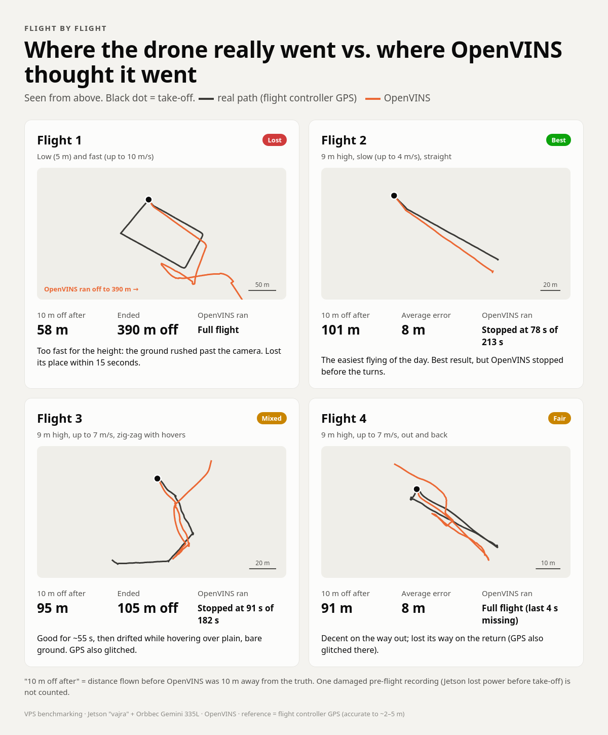
Figure 3. 10 October: real path (black) and OpenVINS (orange) for each flight, seen from above.
Lessons: the worst drift came from the ground moving too fast through the image (flying fast and low), the second worst from plain ground with few features. OpenVINS stopping mid-flight was traced to the SSH terminal setup.

7.2 Second flight day, 26 October 2026
One valid flight: a straight 114 m out and back at about 14 m height, up to 10.2 m/s. Same estimator, new field routine.
Table 13. 26 October results.
Measure | Value
Two-way error | 11.5 m over 229 m = 5.0 %
One-way error at far end | 12.4 m over 114 m = 10.8 %
Ran whole flight | Yes, first time on a real flight
Ground texture | about 400 corners per image (good)
GPS reference | Degraded by nearby interference (accuracy about 4.3 m)
Problems | Jetson lost power during the next flight, which was lost

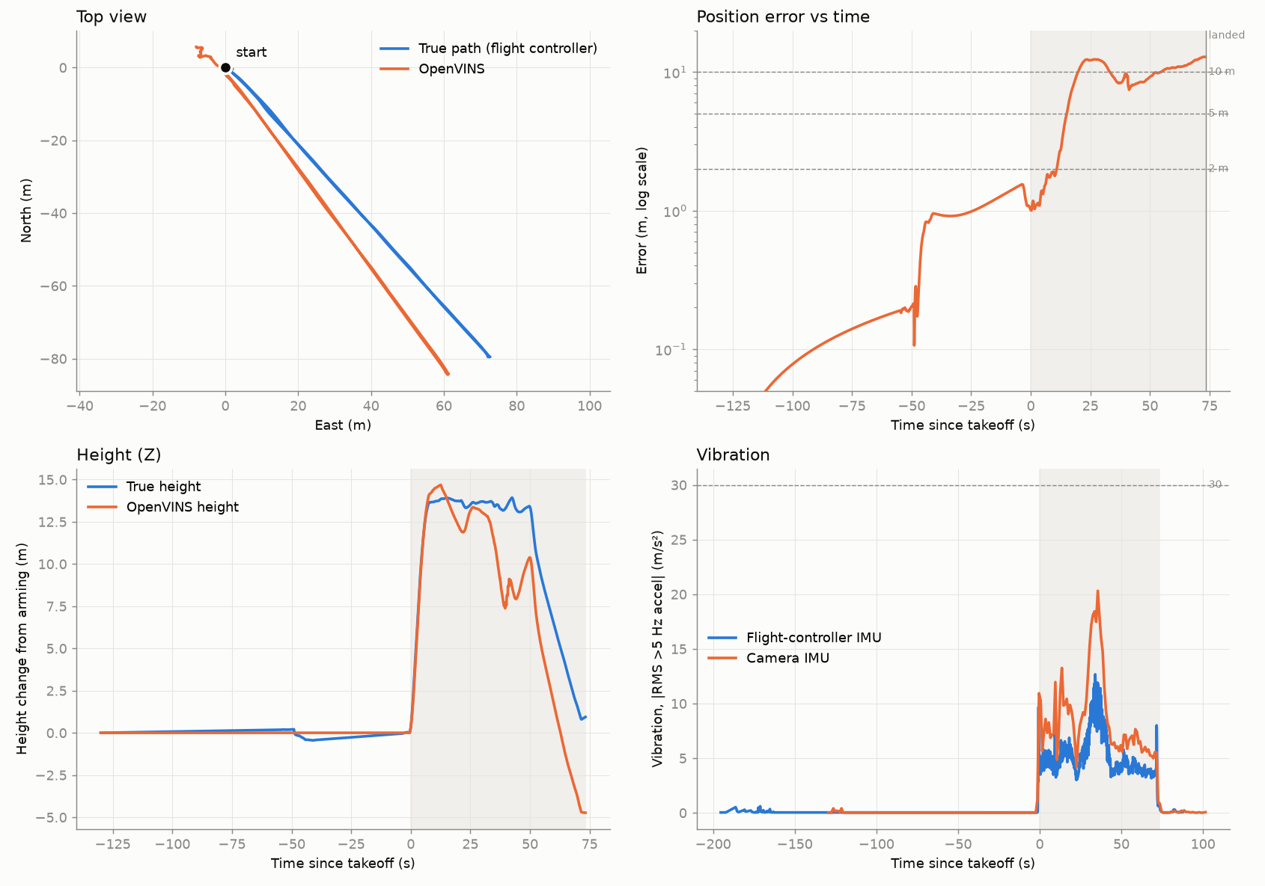
Figure 4. 26 October flight. Top left: real path (blue) and OpenVINS (orange). Top right: error over time. Bottom: height and vibration. The error grew during a fast 35 degree turn and hard acceleration, then stayed flat.

7.3 Third flight day, 1 November 2026
Five automatic missions at about 20 m height (25 m on the last), up to 10 m/s. Flights 1, 2 and 4 went about 74 m out, flights 3 and 5 about 162 m. Flight 4 flew a triangle with a 150 degree turn. The last flight's GPS degraded on the way back, so only its outbound leg is used.
Table 14. 1 November results.
Flight | Route | Two-way error | One-way error, as measured
1 | out and back, 74 m | 1.4 m / 149 m = 1.0 % | 6.3 m = 8.5 %
2 | out and back, 74 m | 2.5 m / 150 m = 1.7 % | 4.9 m = 6.6 %
3 | out and back, 163 m | 16.2 m / 329 m = 4.9 % | 9.0 m = 5.5 %
4 | triangle, 74 m | 0.3 m / 163 m = 0.2 % | 6.0 m = 8.1 %
5 | outbound only, 162 m | not measurable | 11.2 m = 7.0 %

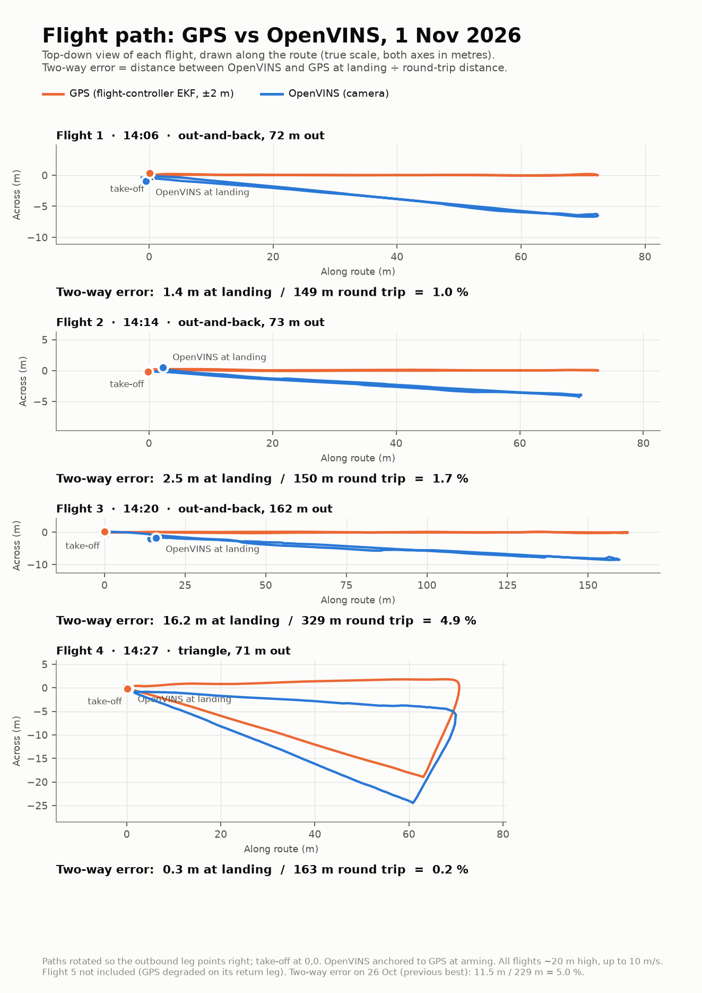
Figure 5. 1 November: GPS path (orange) and OpenVINS (blue) for flights 1 to 4, seen from above and rotated so the outbound leg points right. The OpenVINS path is turned by a few degrees (heading error) but comes back home.
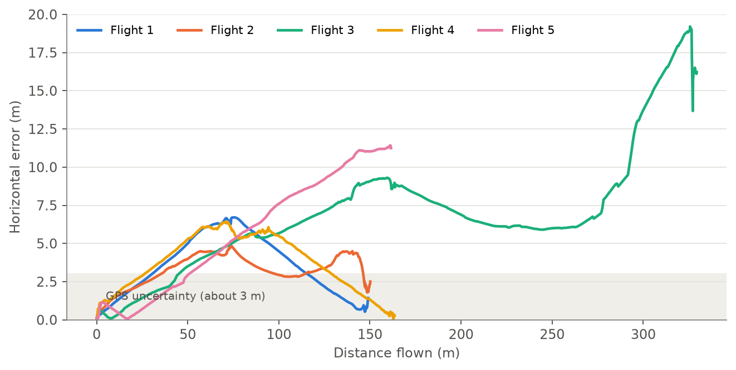
Figure 6. 1 November: error against distance flown, as measured. The rise and fall on out-and-back flights is the heading error growing on the way out and cancelling on the way back. Flight 3 shows a sudden jump near 290 m.
Other observations: all five recordings were clean (30 images per second, IMU at about 493 Hz, OpenVINS at 15 Hz with no gap over 0.18 s). Vibration was low (camera 5 to 9 m/s squared). The GPS reference was good on flights 1 to 4 (1.5 to 2.8 m). The Jetson lost power right after the last recording; the data survived.

7.4 The flight 3 tracking failure
On the fast return leg of flight 3, about 290 m into the flight, OpenVINS under-estimated its own speed by 20 % to 35 % for about 4 seconds. That added about 10 m of error, which then stayed until landing. At that moment the images had only 12 to 77 corners (normally 150 to 300) at 9 to 10 m/s over bare sandy ground.
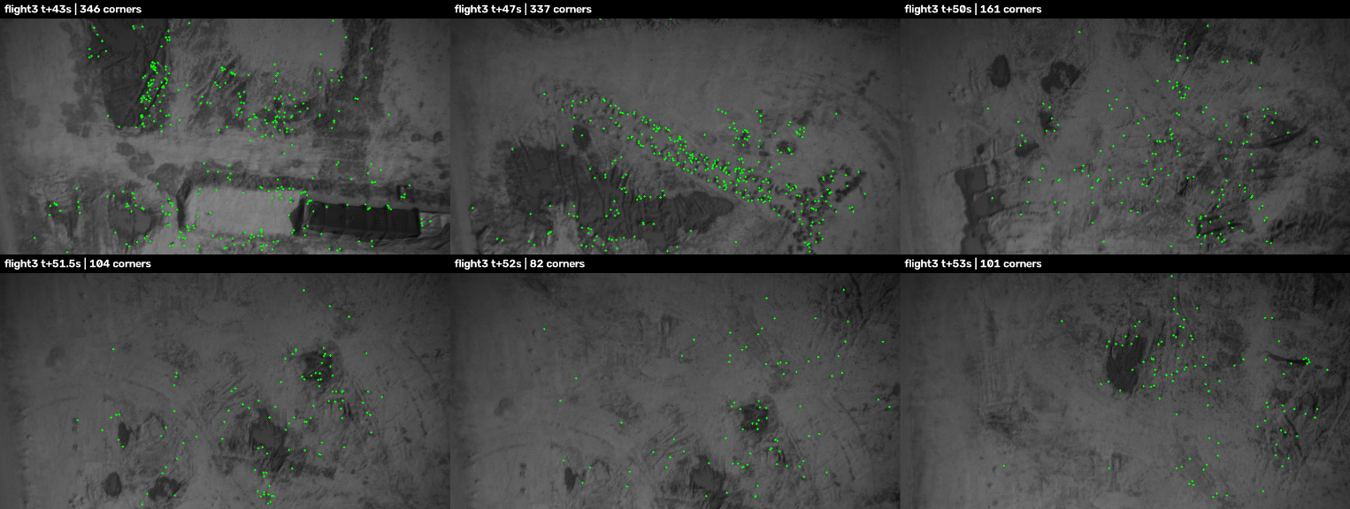
Figure 7. Flight 3 camera frames before and during the jump. Green dots are the corners OpenVINS can track. The bare sandy patch (bottom row) offers few of them.
Flights 1 and 2 flew the same track within 0.5 m at the same speed and did not fail, so ground and speed alone do not explain it. Ruled out: false 'stopped' detection, processing delay, rejected updates, accelerometer bias. The exact trigger is still open. The planned replay test (Section 13) will show whether more features would have prevented it.

Final decisions
- The 1 November flights are the current baseline: 20 to 25 m height, up to 10 m/s, simple routes, about 75 to 160 m out.
- Flight 5 of 1 November is used only up to its far end because of GPS degradation on its return.
- The open problem is short tracking failures over bare ground at speed, not slow drift.

8. What causes the error
We split the error into five kinds. Each needs a different fix.
Table 15. Error sources.
Error type | Meaning | Size on 1 November | Fix
Heading | The whole path drawn a few degrees rotated | About 4 degrees, 5 to 6 m at 70 m. The largest part | Compass (Section 10)
Scale | Distances slightly too long or too short | Scale 0.96 to 1.03, partly GPS noise | Calibration, rangefinder
Slow drift | Small errors adding up | About 1 to 3 m after 70 to 160 m once heading is removed | Better features, tuning, map matching
Tracking failure | Sudden loss of speed estimate over poor ground | One flight in five, about 10 m | Tuning, slower speed, better ground
Height | Vertical error | Under 2.2 m | Barometer or rangefinder

8.1 Ground texture: what the camera needs to see
OpenVINS finds corners with a detector that marks a pixel when at least 9 of the 16 pixels on a small ring around it are all brighter or all darker by more than 20 grey levels. At 20 m height one pixel covers about 5 cm of ground, so a feature must be roughly 15 to 35 cm across and clearly darker or brighter than its surroundings.
Table 16. What the camera likes.
Gives corners | Gives few or none
Dark bushes, rocks, holes, debris on pale ground | Bare sandy or dry soil, evenly lit
Sharp shadows of bushes, stones, ruts | Short uniform grass seen from height (blurs to grey)
Broken edges: ditches, field boundaries, track crossings | Long straight lines (a rut or road edge)
Objects, close-up ground when low | Water, fresh tarmac, uniform crops (untested, expected poor)

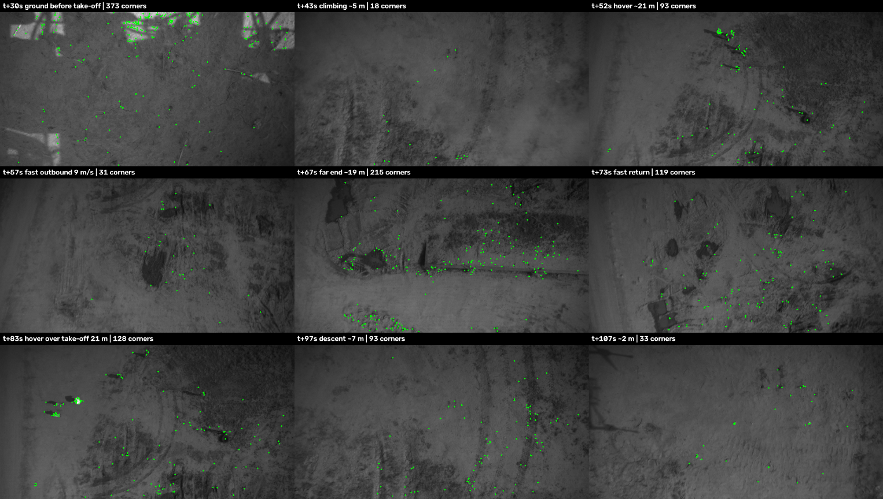
Figure 9. Flight 1 (1 November) frames across the flight with the corners drawn in green and the count in each label.
Note: the camera sees near-infrared light, not colour. Green plants look bright in infrared, often similar to dry soil, so a field that looks colourful to the eye can look flat to the camera. Brightness contrast (shadows, holes, dark objects) is what counts.
Final decisions
- Plan routes over cluttered ground (bushes, rocks, ditches, edges) and aim for at least 100 to 150 corners per image where flying fast.
- Test a lower corner threshold (20 down to 5 to 10) on the recorded flights; it should pick up the fainter soil texture.

9. Operating limits (where it works)
From 10 flights over three days, these are the conditions in which the one-way error with a connected compass stayed at or below 11 %. Seven flights passed, three failed, and every failure broke at least one of the first four limits. This is an observed envelope, not a guarantee.
Table 17. Operating envelope.
# | Limit | Evidence
1 | Height at least 9 m (best 14 to 25 m) | Failed at 4.6 m (10 Oct flight 1)
2 | Speed divided by height at most about 0.5 per second (10 m/s at 20 m, 7 m/s at 14 m, 4.5 m/s at 9 m) | Passed at 0.40 to 0.69; failed at 2.1
3 | Textured ground: median at least 90 corners per image, no long stretches under 50 at full speed | Failed at 29 corners; flight 3 jump at 12 to 77
4 | Straight legs, simple routes, no long hovers or zig-zags | Zig-zag with hovers failed (69 %)
5 | Fast turns are fine (tested 150 degrees at 80 degrees per second) | 1 Nov flight 4
6 | One-way distance up to about 160 m | Nothing tested further
7 | Time in the air up to about 100 s | Longer flights failed, but broke other limits too
8 | Compass accurate to within about 4 degrees | Each degree adds about 1.7 % one-way
9 | Still for 20 to 30 s before arming, OpenVINS initialised | Procedure
10 | Unchanged system setup and the flight_* routine | OpenVINS stopped mid-flight without it
11 | Daylight, nothing over-exposed, IR projector off | All test days

Final decisions
- Fly tests inside this envelope until the next steps (Section 13) widen it.
- Do not quote one accuracy figure without the envelope it applies to and the failure rate.

10. Heading and the compass

10.1 What we found
The trajectory OpenVINS draws had the right shape but was turned by 3 to 6 degrees, always in the same direction, on every flight on two different days. We checked the flight controller: between arming and the far end, its heading turned about 4 degrees more than its own gyro measured, on every flight. Its compass was about 4 degrees off on the ground, and GPS corrected it quietly once the drone started moving. Our analysis took its starting heading from that uncorrected ground compass, so the error appeared as OpenVINS error.
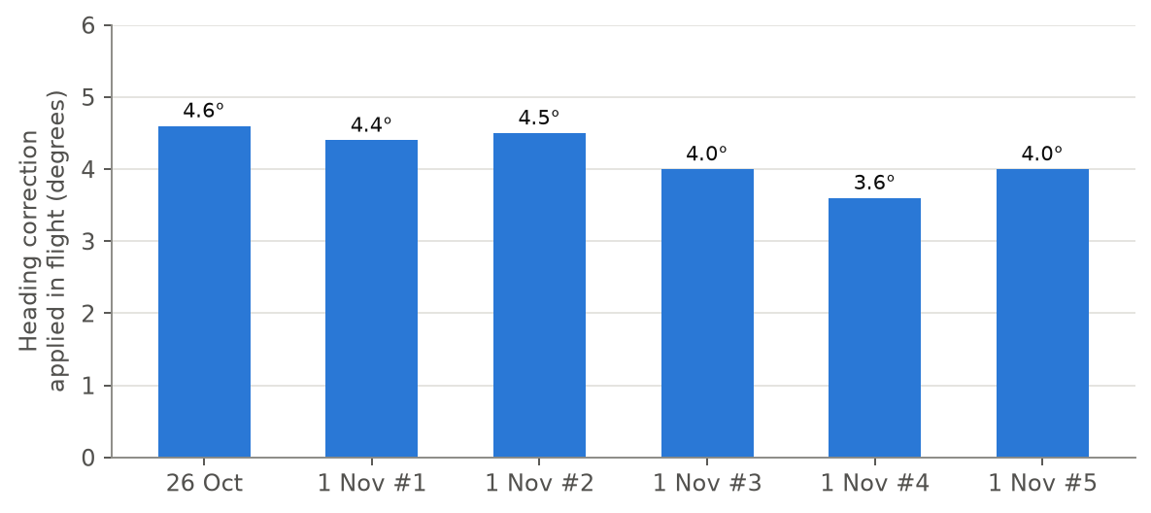
Figure 10. Heading correction the flight controller applied in flight (its EKF heading minus its own gyro). A consistent 3.6 to 4.6 degrees means the compass on the ground was about 4 degrees off.
Why GPS hides this and a GPS denied system does not: with GPS, the flight controller compares the direction the compass reports with the direction GPS says the drone is moving, and learns the compass error. Without GPS nothing can detect the error, so the whole path is drawn rotated.

10.2 How large the compass error can be
Table 18. Compass accuracy.
Setup | Typical heading error
Uncalibrated, or compass near power wiring | 5 to 15 degrees
Ordinary setup, calibrated once | 3 to 6 degrees
Ours on 1 November | about 3.3 to 4.5 degrees
Field calibrated, CompassMot done, compass on a mast | 1 to 3 degrees
High quality external magnetometer, careful setup | 1 to 2 degrees

For planning we use 2.5 degrees, deliberately conservative. A well installed RM3100 magnetometer should do better.

10.3 Ways to fix heading
- Calibrate the compass in the field with everything mounted and powered, away from cars and metal.
- CompassMot: an ArduPilot calibration that cancels the magnetic field from motor current. It needs a working battery current sensor; ours reads 0 A and must be fixed first.
- Move the compass away from the Jetson, its power cable, the ESCs and battery leads (a mast). Use only the external compass if the internal ones disagree.
- High quality magnetometer: RM3100 based DroneCAN units cost about 50 to 130 USD (for example Holybro DroneCAN RM3100 about 66 USD, CUAV C-Compass about 59 USD). The CubePilot Here4 (about 247 EUR) combines an RM3100 compass with an RTK capable GPS that could also serve as a centimetre accurate test reference with a base station.
- Learn the heading while GPS works: fly a 20 to 30 s straight leg with GPS before relying on the camera. The learned correction stays in use after GPS is lost, as long as the magnetic surroundings do not change.
- Long term: map matching gives heading and position without magnetism.

10.4 Things that disturb a compass
- A GPS jammer does not affect the compass directly (different physics and frequencies), but it removes the GPS correction. Degraded GPS just before loss can teach a wrong correction. Spoofed GPS is worse than jammed GPS.
- Large steel structures (radio towers, bridges, sheds, vehicles) bend the magnetic field. Expect several degrees of error within about 10 to 30 m. A better sensor does not help: it measures the bent field precisely.
- Power lines and strong radio transmitters very close by can disturb the electronics.
- The camera itself is not affected by any of these, which is why camera based navigation is attractive.
Final decisions
- Fix the current sensor, run CompassMot and a field calibration, and mount the compass away from the power wiring before any GPS denied flight.
- Plan with a 2.5 degree compass error (one-way about 4.8 % to 6.5 % inside the envelope).
- Add a short straight GPS leg at the start of missions so the compass error is learned before GPS is needed.

11. How this compares with existing systems
Table 21. Comparable systems.
System | Approach | Published accuracy | Relation to ours
Intel RealSense T265 with ArduPilot (discontinued) | Tracking camera computes VIO, sends position to ArduPilot | Under 1 % closed-loop drift (back at start) | Same architecture as ours. Our two-way: 0.2 % to 1.7 % on 3 of 4 flights
ModalAI VOXL | Companion computer with tracking camera, VIO into PX4 or ArduPilot | Hover drift under 1 cm (vendor forum); users report position loss in about 2 to 3 of 10 flights | Closest commercial equivalent
DJI Vision Positioning System | Downward cameras and range sensors to hold position | Hover aid at low height | Same physics and limits (texture, height, light)
Skydio X10 | Many navigation cameras, full visual autonomy | Not published as drift | High-end VIO
Map matching modules | Match camera images to satellite maps | Bounded position error | Our long-term step

Published figures usually use loop-closed drift or best-fit errors, which hide heading error. No published figure was found for one-way error with a real compass, which is what a GPS denied mission needs. On comparable measures our results are in the same range as published VIO, at higher speed (10 m/s against 2 to 4 m/s in most studies).

Appendix A. Glossary
Table 23. Glossary.
Term | Meaning
VPS | Visual Positioning System: estimating position from a camera instead of GPS
VIO | Visual-inertial odometry: tracking motion with a camera and an IMU together
IMU | Inertial measurement unit: sensor measuring rotation (gyroscope) and acceleration
OpenVINS | The open-source VIO software we use
EKF | The flight controller's estimator that combines GPS, IMU, compass and barometer
Drift | Error that grows with distance flown
One-way / two-way error | Error at the far end / at landing, as a percentage of distance flown
Corners (features) | Small distinctive spots in the image that can be followed from frame to frame
Heading | The direction the drone is pointing or travelling
Magnetometer / compass | The sensor measuring the magnetic field / its use to find heading
CompassMot | ArduPilot calibration cancelling the magnetic field of motor current
RTK GPS | GPS with corrections from a base station, accurate to about 2 cm
Bag | A ROS 2 recording of all data from a flight
MAVLink / MAVROS | The message format for drones / the ROS 2 bridge that speaks it
T_cam_imu | The rotation and offset between the camera and its IMU
ATE, RMSE | Error measured over the whole path / an average that weighs large errors more

Appendix B. Flight day checklist (short form)
- Bench: clock sync, disk at least 20 GB, flight_start, INITIALISED, 20 s test recording, flight_stop summary good, power connector firm.
- Field: textured ground, diffuse light preferred, mark the take-off spot, stay inside the envelope (Section 9).
- Each flight: flight_start, slide to initialise, flight_record, 20 to 30 s still, fly, land on the mark, flight_stop, note times and landing offset, photograph the ground.
- After: copy over USB, download .bin logs, shut the Jetson down properly, run the analysis.

Appendix C. Configuration differences from the stock OpenVINS Orbbec example
Table 24. Configuration differences.
Setting | Ours | Stock Orbbec example | Comment
num_pts (features) | 200 | 300 | Planned test: 300
fast_threshold | 20 | 5 | Planned test: 5 to 10
track_frequency | 21 | 31 | Planned test: 31 (every frame)
min_px_dist | 10 | 15
init_max_features | 75 | 30
init_dyn_use | false | true | Static initialisation used
zupt_chi2_multipler | 0 | 5 | 0 means zero-velocity detection uses image motion only
calib_cam_extrinsics | true | false | Online refinement of camera geometry
IMU update rate | 500 Hz | 400 Hz | 400 is not accepted by the driver

