ASSIGNMENT 4

Phil Han

2021-07-15

# Markdown Basics

## Favorite Foods

1. Korean Noodle Dishes
2. Korean BBQ
3. Sushi

## Images

All Caese(Log Plot)

All Caese(Log Plot)

## Add a Quote

“Bumpy roads lead to beautiful places.” - Davey Martinez, Washington Nationals Manager

## Add an Equation

$$\sum_{i=1}^{n}{X_{i}^{3}}$$

## Add a Footnote

[1]

## Add Citations

* R for Everyone (Lander 2014)
* Discovering Statistics Using R (Field, Miles, and Field 2012)

# Inline Code

## NY Times COVID-19 Data

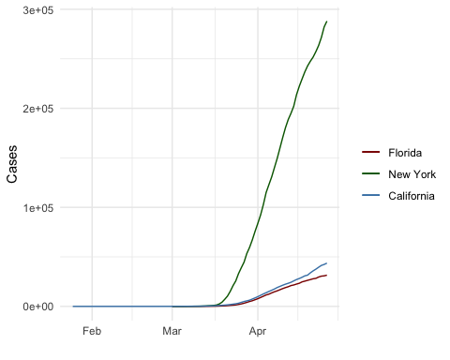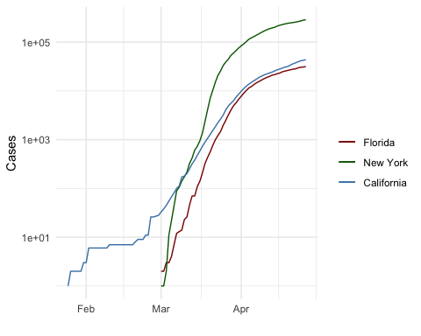

## R4DS Height vs Earnings

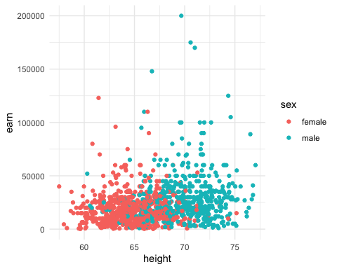 # Tables

## name race in_fellowship ring_bearer age  
## 1 Aragon Men TRUE FALSE 88  
## 2 Bilbo Hobbit FALSE TRUE 129  
## 3 Frodo Hobbit TRUE TRUE 51  
## 4 Galadriel Elf FALSE FALSE 7000  
## 5 Sam Hobbit TRUE TRUE 36  
## 6 Gandalf Maia TRUE TRUE 2019  
## 7 Legolas Elf TRUE FALSE 2931  
## 8 Sauron Maia FALSE TRUE 7052  
## 9 Gollum Hobbit FALSE TRUE 589

## Knitr Table with Kable

## Pandoc Table

One Ring to Rule Them All

| name | race | in_fellowship | ring_bearer | age |
| --- | --- | --- | --- | --- |
| Aragon | Men | TRUE | FALSE | 88 |
| Bilbo | Hobbit | FALSE | TRUE | 129 |
| Frodo | Hobbit | TRUE | TRUE | 51 |
| Galadriel | Elf | FALSE | FALSE | 7000 |
| Sam | Hobbit | TRUE | TRUE | 36 |
| Gandalf | Maia | TRUE | TRUE | 2019 |
| Legolas | Elf | TRUE | FALSE | 2931 |
| Sauron | Maia | FALSE | TRUE | 7052 |
| Gollum | Hobbit | FALSE | TRUE | 589 |

# References

Lander (2014) Field, Miles, and Field (2012)

Field, A., J. Miles, and Z. Field. 2012. *Discovering Statistics Using r*. SAGE Publications. <https://books.google.com/books?id=wd2K2zC3swIC>.

Lander, J. P. 2014. *R for Everyone: Advanced Analytics and Graphics*. Addison-Wesley Data and Analytics Series. Addison-Wesley. <https://books.google.com/books?id=3eBVAgAAQBAJ>.

1. This is a footnote.