FlashMem VIP
Handbook

March 2012
Version 00.00
Table of Contents
1 Datasheet 4
2 Introduction 5
2.1 Flash Memory 5
2.1.1 ONFi 5
2.2 Verification IP (VIP) 6
2.2.1 Interface 7
2.2.2 Transfer 8
2.2.3 Driver 8
2.2.4 Sequencer 8
2.2.5 Monitor 8
3 FlashMem VIP 9
3.1 Architecture 9
3.2 Interface 10
3.2.1 Signals 11
3.2.2 Clocking Block 11
3.3 Transfer 12
3.4 Driver 12
3.4.1 Run Phase 13
3.4.2 Get Transfer 13
3.4.3 Detect Transfer 14
3.4.4 Drive Transfer 15
3.4.5 Idle and Reset 16
3.5 Sequencer 17
3.5.1 Monitor Export 17
3.5.2 Transfer Action 18
3.6 Monitor 19
3.6.1 Run Phase 19
3.6.2 Monitor Transactions 19
3.6.3 Detect Transfer 20
3.6.4 Collect Transfer 21
3.6.5 Write 23
3.7 Agent 23
4 Test 24
4.1 Reporting 24
4.2 Transcript and Wave 26
4.2.1 Test 1: Monitor and Sequencer 27
4.2.2 Test 2: Driver 29
4.3 Future Work 32

Illustration Index
Illustration 1: FlashMem VIP Block Diagram 4
Illustration 2: UVM TB Environment 7
Illustration 3: FlashMem VIP Architecture 10
Illustration 4: Interface Signals (memory_if.sv) 11
Illustration 5: Interface Clocking Block (memory_if.sv) 12
Illustration 6: Transfer (memory_transfer.sv) 12
Illustration 7: Driver Run Phase (memory_slave_driver.sv) 13
Illustration 8: Driver Get and Drive (memory_slave_driver.sv) 14
Illustration 9: Driver Transfer Detection (memory_slave_driver.sv) 15
Illustration 10: Driver Transfer Driving (memory_slave_driver.sv) 16
Illustration 11: Driver Idle and Reset (memory_slave_driver.sv) 17
Illustration 12: Sequencer Monitor Export (memory_slave_sequencer.sv) 18
Illustration 13: Sequencer Transfer Action (memory_slave_sequencer.sv) 18
Illustration 14: Monitor Run Phase (memory_slave_monitor.sv) 19
Illustration 15: Monitor Monitor Transactions (memory_slave_monitor.sv) 20
Illustration 16: Monitor Detect Transfer (memory_slave_monitor.sv) 21
Illustration 17: Monitor Collect Transfer (memory_slave_monitor.sv) 22
Illustration 18: Monitor Detect Transfer (memory_slave_agent.sv) 23
Illustration 19: Reporting Styles 26
Illustration 20: Transcript First Messages 27
Illustration 21: Transcript Repeated Messages 27
Illustration 22: Transcript Command Latch 28
Illustration 23: Transcript Address Latch 28
Illustration 24: Transcript Data Write 29
Illustration 25: Driver Detect Transfer Write Access (memory_slave_driver.sv) 29
Illustration 26: Transcript First Messages 30
Illustration 27: Wave Test2 Driver 31

Index of Tables
Table 1: Task vs. Function 13
Table 2: UVM Verbosity Levels and Report Functions 25

Abbreviations
DUV | Design Under Verification
ISI | Institute of Systems Engineering
ONFi | Open NAND Flash interface
OVM | Open Verification Methodology
SV | SystemVerilog
TB | Test Bench
UVE | Unified Verification Environment
UVM | Universal Verification Methodology
VC | Verification Component
VHDL | VHSIC (Very-High-Speed Integrated Circuit) Hardware Description Language
VIP | Verification Intellectual Property

Datasheet
FlashMem VIP is a Universal Verification Methodology (UVM) verification IP (VIP) that provides an Open NAND Flash interface (ONFi) compatible interface and should simulates the behavioral of a memory chip. The interface consists of the signals shown on the right side of Illustration 1. Please note that only the data port IO0 for single data rate mode is implemented. The data ports DQ0 and DQS0 are not used yet.
FlashMem VIP is able to collect write accesses, prints them out and sends them on to the rest of the TB as transfers with the elements shown on the left side of Illustration 1. On read accesses it delivers random data.
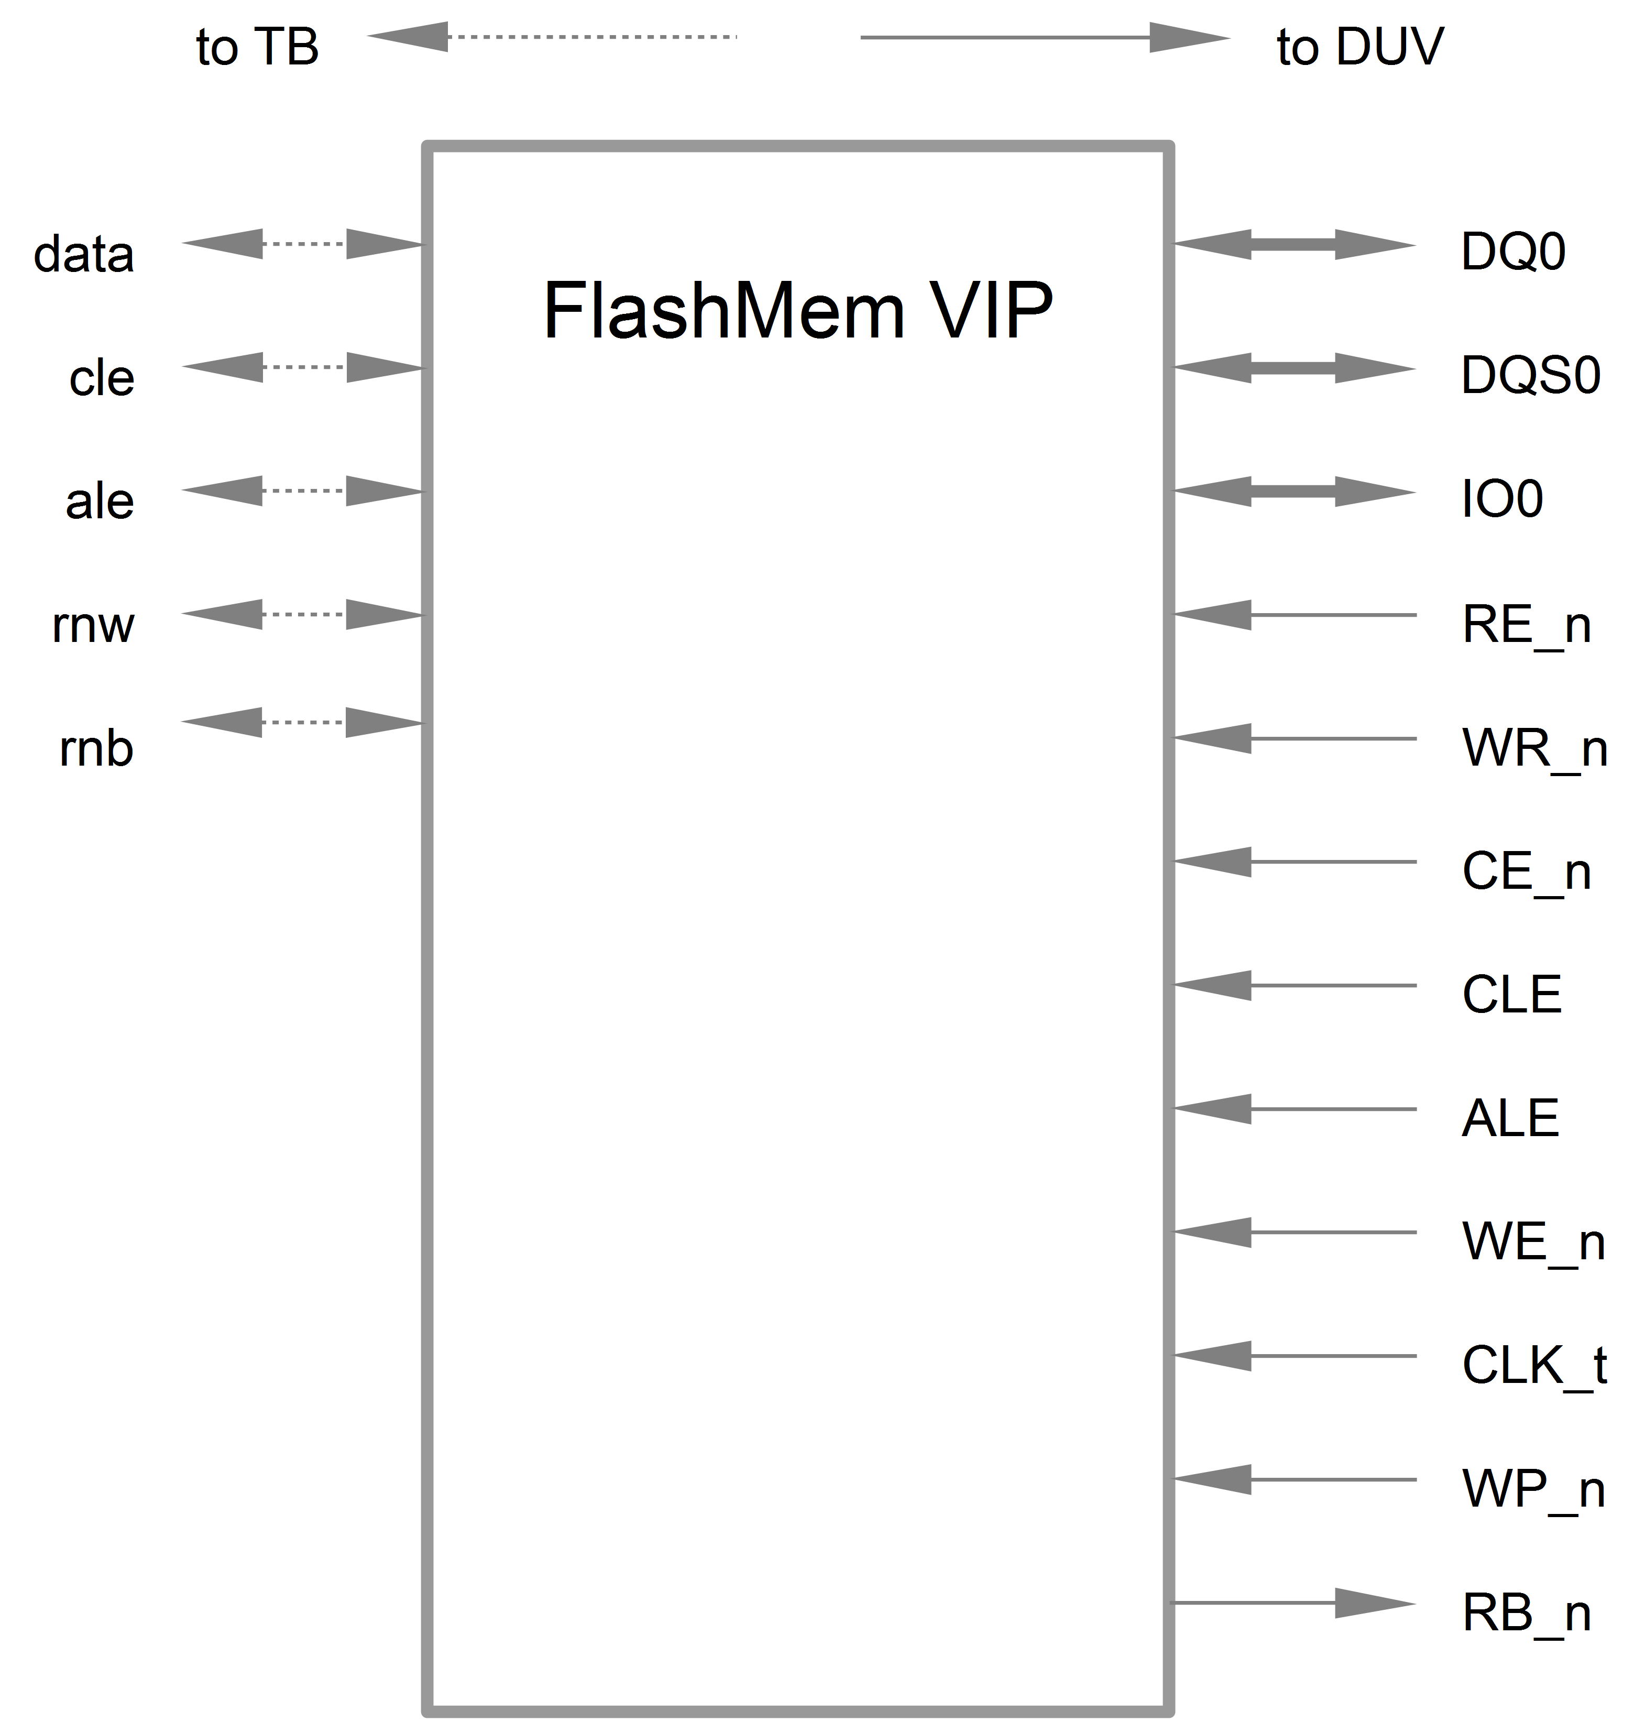Illustration 1: FlashMem VIP Block Diagram

Introduction
The following chapters in this sections give a short introduction to flash memories and verification IPs. The section FlashMem VIP describes the present flash memory verification IP in detail. Finally section Test explains the tests executed to verify the VIP and gives some ideas how the FlashMem VIP could be improved.

Flash Memory
There exist basically two types of flash memory, which differ on their internal structure. They are therefore called NAND and NOR flash. It is left to the interested reader to inform himself about the structural details and differences of the two flash types. For this VIP, the important part of these flash memories is the interface they provide. While NOR memories provide an external address bus for read and program operations (and thus support random-access), unlocking and erasing NOR memories must proceed on a block-by-block basis. With NAND flash memories, read and programming operations must be performed one page at a time, while unlocking and erasing must happen in a block-wise fashion. The FlashMem VIP is built imitating the NAND flash memories.

ONFi
An industry working group of more than 80 companies called Open NAND Flash interface (ONFi) has developed an open standard for the low-level interface to raw NAND flash chips. The goal of this specification is to simplify NAND flash integration. To be compatible to a wide range of memory chips, the FlashMem VIP is based on v3.0 of the ONFi standard, which is available for free on the ONFi web-page. However following restrictions will be applied to simplify the implementation:
- only the asynchronous interface will be implemented
- the target consists of only one Logical Unit
- the target has only one 8-bit I/O port used in single data rate

Verification IP (VIP)
When it comes to TBs in SV, an open source library called Open Verification Methodology (OVM) is widely adopted today. Nevertheless its successor, the Universal Verification Methodology (UVM), is gaining a lot of momentum. This VIP has been developed with OVM and then been adapted to UVM.
There exists a Perl script provided together with the UVM library code that converts any OVM VIP into an UVM compatible VIP. Nevertheless some manual corrections had to be done afterward.
The VIP implemented in this work is derived from a construct called verification component (VC) in UVM terminology. VCs typically contain one or more agents. An agent connects on one side to the DUV and on the other side to the rest of the TB (see Illustration 2). A standard UVM TB consists of several VCs.
An agent is divided into an active and a passive part. The active part acts and reacts on changes on the DUV pins and is build of the sequencer and the driver. The passive part collects and reports the activities on the DUV pins and contains at least a monitor.
Moreover, an agent can be a slave agent or a master agent. Slave agents respond to requests on the DUV IF, whereas master agents can initiate transactions between the TB and the DUV. As the Flash VIP has to react on data accesses form the DUV, it is naturally a slave agent.
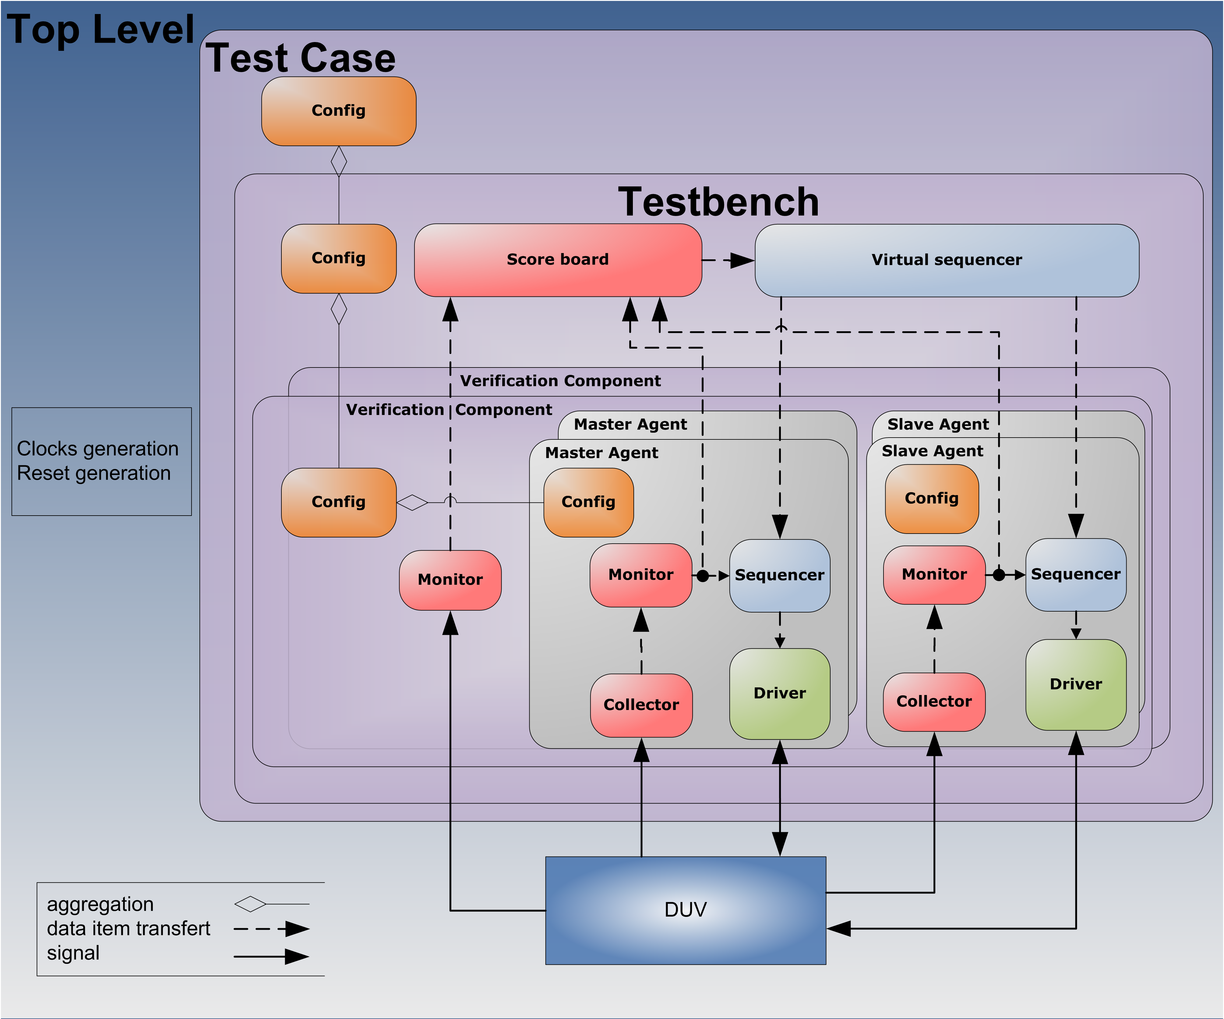Illustration 2: UVM TB Environment

Interface
An interface serves as connection point between the DUV and the TB. It defines the signals used as well as their direction. Therefore the DUV and the agent do not connect directly. Instead they connect to the interface. This has the advantage, that the signals which are connected between DUV and TB are defined in a single place. The interface defines furthermore which signals are inputs or outputs for which component and at which specific moment in simulation time the signals are sampled or driven respectively.
To simplify the description of an agent, the interface is often neglected and it is assumed that the agent connects directly to the DUV.

Transfer
A transfer defines the objects exchanged inside the agent as well as between the agent and the rest of the TB. It serves as abstraction of the pin level interface and provides only the needed information to the rest of the TB. Like this, the higher level TB is not influenced by minor changes on the pin level. The higher level testbench can so also be reused for similar types of interfaces, by simply exchanging a given agent with another one whit the same transfer.

Driver
The active component acting on the DUV pins is called driver. It detects actions on the pins and requests then a transfer from the sequencer. The driver then converts this transfer into signals on the DUV pins.

Sequencer
A sequencer takes sequences from a list and sends them to the driver.

Monitor
The passive component is called monitor. It collects the changes on the DUV pins and verifies their correctness. Then it stores them into transfers and sends them out for further analysis.

FlashMem VIP
The VIP will model a flash memory and is implemented in SystemVerilog (SV). As mentioned above, it follows the UVM methodology and uses the UVM library. The TB environment was generated using the online OVM Template Generator provided by Paradigm Works and then transferred to UVM. In this chapter the lines of code added for the Flash VIP are shown.
It is not the intention of this report to introduce the reader to SV. Nevertheless there are some explanations about the syntax or concepts of SV where it seemed appropriate.

Architecture
The architecture of the FlashMem VIP is shown in Illustration 3 and is composed of an environment containing an agent and an interface. The agent is implemented as an active slave. This implies that it is built out of a monitor, a sequencer and a driver. In the following chapters you find more details about these components.
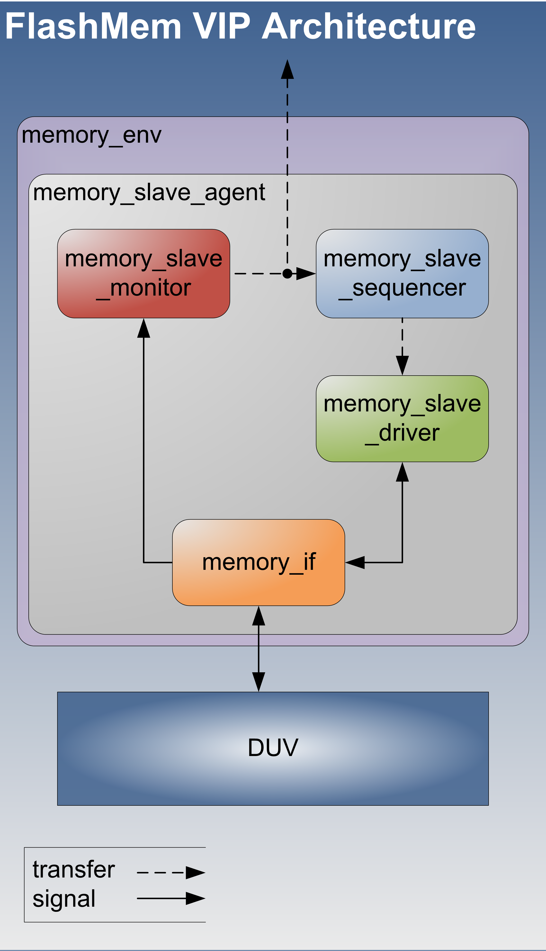Illustration 3: FlashMem VIP Architecture

Interface (memory_if)
The interface contains the signals shown in Illustration 4 and the clocking block shown in Illustration 5. The interface is implemented in file memory_if.sv.

Signals
In SV there exists no specific data type for signals containing more than one bit, a bus is just an array of signals. Variables of the type logic can only be driven by a single module. Therefore the bidirectional signals have to be defined as wire to allow SV to resolve the final value.
In order to make the bidirectional wire IO0 (Line 4) accessible, a local signal IO0_drive (Line 17) has been added. This signal is driven by the driver and continuously assigned to the wire (Line 18).
There exists another solution to the problem of assigning bidirectional DUV pins. It can be solved with the help of modport. This approach would fit better into the UVM methodology and should be elaborated for a future TB or VIP.
48: // flash inouts
49: wire[(NCHIP*8)-1:0] DQ0; // IO Port 0: for source synchronous
50: wire[NCHIP-1:0] DQS0; // data strobe: for source synchronous
51: wire[(NCHIP*8)-1:0] IO0; // IO Port 0: for asynchronous
52: // flash inputs
53: logic RE_n; // not read enable: for asynchronous
54: logic WR_n; // not (write/read direction) = read not write
55: logic CE_n; // not chip enable
56: logic CLE; // command latch enable
57: logic ALE; // address latch enable
58: logic WE_n; // not write enable: for asynchronous
59: logic CLK_t; // clock: for source synchronous
60: logic WP_n; // not write protect
61: // flash outputs
62: logic RB_n; // not (ready not busy) = busy not ready
63: // local signals
64: logic[(NCHIP*8)-1:0] IO0_drive = 'z; // IO Port 0: logic to drive wire
65: assign IO0 = IO0_drive;
Illustration 4: Interface Signals (memory_if.sv)

Clocking Block
The clocking block synchronizes the interfaces signals to a clock and servers therefore as divider between the event driven TB and the clock synchronous DUV. The present clocking block is synchronized to the rising edge of the clock signal (Line 69). The TB top module assigns the clock signal to the interface.
The clocking block also defines the exact time, when inputs are sampled and outputs are driven. On line 72 it is specified that the input signals have to be sampled just before the clock. The outputs to the DUV are driven one time unit after the clock (Line 74). The time unit is set in the TB top module, in this case it is 1ns.
Furthermore the clocking block defines which signals are inputs, outputs or bidirectional signals (Line 75-77). The direction of the signals is defined as seen by the TB.
69: clocking cb @(posedge clk);
70: //input-output as seen by the TB
71: //input (sample) skew, #1step = just before the clock
72: default input #1step;
73: //output (drive) skew, #1 = one time unit after the clock
74: default output #1;
75: input RE_n, WR_n, CE_n, CLE, ALE, WE_n, WP_n, CLK_t;
76: inout DQ0, DQS0, IO0;
77: output RB_n;
78: endclocking : cb
Illustration 5: Interface Clocking Block (memory_if.sv)

Transfer
In the context of this project a transfer (Illustration 6) is defined as a data exchange (Line 57) together with some controlling signals (Line 58-61). The transfer is parametrized by the number of chips in parallel (Line 55, 57). The transfer's code can be found in the file memory_transfer.sv.
All signals are of the type rand logic. This means that they are initialized with a random value for each transfer sent to the driver (§3.4.2). Nevertheless this random value can be overwritten in the sequence by a specific value.
55: parameter int unsigned NCHIP = 3;
56:
57: rand logic[(NCHIP*8)-1:0] data; // data
58: rand logic cle; // command
59: rand logic ale; // address
60: rand logic rnw; // read not write
61: rand logic rnb; // ready not busy
Illustration 6: Transfer (memory_transfer.sv)

Driver (memory_slave_driver)
The driver is modified to contain several custom functions or tasks. The first one serves to detect a data exchange on the DUV pins. Then another task requests a transfer from the sequencer, to respond to the data exchange. A third task executes the transfer on the DUV pins. Of these functions, the first two happen in zero simulation time. Only the driving task advances the simulation time. When there's no data exchange, the output signals have to be driven to an idle state. This is done by a fourth task. A last task then guarantees that the driver advances in simulation time, even if there is no transfer to drive on the DUV pins. The starting point off all these functions is the driver's run_phase task. The source code of this driver is written to the file memory_slave_driver.sv.
In SV there exist tasks and functions. Their syntax is quite similar, though there are some important differences in their usage, which are disclosed in Table 1.
Table 1: Task vs. Function
Task | Function
can consume simulation time  (posedge, negedge, # delay) | should be executed in zero simulation time
many inputs and outputs | many inputs, one output
no return value | return a value  (with return or by assigning a value to the name of the function, whereas the return functionality has priority)
for modeling combinatorial and/or sequential logic | for modeling combinatorial logic
can call other tasks or functions | can call other functions

Run Phase
The run_phase task (Illustration 7) of our VIP forks the task to drive the pins (Line 39 and §3.4.2) as well as the task to set the signals to the reset or idle state (Line 40 and §3.4.5). This means, that the two functions always run in separate threads independently.
37: task memory_slave_driver::run_phase(uvm_phase phase);
38: fork
39: get_and_drive();
40: reset_signals();
41: join_none
42: endtask : run_phase
Illustration 7: Driver Run Phase (memory_slave_driver.sv)

Get Transfer
The get_and_drive task (Illustration 8) tests if there is a data exchange request from the DUV by calling the function detect_transfer (Line 86 and §3.4.3). If this is the case, the sequencer is checked to have a transfer available (Line 89). The available transfer is then fetched from the sequencer (Line 92) and driven on the DUV pins (Line 100). Then it is reported back to the sequencer that the transfer has been used (Line 101). Finally all signals are reset to idle state (Line 118).
80: task memory_slave_driver::get_and_drive();
81: uvm_sequence_item item;
82: memory_transfer t;
83:
84: forever begin
85:
86: if ( detect_transfer() ) begin
87: // if data exchange requested from DUV
88:
89: if ( seq_item_port.has_do_available() ) begin
90: // transfer available
91:
92: seq_item_port.get_next_item(item);
93:
94: uvm_report_info(
95: get_type_name(),
96: "sequencer got next item",
97: UVM_DEBUG );
98:
99: $cast(t, item);
100: drive_transfer(t);
101: seq_item_port.item_done();
102:
103: uvm_report_info(
104: get_type_name(),
105: "sequencer item_done_triggered",
106: UVM_DEBUG );
107:
108: end
109:
110: uvm_report_info(
111: get_type_name(),
112: "sequencer item_done_triggered",
113: UVM_DEBUG );
114:
115: end
116:
117: // Advance clock
118: send_idle();
119: end
120:
121: endtask : get_and_drive
Illustration 8: Driver Get and Drive (memory_slave_driver.sv)

Detect Transfer
This function (Illustration 9) detects data exchanges on the DUV pins. It is called when needed by the get_and_drive task (see §3.4.2). As the current driver only drives the data on read accesses from the DUV, a data exchange is detected when the RE_n signal is driven low by the DUV (Line 55). If this is the case, a 1 is reported back to the caller of the function (Line 65), otherwise a 0 (Line 75).
50: function int memory_slave_driver::detect_transfer();
51:
52: if (
53: // intf.CLE == 1 |
54: // intf.ALE == 1 |
55: intf.RE_n == 0 //|
56: // intf.WE_n == 0
57: )
58: begin
59:
60: uvm_report_info(
61: get_type_name(),
62: "Flash memory transfer request detected",
63: UVM_DEBUG
64: );
65: return 1;
66:
67: end;
68:
69: uvm_report_info(
70: get_type_name(),
71: "_NO_ Flash memory transfer request detected",
72: UVM_DEBUG
73: );
74:
75: return 0;
76:
77: endfunction: detect_transfer
Illustration 9: Driver Transfer Detection (memory_slave_driver.sv)

Drive Transfer
This task (Illustration 10) finally drives the transfer on the DUV pins. As all the previous functions don't use any simulation time, the system has to be synchronized to the system clock on the first access of this task (Lines 130-132). Afterwards the system remains synchronized to the system clock and the synchronization therefore does not has to be repeated. The synchronization simply waits on the next rising edge of the system clock by waiting on the next event of the interfaces clocking block.
After synchronizing, the DUV pins are driven with the values received from the sequencer (Line 135 and 143).
123: task memory_slave_driver::drive_transfer (memory_transfer trans);
124: string msg;
125:
126: uvm_report_info(get_type_name(), "drive_transfer");
127:
128: // sync to clock
129: // only needed on first access, further accesses are synced implicitly
130: if (!synced) begin
131: @(intf.cb);
132: end
133:
134: // drive data
135: intf.IO0_drive = trans.data;
136: $sformat(
137: msg,
138: "access with data = 0x%h",
138: trans.data
139: );
140: uvm_report_info(get_type_name(), {"Memory read ", msg});
141:
142: // and busy
143: intf.RB_n = !trans.rnb;
144:
145: endtask : drive_transfer
Illustration 10: Driver Transfer Driving (memory_slave_driver.sv)

Idle and Reset
These two tasks (Illustration 11) serve, as their names suggest, to drive the signals when there's no data exchange or to reset the signals at the beginning of a test.
In addition the send_idle task also advances the system time by one clock cycle by waiting on an event on the clocking block of the interface (Line 159 and §3.2.2).
The signal RB_n is the only output only signal of the TB. It is therefore set to 0 at reset (Line 165). The bidirectional IO signals are automatically assigned to high impedance when there's no access from the TB.
157: task memory_slave_driver::send_idle();
158: uvm_report_info(get_type_name(), "send_idle ...", UVM_DEBUG);
159: @(intf.cb);
160: endtask:send_idle
161:
162: task memory_slave_driver::reset_signals();
163: uvm_report_info(get_type_name(), "reset_signals ...");
164: // flash outputs
165: intf.RB_n = '0; // not (ready not busy) = busy not ready
166: endtask : reset_signals
Illustration 11: Driver Idle and Reset (memory_slave_driver.sv)

Sequencer (memory_slave_sequencer)
For this project, the sequencer shall model the memorizing behavior of the flash memory. It shall store the received data from the DUV in an array and deliver them on request. It's file is called memory_slave_sequencer.sv.
There shall also be a backdoor access to the data in the array. This is useful to preset the data if it is needed to start from a given data set. It also allows printing or verifying the content of the array at any time. Furthermore it can be used to alter the data during run-time, for example to introduce errors.
The present sequencer does not contain all of this functionality yet.

Monitor Export
The export to get collected transfers from the monitor (Illustration 12) is implemented on Line 37. The transfers are fetched from the monitor by implementing the function write (Line 48-51). This function is called by the monitor's analysis port each time it has a transfer available. The received transfer is then passed on to the transfer_action function (Line 49 and §3.5.2).

Transfer Action
37: item_collected_eport = new("item_collected_eport", this);

47: // get transactions from monitor
48: function void memory_slave_sequencer::write(memory_transfer trans);
49: transfer_action(trans);
50: item_collected = trans;
51: endfunction : write
Illustration 12: Sequencer Monitor Export (memory_slave_sequencer.sv)
The transfer_action function (Illustration 13) shall act on the transfer sent to the driver with the data received from the monitor. Furthermore it shall implement a data array which will store the memory data. This functionality should be added in a future work. At the moment the function only verifies the good reception of the monitors collected transfer with a printout of its content.
53: // act on transfer
54: function void memory_slave_sequencer::transfer_action(input memory_transfer trans);
55:
56: string msg;
57:
58: $sformat(
59: msg,
60: {" data : 0x%h\n",
61: " cle : %b\n",
62: " ale : %b\n",
63: " rnw : %b"},
64: trans.data,
65: trans.cle,
66: trans.ale,
67: trans.rnw
68: );
69: uvm_report_info(
70: .id(get_type_name()),
71: .message({"\nSequencer analysis transaction reception\n", msg}),
72: .verbosity(UVM_DEBUG),
73: .filename(`__FILE__),
74: .line(`__LINE__)
75: );
76:
77: endfunction : transfer_action
Illustration 13: Sequencer Transfer Action (memory_slave_sequencer.sv)

Monitor (memory_slave_monitor)
The monitor is similarly constructed as the driver. Like the driver, the monitor has to detect data exchanges on the DUV pins. But instead of giving a response, the monitor only collects all necessary information of the data exchange. This information is then sent on to the rest of the TB in form of a transfer. The monitor is implemented in the file memory_slave_monitor.sv.

Run Phase
In the monitor the run_phase task (Illustration 14) only calls the monitor_transactions task (Line 80 and §3.6.2) in a separate thread.
78: task memory_slave_monitor::run_phase();
79: fork
80: monitor_transactions();
81: join_none
82: endtask : run_phase
Illustration 14: Monitor Run Phase (memory_slave_monitor.sv)

Monitor Transactions
The monitor_transactions task (Illustration 15) tests if there is a data exchange request from the DUV by calling the function detect_transfer (Line 53 and §3.6.3). If this is the case, a task is called to collect the data exchange into a transfer (Line 56). Then there are two function calls to check the transfer (Line 60) and to perform coverage collection (Line 64). The execution of these two functions can be enabled or disabled by setting the corresponding variable (Line 59 and 63). These two functions are not implemented in the current VIP. The next important step is to call the write function of the monitor's analysis port (Line 67). Finally the simulation time is advanced by waiting on an event on the interface's clocking block (Line 71 and §3.2.2)
50: task memory_slave_monitor::monitor_transactions();
51:
52: forever begin
53: if (detect_transfer()) begin
54:
55: // Extract data from interface into transaction
56: collect_transfer();
57:
58: // Check transaction
59: if (checks_enable)
60: perform_transfer_checks();
61:
62: // Update coverage
63: if (coverage_enable)
64: perform_transfer_coverage();
65:
66: // Publish to subscribers
67: item_collected_port.write(trans_collected);
68: end
69:
70: // Advance clock
71: @(intf.cb);
72: end
73:
74: endtask // monitor_transactions
Illustration 15: Monitor Monitor Transactions (memory_slave_monitor.sv)

Detect Transfer
This function (Illustration 16) detects a data exchange on the DUV pins whenever one of the flash memory control pins is in an active state (Line 87 – 90). On this occasion, it returns 1 (Line 97) else 0 (Line 106).
85: function int memory_slave_monitor::detect_transfer();
86:
87: if ( intf.CLE == 1 |
88: intf.ALE == 1 |
89: intf.RE_n == 0 |
90: intf.WE_n == 0 )
91: begin
92: uvm_report_info(
93: get_type_name(),
94: "Flash memory transfer request detected",
95: UVM_DEBUG
96: );
97: return 1;
98: end;
99:
100: uvm_report_info(
101: get_type_name(),
102: "Flash memory _NO_ transfer request detected",
103: UVM_DEBUG
104: );
105:
106: return 0;
107:
108: endfunction: detect_transfer
Illustration 16: Monitor Detect Transfer (memory_slave_monitor.sv)

Collect Transfer
In Illustration 17 it can be seen how this task collects the state of the interesting DUV pins into a transfer. Line 117 and 166 contain some standard UVM code for transaction handling and are not further explained here. Then on the lines 130-137 the task waits until there is a rising edge on the WE_n signal. This is the moment to sample the data as well as the control signals (Line 140 – 144).
112: task memory_slave_monitor::collect_transfer();
113:
114: string msg;
115:
116: // indicate start of transaction
117: void'(this.begin_tr(trans_collected));
118:
119: if (intf.cb.CLE == 1) begin
120: // command latch
121: msg = "command";
122: end else if (intf.cb.ALE == 1) begin
123: // address latch
124: msg = "address";
125: end else begin
126: //data latch
127: msg = "data";
128: end
129:
130: // wait on WE_n to be low
131: if (intf.cb.WE_n == 1) begin
132: @(intf.cb.WE_n);
133: end
134: // wait on rising edge WE_n
135: if (intf.cb.WE_n == 0) begin
136: @(intf.cb.WE_n);
137: end
138:
139: // collect data for transfer
140: trans_collected.data = intf.IO0; // data
141: trans_collected.cle = intf.CLE; // command
142: trans_collected.ale = intf.ALE; // address
143: trans_collected.rnw = !intf.RE_n; // read not write
144: trans_collected.rnb = !intf.RB_n; // ready not busy
145:
146: $sformat(
147: msg,
148: {"\nCollected ", msg, " transfer with\n",
149: " data: 0x%h\n",
150: " CLE : %b\n",
151: " ALE : %b\n",
152: " REn : %b\n",
153: " RBn : %b"},
154: trans_collected.data,
155: trans_collected.cle,
156: trans_collected.ale,
157: !trans_collected.rnw,
158: !trans_collected.rnb);
159: uvm_report_info( get_type_name(), msg, UVM_DEBUG );
160:
161: // indicate end of transaction
162: this.end_tr(trans_collected);
163:
164: endtask // collect_transfer
Illustration 17: Monitor Collect Transfer (memory_slave_monitor.sv)

Write
This function is not implemented by the monitor, but has to be implemented by any subscriber to the analysis port. It is called in the subscriber by the monitor each time there is a transfer. This has the advantage that the monitor does not has to know who his subscribers are. In the current TB there are two subscribers to the memory monitor, the memory scoreboard and the memory sequencer. An implementation of this function can therefore be seen in §3.5.1.

Agent (memory_slave_agent)
In the agent the connection from the monitors analysis port to the sequencers export is implemented (Illustration 18). This is very easy and straight-forward with the help of the UVM connect method (Line 50). The agent's source code can be found in the file memory_slave_agent.sv.
In UVM a port can only be connected to one export. It is always the module with the port that initiates a transfer on the target with the export. Data can then flow in both directions. When the data flows from the initiator to the target it is called a put operation. The inverse data flow from the target to the initiator is called a get operation. The analysis port is a special port, as it can be connected to any number of exports.
47: function void memory_slave_agent::connect_phase();
48: if(is_active == UVM_ACTIVE) begin
49: driver.seq_item_port.connect(sequencer.seq_item_export);
50: monitor.item_collected_port.connect(sequencer.item_collected_eport);
51: end
52: endfunction : connect_phase
Illustration 18: Monitor Detect Transfer (memory_slave_agent.sv)

Test
Debugging and test of the implemented VIP have been done by analyzing the signals on simulation waveforms and with printouts to the transcript. All simulations have been done with Mentor Graphics Questa.

Reporting
UVM provides a very convenient reporting mechanism. There are predefined macros to publish messages of different severity levels. Furthermore a verbosity level can be applied to these messages. A list off all predefined verbosity levels and their corresponding report function are laid out in Table 2. During a test, a verbosity level for the main reporter function can be defined. Any report whose verbosity level exceeds this level will not be published. For example if the test runs with verbosity level UVM_LOW, no messages of the severity info will be shown. It is however to note that the verbosity is ignored for warning, error and fatal to ensure that the user does not inadvertently filters them out. The verbosity parameter is still in the function body of these macros for backward compatibility.
Verbosity Level Name | Verbosity Level Value | Default Report Function Severity
UVM_NONE | 0 | uvm_report_fatal
UVM_LOW | 100 | uvm_report_error
UVM_MEDIUM | 200 | uvm_report_info  uvm_report_warning
UVM_HIGH | 300 | -
UVM_FULL | 400 | -
UVM_DEBUG | 500
Table 2: UVM Verbosity Levels and Report Functions
Only the macro provided to report info messages is used in this VIP. It is used with the default verbosity level UVM_MEDIUM to inform the user of the VIP about important events. Then it is also used with the verbosity level UVM_DEBUG. These messages are only intended for the developer of the VIP to confirm the functionality of the VIP.
Messages are coded in three different styles (Illustration 19). The simplest one is the one-liner (Line 1 and 2). It is used for short messages. The simple multi-liner (Line 11 – 15) is used for more complex messages, where putting them on one line would render the code unreadable. In the complex multi-liner (Line 21 – 52) the concept of a string variable (Line 21) to build the message is introduced. This is particularly useful when different information in the message is available on different locations in the method (Line 22 – 31). The string is used to build the message and published once all information is collected. As a further advantage signals can be included into the message. It is clear that this could also be included into the message macro, but it's nicer to separate it for better readability. It is also obvious that after the string forming, the message could be published in a one-liner format. However when the specified verbosity level is on a single line it can be temporarily commented out when you need to see just this message in a log without all the other debug messages.
The $sformat system task (Line 32 – 47) is used to include variables into a string. The first argument (Line 33) of the task gets the string constructed from the string in the second argument (Line 34 – 41) together with the variables in the third argument (Line 42 – 46).
Then concatenating strings in SV is also very easy. Just put a series of strings separated by comas between braces (Line 34 – 41).

// 1) one-liner, with default and specific verbosity level
1: uvm_report_info(get_type_name(), "drive_transfer");
2: uvm_report_info(get_type_name(), "send_idle ...", UVM_DEBUG);

// 2) simple multi-liner with specific verbosity level
11: uvm_report_info(
12: get_type_name(),
13. "sequencer item_done_triggered",
14: UVM_DEBUG
15: );

// 3) complex multi-liner with string concatenation, parameters and specific verbosity level
21: string msg;
22: if (intf.cb.CLE == 1) begin
23: // command latch
24: msg = "command";
25: end else if (intf.cb.ALE == 1) begin
26: // address latch
27: msg = "address";
28: end else begin
29: //data latch
30: msg = "data";
31: end
32: $sformat(
33: msg,
34: {
35: "\nCollected ", msg, " transfer with\n",
36: " data: 0x%h\n",
37: " CLE : %b\n",
38: " ALE : %b\n",
39: " REn : %b\n",
40: " RBn : %b"
41: },
42: trans_collected.data,
43: trans_collected.cle,
44: trans_collected.ale,
45: !trans_collected.rnw,
46: !trans_collected.rnb
47: );
48: uvm_report_info(
49: get_type_name(),
50: msg,
51: UVM_DEBUG
52: );
Illustration 19: Reporting Styles

Transcript and Wave
All the published messages are logged in file called transcript by Questa. The complete transcript of a simulation might get some hundreds of thousands of lines. In the following, some excerpts of a transcript are shown to attest the functionality of all the implemented functions. The test sequence applied on the DUV is to execute a write access of one page of the flash memory, and then reread this page several times.

Test 1: Monitor and Sequencer
The first messages logged at simulation time 0 show that the driver, the monitor and the sequencer have been started as intended (Illustration 20).
1096: # UVM_INFO @ 0: uvm_test_top.VIPC_tb0.memory_0_inst.slaves[0].monitor [memory_slave_monitor] Flash memory _NO_ transfer request detected
1097: # UVM_INFO @ 0: uvm_test_top.VIPC_tb0.memory_0_inst.slaves[0].driver [memory_slave_driver] _NO_ Flash memory transfer request detected
1098: # UVM_INFO @ 0: uvm_test_top.VIPC_tb0.memory_0_inst.slaves[0].driver [memory_slave_driver] send_idle ...
1099: UVM_INFO @ 0: uvm_test_top.VIPC_tb0.memory_0_inst.slaves[0].driver [memory_slave_driver] reset_signals ...

667: # [0] hier=uvm_test_top.VIPC_tb0.memory_0_inst.slaves[0].sequencer: Starting default memory slave sequence
668: # [0] hier=uvm_test_top.VIPC_tb0.memory_0_inst.slaves[0].sequencer: Blocking peek waiting in default memory sequence
Illustration 20: Transcript First Messages
As there is no activity from the DUV, the messages shown in Illustration 21 are now repeated every clock cycle until the detection of the first data exchange.
800: # [130] hier=uvm_test_top.VIPC_tb0.memory_0_inst.slaves[0].driver: _NO_ Flash memory transfer request detected
801: # [130] hier=uvm_test_top.VIPC_tb0.memory_0_inst.slaves[0].driver: send_idle ...
802: # [130] hier=uvm_test_top.VIPC_tb0.memory_0_inst.slaves[0].monitor: Flash memory _NO_ transfer request detected
Illustration 21: Transcript Repeated Messages
The first data exchange detected by the monitor is a command latch (Illustration 22). As the driver only waits on data reads, it does not detect the data exchange request (Line 7944 – 7945). The messages clearly show that the monitor collects the transfer in Line 7946 – 7952 and that the sequencer gets the transfer instantly and correct (Line 7953 – 7958). The command 0x80 seen on Line 7948 indicates that the DUV is initiating a write process on the flash memory. The same command is repeated three times on the same data exchange, because the used DUV setup uses three flash memory chips in parallel sharing the same control signals. The next access to be expected would be the writing of the address where the data have to be stored.

7944: # [561630] hier=uvm_test_top.VIPC_tb0.memory_0_inst.slaves[0].driver: _NO_ Flash memory transfer request detected
7945: # [561630] hier=uvm_test_top.VIPC_tb0.memory_0_inst.slaves[0].driver: send_idle ...
7946: # [561880] hier=uvm_test_top.VIPC_tb0.memory_0_inst.slaves[0].monitor:
7947: # Collected data transfer with
7948: # data: 0x808080
7949: # CLE : 1
7950: # ALE : 0
7951: # REn : 1
7952: # RBn : 0
7953: # [561880] hier=uvm_test_top.VIPC_tb0.memory_0_inst.slaves[0].sequencer:
7954: # Sequencer analysis transaction reception
7955: # data : 0x808080
7956: # cle : 1
7957: # ale : 0
7958: # rnw : 0
Illustration 22: Transcript Command Latch
As expected, the next data exchange request detected is an address latch (Illustration 23). Again it is not detected by the driver (Line 7979 – 7980), successfully collected (Line 7981 – 7987) and sent to the sequencer (Line 7988 – 7993). In the complete transcript it can be observed that there are four address latch commands.
7979: # [562380] hier=uvm_test_top.VIPC_tb0.memory_0_inst.slaves[0].driver: _NO_ Flash memory transfer request detected
7980: # [562380] hier=uvm_test_top.VIPC_tb0.memory_0_inst.slaves[0].driver: send_idle ...
7981: # [562630] hier=uvm_test_top.VIPC_tb0.memory_0_inst.slaves[0].monitor:
7982: # Collected data transfer with
7983: # data: 0x000000
7984: # CLE : 0
7985: # ALE : 1
7986: # REn : 1
7987: # RBn : 0
7988: # [562630] hier=uvm_test_top.VIPC_tb0.memory_0_inst.slaves[0].sequencer:
7989: # Sequencer analysis transaction reception
7990: # data : 0x000000
7991: # cle : 0
7992: # ale : 1
7993: # rnw : 0
Illustration 23: Transcript Address Latch
The first real data exchange is detected some clock cycles later (Illustration 24). As it is a write operation it is again not detected by the driver (Line 8104 – 8105), successfully collected (Line 8106 – 8112) and sent to the sequencer (Line 8113 – 8118).
8104: # [564630] hier=uvm_test_top.VIPC_tb0.memory_0_inst.slaves[0].driver: _NO_ Flash memory transfer request detected
8105: # [564630] hier=uvm_test_top.VIPC_tb0.memory_0_inst.slaves[0].driver: send_idle ...
8106: # [564880] hier=uvm_test_top.VIPC_tb0.memory_0_inst.slaves[0].monitor:
8107: # Collected data transfer with
8108: # data: 0xf8f8f8
8109: # CLE : 0
8110: # ALE : 0
8111: # REn : 1
8112: # RBn : 0
8113: # [564880] hier=uvm_test_top.VIPC_tb0.memory_0_inst.slaves[0].sequencer:
8114: # Sequencer analysis transaction reception
8115: # data : 0xf8f8f8
8116: # cle : 0
8117: # ale : 0
8118: # rnw : 0
Illustration 24: Transcript Data Write
This test shows that the driver, the monitor and the sequencer are working as expected for a Command Latch, an Address Latch and a Data Write access from the DUV.

Test 2: Driver
To test the driver, a data read access on the flash memory would be needed. For this to happen with the above described test sequence, the driver needs to set the flash memory's busy signal correctly. This however is only possible when the sequencer controls this correctly. As the sequencer is not completed yet, another way has to be found to test the driver anyways. In consequence the driver has been modified as shown in Illustration 25 to act also on write accesses.
52: if (
53: // intf.CLE == 1 |
54: // intf.ALE == 1 |
55: intf.RE_n == 0 |
56: intf.WE_n == 0 // for debug only: enabled to act also on write accesses
57: )
58: begin
Illustration 25: Driver Detect Transfer Write Access (memory_slave_driver.sv)
In the screenshot of the waveform in Error: Reference source not found it can be seen that the flash_RnB signal takes arbitrary values and is well aligned to the rising edge of the Flash_WE_N signal. Furthermore it can be seen that the data pins Flash_ECC_IN and flash_IO_in change to an undefined state, the moment the TB starts to drive the pins while the DUV is driving them too.
In the transcript (Illustration 26) the same action can be verified with the report messages. Line 10612 shows that the driver detects the transfer as well as the monitor (Line 10611). Then the driver drives the transfer on the DUV pins (Line 10615) and reports the random data it's going to put out (Line 10628). After that the driver advances the simulation time by calling the send_idle task (Line 10631) and that the sequencer prepares a new transfer (Line 10633). One clock cycle later, the data exchange is collected by the monitor (Line 10636 – 10642). As the DUV as well as the TB are driving the data pins, they are in an unknown state (Line 10638).
10611: # [744880] hier=uvm_test_top.VIPC_tb0.memory_0_inst.slaves[0].monitor: Flash memory transfer request detected
10612: # [744880] hier=uvm_test_top.VIPC_tb0.memory_0_inst.slaves[0].driver: Flash memory transfer request detected

10614: # [744880] hier=uvm_test_top.VIPC_tb0.memory_0_inst.slaves[0].driver: sequencer got next item
10615: # [744880] hier=uvm_test_top.VIPC_tb0.memory_0_inst.slaves[0].driver: drive_transfer

10628: # [745130] hier=uvm_test_top.VIPC_tb0.memory_0_inst.slaves[0].driver: Memory read access with data = 0x931f4d
10629: # [745130] hier=uvm_test_top.VIPC_tb0.memory_0_inst.slaves[0].driver: sequencer item_done_triggered
10630: # [745130] hier=uvm_test_top.VIPC_tb0.memory_0_inst.slaves[0].driver: sequencer item_done_triggered
10631: # [745130] hier=uvm_test_top.VIPC_tb0.memory_0_inst.slaves[0].driver: send_idle ...

10633: # [745130] hier=uvm_test_top.VIPC_tb0.memory_0_inst.slaves[0].sequencer: Blocking peek waiting in default memory sequence

10636: # [745380] hier=uvm_test_top.VIPC_tb0.memory_0_inst.slaves[0].monitor:
10637: # Collected data transfer with
10638: # data: 0xXXxXXX
10639: # CLE : 0
10640: # ALE : 0
10641: # REn : 1
10642: # RBn : 0
Illustration 26: Transcript First Messages

This is the confirmation that the driver is really driving the DUV pins on request. Further tests have to be done once the sequencer is completed.

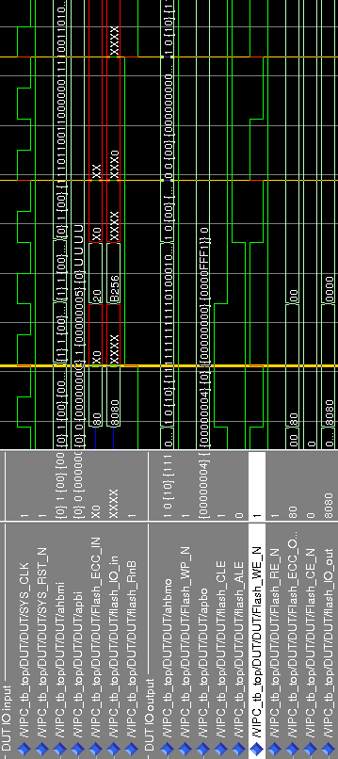Illustration 27: Wave Test2 Driver

Future Work
In a next step the sequencer should be completed to store the received data and provide them on request. Then sequences to respond correctly to page write and page read accesses could be written, including the correct handling of the flash busy signal. Once this is done, a basic flash memory VIP will have been developed.
This basic VIP could then be improved by adding more sequences e.g. for reading the memory status, erasing a block, copy-back programming a page and so on. It could also be improved to be fully compatible with the ONFi specification without restrictions and for all types and sizes of flash memories.
Then also the case of the bidirectional signals could be solved in more genuine way by using a modport.

http://en.wikipedia.org/wiki/Flash_memory#Low-level_access, 17:03, 25 February 2011
http://onfi.org/
http://en.wikipedia.org/wiki/Open_NAND_Flash_Interface_Working_Group, 16:07, 19 December 2010
http://www.onfi.org, 4 March 2011
http://www.accellera.org/activities/vip/uvm-1.0p1.tar.gz
http://svf-tg.paradigm-works.com/svftg/ovm
http://en.wikipedia.org/wiki/SystemVerilog#New_data_types, 18:12, 21 May 2011
http://www.mentor.com/products/fv/questa/

