Daniel Blackford

[DBB24@pitt.edu](mailto:DBB24@pitt.edu)

CS1520 Term Project

Project Plan Part 2

Part 1 wasn’t as successful as I’d hoped, but that leaves plenty of room to work for the second portion of the project. For a summary, I’ll go through the site section by section – but as far as Bootstrap as a framework is concerned I’m really glad I picked it and will continue to use it for the second part of the project. There was a learning curve and it took some time for me to grasp how to use the grid system, but now I feel like it’s a powerful tool that’s pretty easy to use. Additionally, as this is a site I intend to keep working on in the future, the fact that Bootstrap scales for mobile makes it an appealing option.

**Landing Page:**

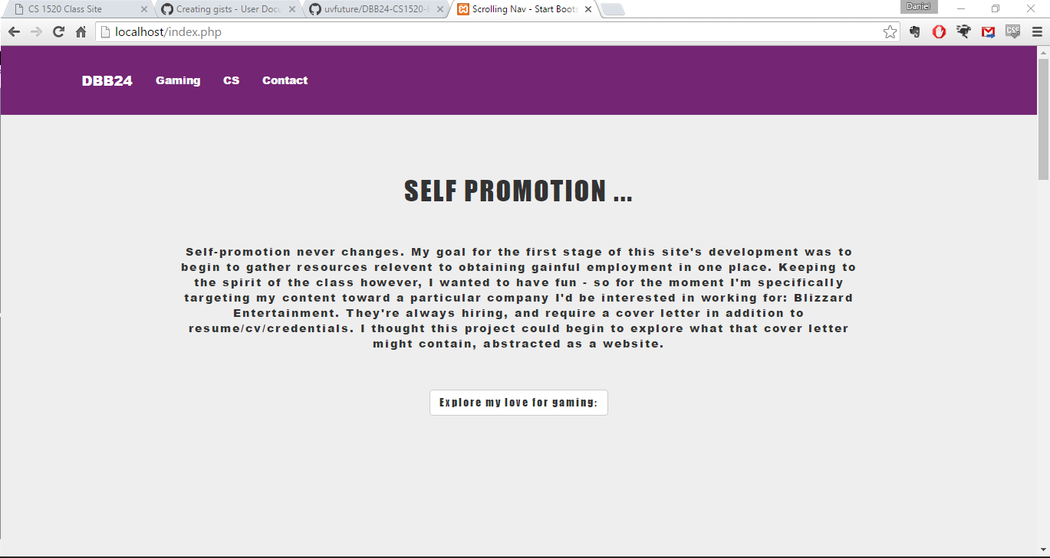

In particular, I wanted this page to be simply styled with clear navigation options. I used the same template as the one for the class site but was able to change the style enough (I think) through css that I think it feels unique. I could have gone further, but will probably leave this alone for the second portion because other sections have larger problems. One quick fix will be to change the styling on the button-link, as it’s not distinct enough from the plaintext above it.

**Gaming Section:**

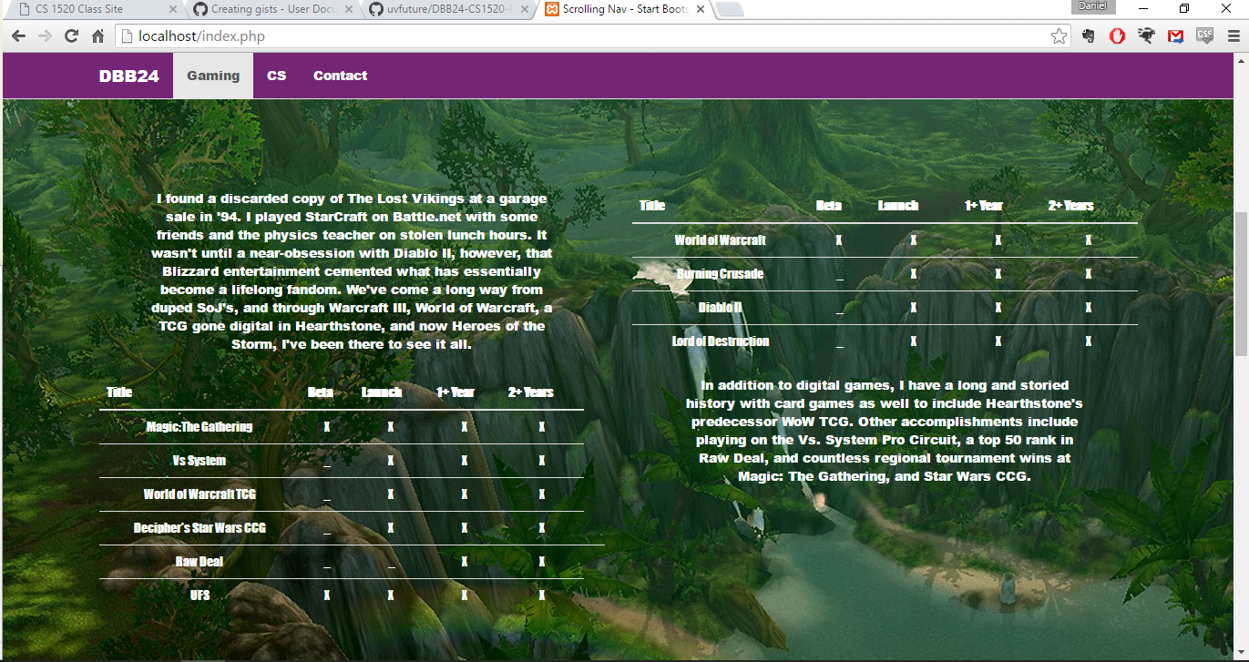

Content wise, I’m happy with how this turned out. It’s the section that actually uses the most PHP, and is probably most applicable to the goal of getting Blizzard to notice me! (…senpai). I did make use of some bootstrap alignment here, but it needs to be formatted better. Changes need to be made so that the text is more legible on the background, and so that the tables are a bit easier to read. I’m targeting the tables as elements I might be able to make a little more dynamic with JS/JQuery, but no new content will be added.

**CS Section:**

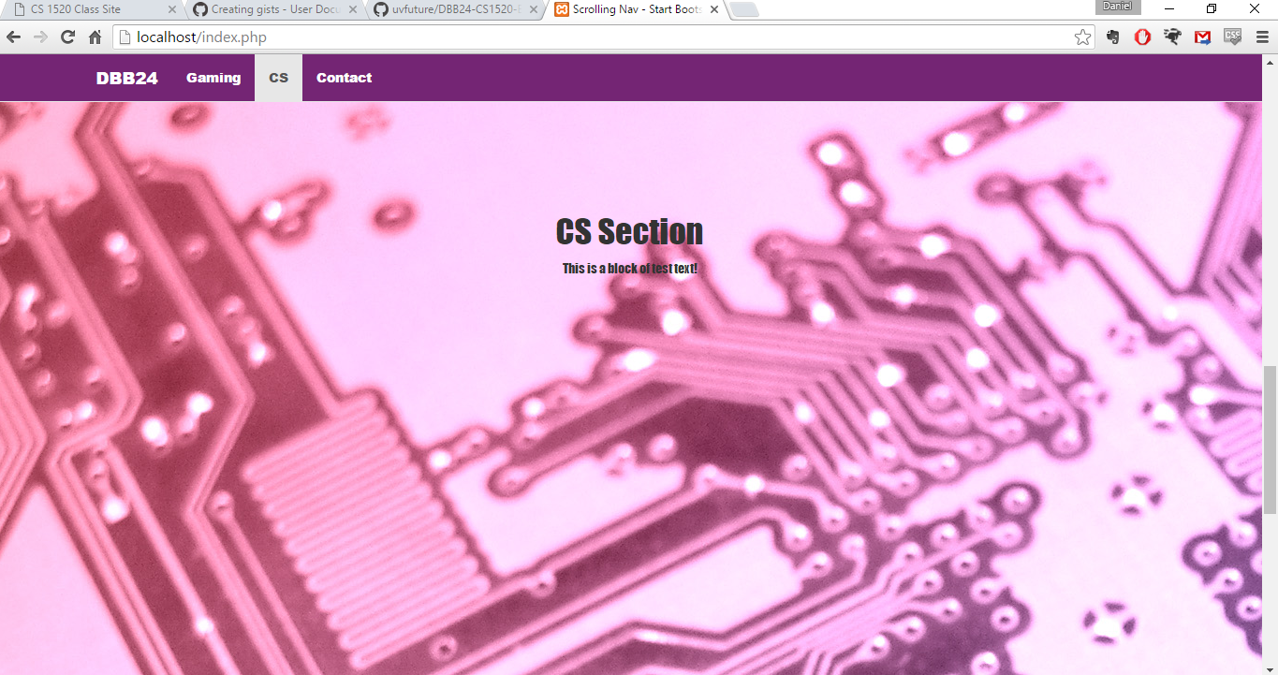

So, nothing was done with this section for the first iteration. Which makes it the prime target for upgrading in the second portion, though I’m not entirely sure what all to put on here. To keep it simple because I’ve dropped the ball, I think the content will likely be some list of the core classes/competencies that are a part of most CS degrees and that employers specifically target. I want to figure out a fun but relevant way to do this with JS/JQuery.

**Contact Section:**

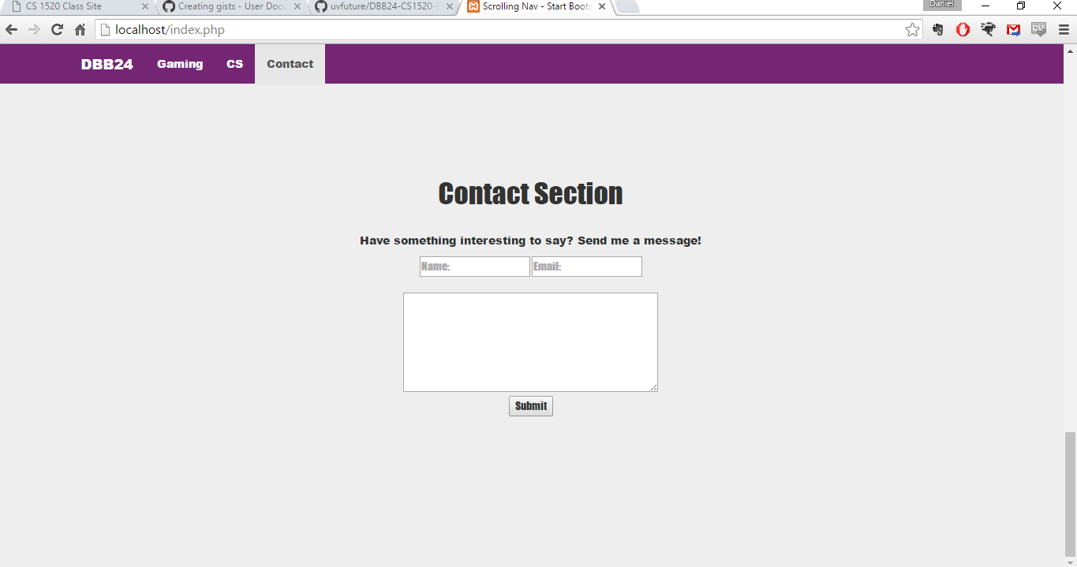

Finally, I wanted the last section to mirror the simple style of the first. The DB is fully functional, though I didn’t display that to you. I tested it with multiple cases, so the code should look right. If there’s a way I can include the files that actually hold the data for the local database I’ll do so with the final submission. While I don’t intend to change the content or look here, I will potentially use JS/JQuery to adjust the form processing.