QUERIES :

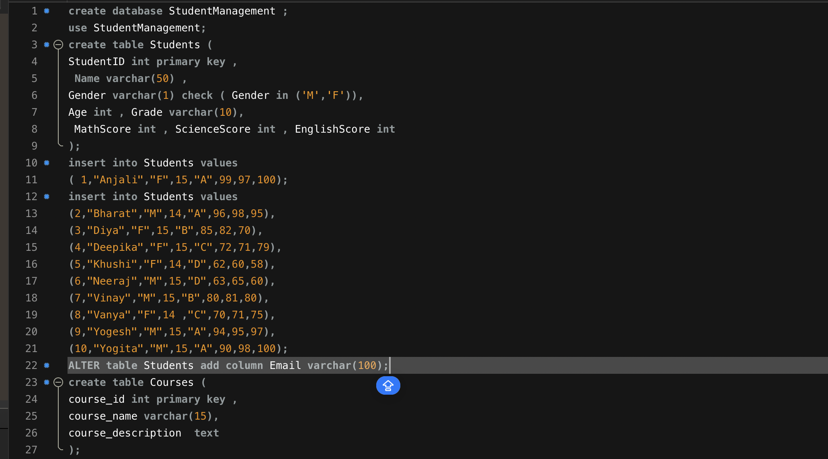

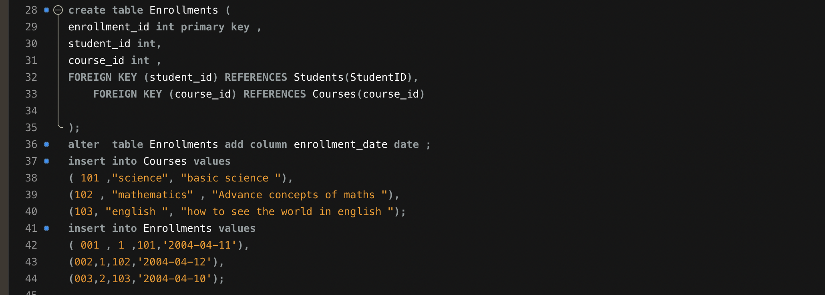

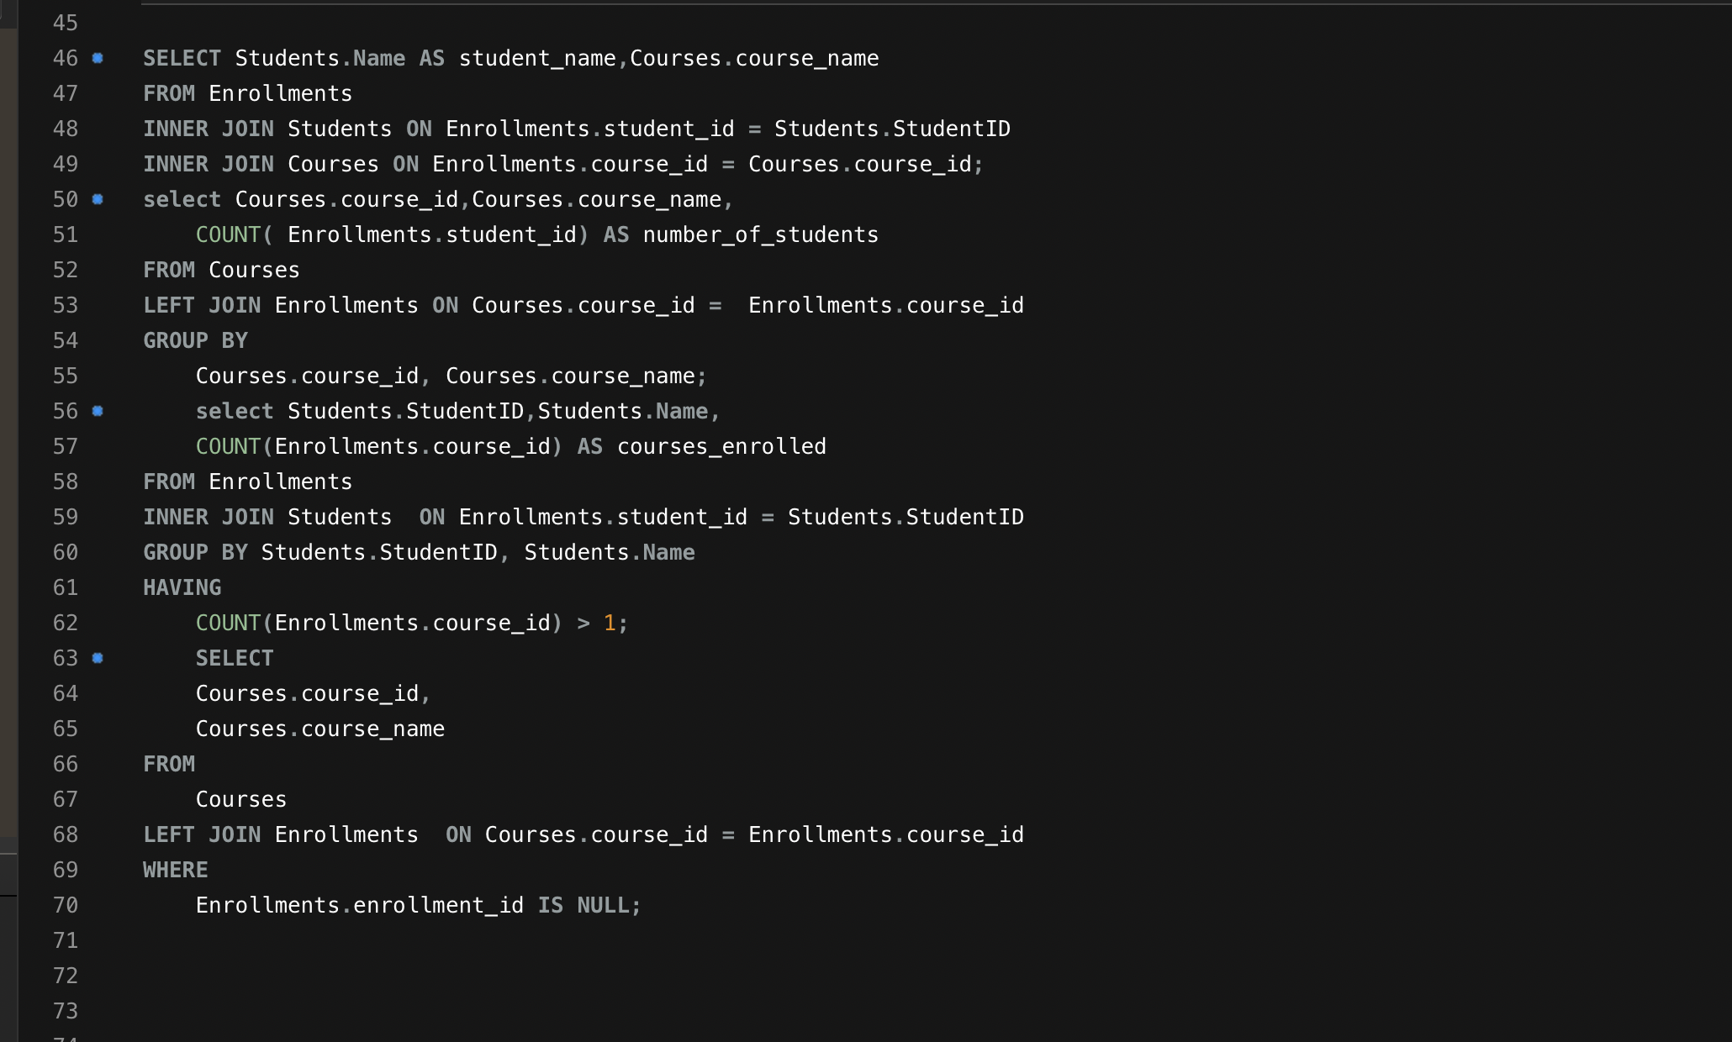

OUTPUT :

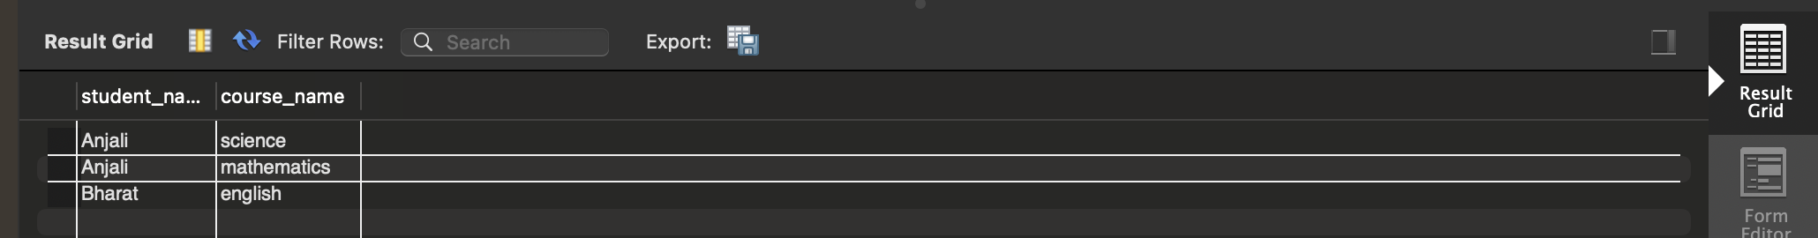

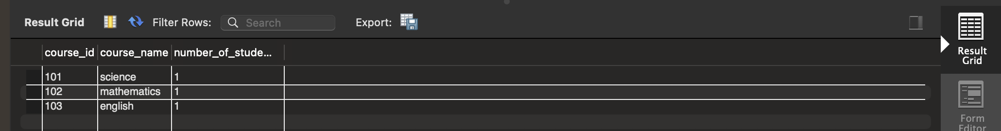

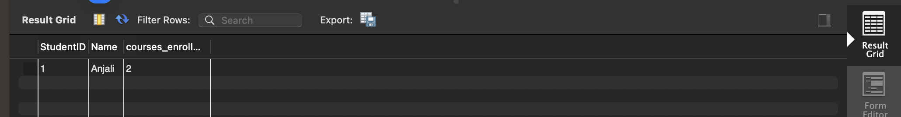



QUERY 1: This query helped me understand how to connect different tables using INNER JOIN. I used it to find out which students are enrolled in which courses. It felt good to see how the data came together from three separate tables to show useful information in one result.

QUERY 2: I learned how to use LEFT JOIN to include all courses, even if no students are enrolled in them. This made me realize that sometimes it's important to see what’s **missing** from the data, not just what’s there. It’s a useful way to find unused or less popular courses.

QUERY 3: This was the first time I used the HAVING clause. It was interesting to see how I could filter students **after** grouping the data. This query showed me how to find students who are more active or involved by being enrolled in multiple courses.

QUERY 4 : This query helped me spot courses that no students have joined. I used a LEFT JOIN and checked for NULL values. It made me think about how useful this can be for schools to understand which courses are not working or need improvement.