Hospital management project
Hospital management has different sets of users to interact with the Database having different usages. For example, doctors want to view the details of the patient after entering the patient’s id, General manager of the hospital wants to view the doctor’s details and their shift timings he wants to enter doctor id and shift to see doctor details.
For making this possible, we created 6 different table to store the respective details about everyone.
First, we see domains.
Domains:
A Domain is a reusable object which stores technical information of the field
Domain Name | Description
ZBB_DOM_ADMON | Admitted date
ZBB_DOM_ALTTO | Allotted to patient
ZBB_DOM_BEDID | Bed identification
ZBB_DOM_BLDG | Blood group
ZBB_DOM_CITY | City of the patient
ZBB_DOM_DAY | Day details
ZBB_DOM_DCODE | Department code
ZBB_DOM_DISD | Discharge date
ZBB_DOM_DOB | Date of Birth
ZBB_DOM_DOCID | Doctor ID
ZBB_DOM_DTEXT | Description of department
ZBB_DOM_EMAIL | Email ID of patient
ZBB_DOM_FNAME | Patient first name
ZBB_DOM_FRTIME | Time
ZBB_DOM_GEND | Gender of patient
ZBB_DOM_HOD | Head of the department
ZBB_DOM_LNAME | Patient last name
ZBB_DOM_PATIENTID | Patient ID
ZBB_DOM_PHN | Phone number
ZBB_DOM_RCODE | Region code of patient
ZBB_DOM_RDATE | Registration date
ZBB_DOM_SHIFT | Shift timings
ZBB_DOM_SPEC | Specialization of doctor
ZBB_DOM_WNAME | Ward name

Data Elements:
A Data Element in SAP ABAP Data Dictionary (DDIC) is an object that defines the business meaning of a field.
While a Domain defines the technical properties, a Data Element describes what the field represents to the business.

Data Element | Description | Domain
ZBB_DE_ADMON | Admitted Date | ZBB_DOM_ADMON
ZBB_DE_ALTTO | Allocated Patient ID | ZBB_DOM_ALTTO
ZBB_DE_BEDID | Bed ID | ZBB_DOM_BEDID
ZBB_DE_BLDG | Blood Group of Patient | ZBB_DOM_BLDG
ZBB_DE_CITY | City | ZBB_DOM_CITY
ZBB_DE_DAY | Day of the Date | ZBB_DOM_DAY
ZBB_DE_DEPTC | Department Code | ZBB_DOM_DCODE
ZBB_DE_DISD | Discharge Date | ZBB_DOM_DISD
ZBB_DE_DOB | Date of Birth | ZBB_DOM_DOB
ZBB_DE_DOCID | Doctor ID | ZBB_DOM_DOCID
ZBB_DE_DTEXT | Description | ZBB_DOM_DTEXT
ZBB_DE_EMAIL | Email ID | ZBB_DOM_EMAIL
ZBB_DE_FNAME | First Name | ZBB_DOM_FNAME
ZBB_DE_FRTIME | Time | ZBB_DOM_FRTIME
ZBB_DE_GEND | Gender | ZBB_DOM_GEND
ZBB_DE_LNAME | Last Name of Patient | ZBB_DOM_LNAME
ZBB_DE_PATIENTID | Patient ID | ZBB_DOM_PATIENTID
ZBB_DE_PHN | Phone Number | ZBB_DOM_PHN
ZBB_DE_RCODE | Region Code | ZBB_DOM_RCODE
ZBB_DE_RD | Registration Date | ZBB_DOM_RDATE
ZBB_DE_SHIFT | Shift Timings | ZBB_DOM_SHIFT
ZBB_DE_SPEC | Specialization | ZBB_DOM_SPEC
ZBB_DE_WNAME | Ward Name | ZBB_DOM_WNAME

Tables:
In SAP ABAP, a Table is a database object used to store data in rows and columns.
A table is created using fields, and those fields are usually defined using Data Elements, which in turn use Domains.
Table | Description
ZBB_BED | Bed allocation details
ZBB_DEPT | Department details
ZBB_DOCTOR | Doctor details
ZBB_OPDSCHED | Op scheduled details
ZBB_PATIENT | Patient details
ZBB_REGION | Address details

Relationship between the tables:
In database tables, a relationship defines how records in one table are connected to records in another table through Primary Keys (PK) and Foreign Keys (FK).

THE RELATION BETWEEN THE TABLE AS FOLLOW:
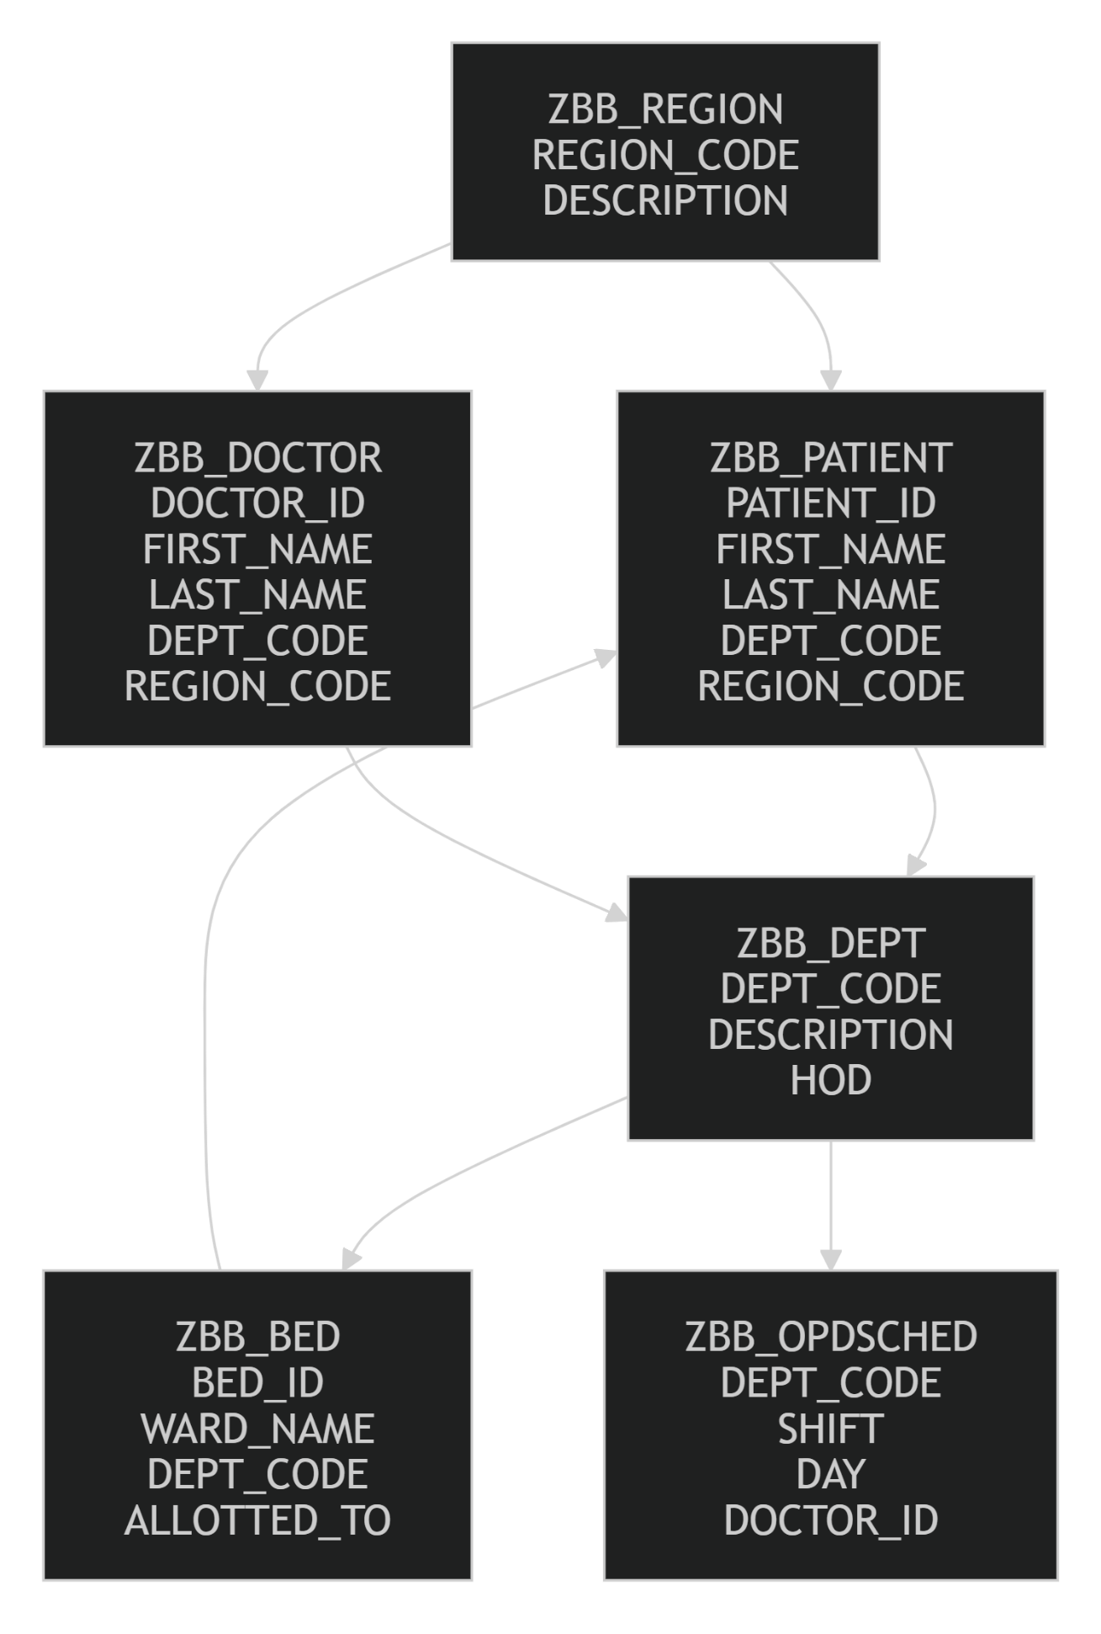

Architecture of the project:

PRESENTATION LAYER
User Interface - ZHOSPMANAGE-0100 (MOD.PROG)
ZHOSPMANAGE-0200 (MOD.PROG)
ZHOSPMANAGE-0200 (MOD.PROG)

Application Layer
Patient management module-ZBB_PATIENT_MODIF (REPORT)
Op schedule module- ZBB_OPDSCHED (REPORT)
Bed report module-ZBB_BED_ALLOT (REPORT)
Patient admit module-ZBB_HOSPMANAGE-USERCOMM0200
Patient discharge module- ZBB_HOSPMANAGE-USERCOMM0300

Database Layer
Tables:
ZBB_REGION | ZBB_DEPT | ZBB_DOCTOR | ZBB_PATIENT | ZBB_BED | ZBB_OPDSCHED

SAMPLE OUTPUTS
HOME SCREEN:
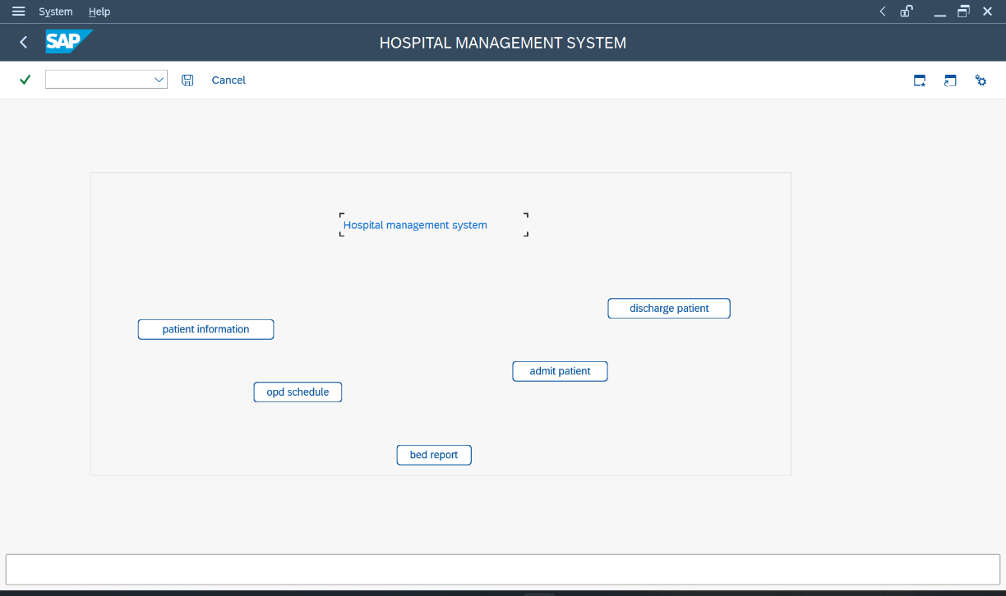
PATIENT MANAGEMENT MODULE:
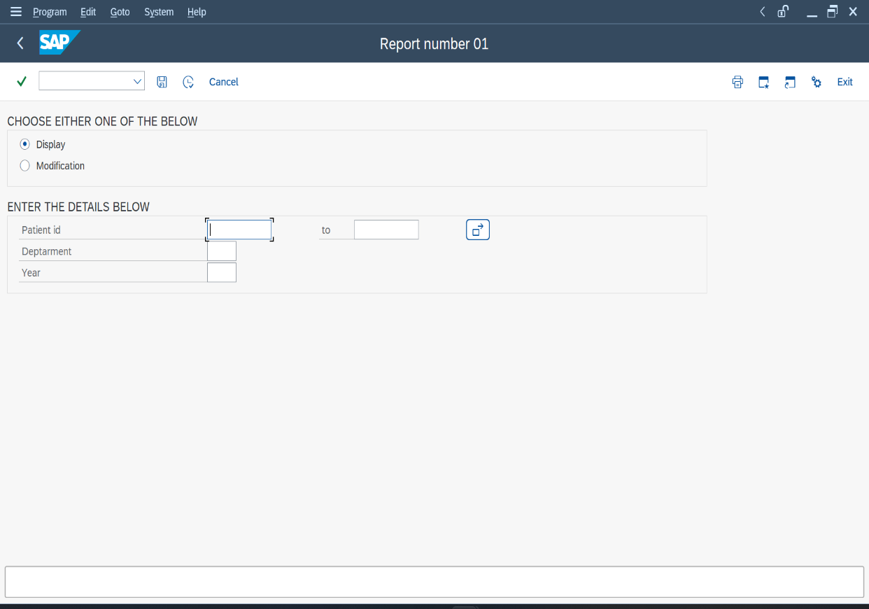

OPD SCHEDULED MANAGEMENT MODULE:
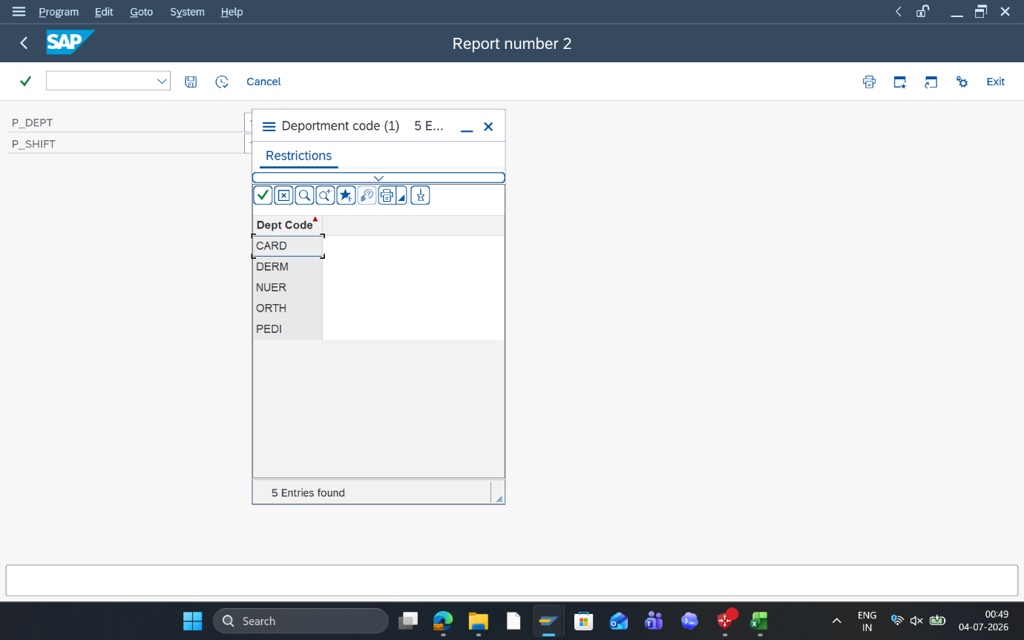

BED MANAGEMENT MODULE:
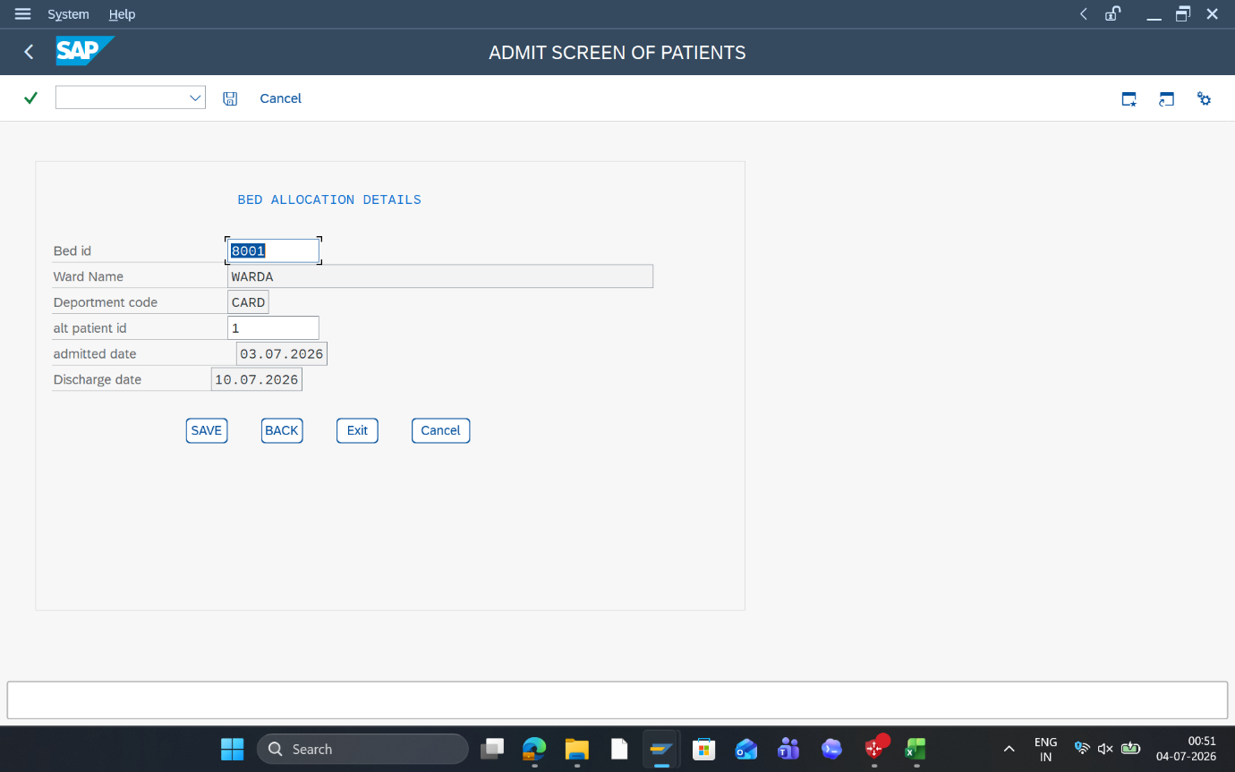

DISCHARGE MANAGEMENT MODULE:
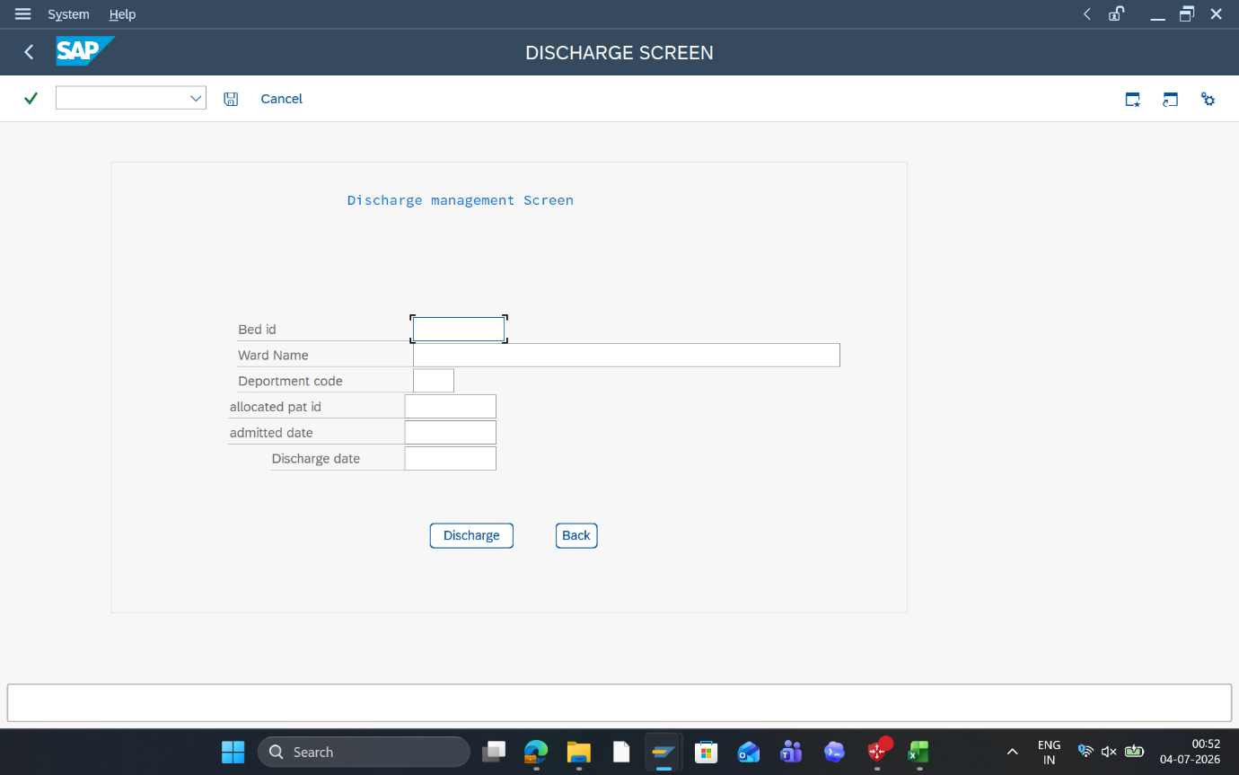

PATIENT ADMIT MODULE:

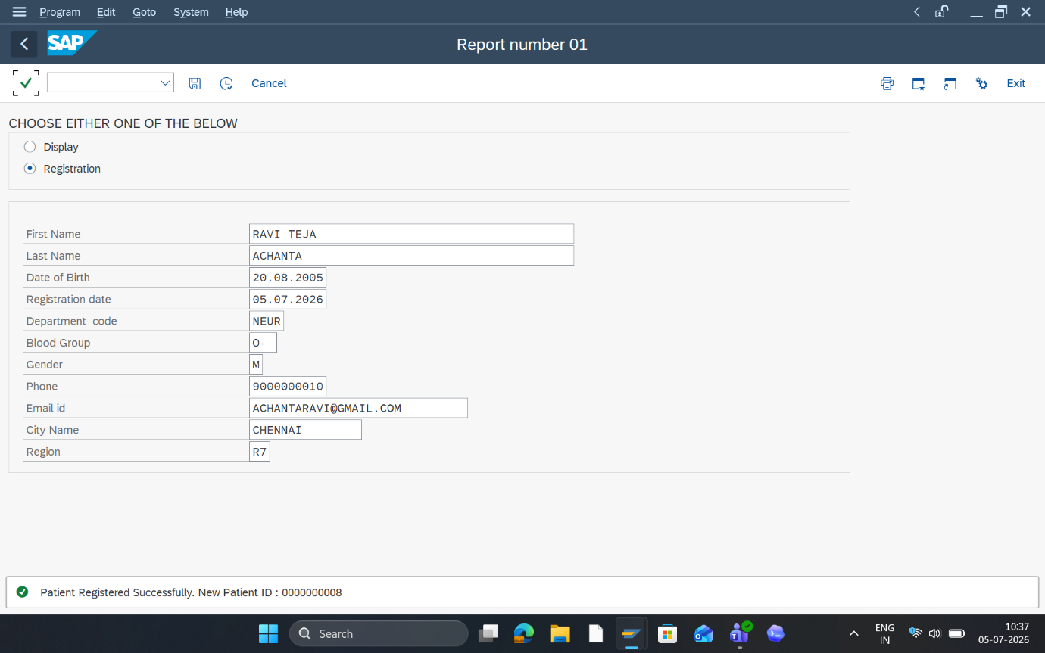
OUTPUTS OF EACH MODULE WITH ALV:
