МИНИСТЕРСТВО ОБРАЗОВАНИЯ РЕСПУБЛИКИ БЕЛАРУСЬ

БЕЛОРУССКИЙ ГОСУДАРСТВЕННЫЙ УНИВЕРСИТЕТ

Факультет прикладной математики и информатики

Кафедра МСС

Ульяницкий Владимир Александрович

Создание VLAN и назначение портов

Отчет по лабораторной работе №9
Вариант 20
(«Компьютерные сети»)
студента 3 курса 1 группы

Преподаватель

Рафеенко Е.Д.

Минск 2020

- Схема сети
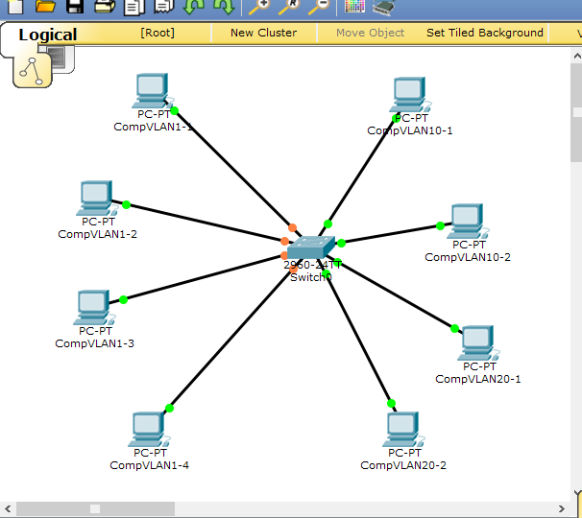

- Базовая настройка компьютеров
Компьютер | IP-адрес | Маска подсети | Шлюз по  умолчанию
CompVLAN10-1 | 170.96.0.2 | 255.255.128.0 | 170.96.0.1
CompVLAN10-2 | 170.96.0.3 | 255.255.128.0 | 170.96.0.1
CompVLAN20-1 | 170.97.0.2 | 255.255.128.0 | 170.97.0.1
CompVLAN20-2 | 170.97.0.3 | 255.255.128.0 | 170.97.0.1
CompVLAN1-1 | 170.98.0.3 | 255.255.128.0 | 170.98.0.1
CompVLAN1-2 | 170.98.0.4 | 255.255.128.0 | 170.98.0.1
CompVLAN1-3 | 170.98.0.5 | 255.255.128.0 | 170.98.0.1
CompVLAN1-4 | 170.98.0.6 | 255.255.128.0 | 170.98.0.1
- Настройка коммутатора
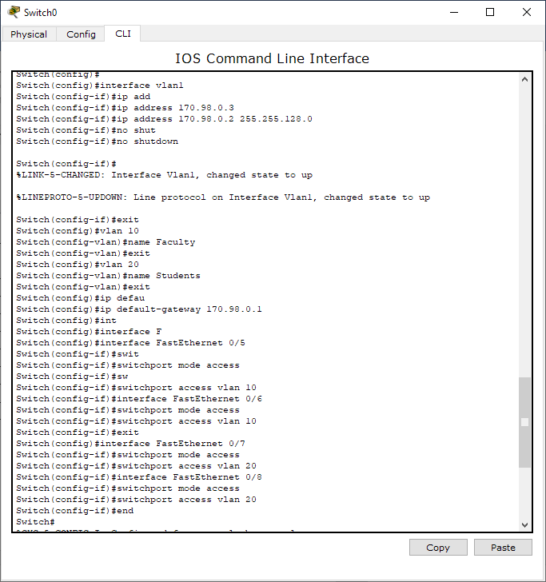
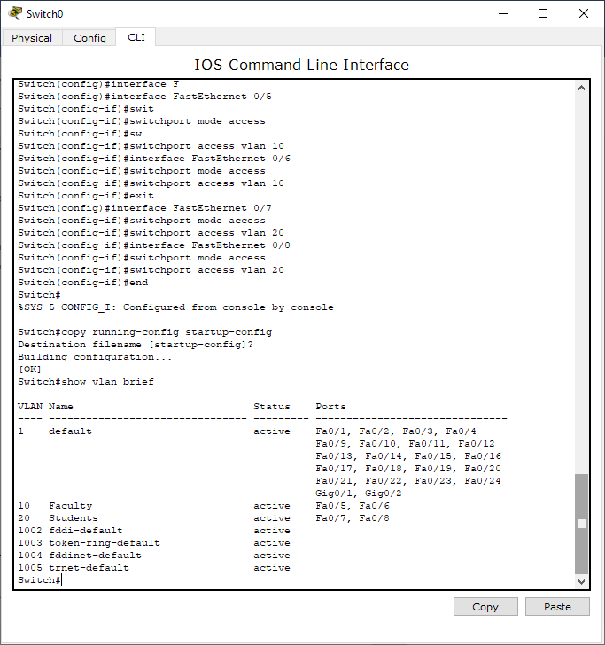

- Отразите в отчете ответы на следующие вопросы:
- Все ли другие порты коммутатора расположены во VLAN 1?
нет, 4 порта были выделены другим сетям
- Какие порты коммутатора расположены во VLAN 10?
Fa0/5, Fa0/6
- Какие порты коммутатора расположены во VLAN 20?
Fa0/7, Fa0/8
- Выполните эхо-запрос с ПК на коммутатор с адресом 170.98.0.2.
  - Были ли эхо-запросы с CompVLAN1-1 выполнены успешно?
да
  - Были ли эхо-запросы с CompVLAN10-1 выполнены успешно?
нет
  - Были ли эхо-запросы с CompVLAN20-1 выполнены успешно?
  - нет
5. Выполните эхо-запрос с CompVLAN1-3 на CompVLAN10-2 и CompVLAN20-2.
5.1. Доступен ли CompVLAN10-2 для CompVLAN1-3?
нет
5.2. Доступен ли CompVLAN20-2 для CompVLAN1-3?
нет
6. Почему CompVLAN1-3 может установить связь с коммутатором, а с CompVLAN10-2 и CompVLAN20-2 - нет?
шлюз по умолчанию у коммутатора совпадает со шлюзом по умолчанию CompVLAN1-3
7. Компьютеры не могут установить связь друг с другом. Почему?
не настроена маршрутизация между коммутатором и vlan10, vlan20

- Настройка маршрутизатора для организации взаимодействия между VLAN.

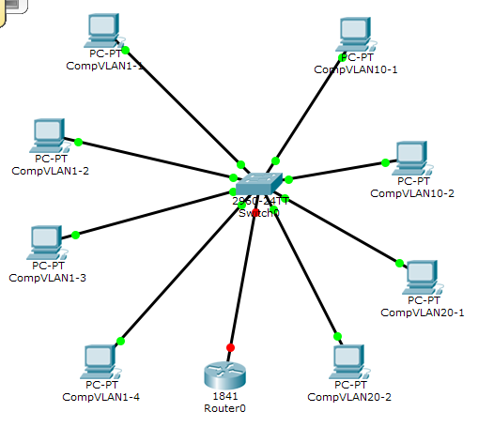
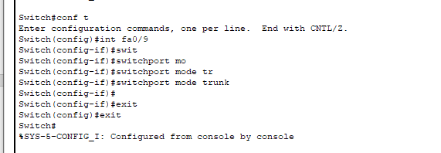
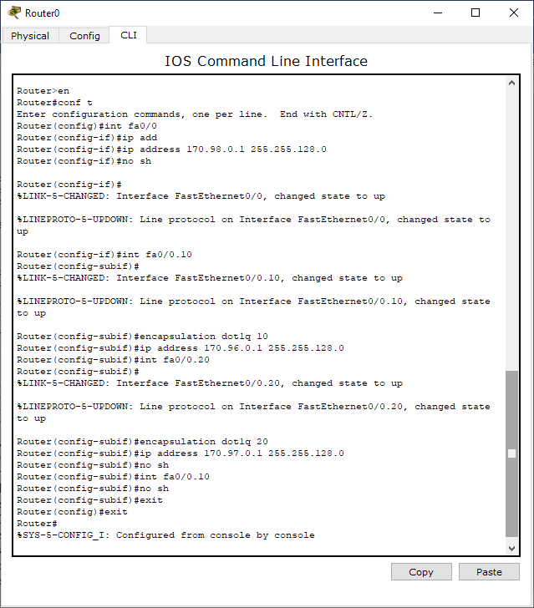

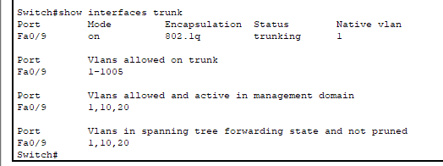

Router#show ip interface
FastEthernet0/0 is up, line protocol is up (connected)
Internet address is 170.98.0.1/17
Broadcast address is 255.255.255.255
Address determined by setup command
MTU is 1500 bytes
Helper address is not set
Directed broadcast forwarding is disabled
Outgoing access list is not set
Inbound access list is not set
Proxy ARP is enabled
Security level is default
Split horizon is enabled
ICMP redirects are always sent
ICMP unreachables are always sent
ICMP mask replies are never sent
IP fast switching is disabled
IP fast switching on the same interface is disabled
IP Flow switching is disabled
IP Fast switching turbo vector
IP multicast fast switching is disabled
IP multicast distributed fast switching is disabled
Router Discovery is disabled
IP output packet accounting is disabled
IP access violation accounting is disabled
TCP/IP header compression is disabled
RTP/IP header compression is disabled
Probe proxy name replies are disabled
Policy routing is disabled
Network address translation is disabled
BGP Policy Mapping is disabled
Input features: MCI Check
WCCP Redirect outbound is disabled
WCCP Redirect inbound is disabled
WCCP Redirect exclude is disabled
FastEthernet0/0.10 is up, line protocol is up (connected)
Internet address is 170.96.0.1/17
Broadcast address is 255.255.255.255
Address determined by setup command
MTU is 1500 bytes
Helper address is not set
Directed broadcast forwarding is disabled
Outgoing access list is not set
Inbound access list is not set
Proxy ARP is enabled
Security level is default
Split horizon is enabled
ICMP redirects are always sent
ICMP unreachables are always sent
ICMP mask replies are never sent
IP fast switching is disabled
IP fast switching on the same interface is disabled
IP Flow switching is disabled
IP Fast switching turbo vector
IP multicast fast switching is disabled
IP multicast distributed fast switching is disabled
Router Discovery is disabled
IP output packet accounting is disabled
IP access violation accounting is disabled
TCP/IP header compression is disabled
RTP/IP header compression is disabled
Probe proxy name replies are disabled
Policy routing is disabled
Network address translation is disabled
BGP Policy Mapping is disabled
Input features: MCI Check
WCCP Redirect outbound is disabled
WCCP Redirect inbound is disabled
WCCP Redirect exclude is disabled
FastEthernet0/0.20 is up, line protocol is up (connected)
Internet address is 170.97.0.1/17
Broadcast address is 255.255.255.255
Address determined by setup command
MTU is 1500 bytes
Helper address is not set
Directed broadcast forwarding is disabled
Outgoing access list is not set
Inbound access list is not set
Proxy ARP is enabled
Security level is default
Split horizon is enabled
ICMP redirects are always sent
ICMP unreachables are always sent
ICMP mask replies are never sent
IP fast switching is disabled
IP fast switching on the same interface is disabled
IP Flow switching is disabled
IP Fast switching turbo vector
IP multicast fast switching is disabled
IP multicast distributed fast switching is disabled
Router Discovery is disabled
IP output packet accounting is disabled
IP access violation accounting is disabled
TCP/IP header compression is disabled
RTP/IP header compression is disabled
Probe proxy name replies are disabled
Policy routing is disabled
Network address translation is disabled
BGP Policy Mapping is disabled
Input features: MCI Check
WCCP Redirect outbound is disabled
WCCP Redirect inbound is disabled
WCCP Redirect exclude is disabled
FastEthernet0/1 is administratively down, line protocol is down (disabled)
Internet protocol processing disabled
Vlan1 is administratively down, line protocol is down
Internet protocol processing disabled

Router#show ip interface brief
Interface IP-Address OK? Method Status Protocol
FastEthernet0/0 170.98.0.1 YES manual up up
FastEthernet0/0.10 170.96.0.1 YES manual up up
FastEthernet0/0.20 170.97.0.1 YES manual up up
FastEthernet0/1 unassigned YES unset administratively down down
Vlan1 unassigned YES unset administratively down down

Router#show ip route
Codes: C - connected, S - static, I - IGRP, R - RIP, M - mobile, B - BGP
D - EIGRP, EX - EIGRP external, O - OSPF, IA - OSPF inter area
N1 - OSPF NSSA external type 1, N2 - OSPF NSSA external type 2
E1 - OSPF external type 1, E2 - OSPF external type 2, E - EGP
i - IS-IS, L1 - IS-IS level-1, L2 - IS-IS level-2, ia - IS-IS inter area
* - candidate default, U - per-user static route, o - ODR
P - periodic downloaded static route

Gateway of last resort is not set

170.96.0.0/17 is subnetted, 1 subnets
C 170.96.0.0 is directly connected, FastEthernet0/0.10
170.97.0.0/17 is subnetted, 1 subnets
C 170.97.0.0 is directly connected, FastEthernet0/0.20
170.98.0.0/17 is subnetted, 1 subnets
C 170.98.0.0 is directly connected, FastEthernet0/0

- Проверьте подключение между узлами и маршрутизатором.
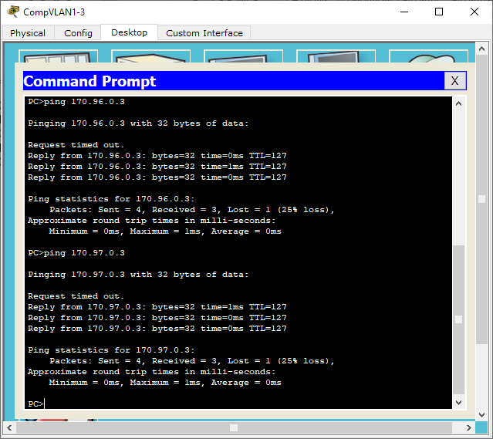

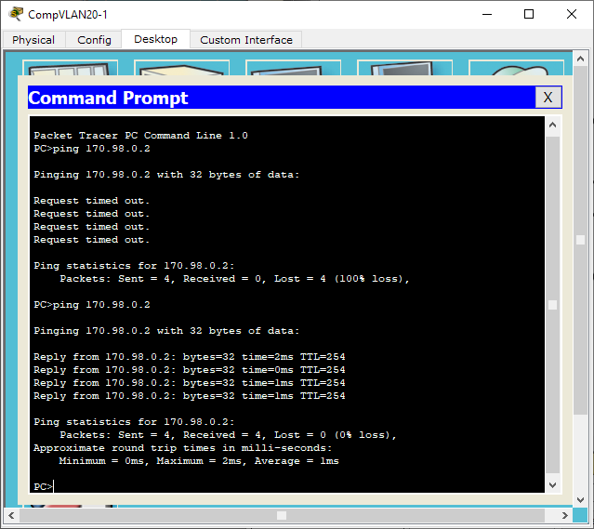
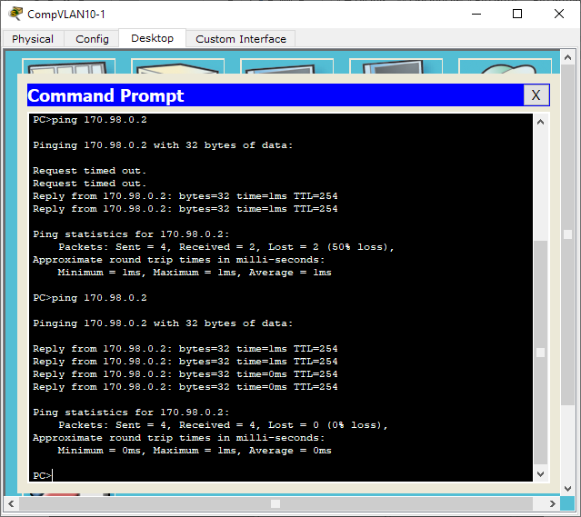
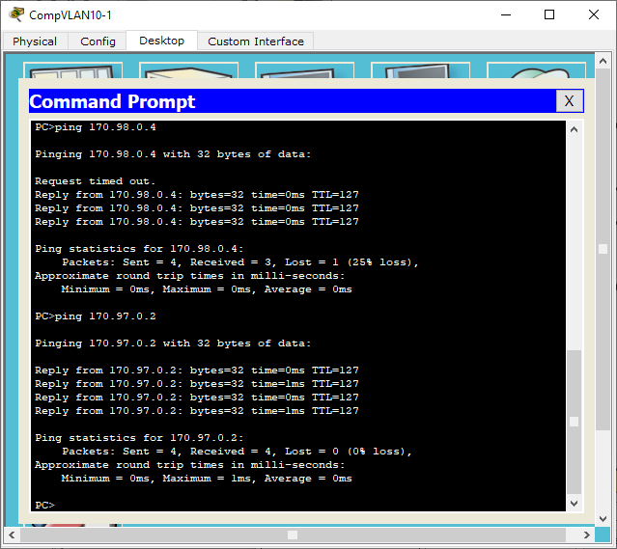
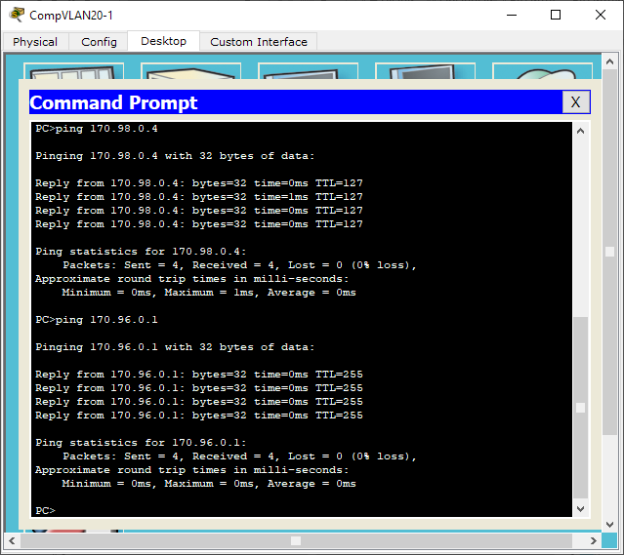

маршрутизация между узлами работает, что говорит о правильности настройки маршрутизатора, коммутатора и конечных узлов.

