Safety bulletin 2026-07
Issued by the HSE team for all field staff.

Working at height
Falls from ladders caused two lost-time injuries this year. From 1 September, the following rules apply to any work more than 2 metres above ground.
- Use a ladder only for short tasks of under 30 minutes.
- Keep three points of contact while climbing.
- Never stand on the top three rungs.
Before you climb, check:
- The ladder has a current inspection tag.
- The ground is firm and level.
- A second person is present to foot the ladder.
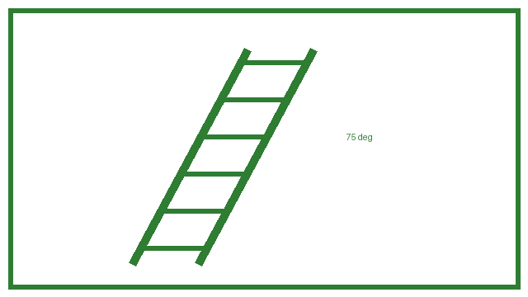
Figure: the safe ladder angle is 75 degrees, one unit out for every four units up.

Hot weather
Drink water regularly and take breaks in the shade when the temperature is above 30 degrees.

Both incidents involved stepladders on uneven ground.

