**Task 1: Mobile robot exploration**

**Random agent :** In random agent the will do tasks randomly without considering any sensor readings .

**Fixed agent:** In fixed agent performs fixed tasks for certain period of time and performs other tasks for some other time it do not consider any sensor reading value.

**Simple reflex agent :** Based on current sensor reading it will take decisions and perform the tasks.

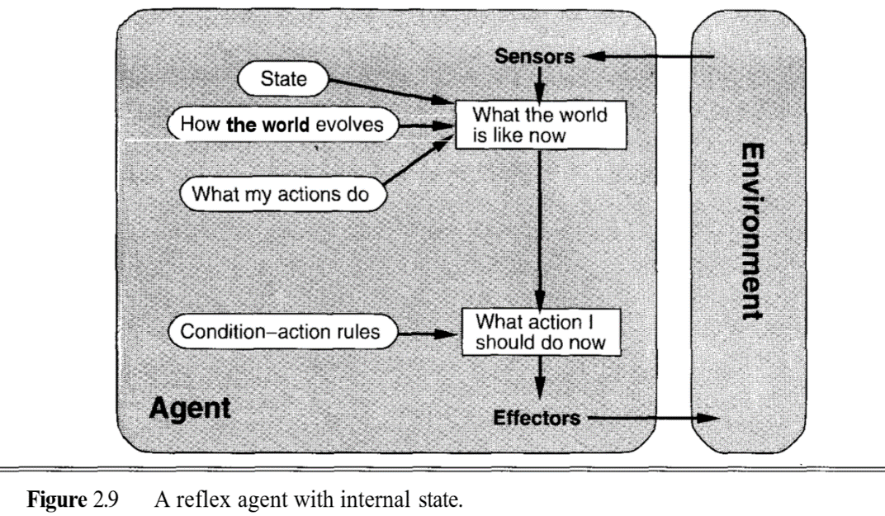

**Memory agent :** In memory agent it performs past sensor readings and perform the task in intelligent way.

**Task 2: Poker game agent**

**Bidding randomly :** The bidding takes randomly with considering the cards.

**Bidding Fixed :** The bidding amount is fixed without taking cards into considerations.

**Random agent vs Fixed agent :** Fixed agent plays better. Fixed agent bids fixed amount of money for each bidding but random agent bidds randomly without taking anything into consideration.

**Simple reflex agent vs random agent:** In simple reflex agent the agents bidds with respect to cards it has.