**Lab 3:**

**Bayesian network**

Task1:

**Connection 1:**

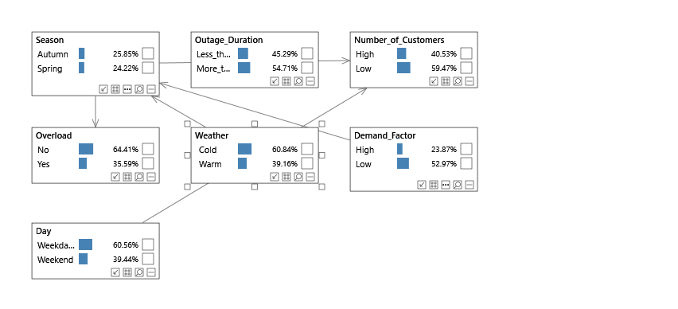

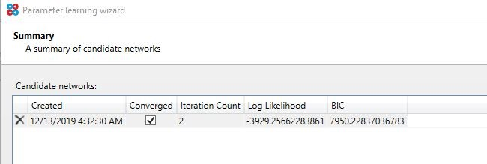

**Log-likelihood:**’

It is a function(natural logarthim) used to measure the maximum likelihood estimator of the parameter.

Likelihood range: **0 to infinity**

Log-likelihood range : - **infinity to infinity**

It is used to detect unusual data known as **anomaly detection**.

**Bayesian Information Criterion(BIC):**

The BIC is a criterion used for model selection among the different set of models,models with lowest value is preffered.

When fitting the model it will increases likelihood value but it will leads to overfitting .

**Connection 2:**

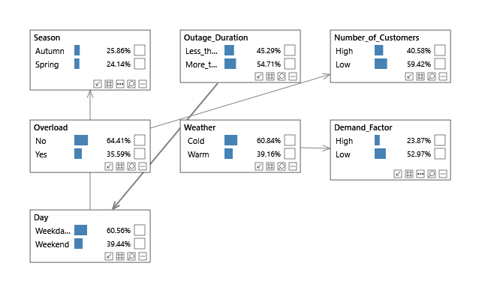

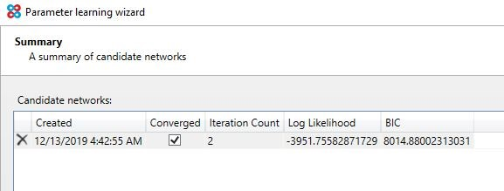

**Connection 3:**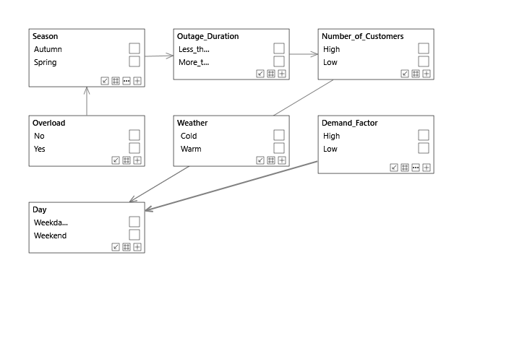

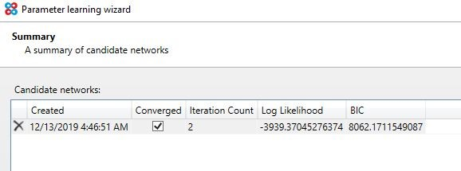

**Connection 4(Structural connection):**

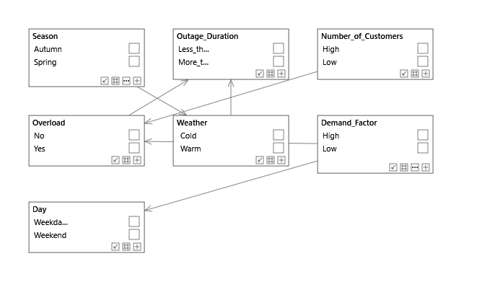

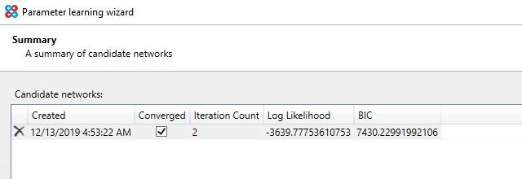

From all the above connection the connection 2 have log-likelyhood value(3951.75) is high but the problem is BIC value for connection 2 is 8014.88 .

For a good network the BIC should be low if it is high means the model is overfitting.

In structural connection BIC is 743.229 which is low when compared to connection 2 this model is the best.

**Task2**

**Connection 1:**

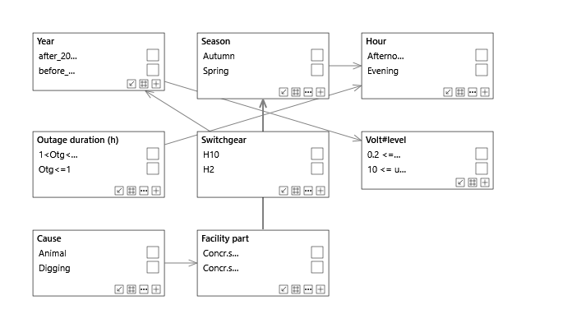

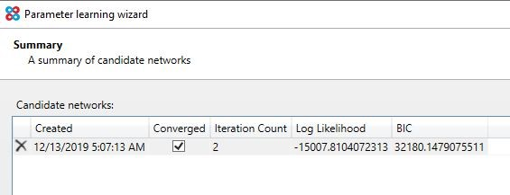

**Connection 2:**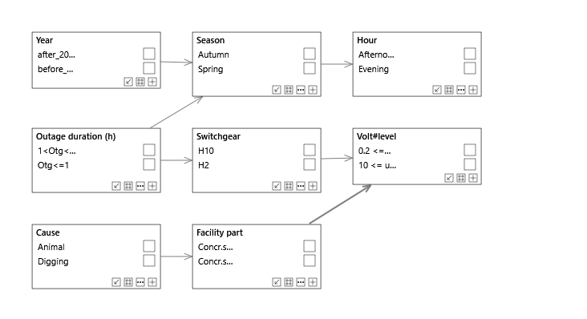

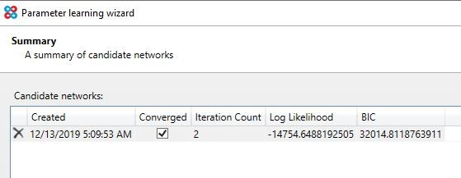

**Connection 3:**

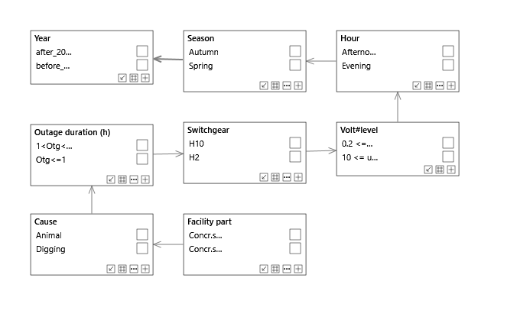

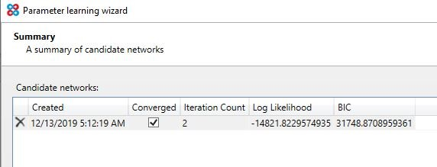

**Connection 4(Structural connection):**

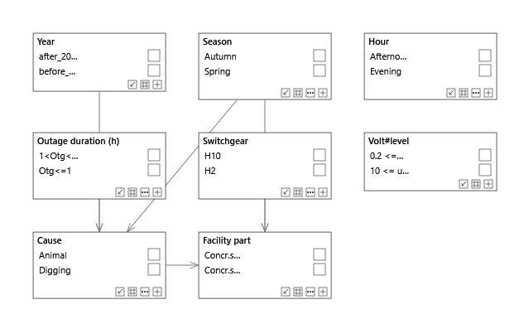

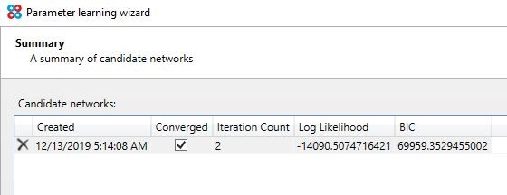

**Task 2(b):**

1. p(Cause=Animal | Season=Autumn)= 0.81%

2. p(Season=Autumn | Cause=Animal)= 33.64%

3. p(Season=Summer | Cause=Thunder)= 75.33%

4. p(Outage duration=Otg ≤ 1 | Facility part = Ground cable pillar)= 29.85%

5. p(Facility part=Ground cable pillar | Switchgear=H7, Cause=Fuse break)= 81.79%

6. p(Facility part=Ground feeder cable in ground|Cause=(Digging, Fabrication fault), Switchgear=H7, Season=Summer)= 49.61%

7. p(Facility part=Ground feeder cable in ground | Cause=¬(Digging, Fabrication fault), Switchgear=H7, Season=Summer)= 27.08%

8. p(Cause=Digging | Facility part = OH line, Switchgear=H7)= 0%

9. p(Facility part = Ground cable pillar | Outrage duration=Otg > 2)= 45.21%

10. p(Cause=Unknown | Year=before2011) p(Cause=Unknown | Year=after2011) = 2.46%

**Task2(c):**

1.p(cause=animal|hour=evening) =0.54%

2.p(switchgear=H2|year=before) =2.36%

3.p(switchgear=H10|volt#level=0.2< =u <=1.0) =15.27%

4.p(season=spring|cause=animal) = 22.97

5.p(season=autumn|wheather=cold) = 28.63%

6.p(Demanfactor=High|wheather=warm) = 23.87%

7.p(demandfactor=high|wheather=~(warm),demandfactor=low) = 0%

8.p(overload=yes|season=autumn,wheather=~(warm)) = 35.30%

9.p(cause=digging|switchgear=~(H10), year=after) = 17.42%

10.p(cause=digging|Facility part=OH line,switch gear=~(H7)) = 0.92%

**Task 2(d):**

The probability of the dependes on it’s childs if the child probability changes the probability of it’s parents also changes

**Task 2(e):**

If Fabrication fault is afailure means if we maximize these attributes will change a lot( Ground cable pillar, Ground feeder cable in ground, Ground cable fuse/apparatus box).

**Task 2(f) :**

**Positive correlation:**

P(Facility part =Ground cable pillar|season=winter) = 60.17%

P(Facility part= OH line |cause = Animal) = 17.85%

P(Facility part= Other secondary substation |cause= Animal) = 8.97%

**Negative correlation:**

P(Facility part=Ground cable fuse/ apparatus box |cause= Digging) =1.19%

P(Facility part =Ground cable feeder in ground | season =winter)=18.95%

P(Facility part= Ground cable pillar |Cause = Animal ) =4.15%