(**C**loud **C**omputing & **I**nternet **o**f **T**hings)

Nokia laboratory 1

Cloud control and monitoring for a parking system using Nokia Internet of Things

|  |  |  |  |
| --- | --- | --- | --- |
|  | | |  |
| Author | Cosmin Ivan, Daniel Iercan, Cristian Cosariu |
| Owner | Nokia Timisoara, West University of Timisoara |
| Organization | Nokia Romania |
| Approver | Florin Ciocan |
| Document ID |  |
| Document location | public |
|  | |  |
|  | | |  |

Contents

1 Introduction 3

1.1 Cloud control and monitoring for a parking system using Nokia Internet of Things 3

1.2 Technologies and skills 3

2 Project 4

2.1 Project description 4

2.2 Project schema 5

2.3 Project tasks 6

2.4 Project scope 6

2.5 Project teams 6

# Introduction

## Cloud control and monitoring for a parking system using Nokia Internet of Things

The scope of the laboratory is to implement a software solution that will control and monitor the parking lots in a smart city using the Cloud and Internet of Things. All work will be done on dedicated virtual machines.

## Technologies and skills

Working with virtual machines JavaScript programming and JQuery



Git versioning system NodeJS server programming



Arduino boards programing and setting up the system



# Project

## Project description

The idea of smart city is getting very popular due to the technologies available on the market and the new innovations. In each city, there is a higher need for more cars and in consequence more parking spots.

The scope of the project is to create an intelligent parking using Nokia cloud technologies and to connect it in the smart city using the Internet of Things. In order to make the drivers life easy an intelligent system should help him find the best place to park and to notice him where there are still free places.

Using an Arduino board the required information is gathered from the parking and is send to a server that will do the control and monitoring for it. The server will always be connected to the internet from where the users will be able to gather the required information’s regarding the parking lots in the city.

## Project schema

Schema for Cloud control and monitoring for a parking system using Nokia Internet of Things

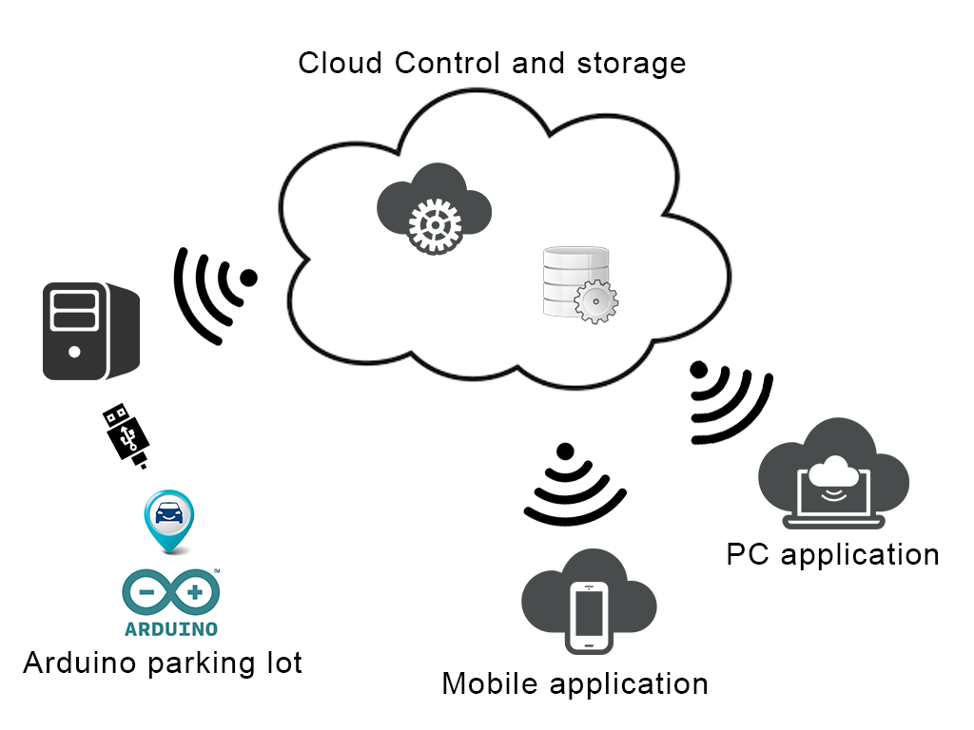

## Project tasks

* Use the Arduino board to control the parking spots in a parking lot. The control should be done in the cloud;
* Each parking spot has a distance sensor and a RGB led to show if the spot is free (green), occupied (red), out of service (blue);
* A server connected through the serial counts how many parking spots are empty and keeps track of their status (the information can be stored using SQL or NoSQL database);
* The administrator of the parking should be able to put a spot in out of service status and to monitor the traffic in the parking spot;
* In case the user connects from the mobile phone he should receive a list with the nearest parking that have free spots.

## Project scope

* Implement the infrastructure (parking lot);
* Control and monitor the system in Cloud;
* Connect everything together using the Internet of Things;
* Learn to work on a project (versioning, define specifications, implementation).

## Project teams

Rules:

* Each team must have 2 to 3 students;
* Each team must have a name that will be provided to the laboratory responsible;
* The team members should come always at the same laboratory session in order to work together.