**Assignment:**

1. Which of the following precaution should be taken before working on computer hardware?

a) Ensure the computer is plugged in to prevent electrostatic discharge. b) Wear an anti-static wrist strap to prevent damage from electrostatic discharge.

c) Work on carpeted surfaces to prevent slipping.

d) Use magnetic tools to handle components more easily.

**Ans : b)** Wear an anti-static wrist strap to prevent electrostatic discharge.

**Reason :** An anti-static wrist strap safely grounds you, preventing static electricity from damaging sensitive computer components.

1. What is the purpose of thermal paste during CPU installation?

a) To insulate the CPU from heat.

b) To provide mechanical support for the CPU.

c) To improve thermal conductivity between the CPU and the heat sink.

d) To prevent the CPU from overheating.

**Ans :** c) To improve thermal conductivity between the CPU and the heat sink.

**Reason :**  Thermal paste is used because it fills tiny gaps between the CPU and heat sink to transfer heat efficiently.

1. Which tool is used to measure the output voltage of a power supply unit (PSU)?

a) Multimeter

b) Screwdriver

c) Pliers

d) Hex key

**Ans :** a) Multimeter

**Reason :**  It is use to measure electrical values like voltage, current and resistance, making the right tool for checking a PSU’s output voltage.

1. Which component is responsible for storing BIOS settings, such as date and time, even when the computer is powered off ?

a) CMOS battery b) CPU

c) RAM d) Hard drive

**Ans :** a) CMOS battery

**Reason :** CMOS battery keeps the BIOS settings like date and time saved even when computer is turned off.

Section 2: True Or False

1. When installing a new hard drive, it is essential to format it before use.

**Ans : True**

**Reason :** Formatting a new hard drive is essential because it creates a file system like NTFS or FAT32 that allows the operating system to store, organize, and access data on the drive.

1. A POST (Power-On Self-Test) error indicates a problem with the CPU.

**Ans : False**

**Reason :** A POST error does not only indicate a CPU problem- it can point to issues with RAM, graphics card, keyboard, hard drive or other hardware components.

1. It is safe to remove a USB flash drive from a computer without ejecting it first.

**Ans : False**

**Reason :** Removing a USB without ejecting can corrupt files because data might still be writing to the drive.

Section 3 : Short Answer

1. Describe the steps involved in installing a new graphics card in a desktop computer.

**Ans :**

* Turn off your computer and unplug all cables then open the PC case side panel.
* Then unscrew the card, unlock the PCIe clip and pull out the old graphics card from the slot.
* Insert the new GPU into PCIe slot, press it in until it clicks, and screw it to the case.
* Connect the required PCIe power cables from the PSU(power supply unit) to the graphics card securely.
* Close the case, Turn on the PC, install the latest GPU drivers, restart, and test to ensure it works properly.

1. What is RAID, and what are some common RAID configurations?

**Ans :**

* **RAID** stands for Redundant Array of Independent Disk.

RAID is a way of using multiple hard drives together to increase performance, protect data, or both.

* Main reason of RAID :

Speed (Performance)- data can be read and written faster.

Safety (Data protection)-if one hard drive fails, then data is still safe.

* RAID level decides whether the system will be faster, safer or both.

**Common RAID configuration:**

**1.RAID 0(striping):** split data across two or more drives.

Faster read and write speed.

If one drive fails, all data is lost.

**2. RAID 1 (Mirroring):** Copies the same data on two drives.

If one drive fails, data is safe.

**3. RAID 5 :** Require atleast 3 drives.

Data and backup code stored across all drives.

Good balance of speed and safety.

**4. RAID 10 :** Combine of RAID 0 and RAID 1.

Require at least 4 drives, and provide both speed and redundancy.

Section 4 : Practical Application

1. Demonstrate how to replace a CPU fan in a desktop computer.

**Ans :**

* Power off & unplug PC, open the case .
* Unplug the old CPU fan from the

Motherboard (CPU_FAN header).

* Remove old cooler, unscrew or unlock the pins,

then lift it off.

* Clean old thermal paste from CPU and

cooler with alcohol.

* Apply new thermal paste in the center.
* Install new cooler place it, tight screw.
* Plug fan cable into CPU_FAN header.
* Close case and power on.

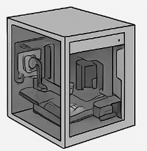



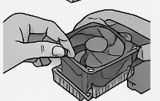

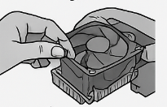

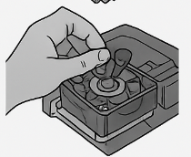

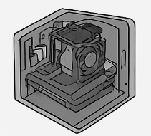

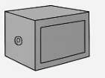

Section 5 : Essay

1. Discuss the importance of regular maintenance for computer hardware and provide examples of maintenance tasks.

**Ans :**

* Computer is important part of our life, so we can regular maintenance helps in improving performance. For example, cleaning dust from the CPU fan and keyboard keeps the computer running smoothly.
* Updating software drivers also helps the system work faster.
* It prevents hardware failure. Heat and dust can damage important parts like the motherboard or hard drive.
* Tasks like checking the cooling system, replacing old cables.
* Regular maintenance increases the lifespan of the computer and applying new thermal paste on the processor or cleaning RAM slots can make the hardware last longer.
* It also helps in data safety. If the hard disk is failing, running disk check tools or keeping backup drives can save important files before they are lost.