**Assignment:**

**Name:** Vaghela Urvashi V.

**Sir :** Kamlesh sir

**Course :** Networking with Security Career Development Program

**Module :** 1 Understanding of Hardware and its Components

**Section 1: Multiple Choice**

**1. Which of the following is NOT a component of the CPU ?**

**Ans :**  2.RAM

**2. What is the function of RAM in computer ?**

**Ans :** RAM is the computer temporary memory that holds data and programs while it’s running. It is fast helping the CPU read and write data quickly , and allows multiple programs to run smoothly. It is volatile so all data is lost when the computer is turned off.

**3. Which of the following is a primary storage device ?**

1. HDD 3. SD card

2. SSD 4. 1 and 2 both

**Ans :** Non of the above answer

Reason- primary storage device means that main storage device like RAM & cache which CPU can directly access.

**4. What is the purpose of a GPU ?**

**Ans :** -A GPU helps the computer show pictures, videos, games, and animation smoothly and quickly.

-Draws images and videos on screen and makes games run faster & look better .

-helps with video editing , 3D design , and animation .

-Speeds up some heavy task like AI, machine learning , and big calculation.

**Section 2: True or False**

**5.** The motherboard is the main circuit board of a computer where other components are attached.

**Ans : True**

**6.** A UPS (Uninterruptible Power Supply) is a hardware device that provides emergency power to a load when the input power source fails.

**Ans : True**

**7.** An expansion card is a circuit board that enhances the functionality of a component.

**Ans : True**

**Section 3: Short Answer**

**8. Explain the difference between HDD and SSD.**

**Ans :**

|  |  |
| --- | --- |
| **HDD(Hard disk drive)** | **SDD(Solid disk drive)** |
| Slower (long boot & load) | Much faster (quick boot & load) |
| Easily damaged(moving parts) | More durable(no moving parts) |
| Produces noise due to spinning disks. | Operates silently. |
| Uses more power | Uses less power |
| Cheaper (more GB for less money ) | More expensive(less GB for same money) |
| Ideal for budget-friendly,high capacity storage | Best for high-speed computing, gaming, and fast system performance. |
| Large, low –cost storage | Fast performance(OS, apps, games) |
| HDD available size is 500 GB to 36 TB | SSD available size is 120 GB to ~61 TB |
| Old DVD player  Like a train slow but carries more data cheaply | Pen drive (USB stick)  Like Aeroplane much faster but more expensive. |

**9. Describe the function of BIOS in a computer system ?**

**Ans : BIOS(**Basic input output system**)**

* BIOSis small program stored on a ROM chip on the computer’s motherboard.
* BIOS acts like a bridge- it’s main role is to connect the hardware and the Operating system.

Hardware(Bottom layer) BIOS(Middle bridge) OS (Top layer)

- CPU, keyboard, HDD, RAM - initializes hardware -windows, linux

- Provides basic drivers

(keyboard ,display, storage)

- Runs the boot loader(load the OS

into RAM so that it can start running)

* POST(Power on self test) - When the computer is turned on then it’s check the hardware is work properly. If an error is detect then it’s produce beep sound or display error code.
* Hardware initialization – BIOS Activates and sets up hardware devices so the operating system can use them.
* Then CMOS (Complementary metal oxide semiconductor) setup utility allows the user to store system setting like boot sequence ,date- time, and security in CMOS memory.
* During startup press a key like Del, F2, F10, ESC to open the BIOS setup.
* User can change and save system setting then BIOS updates the CMOS memory.

**10. List and briefly explain three input devices commonly used with computers.**

**Ans: 1.Keyboard:** It’s most widely used in primary input device that allows the user to enter text, symbols, and commands into the computer.

**2. Mouse :** It is a pointing device that moves the cursor on the screen that’s use for selecting, clicking , dragging, and dropping items in the graphical user interface

**3. Scanner :** It’s used to capture image or text from paper and convert them into digital form.

**Section 4: Practical Application**

**11. Identify and label the following components on a diagram of a motherboard:**

● CPU

● RAM slots

● SATA connectors

-It processes all instruction and controls the work of the system.

-It is usually placed in the center of the motherboard.

● PCI-E slot

**Ans :**

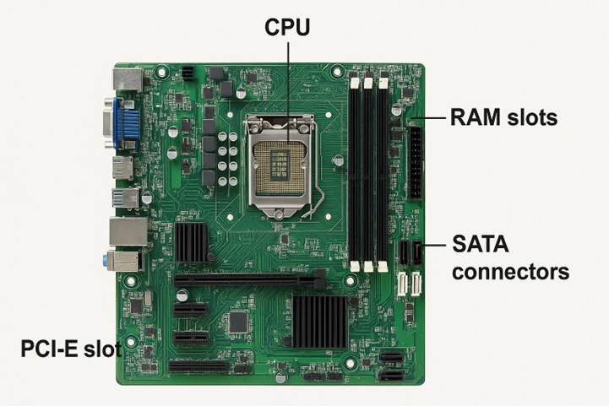

-It’s expansion slot for adding extra hardware like graphics card, sound card & network card.

-It increases the computer’s power & features.

-It’s used to connect storage device like HDD,SDD drives to the motherboard.

-It’s allow the computer to store & access data.

-It’s temporary memory uses for fast data access.

-Slots have different color like blue(dual slot) & black (single slot)

**12. Demonstrate how to install a RAM module into a computer.**

**Ans:**

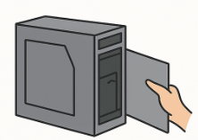

-Turn off the computer –shut down system & unplug power

-Open the cabinet- Remove the side panel of the CPU case

-Locate the RAM slot- find the long DIMM(Dual inline memory module) slots on the motherboard

Insert the RAM module –Match the note on the RAM with slot key

Press & Lock– press firmly on both ends until clips click into place

Close& Test – close the cabinet, power on the computer

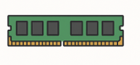

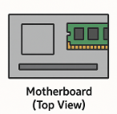

**Section 5: Essay**

**13. Discuss the importance of proper cooling mechanisms in a computer system. Include examples of cooling methods and their effectiveness.**

**Ans :**

* **Introduction:**

Computer is a powerful machine that is used almost every field today, but while working, it inside a computer important parts like CPU, GPU and the power supply produce the lot of heat. If this heat is not controlled, then computer may be slow down because it protect itself, freeze or crash suddenly, and its parts can be damaged over time. The cooling system keep the computer at a safe temperature so it can run fast, stable and last for many years.

Just like a car engine or even a mobile phone gets hot when used for a long time, a computer also heats up while working, especially in the parts that do the most processing.

* **Importance:**
* Reduces noise by Keeping fans from overworking.
* cooling directly helps the computer parts live longer, just like using a fan in summer keeps us more comfortable and prevents us from getting sick.
* Cooling keeps the computer steady and prevents sudden problems while working or playing.
* Keeps the computer working smoothly and stops it from suddenly freezing or shutting down.
* **Cooling Methods in Computer System :**

**1.Air cooling :**

In this method fans and heat sink are used to remove heat from the computer.The heat sink takes heat from the CPU or GPU, and the fan pushes this hot air out of the computer.

It’s cheapest cooling method and found in all normal desktops and laptop.

**2. Liquid Cooling :**

In liquid cooling pipes and liquid are used. It absorbs heat from the CPU or GPU and carries it to the radiator .

Radiator is a metal part that takes heat from the liquid and with the help of a fan releases it into the air to keep the computer cool.

**3. Cooling Pad :**

A cooling pad is an external stands with small fans that is placed under a laptop.The fans blow cool air towards the bottom of the laptop & help reduce heat.

It is very useful during gaming , long classes or heavy work because laptop heat up quickly.

It’s use to improve performance, increase lifespan, and make it more comfortable to use.

**4. Case cooling :**

It’s using extra fans inside the computer cabinet to control airflow.

Some fans case to pull in cool air and push out hot air, keeping all parts at a safe temperature.

* **Advantages :**
* Keeps computer fast and smooth.
* Makes laptop cooler to touch.
* Increases lifespan of parts
* **Disadvantages :**
* Uses extra electricity.
* Extra fans or pads take space.
* Some methods can be expensive.

**14. Explain the concept of bus width and its significance in computer architecture.**

**Ans :** Bus is like a highway that carries data between the CPU, memory and input /output Just like cars travel on a high-way, bits(0s & 1s) travel on a bus.

Bus width means how many bits a bus can carry at one time**. Ex.** 8 bits bus can carry 8 bits at a time.

The width of bus is very important because its directly affects the performance of a computer.

A wider bus can transfer more data in a single operation , resulting in faster processing and efficient memory access.

Bus width have increased from 8-bit to 32 bit & 64 bit in modern computer. It increase allows computers to handle larger amount of data, perform complex operation quickly, and support high speed application.

Computers with wider buses can run large files, games, videos, or software more quickly. The CPU can access more memory at once with a wider bus.

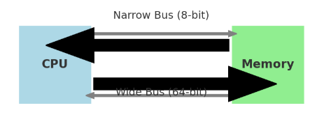

Bus width –A narrow bus (8-bit) and wide bus(64 bit) wider bus carry more data at once.