- Open your computer or laptop and take a clear photo or screenshot of the System Information or About page that shows your processor (CPU), RAM, and storage details.
- open setting -> System -> About

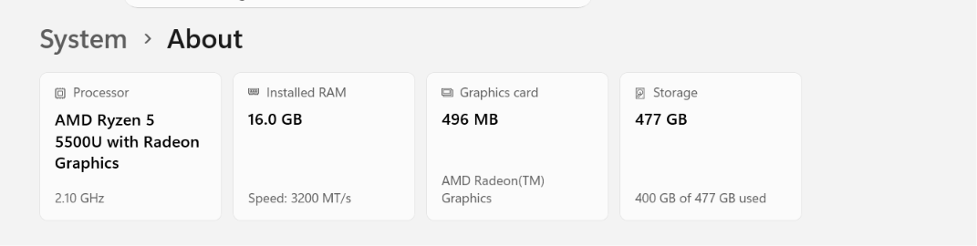
- Draw and label a diagram (on paper or digitally) showing the main hardware components inside a computer cabinet, including CPU, RAM, motherboard, hard drive/SSD, power supply, and at least two ports (USB, HDMI, etc.).

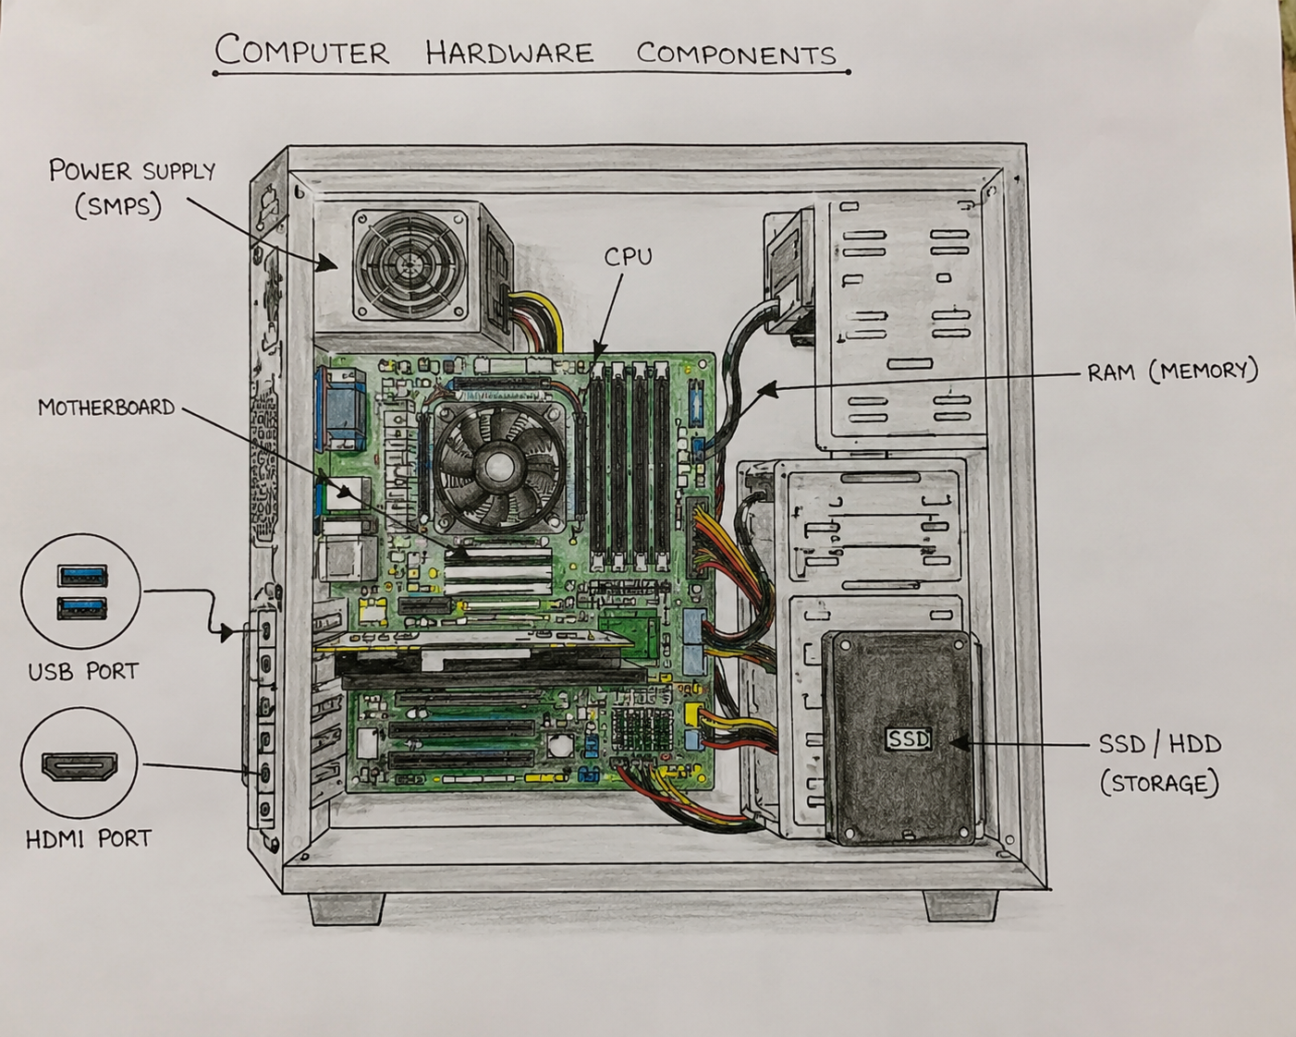

Labels:
- CPU (Processor)
- RAM
- Motherboard
- SSD/HDD
- Power Supply (SMPS)
- USB Port
- HDMI Port
- Hardware Upgrades for Faster Gaming/Video Editing
Component | Why it Helps
RAM Upgrade | More memory allows smoother multitasking and faster application performance.
SSD Upgrade | Faster boot time, file loading, and software performance.
GPU Upgrade | Improves gaming graphics and speeds up video rendering.
Better Cooling System | Prevents overheating and maintains high performance.
Faster CPU | Processes tasks quicker and improves editing/rendering speed.

- SSD vs HDD Comparison
SSD | HDD
Faster read/write speeds | Slower read/write speeds
No moving parts, more durable | Has moving parts, can be damaged more easily
Faster boot and application loading | Slower boot and loading times

