重庆科技学院
上机实验报告(上机操作类)
课程名称 | 移动应用系统开发技术 |  | 实验题目 | 实验10-内容提供者
机房编号 | I302 |  | 上机时间 | 20220531
指导老师 | 冯骊骁 |  | 报告序号 | 10 | 上机成绩
学生姓名 | 杨小童 | 学号 | 2020444223 | 教学班级 | 软件20-01
一、上机操作目的和要求
1、使用ContentProvider创建并注册内容提供者
2、使用ContentResolver查询短信内容提供者的共享内容；
3、 巩固Listview的使用；

二、上机操作需要的软、硬件
JDK + Android + SDK

三、上机操作内容(老师布置的具体任务)
1、利用ContentProvider，在之前程序基础上，创建sqlite数据库中user表的内容提供者（包含增删改查等接口），并编写测试程序。
2、利用ContentResolver，点击查看短信按钮，读取Android系统的短信内容，并显示在Listview列表中。
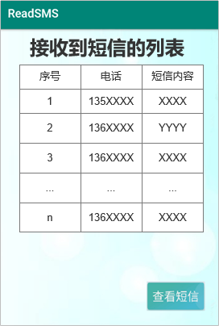
四、上机操作的基本步骤
ContentProvider：
1.创建一个新工程。
2.创建MyContentProvider
3. MainActivity类
4.MyHelper类

ContentResolver：
- 创建两页面以显示内容
- MainActivity类
- MyAdapter类
- MyHelper类
- Dao类
- User类

（1）MyContentProvider类
public class MyHelper extends SQLiteOpenHelper {
public MyHelper(@Nullable Context context, @Nullable String name, @Nullable SQLiteDatabase.CursorFactory factory, int version) {
super(context, name, factory, version);
}
@Override
public void onCreate(SQLiteDatabase sqLiteDatabase) {
sqLiteDatabase.execSQL("create table user (id integer primary key autoincrement,phone varchar(20),content varchar(20))");
sqLiteDatabase.execSQL("insert into user (phone,content) values('123456','test')");
sqLiteDatabase.execSQL("insert into user (phone,content) values('2020444229','彭竹庚')");
}
@Override
public void onUpgrade(SQLiteDatabase sqLiteDatabase, int i, int i1) {
}
}
- MainActivity类
public class MainActivity extends AppCompatActivity {
@Override
protected void onCreate(Bundle savedInstanceState) {
super.onCreate(savedInstanceState);
setContentView(R.layout.activity_main);
}
}
- MyHelper类
public class MyHelper extends SQLiteOpenHelper {
public MyHelper(@Nullable Context context, @Nullable String name, @Nullable SQLiteDatabase.CursorFactory factory, int version) {
super(context, name, factory, version);
}
@Override
public void onCreate(SQLiteDatabase sqLiteDatabase) {
sqLiteDatabase.execSQL("create table user (id integer primary key autoincrement,phone varchar(20),content varchar(20))");
sqLiteDatabase.execSQL("insert into user (phone,content) values('123456','test')");
sqLiteDatabase.execSQL("insert into user (phone,content) values('2020444229','彭竹庚')");
}
@Override
public void onUpgrade(SQLiteDatabase sqLiteDatabase, int i, int i1) {
}
}

- 两个布局，用以显示内容
- 布局一
<?xml version="1.0" encoding="utf-8"?>
<LinearLayout xmlns:android="http://schemas.android.com/apk/res/android"
android:layout_width="match_parent"
android:layout_height="match_parent"
android:background="#99EDEC"
android:orientation="vertical">
<LinearLayout
android:layout_width="match_parent"
android:layout_height="match_parent"
android:layout_marginLeft="42dp"
android:layout_marginRight="42dp"
android:orientation="vertical">
<TextView
android:layout_width="match_parent"
android:layout_height="wrap_content"
android:gravity="center"
android:text="接收到短信的列表"
android:textSize="35sp"
android:textStyle="bold" />
<LinearLayout
android:layout_width="match_parent"
android:layout_height="wrap_content"
android:layout_marginTop="10dp"
android:background="@color/white"
android:orientation="horizontal">
<TextView
android:layout_width="wrap_content"
android:layout_height="wrap_content"
android:layout_weight="1"
android:gravity="center"
android:text="序号"
android:textSize="25sp" />
<TextView
android:layout_width="wrap_content"
android:layout_height="wrap_content"
android:layout_weight="1"
android:gravity="center"
android:text="电话"
android:textSize="25sp" />
<TextView
android:layout_width="wrap_content"
android:layout_height="wrap_content"
android:layout_weight="1"
android:gravity="center"
android:text="短信内容"
android:textSize="25sp" />
</LinearLayout>
<LinearLayout
android:layout_width="match_parent"
android:layout_height="400dp"
android:background="@color/white">
<ListView
android:id="@+id/lv1"
android:layout_width="match_parent"
android:layout_height="wrap_content" />
</LinearLayout>
<Button
android:id="@+id/bt1"
android:layout_width="100dp"
android:layout_height="50dp"
android:layout_gravity="right"
android:layout_marginTop="50dp"
android:backgroundTint="#10E1C2"
android:text="查看短信"
android:textColor="@color/white" />
</LinearLayout>
</LinearLayout>
- 布局二
<?xml version="1.0" encoding="utf-8"?>
<LinearLayout xmlns:android="http://schemas.android.com/apk/res/android"
android:orientation="horizontal"
android:layout_width="match_parent"
android:layout_height="match_parent">
<TextView
android:id="@+id/tv_con1"
android:layout_width="wrap_content"
android:layout_height="wrap_content"
android:hint="id"
android:textSize="30dp"
android:layout_weight="1"
android:gravity="center"
android:textAlignment="center"/>
<TextView
android:id="@+id/tv_con2"
android:layout_width="wrap_content"
android:layout_height="wrap_content"
android:textSize="30dp"
android:text="phone"
android:layout_weight="1"
android:gravity="center"
android:textAlignment="center"/>
<TextView
android:id="@+id/tv_con3"
android:layout_width="wrap_content"
android:layout_height="wrap_content"
android:textSize="30dp"
android:text="content"
android:gravity="center"
android:layout_weight="1"
android:textAlignment="center"/>
</LinearLayout>
- MainActivity类
public class MainActivity extends AppCompatActivity {
List<User> data=new ArrayList<User>();
MyAdapter myAdapter;
Dao dao;
ListView lv1;
Button bt1;
@Override
protected void onCreate(Bundle savedInstanceState) {
super.onCreate(savedInstanceState);
setContentView(R.layout.activity_main);
lv1=findViewById(R.id.lv1);
bt1=findViewById(R.id.bt1);
Uri uri= Uri.parse("content://com.example.experience6_provider/query");
Cursor cursor=getContentResolver().query(uri,null,null,null,null);
dao=new Dao(this);
myAdapter=new MyAdapter(this,data,dao);
dao.select_all(data, cursor);
MyAdapter myAdapter = new MyAdapter(this, data,dao);
bt1.setOnClickListener(new View.OnClickListener() {
@Override
public void onClick(View view) {
lv1.setAdapter(myAdapter);
}
});
}
}
- MyAdapter类
public class MyAdapter extends BaseAdapter {
private Context context;
private List<User> data;
private LayoutInflater inflater;
private Dao dao;
public MyAdapter(Context context, List<User> data, Dao dao) {
this.context = context;
this.data = data;
this.dao = dao;
inflater=LayoutInflater.from(context);
}
@Override
public int getCount() {
return data.size();
}
@Override
public Object getItem(int i) {
return data.get(i);
}
@Override
public long getItemId(int i) {
return i;
}
@Override
public View getView(int i, View view, ViewGroup viewGroup) {
ViewHold viewHold = null;
if (view == null) {
viewHold = new ViewHold();
view = inflater.inflate(R.layout.linear, null);
viewHold.id = (TextView) view.findViewById(R.id.tv_con1);
viewHold.phone = (TextView) view.findViewById(R.id.tv_con2);
viewHold.content = (TextView) view.findViewById(R.id.tv_con3);
view.setTag(viewHold);
} else {
viewHold = (ViewHold) view.getTag();
}
viewHold.id.setText(String.valueOf(data.get(i).getId()));
viewHold.phone.setText(data.get(i).getPhone());
viewHold.content.setText(data.get(i).getContent());
return view;
}
class ViewHold {
TextView id;
TextView phone;
TextView content;
}
}
- MyHelper类
public class MyHelper extends SQLiteOpenHelper {
public MyHelper(@Nullable Context context, @Nullable String name, @Nullable SQLiteDatabase.CursorFactory factory, int version) {
super(context, name, factory, version);
}
@Override
public void onCreate(SQLiteDatabase sqLiteDatabase) {
}
@Override
public void onUpgrade(SQLiteDatabase sqLiteDatabase, int i, int i1) {
}
}
- Dao类
public class Dao {
private Context context;
private MyHelper myHelper;
private SQLiteDatabase db;
private Cursor cursor;
public Dao(Context context) {
this.context = context;
this.myHelper = new MyHelper(context,"mydb112",null,1);
}
void select_all(List<User> data,Cursor cursor){
while (cursor.moveToNext()) {
data.add(new User(cursor.getInt(0), cursor.getString(1), cursor.getString(2)));
}
}
}
- User类
public class User {
private int id;
private String phone;
private String content;
public User(String phone, String content) {
this.phone = phone;
this.content = content;
}
public User(int id, String phone, String content) {
this.id = id;
this.phone = phone;
this.content = content;
}
public int getId() {
return id;
}
public void setId(int id) {
this.id = id;
}
public String getPhone() {
return phone;
}
public void setPhone(String phone) {
this.phone = phone;
}
public String getContent() {
return content;
}
public void setContent(String content) {
this.content = content;
}
}

五、上机操作的结果截图及还存在的问题

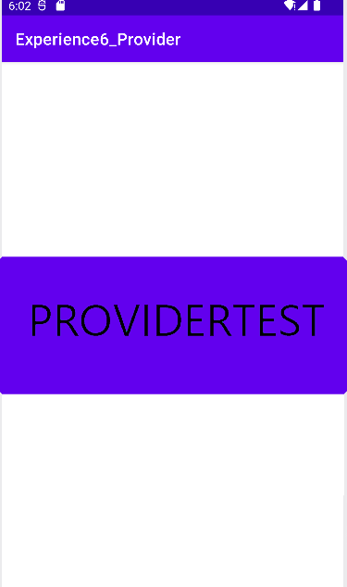

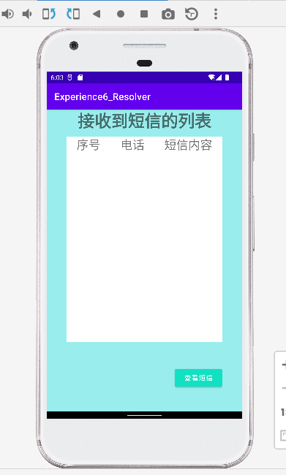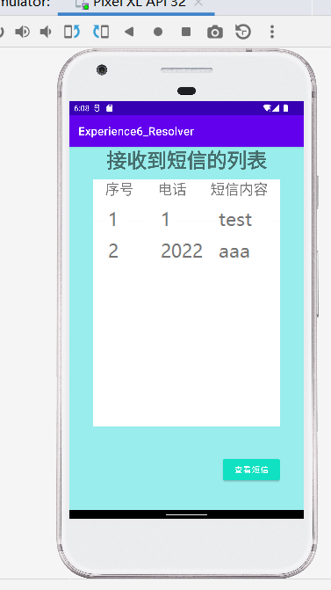

六、上机操作的收获及心得

1、了解了ContentProvider与ContentResolver的相关知识点
2、能使用ContentProvider创建并注册内容提供者
3、能使用ContentResolver查询短信内容提供者的共享内容；
4、巩固了Listview的使用以及对数据库的掌握。

建议：正文采用五宋体，代码用小五号Times new Roman字

