Spec axi_if_cpubus.

This is a Vivado IP block that is used in a Vivado block diagram. The block is connected as an AXI-lite bus slave and allows the block diagram CPU to have a simplified bus interface to user HDL blocks outside of the block diagram. It does not support burst transfers.

The simplified CPU bus interface has an output 18-bit (byte) address bus, 32-bit write data, with read and write strobes. There is a 32-bit input data bus with a data valid signal for data returned by read operations.

The user HDL block does not need to provide any response to a bus write transaction.
For a read transaction the user HDL block should drive ‘cpu_rdata_dv’ high when it is driving valid output data on the ‘cpu_rdata’ bus. Once ‘cpu_rd’ is set low then the ‘cpu_rdata_dv’ input must be driven low. The block passes through the AXI clock ‘s00_axi_aclk’ to the ‘clk_cpu’.

Vivado Symbol

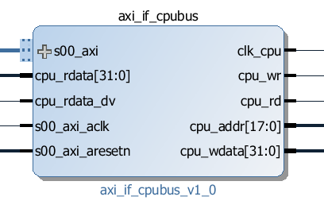

Block I/O

-- AXI-lite slave interface
s00_axi_aresetn Active low reset
s00_axi_aclk AXI-lite bus clock
s00_axi AXI-lite bus

-- CPU Control interface connected to block diagram pins
cpu_clk : out std_logic;
cpu_wr : out std_logic;
cpu_rd : out std_logic;
cpu_addr : out std_logic_vector(17 downto 0);
cpu_wdata : out std_logic_vector(31 downto 0);

cpu_rdata : in std_logic_vector(31 downto 0);
cpu_rdata_dv : in std_logic;

Register table.

The block has no internal registers but is assigned a base address and has a byte address range of 0x3FFFF. Writes and reads within this space are passed through to the CPU bus.

Document Version
1.0 Initial version

