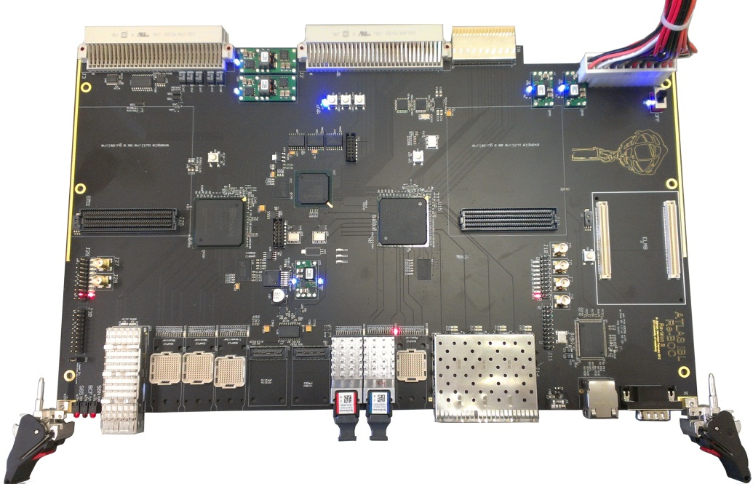

IBL BOC Design and
Firmware Manual

written by
M. Wensing, B. Bergenthal, T. Flick (University of Wuppertal)
A. Kugel, N. Schröer (University of Heidelberg)

Contents
1. Introduction 4
1.1 Interface types 4
2. Hardware 6
2.1 Overview 6
2.2 Board-controller FPGA 8
2.3 ROD-BOC communication 9
2.4 Clock distribution 10
2.5 FPGA Configuration 12
2.6 S-Link 13
3. Card Interfaces 17
3.1 Setup Bus 17
3.2 Ethernet 18
3.3 ROD XC 18
3.4 BOC-to-ROD 18
3.5 Optical interfaces to the detector 19
3.6 Others 20
3.6.1 DCS (ELMB) 20
3.6.2 UART 21
4. Firmware 21
4.1 BOC Control FPGA (BCF) 21
4.2 BOC Main FPGA (BMF) 22
4.2.1 TX path 23
4.2.2 RX path 25
4.3 Register map 26
4.3.1 General remarks 26
4.3.2 BCF registers 26
4.3.3 BMF general registers 29
4.3.4 TX path registers 30
4.3.5 RX path register 30
4.4 Register description 31
4.4.1 Build informations 31
4.4.2 Laser enable register 31
4.4.3 JTAG override register 31
4.4.4 BOC serial number 31
4.4.5 Primitive processing 32
Load environment 32
Save environment 32
Set IP 32
Get IP 32
Set Gateway 32
Get Gateway 32
Set Netmask 33
Get Netmask 33
4.4.6 PLL configuration 33
PLL control 33
PLL status 33
PLL data 34
Input delay 34
4.4.7 ProgUnit registers 35
ProgUnit control 35
ProgUnit status 35
ProgUnit data count 36
ProgUnit data 36
ProgUnit flash address 36
ProgUnit CRC 36
4.4.8 ICAP registers 36
ICAP control/status register 36
ICAP data registers 36
4.4.9 TX path registers 37
TX control register 37
TX status register 37
TX data registers 37
TX coarse delay register 38
4.4.10 RX path registers 38
RX control register 38
RX status register 38
5. Software 39
5.1 Introduction 39
5.1.1 Prerequisites 39
5.1.2 Obtaining and building the library 40

Introduction
During the LHC shutdown in 2013/14 an upgrade of the ATLAS pixel detector called Insertable b-Layer (IBL) is scheduled. The on-detector readout will use new FE-I4 readout ASICs, which needs to be complemented by a new off-detector readout system. To maintain a maximum level of compatibility with the existing off-detector readout the new system architecture will again be based on a pair of VME cards. The Back-of-Crate card (BOC) handles the detector and TDAQ interfaces in the rear of the VME crate and the Read-Out-Driver (ROD) controls the readout and processing detector. The overall IBL readout system is shown in Figure 1.
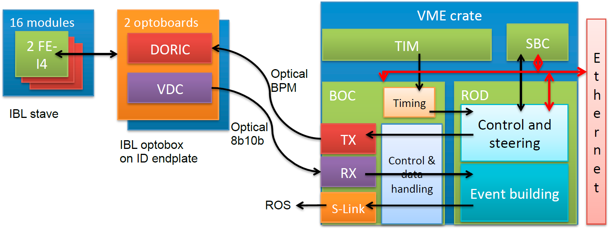Figure 1: Block schematic of the IBL readout system

Interface types
The BOC is responsible to handle the control interface to the detector and the data interface from the detector. Both interfaces run via optical links, however of different speed and protocol. Also, data input operates per FE-I4 chip while data output runs per module (2 * FE-I4). Hence the number of output lines is only half the number of input lines. On the existing BOC, custom-made RX and TX modules are used. The TX modules provide individual bi-phase mark (BPM) encoding of the signals together with a tuning feature for the mark-space-ratio (MSR tuning) and fine-tuning of the signal delay. The optical output power can be adjusted up to around 1mW in order to compensate the sensitivity degradation of the on-detector receiving pin diodes. The same transmission mechanism will be used on the new BOC. However, we plan to perform all encoding and timing adjustments inside an FPGA. Hence the optical transmitters need only to perform the electrical to optical conversion, which can in principle be done with commercial components [2]. However it must be guaranteed that the output power is sufficiently high.
The requirements on the RX path are quite different between the old and new readout, the former running at 40MHz with an unbalanced signal and the latter running at 160MHz with a balanced 8B10B encoded signal. Commercial components [2] are likely to be suitable in this case and will be investigated.
The BOC also handles the interface to the TTC timing system, which provides the 40MHz experiment clock and some other information. The TTC clock is distributed across the private part of the VME backplane as a differential PECL signal to every BOC card. It is the primary reference clock for the BOC and the ROD, the latter getting its copy via the BOC.
The BOC communicates with the ROD across the VME connectors. This communication comprises four different sections (see also Figure 2):
- Board control and configuration via the “setup-bus” interface, a simple extension to the ROD's VME interface.
- Data towards the detector (CMD out)
- Data from the detector (RX decode)
- Data towards the TDAQ subsystem (S-Link)
Figure 2: Functional blocks
The connectivity and the electrical properties of the signals involved on these 4 communication paths must be implemented in a way that interoperability between a new and an old card on either side can be established. Of course a special firmware on the new card (ROD or BOC) will be needed in this case.
Finally, the data processed by the ROD must be sent to the TDAQ subsystem via the standard ATLAS read-out links (ROLs). These ROLs use a 2.0 Gbit/s bi-directional optical interface, driven by the CERN HOLA protocol [3], which only provides a uni-directional user data interface operating at 160MB/s plus flow-control according to the S-Link specification [4]. The HOLA S-Link on the BOC will be implemented directly in the FPGAs and will support twin-channel operation for FTK compatibility. The use of quad opto-transceivers (QSFPs [5]) will be evaluated, as this could simplify routing of the fibers in the cabinet. One of the Spartan-6 devices will connect to 4 individual SFP transceiver and the other to a QSFP transceiver.

Hardware

Overview
The BOC hardware implementation takes advantage from recent FPGA technology and from the advancements provided by the FE-I4 chip compared to FE-I3. The majority (if not all) of the timing adjustment logic used on the existing BOC can be either integrated into the FPGAs or is no longer required. Likewise the multitude of level-shifter circuitry can be omitted. Serially terminated FPGA I/O buffers (SSTL3-I) enable to run the BOC-ROD communication at higher speeds but can still be used for LVTTL signaling when operating an old card together with a new one.
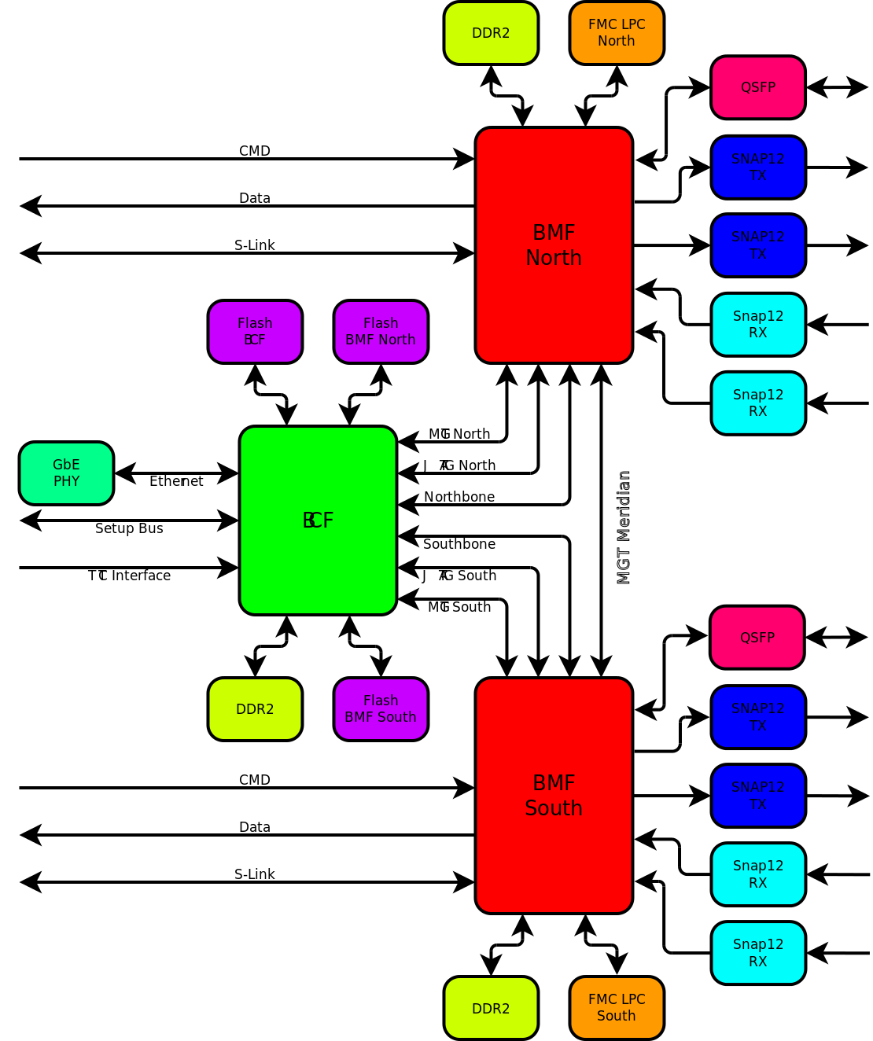Figure 3: Block schematic of the BOC card
The major components on the new BOC are shown in Figure 3. The two Xilinx Spartan-6LX150T FPGA implement two functionally identical BMF-slices. Each slice attaches to two TX interfaces, two RX interfaces, two dual-HOLA S-Links and communicates with the ROD. In addition, each FPGA has a single DDR-2 memory device attached and a low pin-count FMC connector. The FMC connectors can be used to carry mezzanines with test circuitry during prototype or volume production factory tests. In case neither the SNAP-12 transceivers nor the old-style TX plug-ins provide adequate functionality, the FMC mezzanines can carry custom optical modules. The DDR-2 memory can be used to store data from local operational monitoring.
Auxiliary functions, primarily the setup-bus and the FPGA configuration logic, are integrated in an additional board-controller FPGA (BCF) of type Spartan-6LX75T.

Board-controller FPGA
The primary board-control functions of the BOC are related to the setup-bus and power-up configuration (see following chapters). Only little additional logic is required for the mandatory functions and all could well be implemented in a CPLD. However, with the availability of complex functions at relatively low cost provided by the Spartan-6 FPGA family a different approach is taken on the new BOC: a smaller FPGA (XC6SLX75T-3FGG484C) accompanies the two main FPGAs and acts as intelligent board-controller (Figure 4).
Figure 4: Board controller FPGA

The setup-bus logic is implemented in the usual way (VHDL code for the FPGA fabric) and provides the functionality known from the existing BOC:
- Control- and status information are provided via a few dedicated lines between the BCF and the main FPGAs.
- Control and status lines of the optical modules are connected to the BCF.
- SRAM, 1kB (FPGA internal)
The logical interface towards the DAQ software will be as similar to the existing card as possible, given the constraints of the hardware differences.
The BCF loads it's power-up configuration from an attached serial FLASH memory. Subsequently, the controller firmware downloads the configuration bitstreams to the main FPGAs in order to complete power-up configuration of the BOC.
Besides these legacy functions a Microblaze soft-processor running a standard Linux kernel can be implemented in the controller FPGA, which enables a number of advanced features like:
- remote access via an ethernet port to the BOC during tests and stand-alone operation
- emulation of the crate-controller and setup-bus in stand-alone mode
- firmware upgrades via Ethernet
- software-controlled board configuration
- extended operational monitoring.
Only little additional hardware is required to implement such a minimal Linux system: next to the FPGA a single DDR2 memory chip [15], an Ethernet PHY [16] plus RJ45 connector, a serial port driver and a serial FLASH storing the OS. A silicon serial-number device [13] provides board-identification and is used to derive the Ethernet MAC address from.

ROD-BOC communication
As stated above, ROD-BOC communication is comprised of four different groups: CMD, RX, S-Link and setup-bus. The first three groups are made of high-speed signals, while the setup-bus is relatively slow.
For backward-compatibility all signals existing on the VME connectors J2 and J3 must be connected appropriately anyway. Therefore, the locations of clock and setup-bus related lines are fixed. However all “high-speed” signals can be used in a flexible way, as we don't use bus buffers but connect the FPGAs directly to the VME connectors. The J0 connector will be used as well, which doesn't exist on the old cards.
The total number of backplane signals available for the four signal groups is 250. This doesn't satisfy the connectivity requirements if all signals run at the native data-rate of 40Mbit/s. Therefore some signals must be multiplexed onto fewer lines running at a higher data-rate (80Mbit/s). As a result, the four groups require a total of 229 lines out of 250. This already includes the extension of the set-bus to 16 bit addresses. The following signal allocation will be used:
Group | Channels | Lines/channel | Composition | Speed [MHz]
CMD | 2 | 8 | Individual lines | 40
RX | 8 | 12 | 8 data, 2 addr, 2 ctl | 80
S-Link | 4 | 23 | 16 data, 4 ctl, 2 status, 1 spare | 80
The signals of these 3 groups will use SSTL3-I I/O-standard supported by the Spartan-6 FPGAs. The SSTL3-I I/O buffers are shown in Figure 5. All terminating resistors are realised via the Spartan-6 on-chip termination features, which simplifies board layout and allows to re-configure the FPGAs pins for different I/O-standards like LVTTL or LVCMOS. The reference voltage of 1.5V is derived from a 3.0V precision voltage reference (e.g. Burr Brown REF3330) on both ROD and BOC.
Trace routing of all SSTL3 signals must be done with matching lengths on a per-channel basis. Due to the relatively low speed a match of +/- 1ns is sufficient. The fine-tuning will be done with the help of calibration of the Spartan-6 input delays (IDELAY). For this, all SSTL3 output channels will contain logic to provide a known data pattern which is used to calibrate the corresponding inputs. IDELAY calibration is required after power-up only.
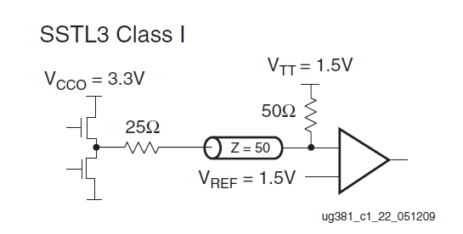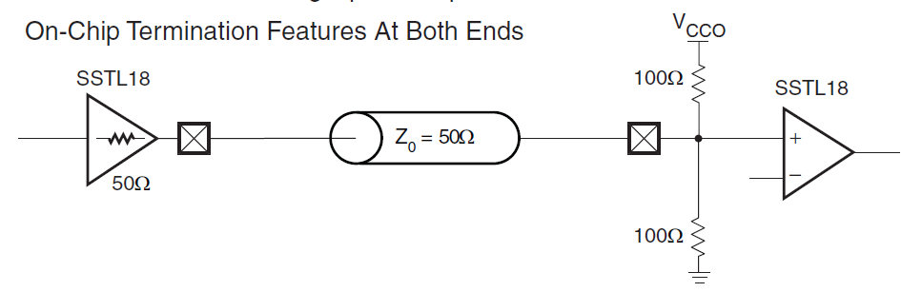Figure 5: SSTL3 buffers (principle: left, Spartan-6 on chip termination example: right)
The setup-bus with it's lower speed requirements will use 3.3V LVTTL/LVCMOS signalling levels.

Clock distribution
On the existing BOC card a complex timing system had to be used with the following basic functions:
- System clock generation for BOC and ROD derived from TTC clock (via backplane).
- Individual adjustment of delay and mark-space-ration on the CMD path. Implemented via programmable TX-modules.
- Individual adjustment of sampling phase and delay on the RX path. Implemented via programmable delay lines (PHOS4).
A further complication came from the fact, that the different components were operating at different voltage levels – 5V-PECL, 3V-PECL, LVDS and LVCMOS – requiring a large number of level-shifting circuitry. An overview of the old clock system is shown in Figure 6.
With the simplified optical interfaces and the advanced timing features of the modern Spartan-6 FPGAs the clock system of the new BOC can be reduced to the “central core”, see Figure 7. Level translation is required when receiving (5V-PECL into 3V-PECL, MC100LVEL92 [10]) and driving (3V-PECL to 5V-PECL, MC100EP16 [9]) the backplane clock signals. A programmable delay (2 cascaded MC100EP195B [11]) is required in order to synchronize the phases of the BOC and ROD clocks with the ATLAS TTC clock. A programmable delay with a range of 20ns together with the FPGA option to invert the clock provides sufficient margin to adjust the phases. A jitter-cleaner TI CDCE62002 [12] after the delay line provides two clean clock outputs, which are fed to the local BOC resources and towards the ROD with low skew. The jitter-cleaner also provides fall-back to a local oscillator in case the TTC clock is not available. Input clock selection can be done automatically or manually, controlled by the BCF.
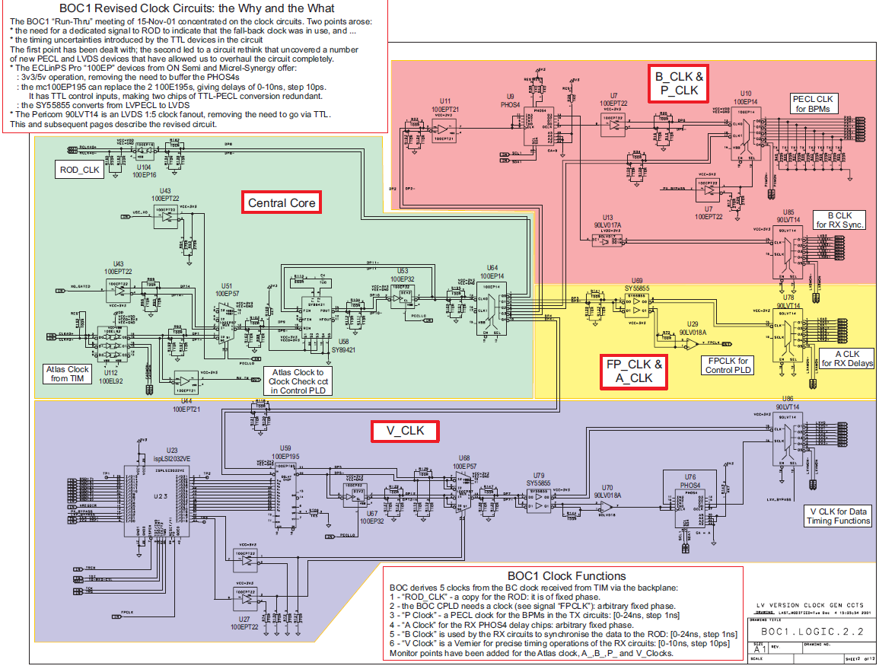Figure 6: Old BOC clock system
The individual delay adjustment of the CMD output signals is discussed in chapter 4.2.1.
In addition, there are a number of individual clocks required, not related to the ATLAS timing system:
- 25 MHz crystal for Ethernet PHY
- 100/125MHz selectable MGT reference clock. This enables to operate the transceivers at 1.25GBit/s, 2.0Gbit/s (HOLA default), 2.5GBit/s and 3.125GBit/s
- 100MHz FPGA design reference clockLow-jitter clock oscillators [14] and buffers will be used for this purpose.

Figure 7: New BOC clock system

FPGA Configuration
The FPGAs are SRAM based devices and require download of a configuration bitstream after power-up. A variety of options is available to accomplish this, as described in the Xilinx Spartan-6 configuration user guide [17]. The lowest-level approach for FPGA configuration is to use a JTAG programmer attached to a JTAG connector. Depending on the wiring of the on-board JTAG signals, either a single device can be accessed or several devices arranged in a JTAG “chain”. On the BOC, we use a two JTAG levels. The JTAG configuration lines of the BCF are connected to a dedicated JTAG connector. A second JTAG connector is attached to user I/O pins of the BCF, likewise the JTAG ports of the two main FPGAs. Thus, the BCF firmware can create a second JTAG chain, consisting of one or two FPGAs attached to the second connector. This is the typical setup for lab tests. The Xilinx JTAG programmer software will also detect and program the SPI FLASH attached to the BCF SPI configuration port (see below).
Using a JTAG programmer is not suitable for normal operation. Instead, a two-step start-up sequence is used here: firstly, the BCF loads it's configuration in “Master Serial Peripheral Interface” mode from a 64Mbit SPI FLASH. Subsequently the BCF firmware reads the configuration data for the two main FPGAs from a second SPI FLASH and downloads it via the Slave Serial configuration ports. Depending on the configuration the BCF will finally load software from a third SPI FLASH.
The BCF firmware makes all configuration ports and the SPI FLASH memories available for access via the setup-bus and potentially for access from the embedded Microblaze processor, enabling firmware updates via VME or Ethernet. A sketch of the configuration logic is shown in Figure 8.
Figure 8: Configuration interfaces
Additional to the external configuration interfaces a internal configuration interface (ICAP) is used in the BMF firmware. This interface allows to reconfigure parts of the BMF firmware in-situ.

S-Link
Within ATLAS, the HOLA S-Link implementation is the standard readout link between detectors and the TDAQ system. At present, all detectors use the mezzanine version of the link source card (LSC), while the TDAQ ROBIN cards [6] use an embedded version of the link destination card (LDC), thus fixing HOLA as de-facto ROL implementation for ATLAS. The BOC will take advantage from this fact by using an embedded S-Link implementation as well, with the protocol core and the high-speed serialisers/deserialisers inside the FPGA. To support the requirements of the FTK [7], the S-Link user data have to be copied to two ROLs, one feeding the TDAQ system and the other feeding the FTK trigger. This is done inside the main FPGAs in a way compatible to the dual-HOLA implementation [ibidem]. The LSC user interface is duplicated onto two HOLA LSC cores. The status signals link-full-flag (#LFF) and link-down (#LDWN) are combined, see Figure 9. Status generation can be selectively enabled via a programmable register.
Concerning the HOLA S-Link firmware, CERN maintains the VHDL source code implementing HOLA source and destination modules interfacing to an external TLK2501 serialiser/deserialiser device. This code can be used as is on the BOC, provided the on-chip gigabit transceivers (MGT) can be configured to a TLK2501 compatibility mode. An initial proof-of-concept design targeted at Virtex-5 FPGA technology has been completed with reasonable success. Migration to Spartan-6 is work in progress:
Figure 9: Dual-HOLA
- Simulation of LSC to LDC communication via FPGA gigabit transceivers is completed. The levels of S-Link user-data (at the LSC) and link-data (at the LDC) and the internal levels of LCS-TX and LDC-RX data corresponding to TLK2501 signals can be observerd - Figure 10 shows the propagation of data through these four levels.
- Architecture migration of an LSC-LDC pair into a Spartan-6 FPGA is completed, resource utilisation is very low:
- Number of occupied Slices: 287 out of 23,038 1%
- Number of bonded IOBs: 95 out of 540 17%
- Number of RAMB8BWERs: 1 out of 536 1%
- Number of BUFG/BUFGMUXs: 7 out of 16 43%
- Number of DCM/DCM_CLKGENs: 2 out of 12 16%
- Number of GTPA1_DUALs: 1 out of 4 25%
The relatively high utilisation of BUFGs is an artefact from having both LSC and LDC implemented independently. The two twin-LSCs of the target implementation will consume less.
- Verification of the design and functional tests connecting a Spartan-6 LSC to a real ROBIN are under preparation.
The BOC exposes the user-data interface of the S-Link source (LSC) to the ROD. In order to reduce the number of signals lines the databits are transmitted in double-data-rate (DDR) style at 80Mbit/s using both edges of the 40MHz system clock. The mapping is shown in the following table:
Line | Signal(s) | Group
1 | UD00 / UD01 | Data
2 | UD02 / UD03 | Data
3 | UD04 / UD05 | Data
4 | UD06 / UD07 | Data
5 | UD08 / UD09 | Data
6 | UD10 / UD11 | Data
7 | UD12 / UD13 | Data
8 | UD14 / UD15 | Data
9 | UD16 / UD17 | Data
10 | UD18 / UD19 | Data
11 | UD20 / UD21 | Data
12 | UD22 / UD23 | Data
13 | UD24 / UD25 | Data
14 | UD26 / UD27 | Data
15 | UD28 / UD29 | Data
16 | UD30 / UD31 | Data
17 | #UCTRL | Control
18 | #UWE | Control
19 | #URESET | Control
20 | #UTEST | Control
21 | #LDOWN | Status
22 | #LFF | Status
23 | UCLK | Unused, spare

The link return lines (LRL) are not used (as on the existing BOC). The data-width indication (UDW) is statically fixed to 32bit. Transmission of the user clock (UCLK) is not necessary, as the communication is system synchronous. This way each S-Link channel consists of 23 lines including 1 spare (unused UCLK). The four S-Link channels occupy rows A, B and C of connector J0, row D plus some pins of rows A, B and C of connector J2.
Typically, every ROL has a dedicated optical transceiver according to the SFP specification [8]. Following this approach requires eight SFP transceivers to be installed on the BOC, which is not a problem and can be done using one 4x1-ganged SFP cage per FPGA (Figure 11, left). An alternative solution which saves some PCB real-estate is to use QSFP transceivers, which contain 4 optical transmitters and 4 optical receivers in one device. A break-out fiber assembly attaches to the QSFP and converts into 4 individual LC-style bi-directional fibers (Figure 11, right). From the point-of-view of overall mechanics this could be an advantage.
Figure 10: S-Link simulation
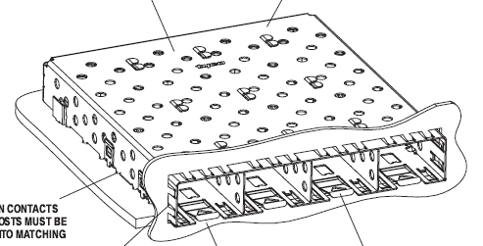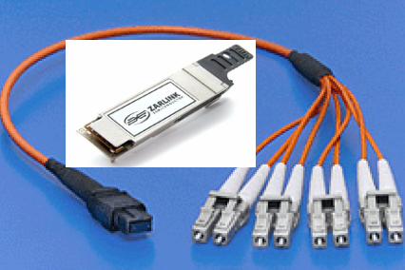Figure 11: SFP options

Card Interfaces

Setup Bus
The Setup Bus is an asynchronous configuration interface between the ROD and BOC card. It provides 16 address, 8 data and 3 control lines. The ROD is the communication master and starts the bus-cycle by pulling the STBN line to low. The WRN line determines if the current cycle is a read or a write cycle. Each bus cycle will be acknowledged by the BOC card. For this the BUSY line acts as acknowledge. For write cycles the BUSY shows that the data has been accepted, for read cycles it shows that the data presented on the data lines is now valid.
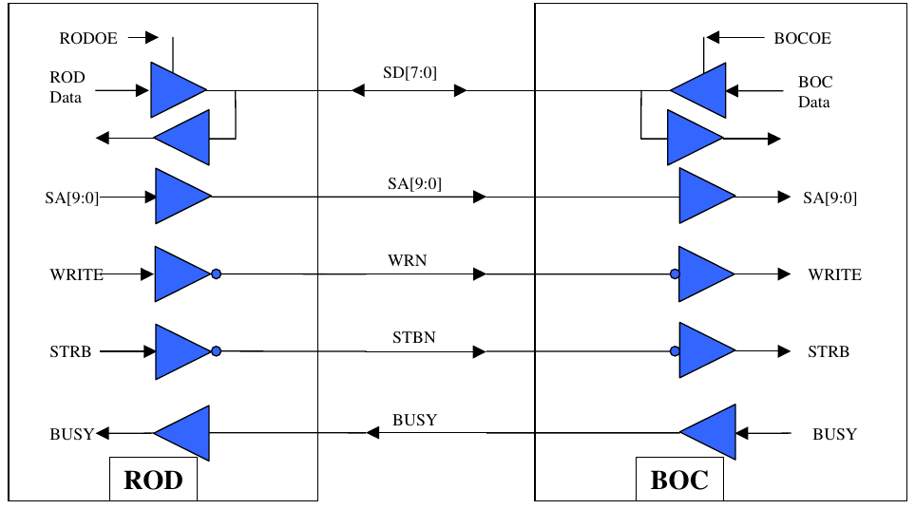Figure 12: Setup Bus interface

Ethernet
The BOC card can connect to the outer world using a Gigabit ethernet interface. The connection is managed by an Microblaze processor.

ROD XC
The data from the ROD to the detector is sent over serial lines. Each module has its own serial line on the backplane connector. The I/O standard of these lines is SSTL3. At the moment the lines are running at 40 Mbit/s, but signals up to 80 Mbit/s have been tested.

BOC-to-ROD
The BOC-to-ROD interface carries all data which has been received from the detector. There are 96 lines with SSTL3 I/O standard between the cards. The 96 lines are divided into 8 12-bit wide data busses. Each data bus transfers the data of 4 front-end chips at a rate of 80 MHz. Table shows the assignment of the lines to the busses. Data lines carry the decoded 8b10b data of the channels and the control line shows if the data is a 8b10b-k-word.
Name | Function
RXDATA<7:0> | Data | BMF south, channel 0...3
RXDATA<9:8> | Address | BMF south, channel 0...3
RXDATA<10> | Valid | BMF south, channel 0...3
RXDATA<11> | Control | BMF south, channel 0...3
RXDATA<35:28> | Data | BMF south, channel 4...7
RXDATA<37:36> | Address | BMF south, channel 4...7
RXDATA<38> | Valid | BMF south, channel 4...7
RXDATA<39> | Control | BMF south, channel 4...7
RXDATA<19:12> | Data | BMF south, channel 8...12
RXDATA<41:40> | Address | BMF south, channel 8...12
RXDATA<43> | Valid | BMF south, channel 8...12
RXDATA<42> | Control | BMF south, channel 8...12
RXDATA<27:20> | Data | BMF south, channel 13...16
RXDATA<45:44> | Address | BMF south, channel 13...16
RXDATA<47> | Valid | BMF south, channel 13...16
RXDATA<46> | Control | BMF south, channel 13...16
RXDATA<55:48> | Data | BMF north, channel 0...3
RXDATA<57:56> | Address | BMF north, channel 0...3
RXDATA<58> | Valid | BMF north, channel 0...3
RXDATA<59> | Control | BMF north, channel 0...3
RXDATA<83:76> | Data | BMF north, channel 4...7
RXDATA<85:84> | Address | BMF north, channel 4...7
RXDATA<86> | Valid | BMF north, channel 4...7
RXDATA<87> | Control | BMF north, channel 4...7
RXDATA<67:60> | Data | BMF north, channel 8...12
RXDATA<89:88> | Address | BMF north, channel 8...12
RXDATA<91> | Valid | BMF north, channel 8...12
RXDATA<90> | Control | BMF north, channel 8...12
RXDATA<75:68> | Data | BMF north, channel 13...16
RXDATA<93:92> | Address | BMF north, channel 13...16
RXDATA<95> | Valid | BMF north, channel 13...16
RXDATA<94> | Control | BMF north, channel 13...16

Optical interfaces to the detector
The optical interface carrying the TTC data to the detector is driven by commercial SNAP12 optical transmitters. These transmitters replace the custom-made TX-plugins by standardized plugins available from different vendors: Tyco, Reflex Photonix, Avago. Figure 13 shows a SNAP12 transmitter and receiver.
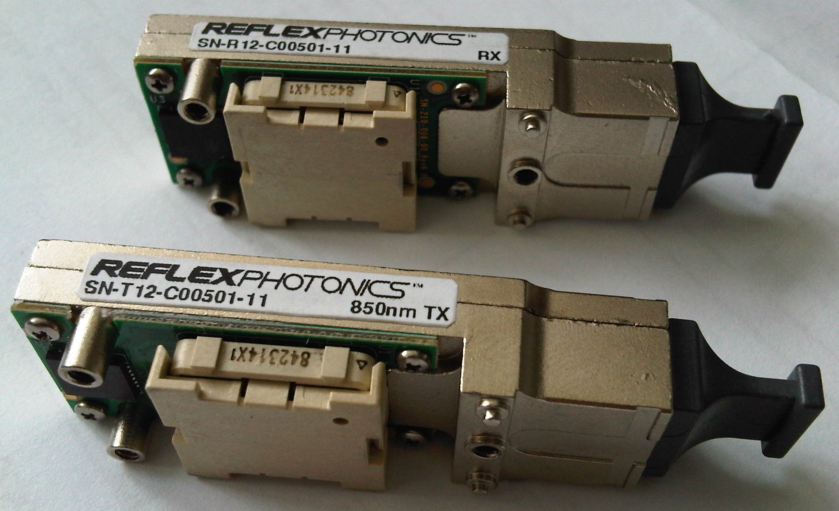Figure 13: SNAP-12 TX (front), RX (rear)

Others

DCS (ELMB)
The detector control system (DCS) is connected to the BOC card over the CAN-bus. On the BOC card there is a expansion slot carrying an ELMB measurement board, which checks different environmental variables of the card:
ELMB channel | Type | Place
0 | NTC 10k | SNAP12 RX1 (north)
1 | NTC 10k | SNAP12 RX2 (north)
2 | NTC 10k | SNAP12 RX1 (south)
3 | NTC 10k | SNAP12 RX2 (south)
4 | NTC 10k | SNAP12 TX1 (north)
5 | NTC 10k | SNAP12 TX2 (north)
6 | NTC 10k
7 | NTC 10k | SNAP12 TX1 (south)
8 | NTC 10k | SNAP12 TX2 (south)
9 | NTC 10k | QSFP (north)
10 | NTC 10k | BMF (north)
11 | NTC 10k | BCF
12 | Voltage | S6 Core 1.2V
13 | Voltage | MGT 1.2V
14 | Voltage | FMC/PHY 2.5V
15 | Voltage | DDR2 1.8V
16 | NTC 10k
17 | NTC 10k
18 | NTC 10k | Ethernet PHY
19 | NTC 10k | QSFP (south)
20 | NTC 10k | BMF (south)
21 | Voltage | PHY 1.8V
22 | NTC 10k | Regulator 1.8V f. PHY
23 | NTC 10k | Regulator 2.5V f. FMC/PHY
24 | NTC 10k | Regulator 1.2V f. S6 Core
25 | NTC 10k | Regulator 3.3V
26 | NTC 10k | Regulator 1.8V f. DDR2
27 | NTC 10k | Regulator 1.2V f. MGT
28 | Voltage | VME 5V over 1k/1k voltage divider
29 | Voltage | VME 3.3V over 1k/1k voltage divider
30 | Humidity (HIH-5030-001)
31 | Humidity (HIH-5030-001)
32 | Humidity (HIH-5030-001)

UART
For debugging purpose there is an USB-UART convertor chip available at the front-panel. It is used to provide debugging messages from the BCF.

Firmware

BOC Control FPGA (BCF)
The BOC Control FPGA (BCF) is responsible for controlling the card. A block diagram of the BCF firmware is shown in Figure 14. Central part of the firmware is a Wishbone interconnect which builds the basis for accessing all peripherals on the card. Two master units are connected to this interconnect: a Setup-Bus connector and the Microblaze processor. Both masters can access all peripherials. The Microblaze processor is mainly used to provide Ethernet access to the card. So all registers available on the Setup Bus are also available over Ethernet. Additional there are some self test functions for the card implemented in the Microblaze.
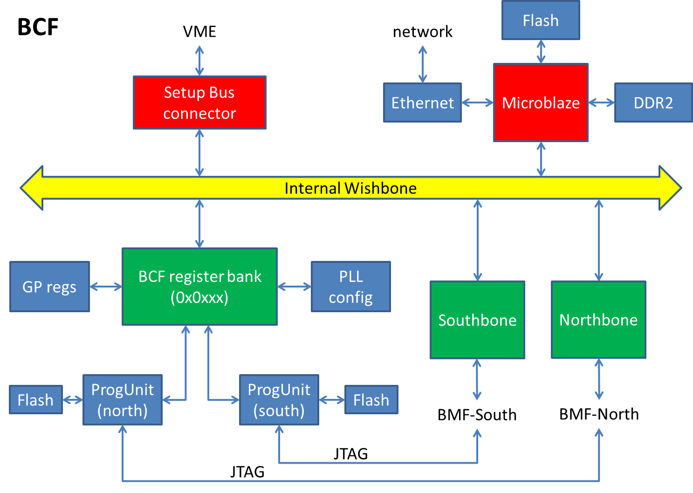Figure 14: Block diagram of the BCF firmware

BOC Main FPGA (BMF)
The signal processing on the card is done by the two Main FPGAs. From the firmware point of view the only difference between both BMF is the different pin-out. A block schematic showing the general part of the BMF firmware is shown in Figure 15.
As in the BCF a Wishbone interconnect is the central part of the firmware. Connected to it are registers for general purpose as well as the RX and TX path registers. In the general purpose register area there are registers for build information and the registers for the ICAP interface which is used for reconfiguration of the fine delay blocks.
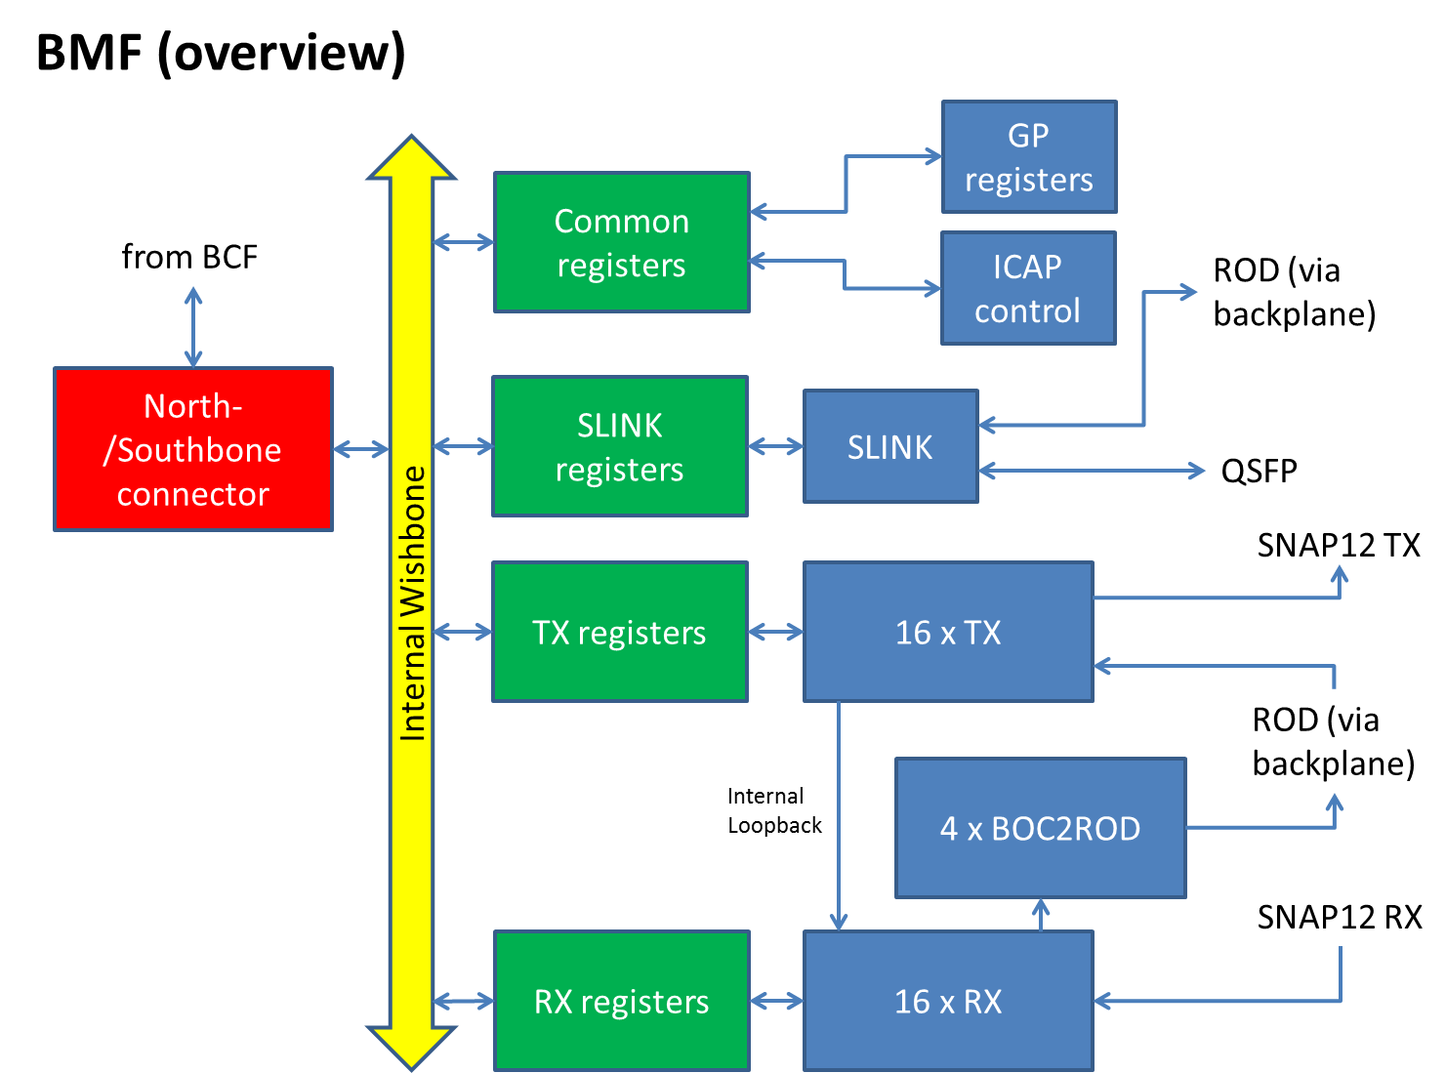Figure 15: Block diagram of the BMF firmware

TX path
The TX path as shown in Figure 16 is used to send commands and triggers to the modules. In normal detector operation it is used to do the BPM encoding (see Figure 17) of the incoming data from the ROD and to adjust the detector timing using coarse and fine delay blocks. The coarse delay is implemented using a variable-tap shift register clocked with 160 MHz. So the coarse delay gives a step of 6.25 ns per tap. The fine delay is adjusted using IODELAY2 elements in the Spartan6 I/O blocks. These IODELAY2 elements are described in [28] and provide a step of around 28 ps per tap. As they can only be used in fixed-output-delay mode the reconfiguration of the delay is done using partial reconfiguation. To do this parts of the BMF configuration bits are reloaded to change the delay value. Figure 18 shows an example of tuning the fine delay inside the FPGA. The duty-cycle change is very small and the delay is linear in steps of ~28 ps.
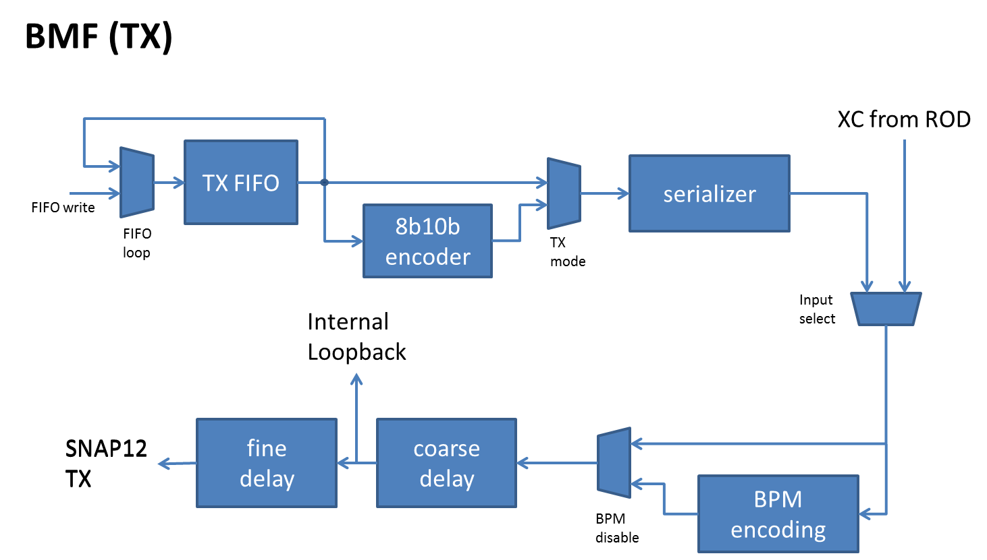Figure 16: Block schematic of the BMF TX path

For debugging and stand-alone operation of the card each TX path can generate its own serial data stream. The generation is configurable to send 40, 80 or 160 Mbit/s either 8b10b-encoded data (for loopback tests) or raw data. The FIFO is accessible through the Setup Bus and can take up to 1k words.
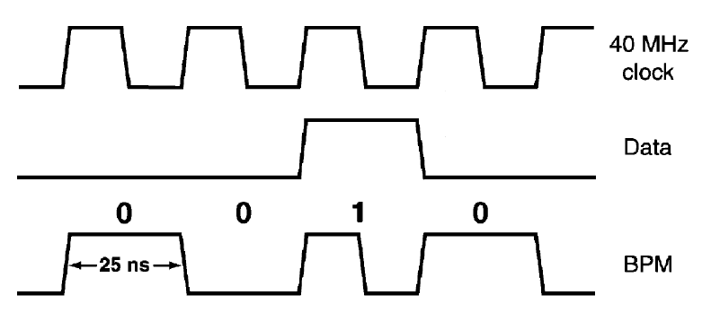Figure 17: Bi-phase-mark encoding
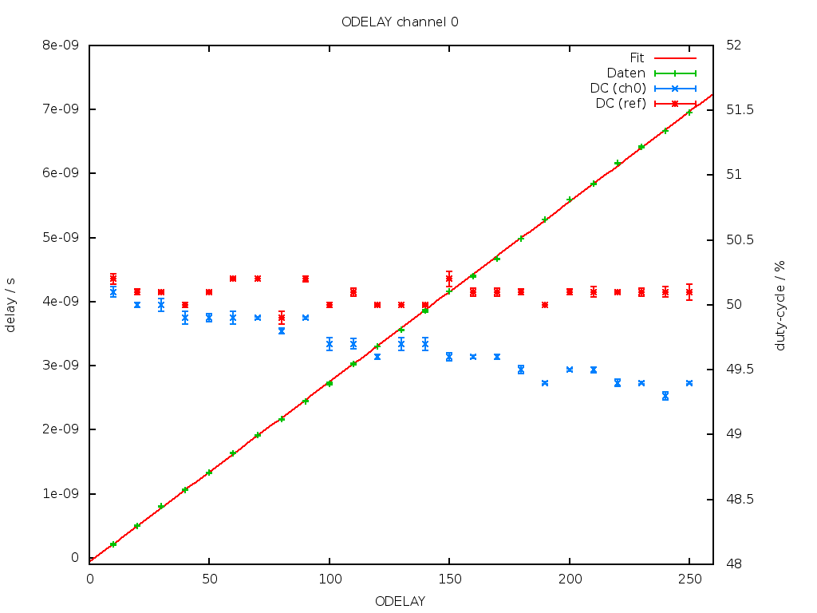Figure 18: Fine delay tuning and corresponding duty cycle

RX path
The RX path in the firmware is responsible for the reception and decoding of incoming detector data. As the detector data can have any phase shift first a clock and data recovery needs to be performed. This is done by oversampling the signal using a SERDES running at 640 MHz. Using an edge-detection algorithm (see [25]) the right sampling point for the data is chosen. After the clock and data recovery the incoming bits need to be aligned to 8b10b words. This word alignment is based on known patterns of the 8b10b-encoding. The FE-I4 uses 3 special patterns: start-of-frame (SOF), end-of-frame (EOF) and IDLE. These pattern can not occur in the data stream, so an word alignment can be performed searching for these unique pattern. After the word aligment the last step is the decoding of the 8b10b data. Figure 19 shows a block schematic of the RX path.
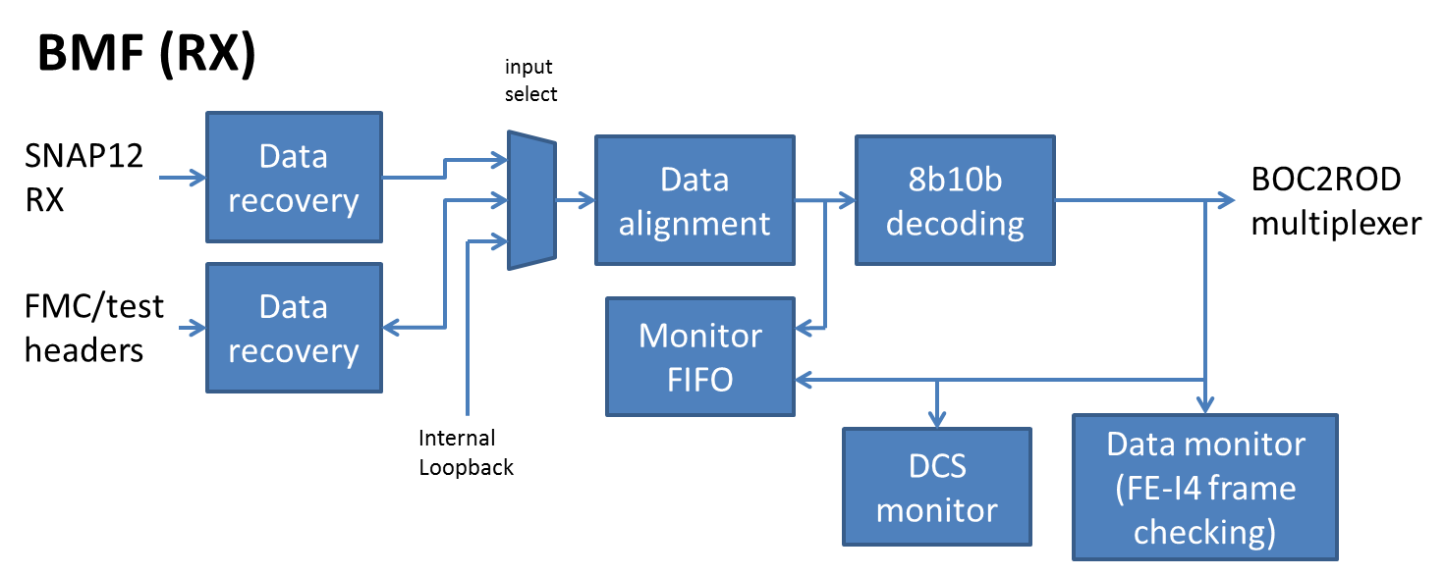Figure 19: Block schematic of the BMF RX path
For monitoring and debugging the RX path there is some functionality around the decoding block. The user can save the incoming data locally on the BOC card for doing analysis of transmission errors etc. Also the status of the decoders is monitored constantly. Beside the data quality monitoring a block for DCS monitoring is implemented. It looks for FE-I4 GADC records and saves them into a FIFO to be forwarded to DCS.
After decoding the data 4 channels are collected and multiplexed to the ROD. The interface is described in chapter 3.4.

Register map

General remarks
All card functionality is available through a memory-mapped data bus. The data bus has 16 address and 8 data bits. This allows 64 kB of memory to be addressed. The memory area is divided into 3 blocks (+ 1 spare) with 16 kB each. The mapping is shown in the following table:
FPGA | address bit
 | 15 | 14 | 13 | 12 | 11 | 10 | 9 | 8 | 7 | 6 | 5 | 4 | 3 | 2 | 1 | 0
BCF | 0 | 0 | 0 | 0 | 0 | 0 | 0 | 0 | 0 | R | R | R | R | R | R | R
BMF | F | F | 0 | 0 | S | S | C | C | C | C | C | R | R | R | R | R
R: register number
C: channel number (0 – 31)
S: register selection (00: general, 10: RX path registers, 11: TX path registers)
F: FPGA selection (01: BMF south, 10: BMF north)

BCF registers
In the BCF memory area currently 80 registers are implemented. The following table shows all registers provided to control the BCF functionality:
register | name | reset value | access | see
0x0000 | BCF_FW | N/A | read-only | 4.4.1
0x0001 | BCF_BUILD_YEAR | N/A | read-only | 4.4.1
0x0002 | BCF_BUILD_MONTH | N/A | read-only | 4.4.1
0x0003 | BCF_BUILD_DAY | N/A | Read-only | 4.4.1
0x0004 | BCF_BUILD_HOUR | N/A | Read-only | 4.4.1
0x0005 | BCF_BUILD_MINUTE | N/A | Read-only | 4.4.1
0x0006 | BCF_BUILD_SECOND | N/A | Read-only | 4.4.1
0x0007 | LASER_ENABLE | 0x00 | Read-write | 4.4.2
0x0008 | JTAG_OVERRIDE | 0x00 | Read-write | 4.4.3
0x0009 | BOC_SERNUM0 | N/A | Read-only | 4.4.4
0x000A | BOC_SERNUM1 | N/A | Read-only | 4.4.4
0x000B | BOC_SERNUM2 | N/A | Read-only | 4.4.4
0x000C | BOC_SERNUM3 | N/A | Read-only | 4.4.4
0x000D | BOC_SERNUM4 | N/A | Read-only | 4.4.4
0x000E | BOC_SERNUM5 | N/A | Read-only | 4.4.4
0x000F | BOC_SERNUM_STAT | N/A | Read-only | 4.4.4
0x0010 | PRIM_OP | 0x00 | Read-write | 4.4.5
0x0011 | PRIM_ARG0 | 0x00 | Read-write | 4.4.5
0x0012 | PRIM_ARG1 | 0x00 | Read-write | 4.4.5
0x0013 | PRIM_ARG2 | 0x00 | Read-write | 4.4.5
0x0014 | PRIM_ARG3 | 0x00 | Read-write | 4.4.5
0x0015 | PRIM_RET0 | 0x00 | Read-write | 4.4.5
0x0016 | PRIM_RET1 | 0x00 | Read-write | 4.4.5
0x0017 | PRIM_RET2 | 0x00 | Read-write | 4.4.5
0x0018 | PRIM_RET3 | 0x00 | Read-write | 4.4.5
0x0019 | VME_SLOT | 0xFF | Read-write
0x001A | VME_CRATE | 0xFF | Read-write
0x001B-0x001E | Reserved (do not access)
0x001F-0x002F | Spare
0x0030 | PLL_CTRL | N/A | Write-only | 4.4.6
0x0031 | PLL_STATUS | 0x00 | Read-only | 4.4.6
0x0032 | PLL_DATA0 | 0x00 | Read-write | 4.4.6
0x0033 | PLL_DATA1 | 0x00 | Read-write | 4.4.6
0x0034 | PLL_DATA2 | 0x00 | Read-write | 4.4.6
0x0035 | PLL_DATA3 | 0x00 | Read-write | 4.4.6
0x0036 | PLL_IDELAY0 | 0x00 | Read-write | 4.4.6
0x0037 | PLL_IDELAY1 | 0x00 | Read-write | 4.4.6
0x0038 | PROG_N_CRC0 | 0x00 | Read-only | 4.4.7
0x0039 | PROG_N_CRC1 | 0x00 | Read-only | 4.4.7
0x003A | PROG_N_CRC2 | 0x00 | Read-only | 4.4.7
0x003B | PROG_N_CRC3 | 0x00 | Read-only | 4.4.7
0x003C | PROG_S_CRC0 | 0x00 | Read-only | 4.4.7
0x003D | PROG_S_CRC1 | 0x00 | Read-only | 4.4.7
0x003E | PROG_S_CRC2 | 0x00 | Read-only | 4.4.7
0x003F | PROG_S_CRC3 | 0x00 | Read-only | 4.4.7
0x0040 | PROG_N_CTRL | 0x00 | Read-write | 4.4.7
0x0041 | PROG_N_STATUS | N/A | Read-only | 4.4.7
0x0042 | PROG_N_DCNT | 0x00 | Read-only | 4.4.7
0x0043 | PROG_N_DATA | 0x00 | Write-only | 4.4.7
0x0044 | PROG_N_FLADDR0 | 0x00 | Read-write | 4.4.7
0x0045 | PROG_N_FLADDR1 | 0x00 | Read-write | 4.4.7
0x0046 | PROG_N_FLADDR2 | 0x00 | Read-write | 4.4.7
0x0047 | Empty
0x0040 | PROG_S_CTRL | 0x00 | Read-write | 4.4.7
0x0041 | PROG_S_STATUS | N/A | Read-only | 4.4.7
0x0042 | PROG_S_DCNT | 0x00 | Read-only | 4.4.7
0x0043 | PROG_S_DATA | 0x00 | Write-only | 4.4.7
0x0044 | PROG_S_FLADDR0 | 0x00 | Read-write | 4.4.7
0x0045 | PROG_S_FLADDR1 | 0x00 | Read-write | 4.4.7
0x0046 | PROG_S_FLADDR2 | 0x00 | Read-write | 4.4.7
0x0047 | Empty

BMF general registers
The BMF general registers are used for controlling the common BMF functionalities. It includes firmware version information as well as access to the partial reprogramming which is used for the fine delay blocks.

register | name | reset value | access | see
0x000 | BMF_FW | N/A | read-only | 4.4.1
0x001 | BMF_BUILD_YEAR | N/A | read-only | 4.4.1
0x002 | BMF_BUILD_MONTH | N/A | read-only | 4.4.1
0x003 | BMF_BUILD_DAY | N/A | Read-only | 4.4.1
0x004 | BMF_BUILD_HOUR | N/A | Read-only | 4.4.1
0x005 | BMF_BUILD_MINUTE | N/A | Read-only | 4.4.1
0x006 | BMF_BUILD_SECOND | N/A | Read-only | 4.4.1
0x007-0x01B | Reserved (do not access)
0x01C | ICAP_CSR | 0x00 | Read-write | 4.4.8
0x01D | ICAP_DL | N/A | Write-only | 4.4.8
0x01E | ICAP_DH | N/A | Write-only | 4.4.8

TX path registers
Each transmit channel has a set of registers for controlling and configuring the path.
register | name | reset value | access | see
0x00 | TX_CONTROL | 0x01 | Read-write | 4.4.9
0x01 | TX_STATUS | 0x01 | Read-only | 4.4.9
0x02 | TX_FIFO_CTRL | N/A | Write-only | 4.4.9
0x03 | TX_FIFO_DATA | N/A | Write-only | 4.4.9
0x05 | TX_COARSE_DELAY | 0x00 | Read-write | 4.4.9

RX path register
The receiver channels can be configured and monitored over several registers.
register | name | reset value | access | see
0x00 | RX_CONTROL | 0x00 | Read-write | 4.4.10
0x01 | RX_STATUS | 0x01 | Read-only | 4.4.10
0x02 | RX_DATA_HIGH | 0x00 | Read-only | 4.4.10
0x03 | RX_DATA_LOW | 0x00 | Read-only | 4.4.10
0x04 | RX_FRAME_CNT0 | 0x00 | Read-only | 4.4.10
0x05 | RX_FRAME_CNT1 | 0x00 | Read-only | 4.4.10
0x06 | RX_FRAME_CNT2 | 0x00 | Read-only | 4.4.10
0x07 | RX_FRAME_CNT3 | 0x00 | Read-only | 4.4.10
0x08 | RX_FRAME_ERR_CNT0 | 0x00 | Read-only | 4.4.10
0x09 | RX_FRAME_ERR_CNT1 | 0x00 | Read-only | 4.4.10
0x0A | RX_FRAME_ERR_CNT2 | 0x00 | Read-only | 4.4.10
0x0B | RX_FRAME_ERR_CNT3 | 0x00 | Read-only | 4.4.10
0x0C | RX_DCS_CSR | 0x00 | Read-write | 4.4.10
0x0D | RX_DCS_DATAL | 0x00 | Read-only | 4.4.10
0x0E | RX_DCS_DATAH | 0x00 | Read-only | 4.4.10

Register description

Build informations
In the firmware of all FPGAs are several registers giving information about the firmware version and when the firmware was built. Following firmware versions are used at the moment:
Register value | Firmware version
0x01 | Pre-RC1
0x10 | RC1
0x20 | RC2
0x21 | RC2.1
0x30 | RC3

Laser enable register
The laser enable register is important for the interlock system on the BOC card. Beside the interlock inputs from the backplane the BCF has control over the lasers. To enable the lasers write 0xAB into the laser enable register.

JTAG override register
The JTAG override register controls the JTAG chain on the BOC card. If the JTAG override register is set to 0xAB both BMF can be accessed with the second JTAG connector J18 on the BOC card.
Note: If the override is enabled, the BCF has no further control over the JTAG lines. So please reset the override register if using the BCF to program the BMF chips.

BOC serial number
To read out the serial number of the BOC card the registers BOC_SERNUM0 (LSB) to BOC_SERNUM5 (MSB) can be used. These registers contain the 48-bit serial number derived from the DS2401 silicon serial number chip on the board. The BOC_SERNUM_STAT register contains additional status information:
- Bit 0: done (serial number readout finished)
- Bit 1: ok (serial number is valid)

Primitive processing
The primitive processing registers are used for communication between the Microblaze processor and the setup bus. With this primitive processing it is possible to change some environmental variables managed by the Microblaze processor (e.g. default IP etc.).
The execution of a primitive starts when the op-code register PRIM_OP is written to a specific operation (see below). After the Microblaze processor has processed the primitive it will set the PRIM_OP register to the NOP value (0x00). This is the indication that the execution is finished and the data in the return registers PRIM_RET* is now valid.

Load environment
Opcode: 0x08
Will load the environmental variables from the flash memory.

Save environment
Opcode: 0x09
Save the environmental variables to the flash memory.

Set IP
Opcode: 0x10
Take the IP from the ARG registers and set the corresponding environmental variable.

Get IP
Opcode: 0x11
Get the IP from environmental variables and put it into the RET registers.

Set Gateway
Opcode: 0x12
Take the default gateway IP from the ARG registers and set the corresponding environmental variable.

Get Gateway
Opcode: 0x13
Get the default gateway IP from environmental variables and put it into the RET registers.

Set Netmask
Opcode: 0x14
Take the netmask from the ARG registers and set the corresponding environmental variable.

Get Netmask
Opcode: 0x15
Get the netmask from environmental variables and put it into the RET registers.

PLL configuration

PLL control
Name: PLL_CONTROL
Access: read-write
7 | 6 | 5 | 4
- | RESET | WRITE | READ
3 | 2 | 1 | 0
REG

- RESET: Write 1 to start a reset cycle which will load the default configuration to the PLL
- WRITE: Write 1 to start a write cycle of PLL_DATA to the register REG
- READ: Write 1 to start a read cycle of the register REG. The value will be stored in PLL_DATA.
- REG: Address of the PLL register to access

PLL status
Name: PLL_STATUS
Access: read-only
7 | 6 | 5 | 4
- | - | - | -
3 | 2 | 1 | 0
- | - | LOCKED | BUSY

- LOCKED: external PLL is locked
- BUSY: read/write/reset cycle is in progress

PLL data
Name: PLL_DATA
Access: read-write
PLL_DATA0:
7 | 6 | 5 | 4
DATA<7:4>
3 | 2 | 1 | 0
DATA<3:0>
PLL_DATA1:
7 | 6 | 5 | 4
DATA<15:12>
3 | 2 | 1 | 0
DATA<11:8>
PLL_DATA2:
7 | 6 | 5 | 4
DATA<23:20>
3 | 2 | 1 | 0
DATA<19:16>
PLL_DATA3:
7 | 6 | 5 | 4
- | - | - | -
3 | 2 | 1 | 0
DATA<28:24>

- DATA: register data

Input delay
Name: PLL_IDELAY
Access: read-write
PLL_IDELAY0:
7 | 6 | 5 | 4
IDELAY<7:4>
3 | 2 | 1 | 0
IDELAY<3:0>
PLL_DATA1:
7 | 6 | 5 | 4
- | - | - | -
3 | 2 | 1 | 0
- | IDELAY<10:8>

- IDELAY: Input delay

ProgUnit registers

ProgUnit control
Name: PROG_X_CTRL
Access: read-write
7 | 6 | 5 | 4
- | - | - | CRC
3 | 2 | 1 | 0
RESET | JTAG | PAGEPROG | CHIPERASE

- CRC: Write 1 to verify the flash content up to PROG_X_FLADDR
- RESET: Write 1 to do a soft-reset of the ProgUnit
- JTAG: Start JTAG programming of the corresponding FPGA
- PAGEPROG: Program a page of 512 bytes to address PROG_X_FLADDR
- CHIPERASE: Perform a chiperase of the flash memory

ProgUnit status
Name: PROG_X_STAT
Access: read-write
7 | 6 | 5 | 4
- | - | DONE | EOF
3 | 2 | 1 | 0
ERR | BUSY | FULL | EMPTY

- DONE: Reads back the status of the BMF-done pin
- EOF: End of ACE-file was reached
- ERR: Error during JTAG programming
- BUSY: ProgUnit is busy
- FULL: Page-FIFO is full
- EMPTY: Page-FIFO is empty

ProgUnit data count
This register gives the current fill status of the page fifo.

ProgUnit data
Writing to this register will put the data into the Page-FIFO.

ProgUnit flash address
The three flash address registers hold the address where the next flash operation will take on. FLADDR0 holds the LSB an FLADDR2 the MSB of the 24-bit address.

ProgUnit CRC
The CRC registers contain the CRC32 after calculation. The CRC is stored LSB first.

ICAP registers

ICAP control/status register
Name: PROG_X_STAT
Access: read-write
7 | 6 | 5 | 4
- | - | - | FIFO_FULL
3 | 2 | 1 | 0
FIFO_EMPTY | DONE | ABORT | START

- FIFO_FULL: Bit-File FIFO is full
- FIFO_EMPTY: Bit-File FIFO is empty
- DONE: ICAP reprogramming has finished
- ABORT: Reset the ICAP interface by writing 1
- START: Start ICAP reprogramming by writing 1

ICAP data registers
Data written to these registers will written to the Bit-File FIFO. Make sure to write the MSB first as writing the LSB will trigger a 16-bit transfer to the FIFO. After writing the full Bit-File the reconfiguration can be started by writing the START bit in the control/status register.

TX path registers

TX control register
Name: TX_CTRL
Access: read-write
7 | 6 | 5 | 4
- | INSEL | MODE | BPM_DISABLE
3 | 2 | 1 | 0
FIFO_LOOP | FIFO_TX | CLKSRC

- INSEL: Input selection (0: ROD, 1: internal)
- MODE: TX mode (0: raw, 1: 8b10b-encoded)
- BPM_DISABLE: Disable BPM encoding (0: BPM on, 1: BPM off)
- FIFO_LOOP: Send FIFO content infinitely
- FIFO_TX: Start transmission of FIFO content
- CLKSRC: Clock selection: 00: disabled, 01: 40 MHz, 10: 80 MHz, 11: 160 MHz

TX status register
Name: TX_STATUS
Access: read-only
7 | 6 | 5 | 4
- | - | - | -
3 | 2 | 1 | 0
- | READONLY | FULL | EMPTY

- READONLY: internal FIFO is read-only, because FIFO_LOOP is active
- FULL: internal FIFO is full
- EMPTY: internal FIFO is empty

TX data registers
Writing to the data registers will immediately write to the TX FIFO. The difference between the two data registers is only important if using 8b10b-encoded mode. Be sure to write 8b10b-k-words to the TX_FIFO_CONTROL register and normal data to the TX_FIFO_DATA register.

TX coarse delay register
The coarse delay can be configured by writing the number of delay steps into the coarse delay register. Each step gives a delay of 6.25 ns.
Note: The fine delay setting cannot be accessed through an register. It can only be changed by using the ICAP interface!

RX path registers

RX control register
Name: RX_CONTROL
Access: read-write
7 | 6 | 5 | 4
INPUT_SELECT |  |  | ALLOW_IDLE
3 | 2 | 1 | 0
MON_RAW | MON_EN | MUX_EN | ENABLE

- INPUT_SELECT: select RX channel input:
INPUT_SELECT | Input name
000 | SNAP12 default input
001 | FMC input
010 | DATA_TEST headers
011 | Loopback input
100 | SNAP12 spareA
101 | SNAP12 spareB
110 | SNAP12 spareC
111 | SNAP12 spareD
- ALLOW_IDLE: Monitor-FIFO accepts IDLE words
- MON_RAW: Monitor-FIFO stores raw input data
- MON_EN: Enable Monitor-FIFO
- MUX_EN: Enable output to ROD
- ENABLE: Enable RX channel

RX status register
Name: RX_STATUS
Access: read-write
7 | 6 | 5 | 4
- | - | FIFO_EMPTY | FIFO_FULL
3 | 2 | 1 | 0
FRAME_ERR | DISP_ERR | DEC_ERR | SYNC

- FIFO_EMPTY: Monitor-FIFO is empty
- FIFO_FULL: Monitor-FIFO is full
- FRAME_ERR: Frame error has occurred, write 1 to reset the flag
- DISP_ERR: Disparity error, write 1 to reset
- DEC_ERR: Decoding error, write 1 to reset
- SYNC: Synchronizatation flag, write 1 to reset

Software

Introduction
The IBL BOC library is used as connecting software between a computer and the IBL BOC and the FE-I4. The design tries to emulate the hardware as close as possible, while giving the user highlevel functions in order to provide easy access to the library and high usability.
The library also contains a lot of low level functions, though it is not recommend to use them directly.

Prerequisites
Required:
- Unix environment (Linux or Mac OS X maybe Windows) with build essentials
- GCC with TR1 compatibility (≥ 4.3.2) or clang ≥2.0
- BOOST libraries ≥ 1.34.0
Optional / Recommended:
- C/C++ compiler with C++11 capabilities
- QT libraries
- Swig
- Ncurses
- lua
- ROOT

Obtaining and building the library
The library can be obtained from the CERN SVN repository:
svn co \ svn+ssh://<USER>@svn.cern.ch/reps/atlaspixeldaq/branches/IBLDAQ/IBLDAQ-0-0-0/RodDaq/IblDsp/Firmware/BocFirmware/boclib
Or for those preferring git:
git svn clone \
svn+ssh://<USER>@svn.cern.ch/reps/atlaspixeldaq/branches/IBLDAQ/IBLDAQ-0-0-0/RodDaq/IblDsp/Firmware/BocFirmware/boclib
The library can then be found in the “boclib” subdirectory.
For building the library a Makefile sexists. The corresponding Makefile targets are:
Target | Description
all (default) | Building the library
help | Print help & usage
clean | Clean up of the directory
mkinfo | Information about the build system
check | Check the build system
lua | Create lua bindings for the libary

A documentation describing the library can be found in the doc-subfolder. Some example applications showing how to use the library can be found in the src-subfolder. There are also applications for programming the BMF firmware and performing some tests of the card.

References

- IBL readout document (restricted access), ATU-SYS-CD-0001, https://espace.cern.ch/atlas-ibl/OffDecWG/Shared%20Documents/Readout%20System/EDMS%20Docs/ATU-SYS-CD-0001.doc
- SNAP-12 parallel optics, e.g. Reflex Photonics SN-T12-C00501/SN-R12-C00501 (http://reflexphotonics.com/PDFs/SN-970-004-00_Rev_3-6_InterBoard_Board-Edge_Data_Sheet.pdf ), Avago HFBR-772BWZ/HFBR-782BZ (http://www.avagotech.com/docs/AV02-1158EN ), Zarlink ZL60101MLDL/ZL60102MLDL (http://www.tycoelectronics.com/catalog/bin/TE.Connect?C=28066&M=PPROP&P=&BML=&LG=1&PG=1&IDS=519863,519864,519848,519847,520057&N=1 )
- HOLA S-Link documentation: http://hsi.web.cern.ch/HSI/s-link/devices/hola
- S-Link specification: http://hsi.web.cern.ch/HSI/s%2Dlink/spec/spec/s-link.pdf
- QSFP, Zarlink ZL60505MKDB, http://www.tycoelectronics.com/catalog/bin/TE.Connect?C=28066&M=PPROP&P=&BML=&LG=1&PG=1&IDS=519863,519864,519848,519847,520057&N=3
- R. Cranfield The ATLAS ROBIN, J. Instrum. 3 (2008) T01002, http://dx.doi.org/10.1088/1748-0221/3/01/T01002
- FTK Technical Proposal, http://hep.uchicago.edu/~shochet/FTK_NSF/FTK_TP.pdf
- SFP multi-source agreement, ftp://ftp.seagate.com/sff/INF-8074.PDF
- MC10EP16, 3V-PECL to 5V-PECL driver, http://www.onsemi.com/pub/Collateral/MC10EP16-D.PDF
- MC100LVEL92, 5V-PECL to 3V-PECL receiver, http://www.onsemi.com/pub/Collateral/MC100LVEL92-D.PDF
- MC100EP195B, Programmable delay line, http://www.onsemi.com/pub/Collateral/MC100EP195B-D.PDF
- TI CDCE62002 jitter-cleaner, http://focus.ti.com/docs/prod/folders/print/cdce62002.html
- Maxim DS2401, silicon serial number, http://datasheets.maxim-ic.com/en/ds/DS2401.pdf
- SiLabs SI532 dual-frequency oscillator, http://www.silabs.com/pages/DownloadDoc.aspx?FILEURL=Support%20Documents/TechnicalDocs/si532.pdf&src=ProductMatrix
- DDR2 RAM 32Mbit*16, e.g. Micron MT47H32M16HR-25E:G, http://www.micron.com/get-document/?documentId=455&file=512MbDDR2.pdf
- Gigabit Ethernet PHY, e.g. National http://www.national.com/profile/snip.cgi/openDS=DP83865
- Spartan-6 configuration user guide, http://www.xilinx.com/support/documentation/user_guides/ug380.pdf
- ATLAS DCS system, https://twiki.cern.ch/twiki/bin/viewauth/Atlas/DetectorControlSystemMainPage
- DSC ELMB documentation, http://elmb.web.cern.ch/ELMB/ELMBhome.html
- FCI BergStak series, http://portal.fciconnect.com
- ATLAS Pixel BOC interlock mechanism, https://www.hep.phy.cam.ac.uk/~goodrick/AtBOC/BOC_Interlock.pdf
- G. Aad et al., ATLAS pixel detector electronics and sensors, http://iopscience.iop.org/1748-0221/3/07/P07007/pdf/1748-0221_3_07_P07007.pdf
- M. L. Chu et al., The off-detector opto-electronics for the optical links of the ATLAS Semiconductor Tracker and Pixel detector, http://dx.doi.org/10.1016/j.nima.2004.04.228
- T. Flick et al., Optical readout in a multi-module system test for the ATLAS pixel detector, http://dx.doi.org/10.1016/j.nima.2006.04.083
- Xilinx CDR application note xapp224, http://www.xilinx.com/support/documentation/application_notes/xapp224.pdf
- T. Flick, Studies on the Optical Readout for the ATLAS Pixel Detector, PhD thesis, Wuppertal, 2006, http://nbn-resolving.de/urn/resolver.pl?urn=urn:nbn:de:hbz:468-20060600
- J. Dopke, Studies for automated tuning of the quality of the Back-of-Crate card for the ATLAS Pixel detector, Diploma thesis, Wuppertal, 2007, http://www.atlas.uni-wuppertal.de/~dopke/diplom.pdf
- Spartan-6 FPGA SelectIO Resources User Guide,
http://www.xilinx.com/support/documentation/user_guides/ug381.pdf
- SNAP12 multi-source-agreement, http://www.physik.unizh.ch/~avollhar/snap12msa_051502.pdf

The S-Link spec states a nominal bandwidth of 160MB/s, however user data-rates of up to 200MB/s can be achieved over the 2Gbit/s link.
The S-Link mezzanine implementation has been encouraged during the development phase of the experiment. With stable operation there is no need to continue this style and an embedded implementation of the HOLA S-Link can be used on the new readout system. The corresponding end – the ROBINs within the TDAQ system – already use an embedded implementation, therefore there is no risk in choosing this approach.
The signal layout will consider 80Mbit/s, but higher speeds will be investigated as well.
With different firmware the I/O buffers can be configured for different I/O standards, which just require a compatible supply voltage (here: 3.3V).
Even smaller devices (LX45T, LX25T) are available in the same package
Microblaze Linux is available at ZITI. Expected FPGA resource utilization is in the order of 10%.
There are some static signals as well, like “BOC-OK”, which have reserved locations and are not considered in the calculation
Currently Wuppertal is looking at improving the speed of the setup-bus in order to reduce the VME busy period.
Xilinx programmer supports specific devices only, here Numyonix M25P64-VMF6P
Bitstream sizes are 19,624,736 bit for XC6SLX75T and 33,761,696 bit for XC6SLX150T. Any standard, fast 128Mbit SPI FLASH (e.g. S25FL128P0XMFI001) is sufficient for the 2 main FPGAs.
A basic Linux OS requires around 6MB. A FLASH size of 128Mbit would be sufficient, however 512Mbit will provide more flexibility, e.g. SST25VF512A
Xilinx nomenclature for high-speed serialisers/deserialisers varies from family to family. This documents uses the terminology “multi-gigabit-transceiver” - MGT which describes the functionality best.
A sample quad gigabit transceiver designs with 2 GTPA1_DUALs consumes 3 BUFGs and 1 DCM.
Windows build are not supported, though there shouldn't be problems building the boclib under Mingw. There is no guaranty for this.

