ChemE 375

Assignment #2

Remember: An Excel file is called a *Workbook*. You can have several *Worksheets* in a workbook. For the following, each problem should be done on a separate worksheet, but each worksheet should be in the same workbook. You can change the name of a worksheet (by default it is Sheet1, Sheet2, …) to another name by double clicking on the Sheet1 name.

**Problem 1**

Visit finance.yahoo.com and select a stock by searching for a company name (e.g. Google).

Download the “Historical Data

”

for t

he stock.

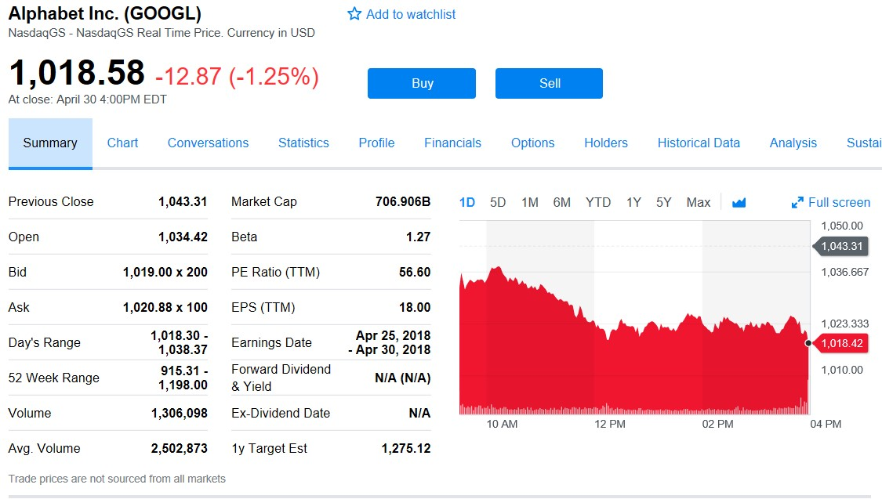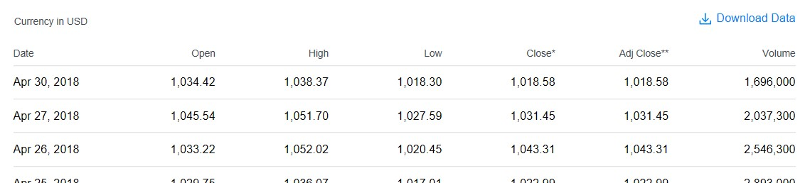

Place that data in an Excel *Worksheet*. Repeat this process for a different company stock so that there are two Worksheets, each with the appropriate stock ticker symbol.

Generate a plot that includes the two stock “Close” data and daily “High” and “Low” values. Normalize the data by the maximum “Close” price over the past month so that all values are divided by the maximum value for that particular stock. Calculate the MAX, MIN, STDEV, AVERAGE, and the MEDIAN for each stock “Close” data. Format the plots with appropriate font size for readability, eliminate shadow effects, make the plot readable in black and white, and remove the outside border. Describe how you would export the figure for a presentation or document. The final plot should be both readable and aesthetically pleasing.

**Problem 2**

Download the data from an Arduino temperature control device and import the data into an Excel workbook.

<http://apmonitor.com/che263/uploads/Main/tclab.txt>

Generate a plot that shows the measured temperature values on one plot and the heater values on another plot. Add appropriate labels to the plots such as x-label, y-label, title, and legend. Make sure that the plot is readable even when printed in black and white or for someone who may be color-blind. Horizontally align the time of two plots so that the heater effect on the temperature is observable.

**Problem 3**

For each of the following problems, on a worksheet entitled *Functions*, allow input of the independent variable, x, in one column. In a second column, show the function in text. In a third, show the value of the function.

|  |  |  |
| --- | --- | --- |
|  | Input value (x) | Output function f(x) |
| a. | 0.5 radians | cos(x) |
| b. | 30 degrees | sin(x) |
| c. | 2 | tan(π/x) π/x in radians |
| d. | 5 | maximum of 2√x, x2/2, x3/3, and (x2+x3)/5 |
| e. | 25 | x! |
| f. | 0.5 | x2 when x<1; sin(πx/2) when x≥1. |
| g. | 4.999 | largest integer less than or equal to x |

The assignment is due midnight **before** the beginning of the next class period.