**Summary of changes needed:**

We are deleting one sentence from the second bullet and adding a new bullet after it.

**Current text on IVERIF, S UNTAX, S EXCLUSIONS, S EXP/RES:**

* You will be asked to verify tax return information. Your choices for doing this will be to either confirm that you used the Data Retrieval Tool when you completed the FAFSA or to give us a copy of a 2016 Tax Return Transcript. You can get an electronic version of this at <http://www.irs.gov/Individuals/Get-Transcript> or by calling the automated IRS transcript request line at 1.800.908.9946. If you were not required to complete a tax return, you will provide earning information.

**Revised text for IVERIF, S EXP/RES:**

* You will be asked to verify tax return information. Your choices for doing this will be to either confirm that you used the Data Retrieval Tool when you completed the FAFSA or to give us a copy of a 2016 Tax Return Transcript. You can get an electronic version of this at <http://www.irs.gov/Individuals/Get-Transcript> or by calling the automated IRS transcript request line at 1.800.908.9946. ~~If you were not required to complete a tax return, you will provide earning information.~~
* If you (and spouse, if married) did not file a 2016 federal tax return, you will need to provide us a copy of a ‘Verification of Nonfiling Letter’ from the IRS or other relevant tax authority, dated on or after October 1, 2017, confirming that you (and spouse, if married) did not file in 2016.  You will also need to provide us copies of all 2016 W-2 forms, if you (and spouse, if married) worked in 2016.  A Verification of Nonfiling Letter can be requested from the IRS by using Form 4506-T with box 7 checked.  Here is the link: <https://osfa.washington.edu/forms/1819f4506t.pdf>

**Revised text for S UNTAX, S EXCL:**

* You will be asked to verify tax return information. Your choices for doing this will be to either confirm that you used the Data Retrieval Tool when you completed the FAFSA or to give us a copy of a 2016 Tax Return Transcript. You can get an electronic version of this at <http://www.irs.gov/Individuals/Get-Transcript> or by calling the automated IRS transcript request line at 1.800.908.9946. ~~If you were not required to complete a tax return, you will provide earning information.~~
* If you (and spouse, if married) did not file a 2016 federal tax return, you will need to provide us a copy of a ‘Verification of Nonfiling Letter’ from the IRS or other relevant tax authority, dated on or after October 1, 2017, confirming that you (and spouse, if married) did not file in 2016.  You will also need to provide us copies of all 2016 W-2 forms, if you (and spouse, if married) worked in 2016.  A Verification of Nonfiling Letter can be requested from the IRS by using Form 4506-T with box 7 checked.  Here is the link: <https://osfa.washington.edu/forms/1819f4506t.pdf>

**NOTE:** If you are considered a dependent student (you are required to provide parent information on your financial aid application), you are NOT required to obtain a Verification of Nonfiling Letter from the IRS.

**APPENDIX: OSFA’s original info. Dev can ignore this.**

**1819 Update to Entry Pages (IVERIF, S UNTAX, S EXCLUSIONS and S EXP/RES)**

1. Please delete the red boxed sentence from the Entry Pages of IVERIF, S UNTAX, S EXCLUSIONS and S EXP/RES.

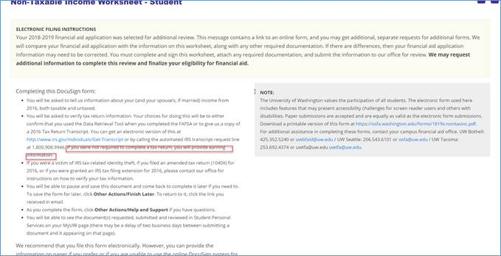

1. Please add a new bullet added after that 2nd bullet (the one with the red box that will be deleted) for **IVERIF and S EXP/RES**:

 This new bullet will be the 3rd bullet and it will say:

* If you (and spouse, if married) did not file a 2016 federal tax return, you will need to provide us a copy of a ‘Verification of Nonfiling Letter’ from the IRS or other relevant tax authority, dated on or after October 1, 2017, confirming that you (and spouse, if married) did not file in 2016.  You will also need to provide us copies of all 2016 W-2 forms, if you (and spouse, if married) worked in 2016.  A Verification of Nonfiling Letter can be requested from the IRS by using Form 4506-T with box 7 checked.  Here is the link: <https://osfa.washington.edu/forms/1819f4506t.pdf>

1. Please add the same new bullet as above for **S UNTAX and S EXCLUSIONS** except it will have an extra sentence:

This new bullet will be the 3rd bullet and it will say:

* If you (and spouse, if married) did not file a 2016 federal tax return, you will need to provide us a copy of a ‘Verification of Nonfiling Letter’ from the IRS or other relevant tax authority, dated on or after October 1, 2017, confirming that you (and spouse, if married) did not file in 2016.  You will also need to provide us copies of all 2016 W-2 forms, if you (and spouse, if married) worked in 2016.  A Verification of Nonfiling Letter can be requested from the IRS by using Form 4506-T with box 7 checked.  Here is the link: <https://osfa.washington.edu/forms/1819f4506t.pdf>

**NOTE:** If you are considered a dependent student (you are required to provide parent information on your financial aid application), you are NOT required to obtain a Verification of Nonfiling Letter from the IRS.