

**ENTERNSHIP REPORT**

**Names**: **NDAYISENGA Jean paul**

SCHOOL: **COLLEGE APPEC REMERA RUKOMA**

**ACADEMIC YEAR 2023s**

**COLLEGE OF SCIENCE AND TECHNOLOGY DEPARTMENT OF ICT (INFORMATION COMMUNICATION AND TECHNOLOGY)**

**INTERNSHIP REPORT CARRIED OUT IN**

**BYOSE HIGH TECHNOLOGY COMPANT *From 17th April 2023 to 12th* MAINTERNSHIP REPORT CARRIED OUT IN**

**BYOSE HIGH TECHNOLOGY COMPANT From 14th April 2022 to 5 th MAY**

**INTERNSHIP REPORT CARRIED OUT IN**

**BYOSE HIGH TECHNOLOGY COMPANT From 14th April 2022 to 5 th MAY**



Internee: **NDAYISENGA Jean paul**

Sector**: ICT (information communication technology)**

Subsector**: SOFTWARE DEVELEOPMENT**

School name: **COLLEGE APPEC REMERA RUKOMA TVET SCHOOL**

Trainer supervisor: IRADUKUNDA Ididore

**Date: on the 16th April 2022**

**DEDICATION**

I dedicated this report to God and people Who helped me to achieve my internship.

Most people are supervisor and class mates, Teacher, all Team member of ICT trade where I practiced and all friends who helped me to pass through difficulties during this period.

**ACKNOWLEDGEMENT**

Especially I thank to God who helped me in all days during the internship, Also I thank to College Appec which helped to improve my knowledge and skills.

**Contents:**

**CHAPTER 1: ABOUT WORKING ENVIRNOMENTAL INSTALLATION SETUP**

**.............................................. 3**

1.1: DEFINING XAMP AND SUBLIME ....................................................................................................... 3

1.1.1: CREATE HTML INTERFACE ............................................................................................................. 3

1. 1.2: INSERT ........................................................................................................................................... 4

1.1. UPDATE ....................................................................................................................................... 5

1.1. DELETE ......................................................................................................................................... 5

1.2: SUBLIME TEXT .................................................................................................................................. 5

Chapter 2: INTRODUCTION TO HTML ..................................................................................................... 6

**2.1:HTML TAGS** ................................................................................................................................... 6

2.2: DEFINING TAGS ................................................................................................................................ 7 **Chapter 3: INTRODUCTION TO PHP ........................................................................................................ 8**

3.1: USING PHP ....................................................................................................................................... 8

3.2:PHP Connection ................................................................................................................................ 9

3.3: USING QUERIES TO MAKE CHANGE IN DATABASE BY USING PHP .................................................. 9 **Chapter 4: INTRODUCTION TO CSS .......................................................................................................** **10**

4.1:DEFINING CSS .................................................................................................................................. 10

4.2. CSS SELECTOR AND IT’S DECLARATIONS ........................................................................................ 12

4.3.CSS PROPERTIES FEATURES

# **CHAPTER 1: ABOUT WORKING ENVIRNOMENTAL INSTALLATION SETUP**

# 1.1: DEFINING XAMP AND SUBLIME

**XAMPP**: is a local server that used to store data and other database activities It is also used to run queries in order to perform task like:

* UPDATE, INSERT, DELETE, CRAETE(CRUD)

# 1.1.1: CREATE HTML INTERFACE

HTML: Hypertext Markup Language

HTML is language which used to create webpage interface using different tags

* For example, of Html tags: **-br: break**

**-ul: unordered list**

**-link**

**-table**

**-form**

**-tr: table row**

**-td: table data**

**-input**

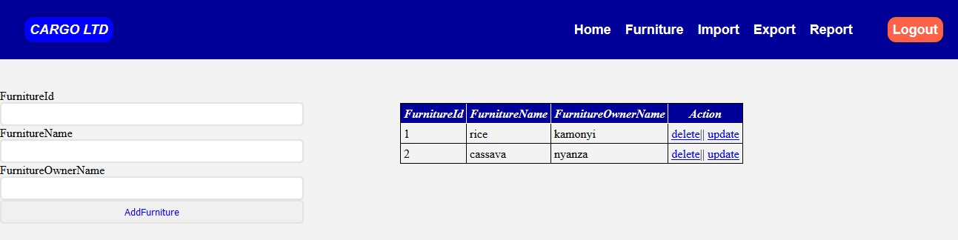

# 1.1.2: INSERT

This is used to insert data or to add information in database using tables

Syntax of INSERT QUERY INSERT INTO Table name (column 1, column 2, column 3) VALUES (value1, value 2, value 3)

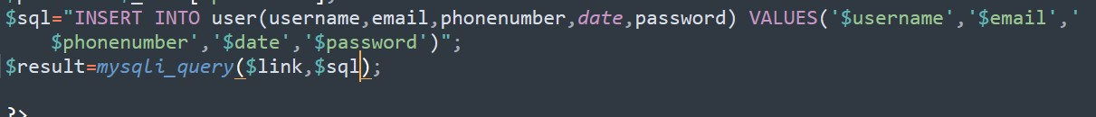

## 1.1. UPDATE

**THE UPDATE:** is used to change data or information in database

Syntax of UPDATE QUERY UPDATE (Table name) SET current name TO new name WHERE (condition);

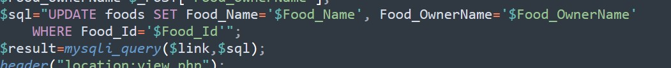

## 1.1. DELETE

**THE DELETE: is** used to delete existing record in table

Syntax of DELETE QUERY DELETE FROM Table name WHERE condition

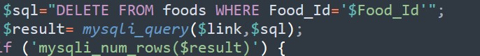

# 1.2: SUBLIME TEXT

**DEFINITION OF Sublime Text**: is text editor that helps to write or edit code(html) or scripting code

This helps to create HTML files that works as frame work of the page. Sublime text Editor is full featured text editor for editing local files or a code base. it includes various features editing code base which helps developers to keep track of changes

# **Chapter 2: INTRODUCTION TO HTML**

#### 2.1:HTML TAGS

SUBLIME TEXT contains many HTML (Hypertext Markup Language) Tags but before using tags, we have to know how to start html do the following in picture:

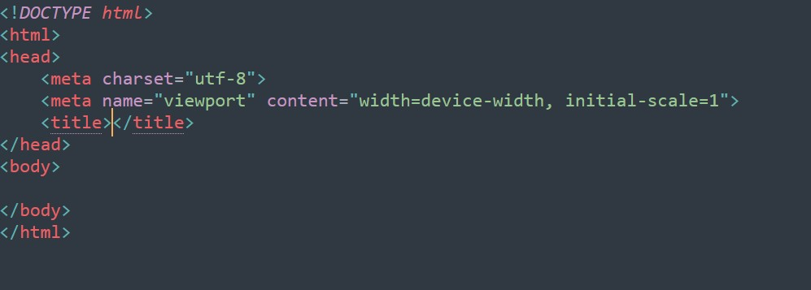

2.2: TAGS IN HTML

These are some HTML Tags you can use in html

* <Form>
* <Li(list)>
* <Link>
* <Ul (un ordered list)>
* <Input >
* <Table>
* <Button>
* <Section>
* <div>

All that can be used to make different task.

* + **Form tag:** used to make html for user input
  + **Li tag:** used to represent items in list
  + **Link tag**: define relationship between current document
  + **Ul tag:** represent unordered list of items
  + **Input tag:** use to make an input field for user to enter text or other characters
  + **Table tags:** is a block element used to create table
  + **Button tags:** is used to define the clickable button
  + **Section tags:** is used when requirements of two headers or footers or any other section of documents needed
  + **Div tags:** used as container of HTML element

And if you want to start your html tag

HTML tag start like this <………….> and end like this <………. />

For example:

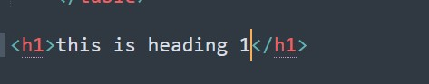

a

# Chapter 3: INTRODUCTION TO PHP

# 3.1: USING PHP

When We are using PHP, we have to create a .php file to start your PHP The Syntax of PHP are as the following:

For example:

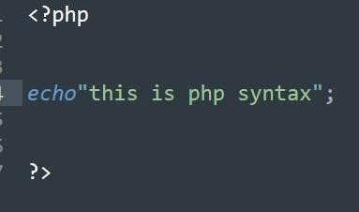

In PHP always we use ‘**?**’ tag start PHP codes and semi colon ‘;’ at the end of the line

# 3.2:PHP Connection

When we are going to connect website to server. we have to create a new file .PHP to make connection. this is when we do this:

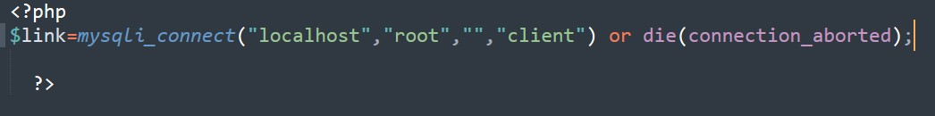

And to make a full connection we go in our HTML and make connection like this:



The ‘**POST**’ option in picture means to add information from website to database and if you want to retrieve data from database you use ‘**GET**’ instead of ‘**POST**’

# 3.3: USING QUERIES TO MAKE CHANGE IN DATABASE BY USING PHP

In Chapter one, we said about queries you can use in database and that’s what return in PHP and then we do the following

For example: We need to insert data in created table called

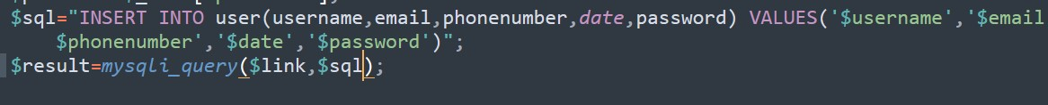

All of those we learned in PHP can help you in back end of website in order to make dynamic website

Here we are, you can make a simple website by reading this. And if you want to study more you can go at [http://www.w3school.com](http://www.w3school.com/)

# **Chapter 4: INTRODUCTION TO CSS**

# 4.1:DEFINING CSS

**CSS:** is Cascading Style Sheet, it is a style sheet language used for describing the presentation dof document written in markup language like HTML.

**CSS** is used for styling webpage to look better and that can attract user

There are three types of CSS including:

* Inline CSS
* Internal CSS or embedded CSS
* External CSS

Inline CSS: is style that designed in line with tag in HTML and continue to write your codes.

Example:



Internal CSS is a form of CSS which you can add CSS to HTML document.

Example:

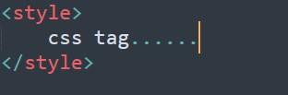

External CSS: is a file with an extension of a .CSS that contain Cascading Style Sheet. It is useful when it is connected or linked to HTML file in header.

This picture below shows how to link external CSS in HTML document:

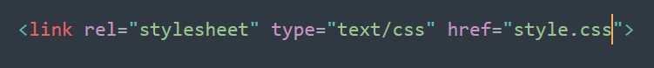

‘href’ means reference and what CSS file is about to be used that’s how we write our CSS to start design our HTML document

## 4.2. CSS SELECTOR AND IT’S DECLARATIONS

In CSS we have ways to get our design; We are writing CSS we have t target element or tag from HTML and start to design after that we.

In picture above ‘**ul**’ is a selector and Color and Text-decoration are properties.

We always use braces to start declaring properties and the end with semi colon

# 4.3.CSS PROPERTIES FEATURES

in CSS we have more features properties and down here we listed some of it

* Size
* Padding
* Margin
* Font-family
* Box-shadow
* Text- decoration
* Text- align
* Color
* Background-image
* Border-radius

***NB:*** The properties is used according to the element

Example: When you are going to target text we use font properties listed above like text decoration, font decoration, font- size , font family but when we are designing layouts page, for and other like that we use border radius , background – image and more .

**a{ color: black; text-decoration: none;**

**}**

We also have what we call pseudo- class.

Pseudo-class is used to add design to selector

There are example of CSS pseudo-classes

* Focus
* Active
* Hover

Example of where we use pseudo-class:

**. nag a:hover{**

**Color: greenyellow;**

The internship program aided the term to have knowledge about practical solving in our society. It was nice and we have gained more experience that can help in every society thanks for everyone and thanks for having this.

Ndayusenga jean paul

# CONCLUSION

As conclusion industrial attachment program is good for all

I would like to advice the school and other institution to

Accept those trainees who need internship . because it bring the advantages to both company and student.

**INDUSTRIAL ATTACHMENT PROGRAM**

**LEVEL4 SOFTWARE DEVELOPMENT**

**COMPANY NAME: ………………………………..**

**TRAINER NAME :** ………………………………...

**TRAINEE NAME :** **NDAYISENGA** jean paul