- Progress in 3 days to get the feedback. Tugashyiraho akantu nkaka, kerekana igihe case bayikoreye nigihe igomba kuba yakozweho
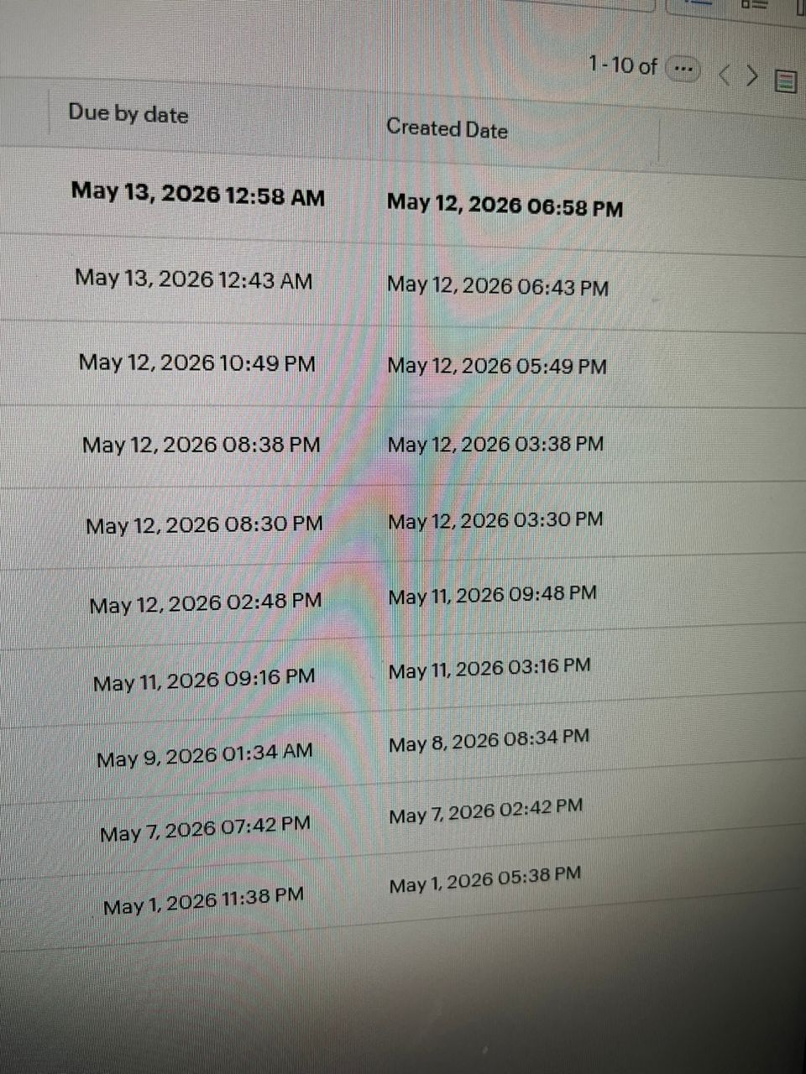

- Flagging izo igihe cyarenze, nurugero niba ari muminsi 5 bagomba kuba bagikozeho, bakaba ntacyo barakora igashyiraho kariya ga flag ka red
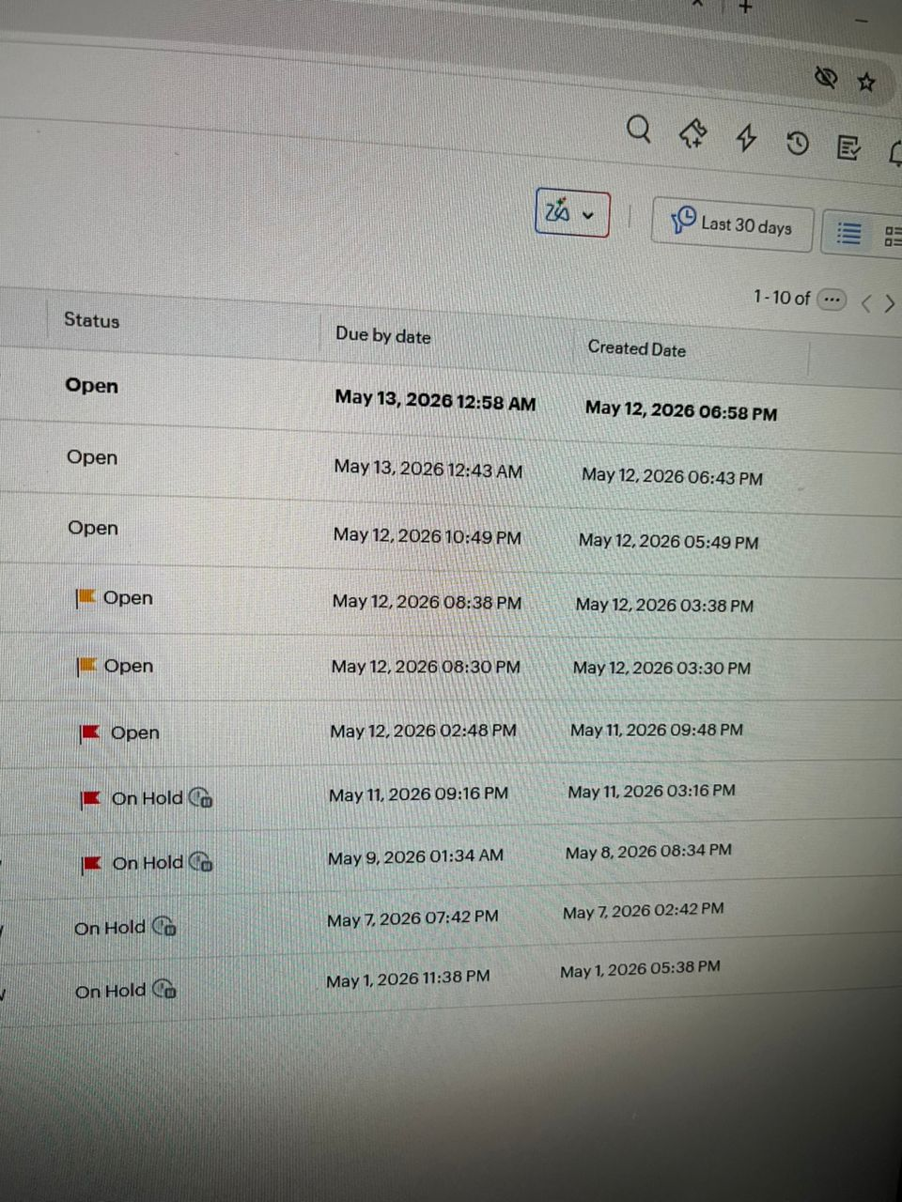
- Validation on the fields, gender (add others), ID, umuntu uri gukora login akaba agomba kushyiramo digits 16 ntizirenge

- officer sending a request back. aba officer bakaba bafite access yo kohereza case nko mu karere, cg niba aruwo mukarere akabasha kuyohereza kumuvunyi, akayohereza mu rukiko. Nukongeraho nka ga field.

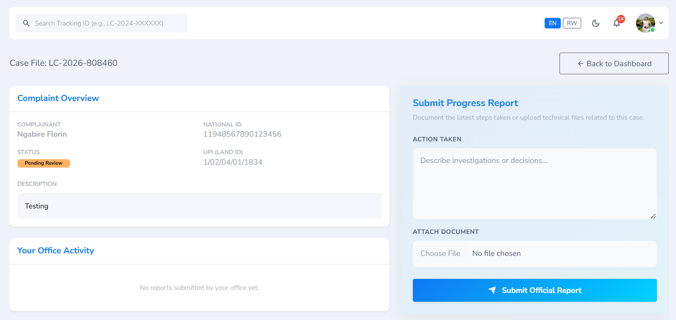

Warebera nkaha
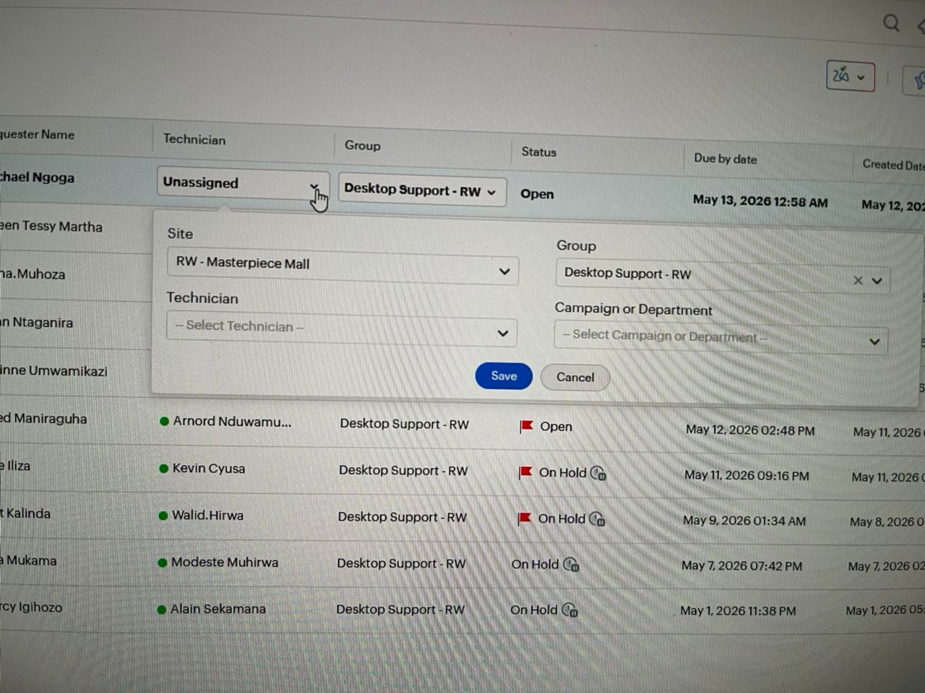
- Closed cases leaving the queue. Noneho cases zabaye closed zikava muzindi kugira queue itaba overload. Zikajya nko muri report. Ariko kuburyo officer cg admin azikeneye azibona
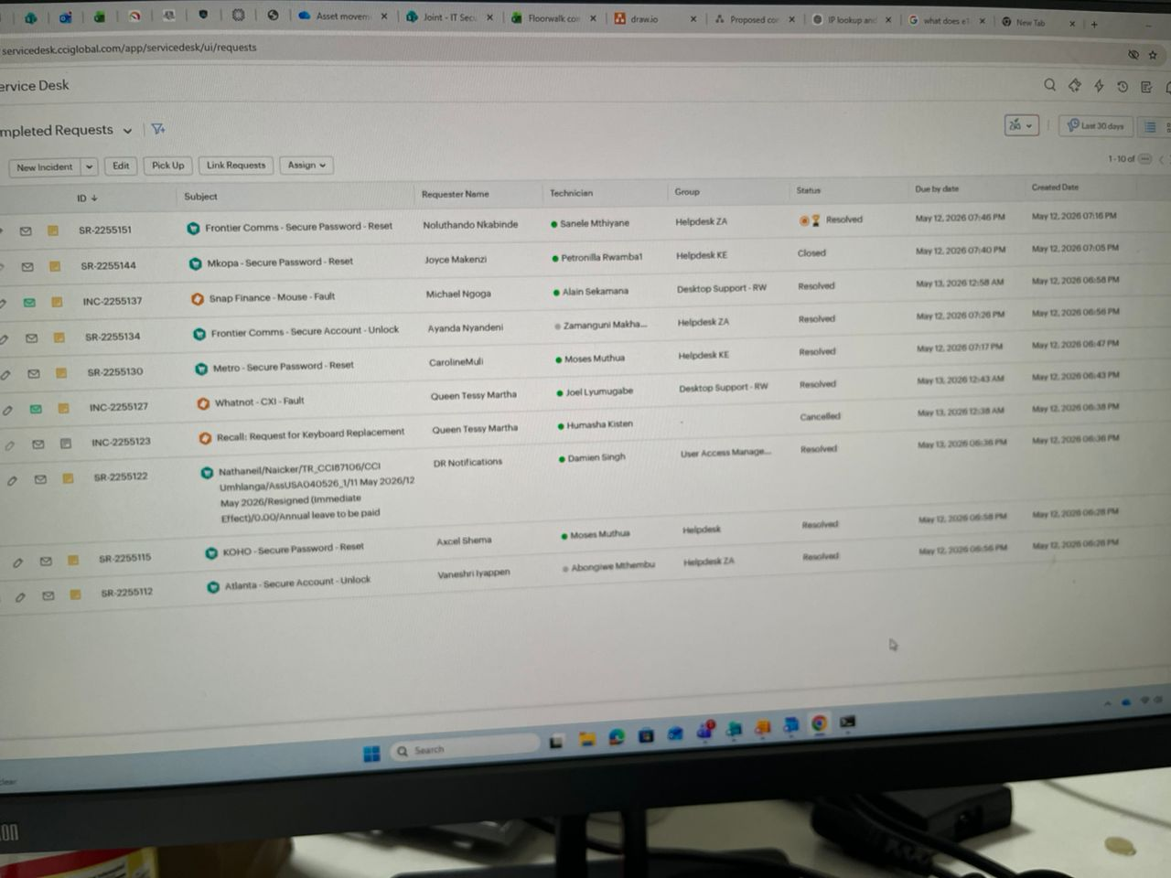

Izi ziri hasi wareberaho niba haricyo zagufasha
