FEEDBACK
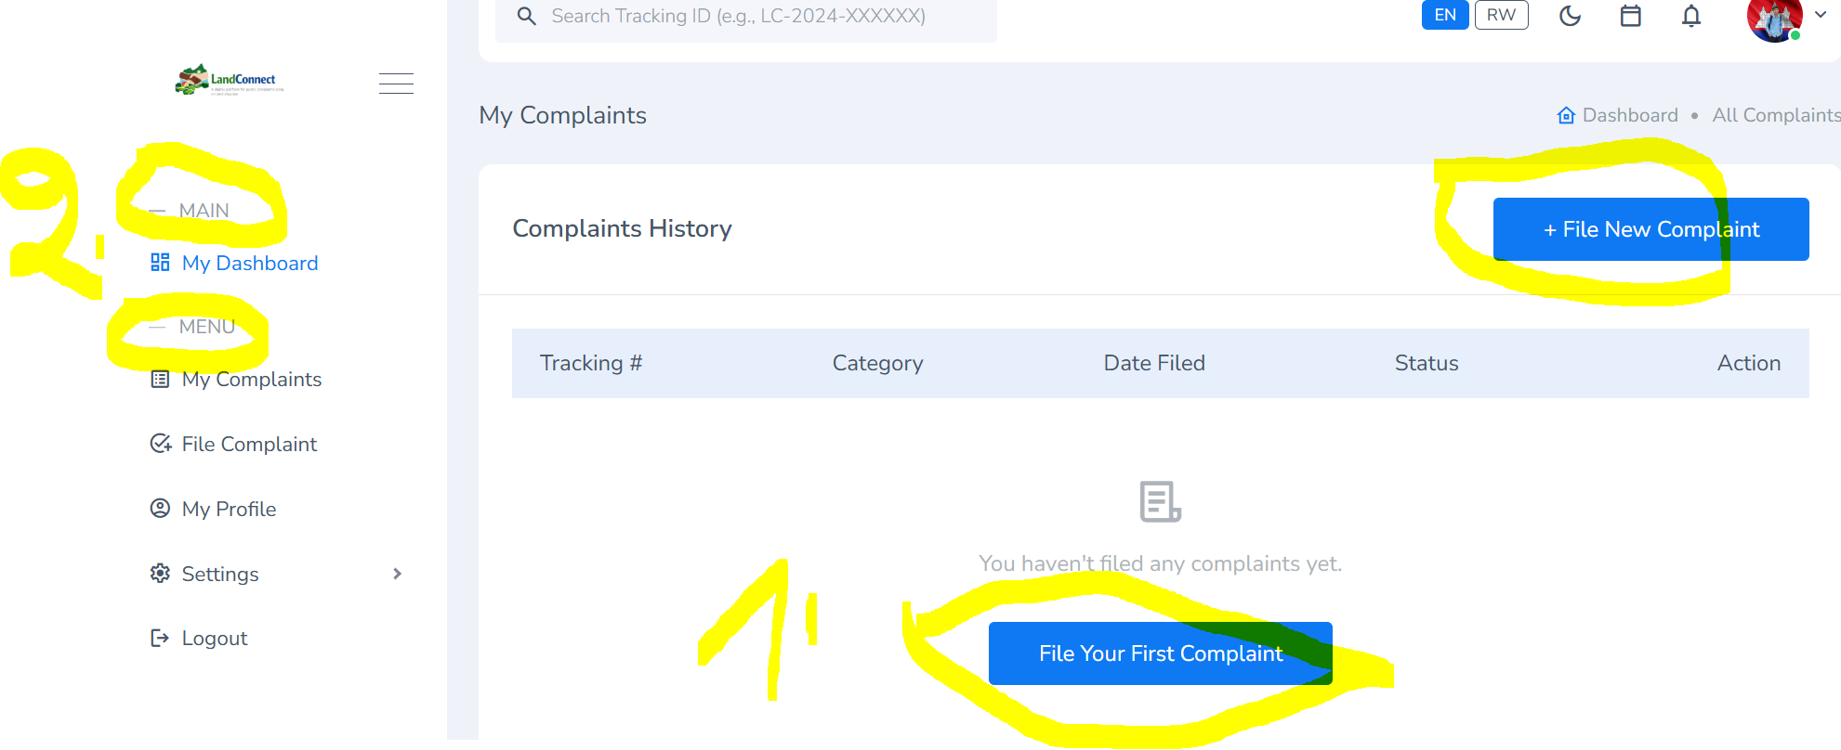
1. Ndi logged in nka admin, iyi button ya file complaint ndumva twayikuraho
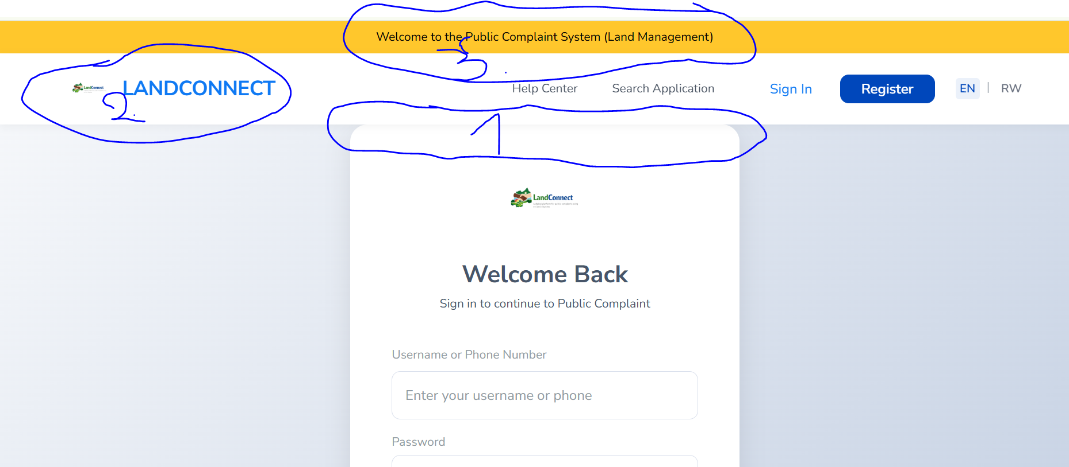
1. Space hagati ya header na form
2. Welcome to “A DIGITAL PLATFORM FOR PUBLIC COMPLAINTS FOCUSING ON LAND DISPUTSES”
3. To remove land connect

1. Public Complaints platform is a custom by Office of Ombudsman
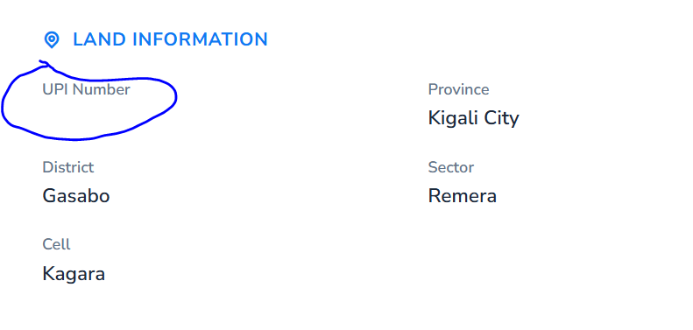
1. UPI ntabwo iri kuba displayed under details
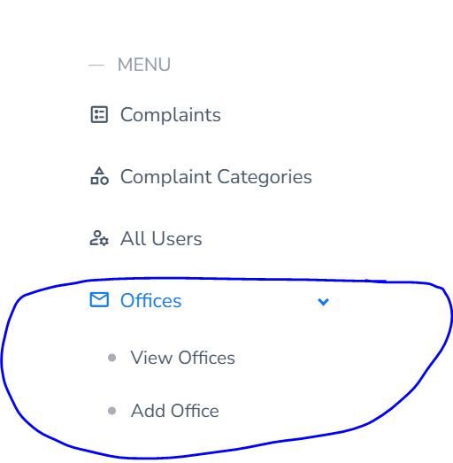
Officers
View Officers
Add officer
On the dashboard, intara, akarere byagaragayemo ibibazo byinshi,
reports

