Phase manipulation software manual

How to download the software?

Code is available from the LOCI Subversion repository:

https://skyking.microscopy.wisc.edu/svn/misc/trunk/adaptive-optics

Files can be downloaded individually with a web browser, or checked out en masse with a Subversion client such as TortoiseSVN.

Software structure

Phase manipulation control software is programmed by Min Ren for control phase modulator that is used in mulitphoton microscopy in LOCI, University of Wisconsin-Madison.

The project includes 3 parts. The project is saved in the directory misc/min/adaptive-optics/

- The dynamic link library files and header files from the BNS (Boulder Nonlinear Systems) as the interfaces to be call from user program. They are BNSBoard.dll, 512ABoard.dll, 256ABoard.dll, BNSHardware.h and BNSBoard.h.

- Java code that is used to show the SLM surface 3D image and generate the data. The code files are saved in directory ./slm_interface. If you change the code, you need use netbeans 5.5 or later version to rebuilt and generate new jar file.

- JNI project, saved in ./slmAPI, offer a dynamic linked library file to java code including the JNI interface and call the library from BNS for driving the SLM.

If you want to use SLM control software without any change, just copy all files in directory ./slm_interface/dist/.
SlmAPI.dll is generated by VC++ project, slmAPI in ./adaptive-optics.

Another directory LUT_Files includes a brunch of look up table used by software. In it, the slm7041.LUT is the default lut file for this mirror (check the manual in the documents directory)

Lastly, the slmdll_ga folder contains the native library for use with WiscScan. Support for SLM can be enabled in WiscScan by copying four DLL files into the WiscScan folder:
- slmdll_ga/Debug/slmdll.dll
- slmdll_ga/BNSBoard.dll
- slmdll_ga/256ABoard.dll
- slmdll_ga/512ABoard.dll

How to run the software?
Two options,
- Click the slm.bat.
- if you want to start the software by jar file from command line, you need type in
java –mx256m –jar slm_interface.jar, -mx256m is for larger memory.

- double click jar file doesn’t work.

How to use the software?
There are several parts in the interface.
- Parameters input.
The SLM is controlled with Zernike polynomials. So the wavefront depends on the parameters of Zernike polynomials. The first 16 polynomials are listed in the interface. You can input the parameters. The value must be a number, positive or negative. There are three buttons used to change the parameters. “save”, you can use it save the parameters to a file. “open”, you can use it open a file you saved before to load the parameters in. “reset” will reset all the parameters to zero.

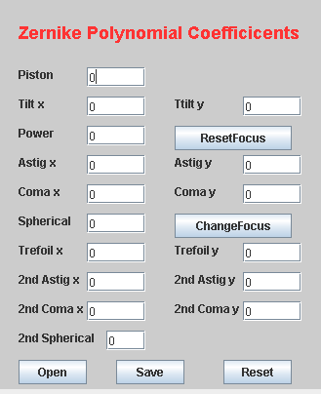

In the parameters, “piston” will change the wavefront of whole mirror for same value. “tilt x” and “tilt y” will cause shift aberration, “power” is related to defocus aberration, “astig x” and “astig y” are related to astigmatism, “coma x” and “coma y” are related to coma aberration, “spherical “ are related to spherical aberration.

- When you change the spherical aberration, it does cause the focus change. That is against to our idea in 3 dimension imaging, the focus is fixed in one depth and then the wavefront is manipulated to find a best image. So we added two buttons for focus change by spherical aberration parameter.
- Everytime when you change the “spherical “value, click the button “changfocus” and when you done and before changing spherical value again, click “reset focus”.

- select a lut file.

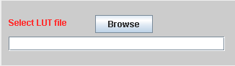

The LUT files are used to correct the nonlinear of SLM. Therefore it is related to the laser wavelength. We test the several LUT files for several laser wavelengths. The best LUT files are saved for 780nm and 890nm laser. All the LUT files are in LUT_Files directory.

- set the slm size and resolution

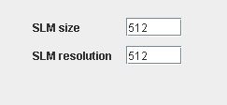

The software has the function to set the SLM size and resolution. The original size is 512*512 mirrors. The original resolution is 512*512. The user can change the SLM mirror size, so only the center mirrors are enabled and other mirrors are zero value.

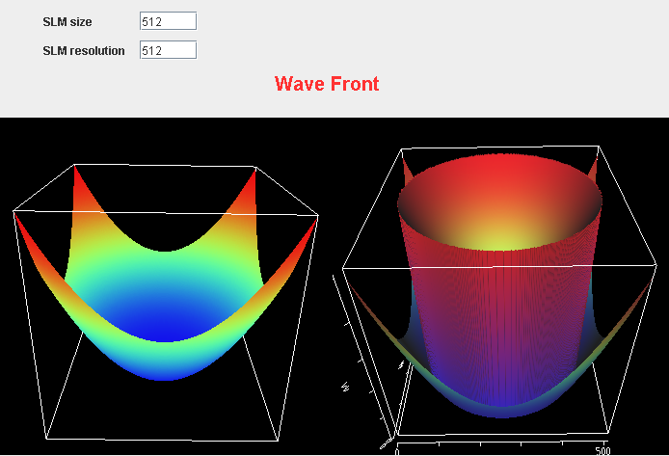

slm size is 512*512, slm resolution is 512*512

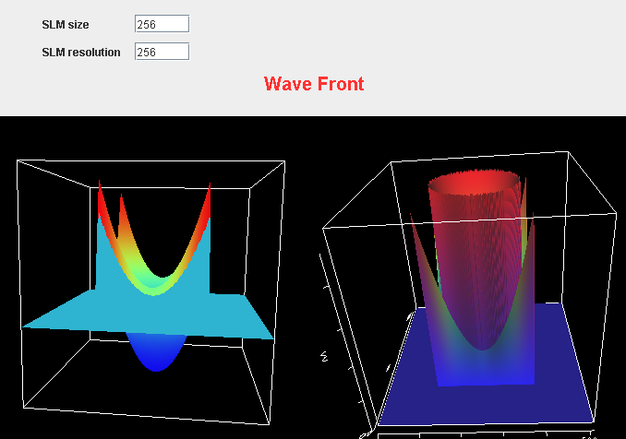

slm size is 256*256, slm resolution is 256*256

*The resolution is also can be changed to make it low by combining several mirror pixels. If mirror size is 512*512, the resolution is 256*256, every 4 pixels are set the same value. The value of size and resolution must be exponential of 2. such as 512, 256, 128, 64. And the value of resolution should be less or equal to the value of size.

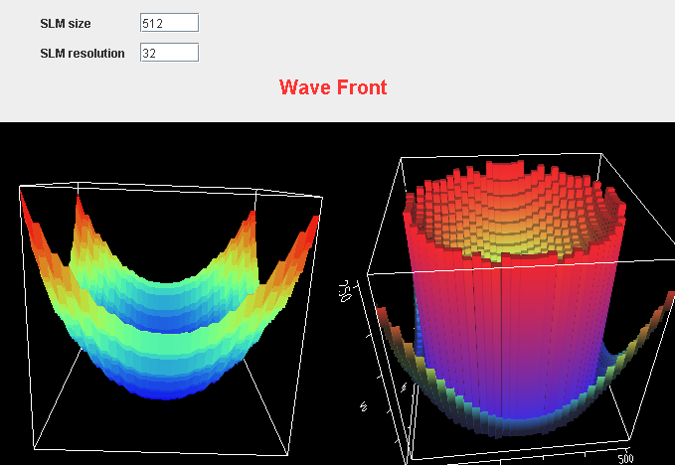

slm size is 512*512, slm resolution is 32*32

4. Load a pattern

Besides generating the wavefront by Zernike polynomials, you can also load an image to SLM. The image must be 512*512 8 bits bmp file.

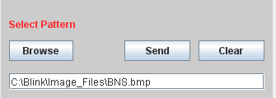

Select an image file by “browse” and “send” to SLM. “Clear” is used to clear the file name in text field.

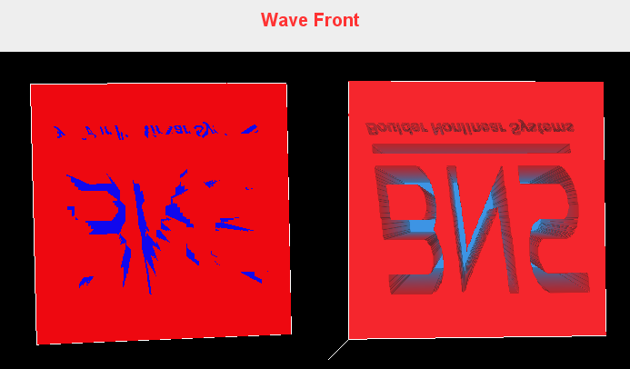

- Three dimension image

There are two three dimension images in interface. They both show the phase change on the SLM. The difference is that the phase change value of the right one is limited 0 to 2pi. And they are the actually value sent to SLM.

Dynamic linked library project
There is another project named slmAPI in ./adaptive-optics directory. This project generated the DLL file used in java interface program. There are three source files mainly used in this project. Com_slmcontrol_slmAPI.cpp is the interface between slmAPI and java code, slm_interface. It is a JNI interface. Slmcontrol.cpp calls the driver of slm. Test. Cpp receive the data from slm_interface and sent to slmcontrol.cpp. There is also another file, fft2d.cpp, not used in the control process. It includes several fourier transform function used in testing slm.
The project is compiled by VC++ 6.0 in PC.

